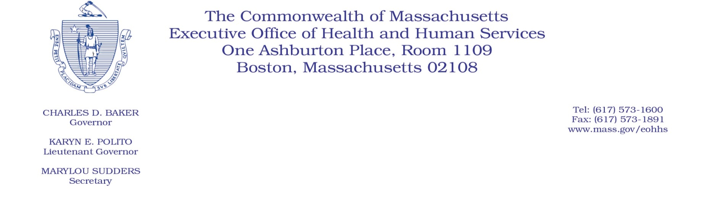

Administrative Bulletin 22-03

101 CMR 204.00: Rates of Payment to Resident Care Facilities

Effective January 15, 2022

Updated Payments Related to Coronavirus Disease 2019 (COVID-19) to Resident Care Facilities

Purpose, Scope, and Effective Period

The Executive Office of Health and Human Services (EOHHS) is issuing this administrative bulletin to implement certain time-limited staffing add-on payments related to Coronavirus Disease 2019 (COVID-19) and update surveillance testing payments processes under 101 CMR 204.00: Rates of Payment to Resident Care Facilities. EOHHS intends to incorporate the payment methodologies described herein into the final amendments to 101 CMR 204.00: Rates of Payment to Resident Care Facilities, originally filed as emergency amendments effective for dates of service on or after December 1, 2021.

This administrative bulletin is being issued pursuant to 101 CMR 204.08(6). The provisions of this administrative bulletin are effective January 15, 2022.

Certain Time-limited Staffing Add-on Payments Related to COVID-19

Effective January 15, 2022, a resident care facility will be eligible for an add-on payment to offset increased cost of providing care, not accounted for in the resident care facility’s prospective payment system rates, during the COVID-19 pandemic. The add-on payment will be made in three equal installments in the months of January, February, and March 2022. The aggregate amount of funding available for these payments is $1,527,778.

Calculation of a monthly add-on payment: EOHHS will use the following methodology to calculate the COVID-19 dd-on payment for each SSI/SSP and EAEDC resident care facility provider:

- Divide the number of Massachusetts DTA and EAEDC days annualized from the days reported by each resident care facility provider on their 2020 HCF-4 cost report, by the total number of Massachusetts DTA and EAEDC days, across all resident care facility providers, as annualized from the days reported by all SSI/SSP and EAEDC resident care facility providers on the 2020 HCF-4 cost report.
- Multiply the quotient calculated in a., above, by $1,500,000.
- Divide the product in b. by three.
- Each monthly add-on payment shall equal the amount calculated in paragraph c. above for each resident care facility. Note: for SSI/SSP and EAEDC resident care facilities with no SSI/SSP and EAEDC days reported in the 2020 HCF-4 cost report, the monthly payment will be equal to the average across all SSI/SSP and EAEDC resident care providers of the amount calculated in c

EOHHS may adjust any add-on payment upon EOHHS’s determination that there was a material error in the calculation of the payment. EOHHS will not adjust any add-on payment solely because a facility under-reported DTA and EAEDC days on the 2020 HCF-4 cost report.

Permissible uses of add-on payments: Facilities may use these add-on payments only for the following direct-care staff expenses: increases in base wages or retention bonuses for directly employed staff, signing bonuses for new employees, premium pay, shift differentials, and expenses related to temporary agency staff. These payments are to be used for heightened costs of care incurred for dates of service beginning January 1, 2022, through March 31, 2022.

For the purposes of this bulletin, direct-care staff shall include the following staff categories: Resident/personal care, nursing, dietary, housekeeping, recreational therapy, social workers. Direct-care staff shall not include facility administrators.

Reporting requirements: Each facility will be required to report to EOHHS, in a format prescribed by EOHHS, on the ways in which it expects to use, and ultimately uses, its received staffing add-on payments. The required report regarding expected use of these staffing add-on payments must be submitted by March 1, 2022. The required report for actual use of these add-on payments must be submitted by July 30, 2022, in accordance with 101 CMR 204.07. Failure to complete the required staffing add-on payment reporting, failure to timely submit the required reports, use of funds on anything other than permissible uses described herein, failure to incur permissible expenses to be funded through these add-on payments by March 31, 2022, or failure to actually pay the add-on payments for such incurred permissible expenses may result in partial or full recoupment of received staffing add-on payments.

All information included in the reports regarding add-on payments is subject to verification and audit by EOHHS. Failure to submit the required reporting in accordance with this bulletin or comply with audits or document requests with respect to the requirements under this bulletin may result in recoupment of the funds.

Updates to the Surveillance Testing Add-on Payment Requirements

Notwithstanding any applicable provisions of 101 CMR 204.09(3): Disallowance of COVID-19 Staff Testing Add-on Payments to the contrary, for dates of service beginning October 28, 2022, resident care facilities will not be disqualified for on-going COVID-19 staff testing add-on payments due to accumulating three or more instances of non-compliant testing periods. However, resident care facilities will not receive reimbursement for those tests performed within periods of non-compliance. In other words, individual non-compliant testing periods will not be included in the calculation of the resident care facility’s add-on payment.

Public Comments

EOHHS will accept comments on the payment methodologies established via this administrative bulletin, which are proposed to be codified as additional amendments to 101 CMR 204.00: Rates of Payments to Resident Care Facilities in the final adoption of the emergency amendments to that regulation that were originally filed with an effective date of December 1, 2021. Further, EOHHS will hold a public hearing and accept public comments regarding these amendments. The date and time of the public hearing and the public comment period will be forthcoming and will be identified in a Notice of Public Hearing, which will be published in the Massachusetts Register, and will be posted on the EOHHS public hearings webpage here: www.mass.gov/service-details/executive-office-of-health-and-human-services-public-hearings, as well as on regulations page for 101 CMR 204.00 here: https://www.mass.gov/regulations/101-CMR-20400-rates-of-payment-to-resident-care-facilities.

Individuals may submit written comments by emailing: ehs-regulations@mass.gov. Please submit written comments as an attached Word document or as text within the body of the email with the name of this administrative bulletin in the subject line. All submissions of comments must include the sender’s full name, mailing address, and organization or affiliation, if any. Individuals who are unable to submit comments by email may mail written comments to EOHHS, c/o D. Briggs, 100 Hancock Street, 6th Floor, Quincy, MA 02171.

EOHHS Website

This administrative bulletin is available on the 2022 EOHHS Administrative Bulletins web page.
To receive email alerts when EOHHS issues new regulatory actions, sign up at the EOHHS regulatory email notifications web page.

Questions

If you have questions about the information in this administrative bulletin, please email your inquiry to either Meera Ramamoorthy at Meera.e.ramamoorthy@mass.gov or to Pavel Terpelets at Pavel.terpelets@mass.gov.

