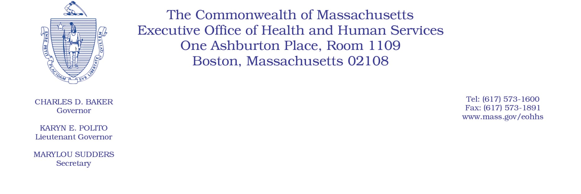

Administrative Bulletin 22-05

101 CMR 322.00: Durable Medical Equipment, Oxygen and Respiratory Therapy Equipment

Effective November 1, 2021

Rates for Digital Therapy Products for the Treatment of Opioid Use Disorder and Substance Use Disorder
Under the authority of 101 CMR 322.00, the Executive Office of Health and Human Services (EOHHS) is issuing this bulletin to establish rates for reSET® and reSET-O®, digital therapy products for the treatment of substance use disorder and opioid use disorder. 101 CMR 322.01(6)(c) provides authority for EOHHS to establish rates via administrative bulletin for durable medical equipment (DME) or medical supplies subject to a rebate agreement or agreements between a manufacturer and a governmental unit or units.

EOHHS has a rebate agreement in place for digital therapeutic products for the treatment of opioid use disorder and substance use disorder with Pear Therapeutics, Inc., effective November 1, 2021, through October 31, 2022. EOHHS is establishing a rate of no higher than wholesale acquisition cost (after rebate), as defined in 101 CMR 331.02, for any claims for reSET® and reSET-O® provided to MassHealth members by MassHealth-enrolled pharmacies designated by the manufacturer for claims submitted via the Pharmacy Online Processing System (POPS).

Please note, this rate is only established for digital therapy product pharmacy providers designated by the manufacturer. EOHHS has not otherwise established a rate for digital therapy products or for such products supplied by non-pharmacy providers.

