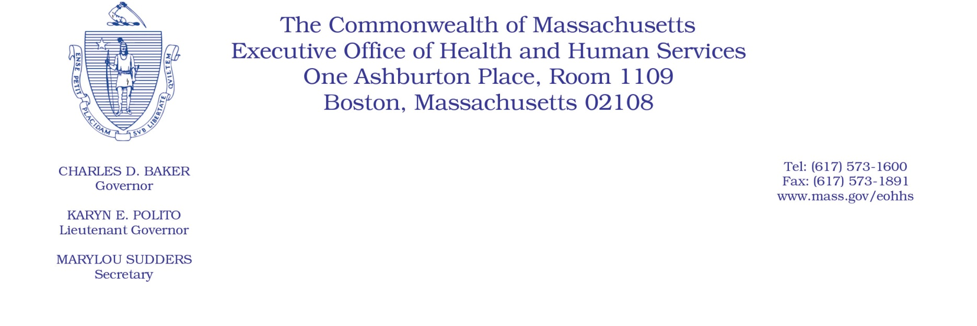

Administrative Bulletin 22-07

101 CMR 322.00: Durable Medical Equipment, Oxygen and Respiratory Therapy Equipment
Effective January 1, 2022
CPT/HCPCS 2022 Coding Updates
Under the authority of 101 CMR 322.01(5), the Executive Office of Health and Human Services (EOHHS) is adding new service codes and deleting an existing code, effective for dates of service on or after January 1, 2022.
For entirely new codes with associated Medicare fees as of the administrative bulletin adoption date, payment rates are set at a percentage of prevailing Medicare fees as described in 101 CMR 322.03(16)(a). Rates listed in this administrative bulletin are applicable until revised rates are issued by EOHHS.

The appearance of a code in the table below does not constitute authorization for, or approval of, the procedures or services for which rates are determined pursuant to 101 CMR 322.00. Governmental units that purchase care are responsible for the definition, authorization, and approval of care to publicly aided individuals.
New Codes
Code | Rate | Description
A4436 | 16.95 | Irrigation supply: sleeve, reusable, per month
A4437 | 16.95 | Irrigation supply: sleeve disposable, per month

Deleted Code
Code | Description
A4397 | Irrigation supply; sleeve, each

Crosswalked Codes

Deleted Code | Replacement Codes
A4397 | A4436  A4437

