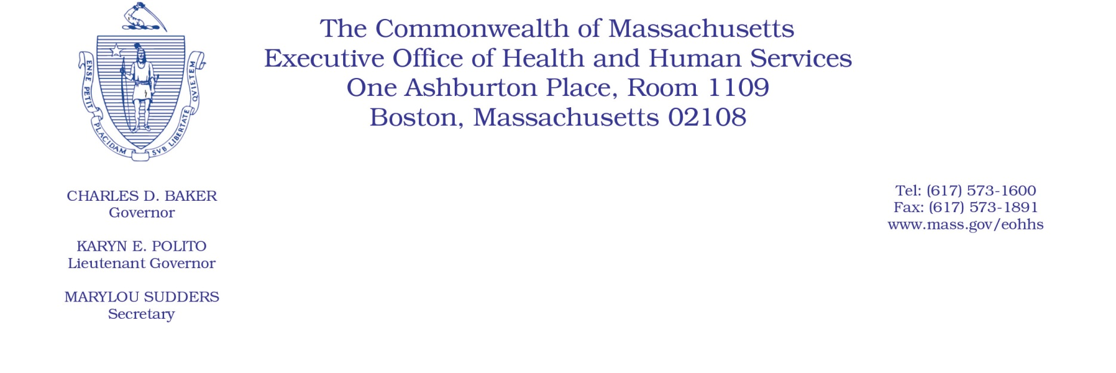

Administrative Bulletin 22-19

101 CMR 323.00: Rates for Hearing Services

Effective January 1, 2022
CPT 2022 Procedure Code Update
In accordance with 101 CMR 323.01(5): Coding Updates and Corrections, the Executive Office of Health and Human Services (EOHHS) is deleting an outdated code and cross-walking the deleted code to an existing replacement code, effective for dates of service on or after January 1, 2022. The code that is deleted and cross-walked is identified in the respective tables below. The deleted code is not available for use for dates of service after December 31, 2021.
Deleted codes
Deleted Code | Code Description
92564 | Short increment sensitivity index (SISI)

Cross-Walk Codes
Deleted Code | Replacement Code
92564 | 92700

