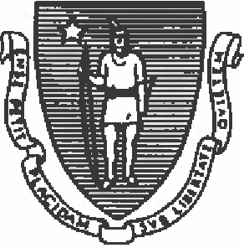
COMMONWEAL TH OF MASSACHUSETTS EXECUTIVE OFFICE OF HEALTH AND HUMAN SERVICES DEPARTMENT OF PUBLIC HEALTH
BUREAU OF HEALTH PROFESSIONS LICENSURE
BOARD OF REGISTRATION OF NURSING HOME ADMINISTRATORS
250 W ASHJNGTON STREET
BOSTON, MA 02108

800-414-0168
617-973-0806
www.mass.gov/dph/boards/nh

ADMINISTRATOR AFFIDAVIT CERTIFICATE OF INTERNSHIP TRAINING

(Trainee Name)

I, ,
(Administrator)
(Degree Level)

,hereby certify that (License number)

the trainee named above has trained in the

from to ,working (mm/dd/yyyy} mm/dd/yyyy)

(Name of Nursing Home}

hours per week, for a total of hours.

During this training period, the trainee named above has worked as an Administrator In Training; if the trainee held another position at the facility during the AIT, the AIT training has been completed separately from the normal working hours for that position. During the course of this training, the trainee was exposed to all aspects of nursing home management and the operation of the named facility, including the following: admittance procedures, patient care policies, utilization review processes, in-service training procedures, social services, medical records, housekeeping and sanitation, dietary and kitchen operations, medical department and applicable rehabilitation procedures, laundry services, purchasing procedures, personnel department procedures and policies, management functions including budgeting, billing, accounts receivable and payable, and departmental scheduling, etc.

I have been licensed in good standing for at least five years.

UNDER THE PENALTY OF PERJURY, THIS AFFIDAVIT HAS BEEN SIGNED AFTER THE COMPLETION
DATE OF THE AIT.

Signature of Administrator Date

Notary Public Notary Expiration Date

Effective Date of This Document Seal

APPLICATION FOR NURSING HOME ADMINISTRATOR LICENSURE
BOARD OF REGISTRATION OF NURSING HOME AoMINISTRA TORS
Revised 7-2023

