Massachusetts Department of Public Health
Bureau of Infectious Disease and Laboratory Sciences
Massachusetts HIV Epidemiologic Profile: Data as of 1/1/2022
Population Report: Adolescents and Young Adults, Accessible MS Word Version, optimized for screen reader use
Please note that while the content of this report is the same as the PDF version, the format and pagination have been modified significantly to optimize use with screen readers to ensure access for blind or visually impaired audiences.
Suggested citation:
Massachusetts Department of Public Health, Bureau of Infectious Disease and Laboratory Sciences. Massachusetts HIV Epidemiologic Profile: Data as of 1/1/2022, Population Report: Adolescents and Young Adults, https://www.mass.gov/lists/hivaids-epidemiologic-profiles Published April 2023. Accessed [date].
Bureau of Infectious Disease and Laboratory Sciences
Massachusetts Department of Public Health
Jamaica Plain Campus/State Public Health Laboratory
305 South Street
Jamaica Plain, MA 02130
Questions about this report
Tel: (617) 983-6560
To reach the Reporting and Partner Services Line
Tel: (617) 983-6999
To speak to the on-call epidemiologist
Tel: (617) 983-6800
Questions about infectious disease reporting
Tel: (617) 983-6801
Requests for additional data
https://www.mass.gov/lists/infectious-disease-data-reports-and-requests
Slide sets for HIV Epidemiologic Profile Reports
https://www.mass.gov/lists/hivaids-epidemiologic-profiles
ADOLESCENTS AND YOUNG ADULTS AT A GLANCE
N = 199, 12% of 1,635 new HIV diagnoses from 2018–2020 were among adolescents and young adults (aged 13 to 24 years)
N =347, 1% of 23,368 persons living with HIV infection in MA as of 12/31/2020 were adolescents and young adults (aged 13 to 24 years)
KEY FINDING: Nationally, from 2018 to 2020, 26% of HIV infections were diagnosed among adolescents and young adults (aged 13 to 24 years), compared to 12% in Massachusetts.
FIGURE 1. Individuals diagnosed with HIV infection at age 13–19 years vs. 20–24 years by sex assigned at birth, race/ethnicity, and exposure mode, Massachusetts 2018–2020
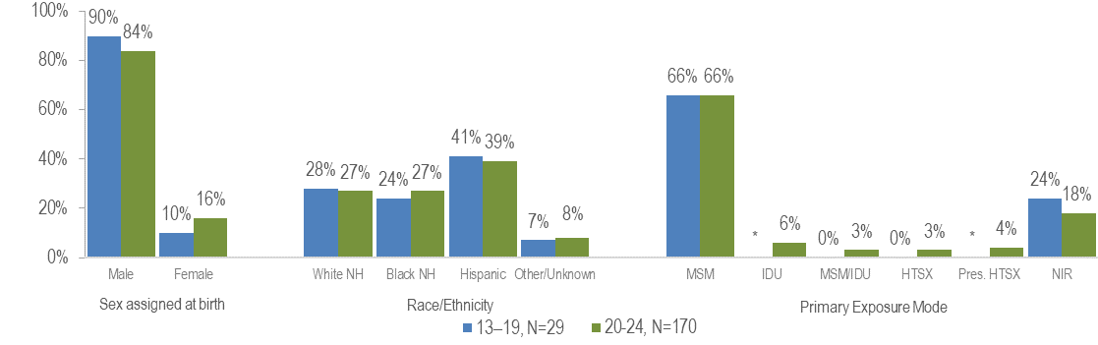
* Values less than five are suppressed for populations less than 50,000 or for populations of unknown size. MSM=male-to-male sex; IDU=injection drug use; HTSX=heterosexual sex; Pres. HTSX=presumed heterosexual exposure, includes individuals assigned female at birth with a negative history of injection drug use who report having sex with an individual that identifies as male of unknown HIV status and risk; NIR=no identified risk
- Among adolescents and young adults (aged 13–24 years) recently diagnosed with HIV infection (2018–2020), 85% (N=170) were 20 to 24 years of age and 15% (N=29) were 13 to 19 years of age. Additionally, 4% (N=8) were considered minors (under 18 years of age) and 96% (N=191) were 18 years of age or older.
- A larger proportion of youth diagnosed with HIV infection at age 13–19 years than at age 20–24 years was assigned male at birth (90% vs. 84%), and a smaller proportion was assigned female at birth (10% vs. 16%).
- The distribution by race/ethnicity was similar for youth recently diagnosed with HIV infection at age 13–19 years and those diagnosed at age 20–24 years.
- The proportion of youth recently diagnosed with HIV infection at age 13–19 years with no identified risk for HIV exposure mode (24%) was greater than that among youth diagnosed at age 20–24 years (18%).
SEX ASSIGNED AT BIRTH
FIGURE 2. HIV infection diagnoses by age at HIV diagnosis and sex assigned at birth, Massachusetts 2018–2020
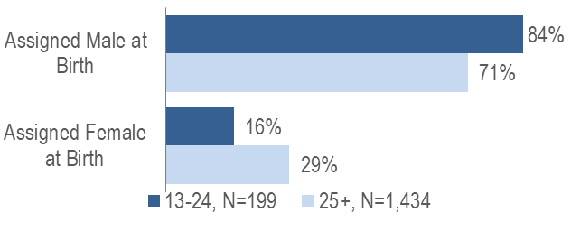
- A larger proportion of adolescents and young adults recently diagnosed with HIV infection at age 13–24 years (84%) than at age 25 years and older (71%) was assigned male at birth (AMAB).
RACE/ETHNICITY
FIGURE 3. HIV infection diagnoses by age at HIV diagnosis and race/ethnicity, Massachusetts 2018–2020
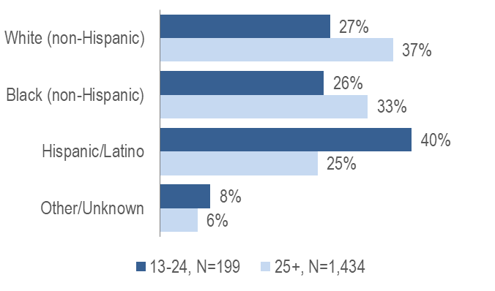
- While the largest proportion of adolescents and young adults recently diagnosed with HIV infection at age 13–24 years was Hispanic/Latino (40%), the largest proportion of individuals recently diagnosed at age 25 years and older was white (non-Hispanic) (37%).

EXPOSURE MODE
FIGURE 4. HIV infection diagnoses by age at HIV diagnosis and exposure mode, Massachusetts 2018–2020
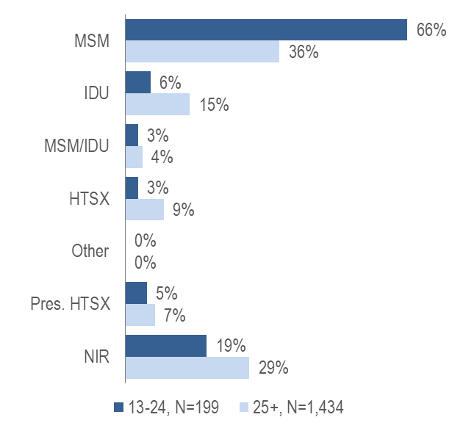
MSM=male-to-male sex; IDU=injection drug use; HTSX=heterosexual sex; Pres. HTSX=presumed heterosexual exposure, includes individuals assigned female at birth with a negative history of injection drug use who report having sex with an individual that identifies as male of unknown HIV status and risk; NIR=no identified risk
KEY FINDING
- A larger proportion of individuals recently diagnosed with HIV infection at age 13–24 years (66%) than at age 25 years and older (36%) had MSM exposure mode.
KEY FINDING
- A larger proportion of individuals AMAB recently diagnosed with HIV infection at age 13–24 years (78%, N=131/168) than at age 25 years and older (51%, N=514/1,019) had MSM exposure mode.

FIGURE 5. HIV infection diagnoses among individuals aged 13–24 years by race/ethnicity and exposure mode, Massachusetts 2018–2020
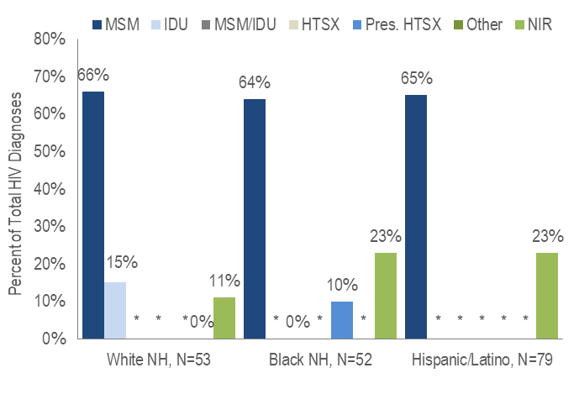
* Values less than five are suppressed for populations less than 50,000 or for populations of unknown size. Percentages do not add up to 100% due to suppressed values.
- The proportion of adolescents and young adults (aged 13–24 years) recently diagnosed with MSM exposure mode was 66% among white (non-Hispanic) youth, 65% among Hispanic/Latino youth, and 64% among black (non-Hispanic) youth.
- IDU was the exposure mode for a larger proportion of adolescents and young adults (aged 13–24 years) recently diagnosed with HIV among white (non-Hispanic) youth (15%) than among other race/ethnicities.
AREA OF RESIDENCE
TABLE 1. Massachusetts cities/towns with the highest percentage of HIV diagnoses among adolescents and young adults (13–24 years old), 2018–2020
 | HIV Diagnoses Among 13–24 Year-Olds (N) | HIV Diagnoses Among 13–24 Year-Olds as Percent of Total HIV Diagnoses in City/Town(%)
Massachusetts Total | 199 | 12%
Waltham | 6 | 26%
Framingham | 5 | 22%
Springfield | 15 | 21%
Lynn | 8 | 19%
Worcester | 14 | 15%
Everett | 5 | 15%
All Other Cities/Towns | 146 | 11%

- Among cities and towns with at least 20 reported HIV diagnoses in 2018–2020 and at least 5 diagnoses among 13-24 year-olds, Waltham, Framingham, and Springfield had the largest proportions of HIV infections diagnosed among adolescents and young adults (aged 13–24 years old). Each had at least 20% of new HIV infections diagnosed between the ages of 13 and 24 years.
INFORMATION FROM ADDITIONAL DATA SOURCES
Massachusetts Youth Risk Behavior Survey (YRBS): An anonymous survey of public high school students conducted every odd year that collects data on health-related behaviors that may threaten the health and safety of young people.
Sexual behaviors
Respondents to the 2019 Massachusetts YRBS reported the following rates of sexual behaviors:
  - ever having sexual intercourse: 36.9% (95% Confidence Interval [CI]: 32.8%–41.3%, n=1,946);
- sexual intercourse in the past three months: 26.9% (95% CI: 23.6%–30.4% n=1,943);
- condom use at last intercourse: 51.4% (95% CI: 45.3%–57.4%, n=427);
- alcohol or drug use at last intercourse: 23.4% (95% CI: 19.5%–27.9%, n=434);
- having four or more lifetime sexual partners: 7.8% (95% CI: 6.3%–9.5%, n=1,938); and
- sexual intercourse before age 13: 2.5% (95% CI: 1.7%–3.4%, n=1,951).
Drug use
Both injection and non-injection substance use have been documented to increase risk for HIV and hepatitis C virus infection.
Respondents to the 2019 Massachusetts YRBS reported the following rates of drug use:
- ever using marijuana: 41.9% (95% CI: 37.5%–46.4%, n=1,917);
- ever using cocaine: 3.7% (95% CI: 2.8%–5.0%, n=1,937);
- ever using ecstasy 3.4% (95% CI: 2.4%–4.9%, n=1,933);
- ever using methamphetamines: 2.2% (95% CI: 1.4%–3.5%, n=2,162); and
- ever using heroin: 1.9% (95% CI: 1.2%–3.0%, n=2,152).
Data Source for Youth Risk Behavior Survey Data: Centers for Disease Control and Prevention (CDC). 2019 High School Youth Risk Behavior Survey Data. Available at http://nccd.cdc.gov/youthonline/. Accessed on [9/2/2020] CDC, Accessed at Youth Online, https://nccd.cdc.gov/Youthonline/App/Default.aspx.
HIV Surveillance Data Source: MDPH Bureau of Infectious Disease and Laboratory Sciences, data are current as of 1/1/2022 and may be subject to change

Providers may use this number to report individuals newly diagnosed with a notifiable sexually transmitted infection, including HIV, or request partner services. Partner services is a free and confidential service for individuals recently diagnosed with a priority infection. The client-centered program offers counseling, linkage to other health and social services, anonymous notification of partners who were exposed and assistance with getting testing and treatment. For more information, see: https://www.mass.gov/service-details/partner-services-program-information-for-healthcare-providers)
Please consider the impact of the COVID-19 pandemic on infectious disease screening, treatment, and surveillance in the interpretation of 2020 data
Centers for Disease Control and Prevention. HIV Surveillance Report, 2020; vol. 33. http://www.cdc.gov/hiv/library/reports/hiv-surveillance.html Published May 2022. Accessed [12/18/22].
Please consider the impact of the COVID-19 pandemic on infectious disease screening, treatment, and surveillance in the interpretation of 2020 data
Please consider the impact of the COVID-19 pandemic on infectious disease screening, treatment, and surveillance in the interpretation of 2020 data
Please consider the impact of the COVID-19 pandemic on infectious disease screening, treatment, and surveillance in the interpretation of 2020 data
City/town is based on residence at HIV infection diagnosis
All Other Cities/Towns includes individuals diagnosed in a correctional facility
Please consider the impact of the COVID-19 pandemic on infectious disease screening, treatment, and surveillance in the interpretation of 2020 data

