Commonwealth of Massachusetts

Executive Office of Health and Human Services
Office of Medicaid
www.mass.gov/masshealth
MassHealth

Adult Day Health Bulletin 34
July 2022

TO: Adult Day Health Providers Participating in MassHealth
FROM: Amanda Cassel Kraft, Assistant Secretary for MassHealth [signature of Amanda Cassel Kraft]
RE: Adult Day Health (ADH) Wheelchair Transportation Prior Authorization (PA)

Background
MassHealth promulgated ADH rates for wheelchair transportation services (T2003 U6) effective for dates of service on or after July 1, 2022. See 101 CMR 310.00: Rates for Adult Day Health Services. In order to bill MassHealth using the T2003 U6 rate, an ADH provider must obtain a PA from MassHealth for each member it seeks to transport via wheelchair transportation services to or from its ADH program. This bulletin describes the PA process for wheelchair transportation services to or from an ADH program.

Significant Change Prior Authorization for Active PAs
For all members whose primary mode of locomotion is a wheelchair, ADH providers must submit a Significant Change PA to indicate the member’s locomotion status and the need for wheelchair transportation to and from the ADH program. Providers must complete all required fields within the Significant Change PA, including the diagnosis fields, skilled services, ADL assistance fields, and health related services fields. If the PA for wheelchair transportation is approved, the active PA will be modified with the new transportation line backdated to July 1, 2022, (or the date the member started the ADH program, if after July 1, 2022) and the Significant Change PA will be voided. If the PA for wheelchair transportation is not approved, the Significant Change PA will be denied. The member’s most recent Minimum Data Set (MDS)/assessment tool must be uploaded with the Significant Change PA. ADH providers should not complete a new MDS/assessment tool for this significant change. Section G:4 of the MDS must indicate that “4. Wheelchair” is the primary mode of locomotion.

Reason for Significant Change Prior Authorization
When submitting a Significant Change PA for wheelchair transportation, please select “Change in service payment level” as the reason for the significant change.

Initial PAs for New Admissions
When submitting an initial PA for a new admission to the ADH program, providers must submit an MDS/assessment tool as part of the required documentation if wheelchair transportation is requested.

Process to Request Wheelchair Transportation
When submitting the PA, select the line item associated with code T2003 and add the requested modifier “U6” and the requested effective date. The effective date cannot be prior to the admission date and the service must have been provided for claims to be submitted for dates of service on or after the admission date.
Follow the standard process as reflected in the training guide to add the line items. Once all the line items are added and reflected on the main PA page, click on the “C” to open the line item detail page for Transportation Line Item.
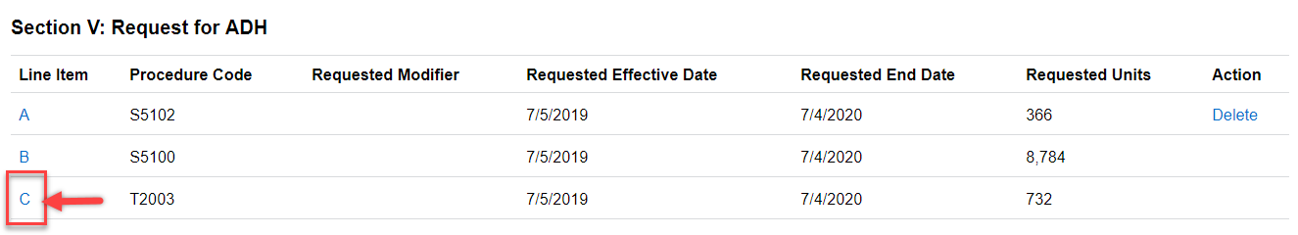
On the line item detail page for Transportation (T2003), click on the drop-down on “Requested Modifier.” Select the modifier “U6” and click “Save & Return.”
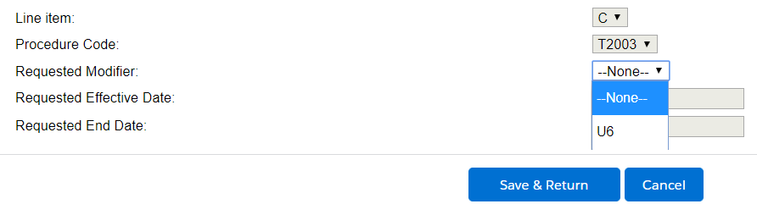
After the user has clicked on “Save & Return,” the system will save this new modifier and bring the user to main PA page with the line item summary and the modifier will be reflected on this page.
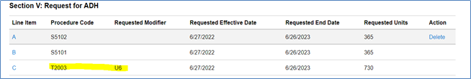

Reevaluation PAs for Current Members
When submitting a re-evaluation PA for current members who require wheelchair transportation, providers must ensure the MDS/assessment tool identifies the member’s primary mode of locomotion as “wheelchair” and follow the steps detailed above.

MassHealth Website
This bulletin is available on the MassHealth Provider Bulletins web page.
Sign up to receive email alerts when MassHealth issues new bulletins and transmittal letters.

Questions
If you have questions about the information in this bulletin, please contact the Long Term Services and Supports (LTSS) Provider Service Center.
Phone: Toll free (844) 368-5184
Email: support@masshealthltss.com
Portal: www.MassHealthLTSS.com
Mail: MassHealth LTSS
PO Box 159108
Boston, MA 02215
Fax: (888) 832-3006

