The Commonwealth of Massachusetts
Executive Office of Health and Human Services
Department of Public Health
Bureau of Health Care Safety and Quality
67 Forest Street, Marlborough MA 01752
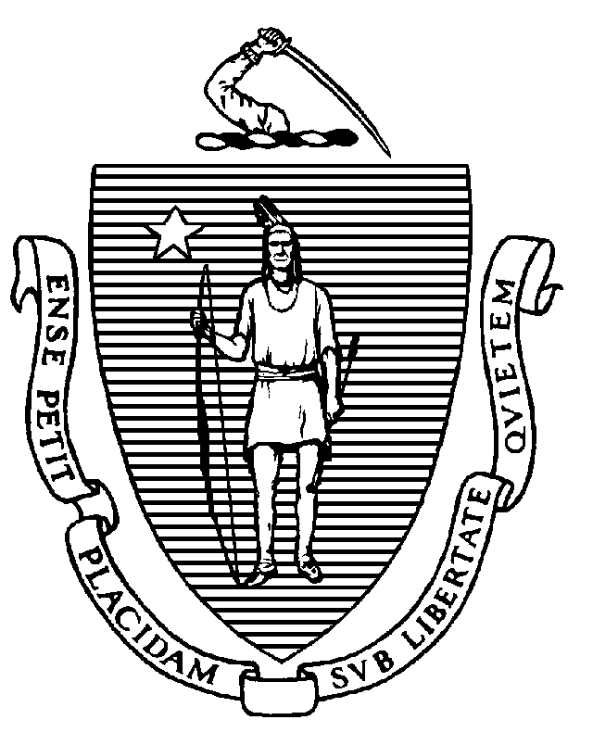

KATHLEEN E. WALSH
Secretary
ROBERT GOLDSTEIN, MD, PhD Commissioner

Tel: 617-624-6000
www.mass.gov/dph

MAURA T. HEALEY
Governor
KIMBERLEY DRISCOLL
Lieutenant Governor

Memorandum

TO: Adult Day Health Program Administrators
FROM: Elizabeth Daake Kelley, MPH, MBA, Director
Bureau of Health Care Safety and Quality
SUBJECT: Adult Day Health Personnel Vaccination for COVID-19 and Influenza
DATE: November 6, 2023

The purpose of this memorandum is to inform Massachusetts adult day health programs of the steps needed to fulfill the Massachusetts Department of Public Health (DPH) requirement to vaccinate healthcare personnel (HCP) for influenza and COVID-19 and to submit these data in accordance with DPH guidelines outlined in this memorandum.

COVID-19 and Influenza Vaccination Requirement:
As a condition of licensure, under 105 CMR 158.030(L) and (M), DPH adult day health program licensure regulations require licensed adult day health programs to ensure all HCP are vaccinated annually with seasonal influenza vaccine and are up to date with vaccine doses for COVID-19 as recommended by the Centers for Disease Control and Prevention (CDC), unless an individual is exempt from vaccination. For the purposes of this memo, being up to date with vaccine doses for COVID-19 means that HCP must receive one updated COVID-19 vaccine, at least two months after getting the last dose of any COVID-19 vaccine. An individual who has not previously received any doses of COVID-19 vaccine but who receives one dose of the updated COVID-19 vaccine is also up-to-date.
HCP means an individual or individuals who either work at or come to the licensed program site and who are employed by or affiliated with the program, whether directly, by contract with another entity, or as an independent contractor, paid or unpaid including, but not limited to, employees, members of the medical staff, contract employees or staff, students, and volunteers, whether or not such individual(s) provide direct care.

All HCP, who are not subject to an exemption, must be up-to-date with COVID-19 vaccine and have received the 2023-2024 seasonal influenza vaccine no later than December 31, 2023.

For any individual that is subject to the vaccine exemption, the adult day health program may choose to require such individual to take mitigation measures in addition to continuing to self-assess for any signs or symptoms of illness. Mitigation measures that the adult day health program may require an individual to take if they are exempt from vaccination include, but are not limited to:
- wearing a facemask during all participant care encounters for the duration of the respiratory illness season; and
- avoiding direct participant care.
DPH continues to recommend staff using personal protective equipment consistent with the Department’s Comprehensive PPE Guidance.

Facility Documentation:

The regulation requires adult day health programs maintain for each individual proof of seasonal influenza vaccination and being up-to-date with COVID-19 vaccination or, the individual’s declination statement should the HCP decline vaccination. This must be maintained via a central system to track the vaccination status of all personnel and available to DPH upon request. Examples of individual proof of current vaccination include but are not limited to:
- Copy of CDC Vaccination Card
- Copy of MA Immunization Information System (MIIS) Vaccination Record
- Copy of vaccination from an electronic health record
- COVID-19 SmartHealthcard from the Commonwealth’s MyVaxRecords public portal

Declination statements from personnel must include a signed statement certifying they received information about the risks and benefits of COVID-19 and/or influenza vaccine.

Adult Day Health Program Reporting

To comply with the regulation all Massachusetts adult day health programs must annually report its aggregate HCP COVID-19 and influenza data through Virtual Gateway’s Health Care Facility Reporting System (HCFRS). For reporting users should create a new case and use the incident type “HCP COVID and influenza reporting.”
- Only reports submitted through HCFRS will be accepted. HCFRS can be accessed at: https://sso.hhs.state.ma.us/vgportal/login
- Each Adult Day Health Program is required to report the following no later than February 15, 2024:
- Number of HCP who worked at the Adult Day Health Program for at least 1 day between October 1, 2023 and December 31, 2023
- Number of HCP who received an influenza vaccine as of December 31, 2023 since the influenza vaccine became available this season
- Number of HCP who are exempt from the influenza vaccine (unvaccinated at time of reporting).
- Number of HCP who are up-to-date with COVID-19 vaccine as of December 31, 2023 since the updated COVID-19 vaccine became available this season
- Number of HCP who are exempt from the updated COVID-19 vaccine (unvaccinated at time of reporting).

To assist adult day health programs in documenting, monitoring and tracking HCP COVID-19 & influenza vaccination data throughout the respiratory season, DPH has developed a Facility COVID-19 & Flu Tracking Tool, available at the following link: Health Care Personnel Influenza Vaccination References and Resources | Mass.gov

Updated COVID-19 vaccine means one dose of the updated Pfizer-BioNTech, Moderna, or Novavax COVID-19 vaccine. https://www.cdc.gov/coronavirus/2019-ncov/vaccines/stay-up-to-date.html

