Commonwealth of Massachusetts
Executive Office of Health and Human Services

Office of Medicaid
www.mass.gov/masshealth
MassHealth
Adult Foster Care Bulletin 11
June 2017
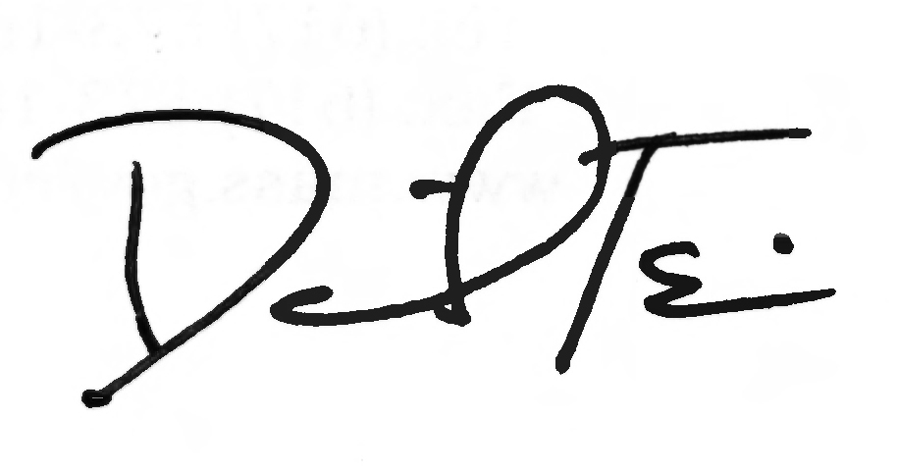

TO: Adult Foster Care Providers Participating in MassHealth

FROM: Daniel Tsai, Assistant Secretary for MassHealth

RE: Immediate Action Required: All Adult Foster Care providers must reassess or validate the service payment levels of their AFC members

Background

Recently, MassHealth promulgated amendments to the MassHealth provider regulations for the Adult Foster Care (AFC) program at 130 CMR 408.000. These amendments include revisions and clarifications to the definitions for Activities of Daily Living (ADL) and to the service payment levels for AFC services.

Please note that this bulletin and the reassessment or validation of service payment levels do not apply to members receiving AFC provided through an integrated or managed care entity (SCO, PACE, and OneCare).

Service Payment Level Reassessment and Validation

To ensure that AFC providers bill at the proper service payment level, all AFC providers must reassess or validate the service payment levels for the members to whom they are providing AFC services. Service payment levels are specified at 130 CMR 408.419(D), and restated below.

AFC providers must submit the results of their reassessment to MassHealth using the Adult Foster Care Service Payment Level Revalidation form. This form can be found at www.mass.gov/masshealth in the Provider Library under MassHealth Provider Forms. AFC providers are responsible for submitting the form containing the results of their reassessment to MassHealth on or before August 7, 2017.

Following this reassessment or validation initiative, MassHealth will conduct compliance audits that specifically target the accuracy of service payment levels. Providers found in violation of MassHealth regulatory requirements may be subject to corrective action, sanctions, or overpayments.

Clinical Eligibility for AFC Services and Service Payment Levels

To be clinically eligible for AFC services, a member must meet the clinical eligibility criteria specified at 130 CMR 408.416 (B), provided below.

(B) The member has a medical or mental condition that requires daily hands-on (physical) assistance or cueing and supervision throughout the entire activity in order for the member to successfully complete at least one of the following activities:
(1) Bathing – a full-body bath or shower or a sponge (partial) bath that may include washing and drying of face, chest, axillae (underarms), arms, hands, abdomen, back and peri-area plus personal hygiene that may include the following: combing or brushing of hair, oral care (including denture care and brushing of teeth), shaving, and, when applicable, applying make-up;

Clinical Eligibility for AFC Services and Service Payment Levels (cont.)

(2) Dressing – upper and lower body, including street clothes and undergarments, but not solely help with shoes, socks, buttons, snaps, or zippers;
(3) Toileting – member is incontinent (bladder or bowel) or requires assistance or routine catheter or colostomy care;
(4) Transferring – member must be assisted or lifted to another position;
(5) Mobility (ambulation) – member must be physically steadied, assisted, or guided during ambulation, or is unable to self-propel a wheelchair appropriately without the assistance of another person; and
(6) Eating – if the member requires constant supervision and cueing during the entire meal, or physical assistance with a portion or all of the meal.

Please note that Dressing as defined at 130 CMR 408.416(B)(2) and as restated above is a single qualifying ADL. Assistance with dressing the upper and lower body are not two separate ADLs, but are one ADL together.

MassHealth pays for AFC services provided to AFC-eligible members at the service payment levels specified at 130 CMR 408.419(D). The criteria for Level I and Level II service payment levels are as follows.
Level I: The member requires hands-on (physical) assistance with one or two of the activities described in 130 CMR 408.416 or requires cueing and supervision throughout one or more of the activities listed in 130 CMR 408.416 in order for the member to complete the activity.

Level II: The member requires:
(a) hands-on (physical) assistance with at least three of the activities described in 130 CMR 408.416; or
(b) hands-on (physical) assistance with at least two of the activities described in 130 CMR 408.416 and management of behaviors that require frequent caregiver intervention as described below:
(i) wandering: moving with no rational purpose, seemingly oblivious to needs or safety;
(ii) verbally abusive behavioral symptoms: threatening, screaming, or cursing at others;
(iii) physically abusive behavioral symptoms: hitting, shoving, or scratching;
(iv) socially inappropriate or disruptive behavioral symptoms: disruptive sounds, noisiness, screaming, self-abusive acts, disrobing in public, smearing or throwing food or feces, rummaging, repetitive behavior, or causing general disruption; or
(v) resisting care.

Questions

The MassHealth LTSS Provider Service Center is open, 8 a.m. to 6 p.m. ET, Monday through Friday, excluding holidays. LTSS providers should direct their questions about this bulletin or other MassHealth LTSS provider questions to the LTSS TPA as follows.

Method | Contact Information for MassHealth LTSS Provider Service Center
Phone | Toll-free 1-844-368-5184
Email | support@masshealthltss.com
Portal | www.MassHealthLTSS.com
Mail | MassHealth LTSS  PO Box 159108  Boston, MA 02215
Fax | 1-888-832-3006
LTSS Provider Portal | Trainings, general Information, and future enhancements are available at www.MassHealthLTSS.com.

