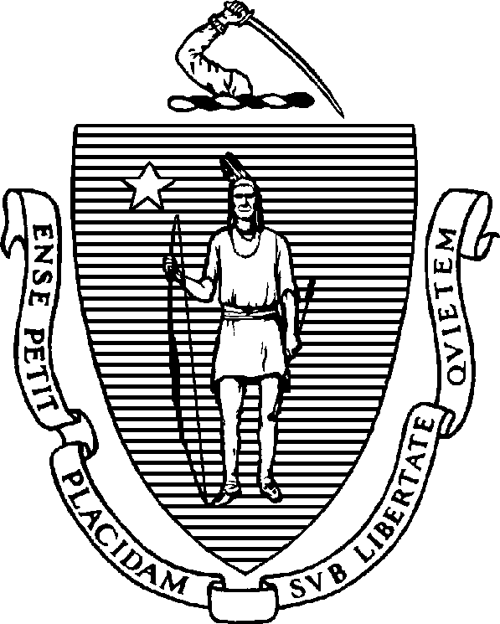

MAURA T. HEALEY
Governor
KIMBERLEY DRISCOLL
Lieutenant Governor
The Commonwealth of Massachusetts
Executive Office of Health and Human Services Department of Public Health
250 Washington Street, Boston, MA 02108-4619

ADVISORY NOTICE

Board of Certification of Community Health Workers Waiver Extended for the Cap on Online Training Hours

KATHLEEN E. WALSH
Secretary
ROBERT GOLDSTEIN, MD, PhD
Commissioner
Tel: 617-624-6000
www.mass.gov/dph

Please be advised that the Board of Certification of Community Health Workers, at its regularly scheduled meeting on Tuesday, March 11, 2025, discussed the original sunset date of July 31, 2023, of the waiver, on the maximum online training hours for Community Health Worker Education and Training Programs. The Board voted to extend the waiver through July 31, 2028.

Per the regulations, a maximum of 70% of 80 hours (56 hours in total) can be taught online, regardless of the total number of hours offered by the program. However, during the COVID- 19 pandemic, the Board voted to waive this threshold to provide greater access to applicants and community health workers.

This extension allows the waiver to remain in place, ensuring that Community Health Worker Education and Training Programs can continue offering flexibility for applicants to obtain training in the ten core competencies.

Should you have any questions, kindly contact the Board of Certification of Community Health Workers at 617-973-0806.

