MAURA T. HEALEY

Governor

The Commonwealth of Massachusetts

# Executive Office of Health and Human Services Department of Public Health

Bureau of Climate and Environmental Health 250 Washington Street,

KATHLEEN E. WALSH

Secretary

KIMBERLEY DRISCOLL

Lieutenant Governor

# Boston, MA 02108-4619

ROBERT GOLDSTEIN, MD, PhD

Commissioner

**Tel: 617-624-6000**

[**www.mass.gov/dph**](http://www.mass.gov/dph)

ADVISORY ON SHORT-TERM RESIDENTIAL POOL RENTALS

The Department of Public Health (DPH), Community Sanitation Program (CSP), is issuing this advisory to clarify the application of [*105 CMR 435.00: Minimum Standards for Swimming Pools (State Sanitary Code: Chapter V)*](https://www.mass.gov/regulations/105-CMR-43500-state-sanitary-code-chapter-v-sanitary-standards-for-swimming-pools)(“Pool Code”) to residential swimming and special purpose pools that a property owner may rent to the general public for short-term use or that may be available for use as part of a short-term home rental.

A residential pool under the Pool Code includes “a swimming or wading pool established or maintained by an individual for his own or family's use, or for the use of personal guests of his household.” A residential pool is exempt from the requirements of the Pool Code. However, when a swimming or wading pool is used by the general public that rents the pool directly or uses the pool as part of a home rental, it no longer meets the definition for an exempt residential pool. It also does not meet the current Pool Code definitions for semi-public or public pools. As such, residential pools that are rented to the general public either directly or through a home rental are not currently regulated under the Pool Code. CSP is evaluating the regulatory status of these pool rentals and will consider additional rule making in future amendments to the Pool Code.

In order to ensure the health and safety of the general public who may use residential pools as part of a pool or home rental, the CSP is providing the attached guidance that contains recommendations for minimum health and safety precautions for owners of residential pools who rent their pool for short term use or make their pool available as part of a home rental.



**Bureau of Climate and Environmental Health**

**Guidance for Short-Term Residential Pool Rentals**

The Department of Public Health (DPH), Community Sanitation Program (CSP), recommends these health and safety tips for residential pool owners who rent their pool for short-term use or make their pool available as part of a home rental.

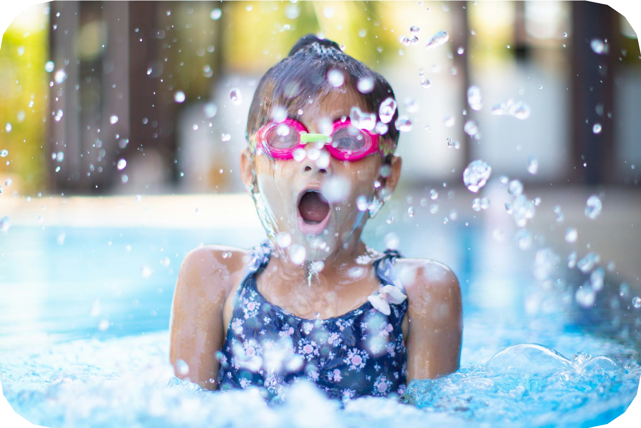

***r***

**Water depth markings:** Clear markings should be visible on the pool deck and the vertical pool walls

to indicate the depth of the water.

**NO DIVING**

**Rental Ready, Safety Steady: Keep Kids in Sight by the Poolside!**

To reduce drowning risk, it is essential that children swimming in and playing near pools are actively supervised by an adult. Owners who rent their pools or homes with pools should promote active supervision around pools to help prevent drownings.

**Here are additional safety recommendations to make pools safer and protect swimmers:**

***r***

**Pool enclosure:** A barrier of at least 48 inches high around the pool, as per local building codes, to prevent unsupervised access, especially by children.

***r***

**Rope line with floats:** This line should separate shallow and deep ends of the pool to help swimmers gauge where it is safe for them based on their swimming ability.

\.

**Ring buoy:** A life-saving buoy should be available for every 2000 square feet of water surface area and be attached to a suitable length of rope.

***r***

**Pool chemicals and supplies:** These should be securely stored away from renters to prevent accidental exposure or misuse.

**First-aid kit:** Accidents happen - The kit should be visible and easily accessible. We recommend a kit that meets ANSI 2308.1-2015 standards (including items like adhesive bandage, trauma pad & CPR mask).

\.

**Water source:** The water used in the pool must come from a source approved by the Board of Health.

**Re-circulation and filtration:** The entire volume of the pool should be filtered and recirculated within set times (every 8 hours

**Chemical levels:**

Free Chlorine: 1.0-3.0 ppm Combined Chlorine: 0.0-0.2 ppm pH: 7.2-7.8

Alkalinity: 50-150 ppm

**Hot tubs and spas:** The water temperature should not exceed 104°F, with thermostatic controls accessible only to adults managing the system.

for swimming pools and every 30 minutes for hot tubs and spas).

The pool water should be tested for water clarity with a secchi disk. A secchi disk should be clearly visible at the bottom of the pool at its deepest point.

For more tips, visit: [mass.gov/PoolSafety](https://www.mass.gov/info-details/safety-tips-for-pool-owners)