CHARLES D. BAKER
GOVERNOR

KARYN E. POLITO
LT. GOVERNOR

DANIEL BENNETT
SECRETARY

The Commonwealth of Massachusetts Executive Office of Public Safety and Security Department of Fire Services
P.O. Box 1025 ∼State Road
Stow, Massachusetts 01775
(978) 567∼3100 Fax: (978) 567∼3121
www.mass.gov/dfs
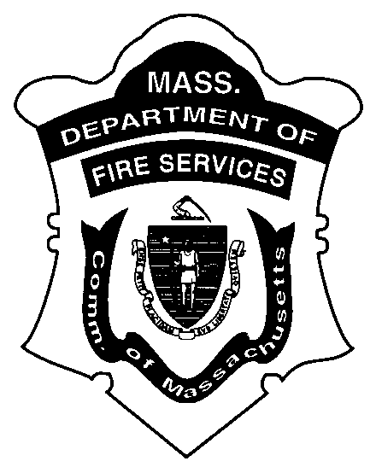

PETER J. OSTROSKEY
STATE FIRE MARSHAL

MEMORANDUM

To: Heads of Fire Departments

From: Peter J. Ostroskey, State Fire Marshal

Date: March 1, 2017

Re: 29th annual Firefighter of the Year

I am pleased to announce that we will be starting to accept nominations for the 29th annual Firefighter of the Year Awards. Since its inception in 1990, the annual Firefighter of the Year Awards has grown from a simple ceremony to honor those firefighters that performed heroic actions to the premier event in the fire service to recognize our firefighters and the outstanding work they do both on and off-duty.

I hope that you will review the incidents within your own department in the last year and nominate candidates from your department who have gone beyond the call of duty to serve their community. The acts of bravery must have occurred between July 1, 2017, and June 30, 2018, and follow the guidelines included. We are accepting nominations on a rolling basis, so that you can forward a nomination at any time. Nominations must be postmarked by July 16, 2018, and sent to the Department of Fire Services c/o Kerry Weihn.

The Heroic Awards Committee will meet to review the nominations and forward their decisions to the Governor in early September, and we plan to hold the annual ceremony this fall. Fire chiefs who have submitted nominations will be invited to meet with the committee to further discuss their nomination(s) and answer any questions that the Committee may have.

Thank you for your attention to this matter. I look forward to hearing from your department.

Administrative Services • Division of Fire Safety
Hazardous Materials Response • Massachusetts Firefighting Academy

