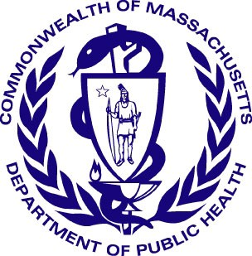 draft version 3-15-2017
Massachusetts Department of Public Health Determination of Need
Affiliated Parties

Application Date: 3/31/2022
Application Number: 22031611-CL

Applicant Information

Applicant Name: Royal Norwell Nursing & Rehabilitation Center, LLC
Contact Person: Karen Koprowski
Title: Regulatory Advisor
Phone: 7742395885
E-mail: kkoprowski@strategiccares.com

Affiliated Parties
1.9 Affiliated Parties: List all officers, members of the board of directors, trustees, stockholders, partners, and other Persons who have an equity or otherwise controlling interest in the application.
Add/ Del Rows | Name (Last) | Name (First) | Mailing Address | City | State | Affiliation | Position with affiliated entity (or with Applicant) | Stock, shares, or partnership | Percent Equity (numbers only) | Convictions or violations | List other health care facilities affiliated with | Business relationship with Applicant
+/- | Mamary, Sr. | James | 42 Winter Street, Unit 1 | Pembroke | MA | Owner | Owner | Partnership | 96% | No | [blank] | Yes
+/- | Megansett | Ventures | 42 Winter Street, Unit 1 | Pembroke | MA | Owner | Owner | Partnership | 4% | No | [blank] | Yes

Document Ready for Filing
When document is complete click on "document is ready to file". This will lock in the responses and date and time stamp the form. To make changes to the document un-check the "document is ready to file" box.
Edit document then lock file and submit Keep a copy for your records. Click on the "Save" button at the bottom of the page. To submit the application electronically, click on the "E-mail submission to Determination of Need" button.

This document is ready to file? Yes
Date/time Stamp: 05/10/2022 4:36 p.m.
E-mail submission to Determination of Need

