INDOOR AIR QUALITY ASSESSMENT

Agawam High School
760 Cooper Street
Agawam, MA

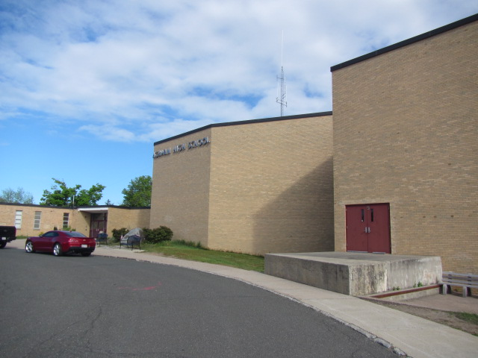

Prepared by:
Massachusetts Department of Public Health
Bureau of Environmental Health
Indoor Air Quality Program
June 2022

BACKGROUND

Building: | Agawam High School (AHS)
Address: | 760 Cooper Street, Agawam, MA
Assessment Requested by: | Referral from the Massachusetts Department of Labor Standards (DLS) and coordinated through Agawam Building Maintenance Director Brian Pagella
Reason for Request: | General indoor air quality (IAQ)
Date of Assessment: | May 11, 2022
Massachusetts Department of Public Health/Bureau of Environmental Health (MDPH/BEH) Staff Conducting Assessment: | Cory Holmes, Assistant Director, IAQ  Program
Building Description: | The AHS is a single-story, yellow brick building with occupied basement originally built in 1955. Numerous additions have been made over the years (1961, 1980, 1998, 2001 and 2016). Most building components (e.g., flooring, ceilings, mechanical ventilation) date back to the era that section of the building was constructed. The rubber membrane and shingled roofs date back to 1997.
Windows: | Windows are openable

In August 2021 the town of Agawam received preliminary approval from the Massachusetts School Building Authority (MSBA) and is currently in Phase II, which entails a formal feasibility study of the building. The MSBA partners with Massachusetts communities to support the design and construction of educationally-appropriate, flexible, sustainable and cost-effective public school facilities. More information can be found at this link: MSBA Invites Agawam High School into Eligibility Period | Massachusetts School Building Authority (massschoolbuildings.org).
The feasibility phase is an important step to detail numerous deficiencies with the building’s systems and structure including current building and life safety codes, condition of heating, ventilation, and air conditioning (HVAC) systems, windows, building envelope issues, fire prevention, plumbing and electrical, and handicapped access.

IAQ TESTING RESULTS
Please refer to the IAQ Manual for methods, sampling procedures, and interpretation of results (MDPH, 2015). The following is a summary of indoor air testing results (Table 1).
- Carbon dioxide levels were above the MDPH guideline of 800 parts per million (ppm) in a number of occupied areas tested, indicating a need for increased air exchange in those areas.
- Temperature was within or close to the MDPH recommended range of 70°F to 78°F in most areas the day of the assessment. Occupants in a few areas expressed temperature complaints, which is to be expected in a building of this age/condition. Excessive heat complaints were reported in classroom 71 (79°F when the outside temperature was 63°F).
- Relative humidity was below the MDPH recommended range of 40 to 60% in all areas the day of assessment and reflective of outdoor conditions.
- Carbon monoxide levels were non-detectable (ND) in all areas tested.
- Fine particulate matter (PM2.5) concentrations measured were below the National Ambient Air Quality (NAAQS) limit of 35 μg/m³ in all areas tested.

Ventilation
An HVAC system has several functions. First it provides heating and, if equipped, cooling. Second, it is a source of fresh air. Finally, an HVAC system will dilute and remove normally occurring indoor environmental pollutants by not only introducing fresh air, but by filtering the airstream and ejecting stale air to the outdoors via exhaust ventilation. Even if an HVAC system is operating as designed, point sources of respiratory irritation may exist and cause symptoms in sensitive individuals.
It was reported that HVAC components at AHS are controlled by a computerized control system. The control system uses temperature sensors in each room to respond to changing conditions and feed back to a centralized computer for monitoring and adjustment. To maximize air exchange, the MDPH recommends that both supply and exhaust ventilation operate continuously during periods of occupancy.
Fresh air in the majority of classrooms is supplied by 1950’s/1960’s vintage unit ventilators (univents, Pictures 1 and 2). A wing built in the 1980’s contains univents from that era (Picture 3), which are now over 40 years old. According to the American Society of Heating, Refrigeration, and Air-Conditioning Engineering (ASHRAE), the service life of this type of unit is 15-20 years, assuming routine maintenance of the equipment (ASHRAE, 1991).
Univents draw air from the outdoors through a fresh air intake located on the exterior wall of the building (Picture 4) and return air through an air intake located at the base of the unit. Fresh and return air are mixed, filtered, heated or cooled and provided to rooms through an air diffuser located in the top of the unit (Figure 1). In order for univents to provide fresh air as designed, intakes/returns must remain free of obstructions. Importantly, these units must remain on and be allowed to operate while rooms are occupied. Most of the units throughout the school were operating and free from obstructions, with a few exceptions (Table 1, Picture 5).
Classroom exhaust vents are located in the ceilings of classrooms (Picture 6), or classroom coat closets (Pictures 7 and 8) connected with ducts to exhaust fans on the roof. It was reported that approximately 50 rooftop exhaust units were replaced over the last several years. Exhaust vents in a few areas of the school were not drawing air during the assessment (Table 1). Note that in many classrooms, exhaust vents were located near classroom doors (Picture 9). This design works best with the doors to the hallway closed, otherwise the exhaust vents tend to draw air from the hallway rather than the room which reduces the effectiveness of air circulation.
Mechanical exhaust ventilation in the wing that contains classrooms 37 through 50 is provided by unit exhaust ventilators (Picture 10), also installed during the 1960’s. A unit exhaust ventilator appears similar to a univent but removes air from the classroom and exhausts it out of the building (Picture 4). A number of these units appeared to be in an “off cycle” or not operating during the assessment. Furthermore, since both the unit exhaust and univent are on the same side of the room (Pictures 4 and 11) this design is not optimal for complete room circulation. Without adequate supply and exhaust ventilation, excess heat/humidity and environmental pollutants can build up and lead to indoor air/comfort complaints.
Mechanical ventilation for common areas like the gym, cafeteria and interior rooms is provided by rooftop or ceiling-mounted air handling units (AHUs). Fresh air is distributed via ductwork connected to ceiling-mounted air diffusers (Picture 12). Return vents draw air back to the AHUs through wall or ceiling-mounted grilles. Neither supply nor exhaust ventilation could be identified in classroom 85. This room was in the shop wing and contained several runs of ductwork (Picture 13).
To have proper ventilation with a mechanical supply and exhaust system, these systems must be balanced to provide an adequate amount of fresh air while removing stale air from a room. It is recommended that existing ventilation systems be re-balanced every five years to ensure adequate air systems function (SMACNA, 1994).
It is also important to note that despite ongoing maintenance and replacement of parts/components by Agawam town facilities staff, many of the HVAC units are at the end of their life cycle. Efficient function of equipment of this age is difficult to maintain since compatible replacement parts are often unavailable.

Microbial/Moisture Concerns
Water-damaged ceiling tiles were observed in a number of areas throughout the building (Table 1, Pictures 14 and 15), which indicate leaks from the building envelope or plumbing system. Many of these areas were reported to be from historic water leaks that have since been repaired. Ceiling tiles are considered a porous material which, if exposed to chronic moisture, may become a source for microbial colonization. These tiles should be discarded and replaced. Some ceiling tiles are of a type that are adhered directly to the ceiling substrate (Pictures 16 and 17). These tiles are difficult to replace and necessitate the destruction of the tile, furthermore, replacement tiles are most likely obsolete and difficult to obtain.
BEH/IAQ staff noted gaps in some exterior doors where light could be seen penetrating (Table 1, Picture 18). This is an indicator that these doors need to be fitted with weather stripping/door sweeps to prevent moisture, pests, and unconditioned air from infiltrating occupied areas.

Other IAQ Evaluations
Other conditions that can affect IAQ were observed during the assessment. The MDPH recommends filters for HVAC equipment with a Minimum Efficiency Reporting Value (MERV) of 8, which are adequate in filtering out pollen and mold spores (ASHRAE, 2012) or the highest MERV rating the ventilation system can accommodate. Filters should also be changed two to four times a year, or per the manufacturer’s recommendations. Univent filters used at AHS are reported to be MERV 8 and are changed quarterly or as the manufacturer’s instructions (for rooftop AHUs).
A few classrooms contained high efficiency particulate arrestance (HEPA)-filtered air purifiers. It is important to note that filters should be changed, and these units be maintained in accordance with the manufacturers’ recommendations.
Some classrooms had personal fans. Some of these had dusty blades/housings (Table 1, Picture 19). Some supply diffusers and exhaust/return vents were also observed to have accumulated dust/debris (Table 1, Pictures 6 and 12). This dust can be reaerosolized when the equipment is activated and provide a source of eye and respiratory irritation.
In some areas, accumulated items including books, papers, and decorative items were observed on floors, windowsills, tabletops, counters, bookcases, and desks. Excess items on surfaces can make it more difficult for custodial staff to clean.
Missing, broken or ajar ceiling tiles were observed in some areas (Table 1, Picture 14). These breaches can provide a pathway for dust, debris, and particulates from the ceiling plenum into occupied areas, which can be a source of eye, skin, or respiratory irritation.
Tennis balls were found sliced open and placed on chair legs to reduce noise (Table 1, Picture 20). Tennis balls are made of a number of materials that are a source of respiratory irritants. Constant wearing of tennis balls can produce fibers and off-gas VOCs. Tennis balls are made with a natural rubber latex bladder, which becomes abraded when used as a chair leg pad. Use of tennis balls in this manner may introduce latex dust into the school environment. Some individuals are highly allergic to latex (e.g., spina bifida patients) (SBAA, 2001). It is recommended that the use of materials containing latex be limited to reduce the potential for symptoms in sensitive individuals (NIOSH, 1997). Latex-free glides should be used for this purpose.
The library and some office areas contained wall to wall carpeting. The usable life of carpeting in schools is approximately 10-11 years (IICRC, 2002). Aging carpet can produce fibers that can be irritating to the respiratory system. Carpets should be cleaned annually (or semi-annually in soiled/high traffic areas) in accordance with Institute of Inspection, Cleaning and Restoration Certification (IICRC) recommendations, (IICRC, 2012). Regular cleaning with a high efficiency particulate air (HEPA) filtered vacuum in combination with an annual cleaning will help to reduce accumulation and potential aerosolization of materials from carpeting.
Note that the Environmental Protection Agency (EPA) conducted a National School Radon Survey in which it discovered nearly one in five schools had “…at least one frequently occupied ground contact room with short-term radon levels above 4 [picocuries per liter] pCi/L” (US EPA, 1993). The BEH/IAQ Program therefore recommends that every school be tested for radon, and that this testing be conducted during the heating season while school is in session in a manner consistent with USEPA radon testing guidelines. Radon measurement specialists and other information can be found at www.nrsb.org and http://aarst-nrpp.com/wp, with additional information at: http://www.mass.gov/eohhs/gov/departments/dph/programs/environmental-health/exposure-topics/iaq/radon.

Total Volatile Organic Compounds
Exposure to low levels of total volatile organic compounds (TVOCs) may produce eye, nose, throat, and/or respiratory irritation in some sensitive individuals. To determine if VOCs were present, BEH/IAQ staff examined rooms for products containing VOCs. BEH/IAQ staff noted hand sanitizers, scented cleaners, air fresheners, and dry erase materials in use within the building. All these products have the potential to be irritants to the eyes, nose, throat, and respiratory system of sensitive individuals (e.g., asthmatics).

Science Chemical Storage
Of particular note were conditions found in chemical prep room 60/61. The area appeared organized; however, some issues were observed such as:
- Chronic off-gassing of acids and other material was observed in the form of corrosion on metal surfaces around the acid storage cabinet (Pictures 21 and 22).
- Unknown debris/chemical crystallization on materials in acid cabinet (Picture 23).
- A number of bottles labeled by chemical formula and not name was noted (Picture 24). Containers should be labeled with the chemical name of its content so an untrained person can identify the material in the case of an emergency.
- Containers had glass or rubber stoppers, which are not a permanent storage method, some of the rubber stoppers were damaged, which allow chemicals to leak into the environment (Picture 25).
- Some labels were so corroded they were no longer readable (Picture 26).

It is important to conduct regular inventories and chemical cleanouts in science areas to prevent accidental releases/hazardous conditions.

CONCLUSIONS AND RECOMMENDATIONS
As mentioned previously, at the time of assessment the AHS has been admitted to the MSBA’s program to replace the existing building through new construction or renovation and will be undergoing a thorough feasibility study that will detail numerous deficiencies with the buildings systems and structure, which will likely address several the recommendations listed below. In view of the findings at the time of the visit, the following recommendations are made:

Ventilation Recommendations
- Make necessary adjustments to HVAC controls/air intakes to allow an increase in fresh air to rooms with elevated carbon dioxide levels (Table 1).
- As previously discussed, the age (> 20-60 years old), physical deterioration and availability of parts for mechanical ventilation system components and controls should be fully evaluated by an HVAC engineering firm to determine the operational lifespan of existing equipment and the feasibility of repair vs. replacement.
- Operate all supply and exhaust ventilation equipment continuously during occupied hours.
- Ensure all univents, unit exhaust ventilators and exhaust/return vents are free of obstructions to facilitate airflow.
- Examine classroom 85 to determine if room is outfitted with general supply and exhaust ventilation, and if not, consider adding both to the room.
- Close classroom doors during occupancy to allow for more effective function of exhaust vents.
- Temperature/comfort complaints should be made through proper channels and followed up by facilities staff (e.g., classroom 71 excessive heat).
- Use openable windows to supplement fresh air during temperate weather. Ensure all windows are tightly closed at the end of the day or during periods of elevated relative humidity or extreme cold to avoid condensation/mold issues and freezing of pipes.
- Check exhaust vents in classrooms and restrooms for draw periodically and repair any non-operating motors/vents.
- Ensure laboratory hoods are operating as designed, make repairs/adjustments as needed.
- Consider adopting a balancing schedule of every 5 years for all mechanical ventilation systems, as recommended by ventilation industrial standards (SMACNA, 1994).
- Continue to change filters for HVAC equipment 2-4 times a year using the highest MERV rating the ventilation system can accommodate to improve air filtration as much as possible without significantly reducing airflow.

Water Damage Recommendations
- Continue to ensure any roof and plumbing leaks are repaired promptly and replace any remaining water-damaged suspended ceiling tiles or other porous building materials.
- Install tight-fitting door gaskets/door sweeps on exterior doors to prevent the infiltration of moisture, pests, and particulates.
- Closely monitor parameters such as temperature, relative humidity, and dew point over summer months to prevent condensation on floors/surfaces. Refrain from storing porous items, such as cardboard and paper on floor in these areas. If carpeting is present, consider removing from areas that are prone to condensation.
- Consider using the methods described in the document “Preventing Mold Growth in Massachusetts Schools During Hot, Humid Weather” to help reduce impact of conditions during hot, humid weather. This guideline can be found online at: https://www.mass.gov/service-details/preventing-mold-growth-in-massachusetts-schools-during-hot-humid-weather

Other Recommendations
- Conduct a regular inventory of science chemicals and properly discard all expired or unwanted items.
- Reduce use of products and equipment that create irritating volatile organic compounds (VOCs) and only use in well-ventilated areas. Minimize the use of air fresheners (e.g., plug-ins), deodorizers and scented products.
- Encourage staff to use current system (i.e., school dude) to report and track maintenance issues so that concerns can be reported by staff and maintenance staff can report when issues have been resolved.
- Change filters and maintain portable air purifiers/HEPA units in accordance with manufacturers’ recommendations.
- Regularly clean supply/return/exhaust vents and fans to avoid aerosolizing accumulated particulate matter. To clean ceiling vents/grills, remove and wash, replace if necessary.
- Clean AC filters prior to the start of the cooling season and on a regular basis while in use.
- Replace missing and/or broken ceiling tiles. Please note that some adhered ceiling tiles (or mastic) may contain asbestos. Having these materials examined and if necessary remediated by a licensed asbestos inspector is advisable.
- Consider reducing the amount of items stored in rooms to make cleaning easier. Periodically move items to clean flat surfaces. Store porous items on shelving and away from walls.
- For buildings in New England, periods of low relative humidity during the winter are often unavoidable. Therefore, scrupulous cleaning practices should be adopted to minimize common indoor air contaminants whose irritant effects can be enhanced when the relative humidity is low. To control dusts, a high efficiency particulate arrestance (HEPA) filter equipped vacuum cleaner in conjunction with wet wiping of all surfaces is recommended. Avoid the use of feather dusters. Drinking water during the day can help ease some symptoms associated with a dry environment (throat and sinus irritations).
- Replace tennis balls on chair footings with latex-free glides.
- Clean carpeting annually or semi-annually in soiled high traffic areas as per the recommendations of the Institute of Inspection, Cleaning and Restoration Certification (IICRC, 2012).
- Consider replacing any carpeting that is beyond its service life (i.e., > 11 yrs.).
- The school should be tested for radon by a certified radon measurement specialist during the heating season when school is in session. Radon measurement specialists and other information can be found at: www.nrsb.org, and http://aarst-nrpp.com/wp.
- To learn more about radon, review the MDPH’s Radon in Schools and Child Care Programs factsheet, with additional information at: http://www.mass.gov/eohhs/gov/departments/dph/programs/environmental-health/exposure-topics/iaq/radon.
- Consider forming an IAQ committee in each school building district wide. Committees should have an IAQ liaison/teacher representative, a member of maintenance/facilities and administration that conduct regular walk-throughs to identify on-going and/or potential environmental issues.
- Utilize the US EPA’s (2000), “Tools for Schools”, as an instrument for maintaining a good IAQ environment in the building available at: https://www.epa.gov/iaq-schools.
- Refer to resource manual and other related IAQ documents located on the MDPH’s website for further building-wide evaluations and advice on maintaining public buildings. These documents are available at: http://mass.gov/dph/iaq.

REFERENCES
ASHRAE. 1991. ASHRAE Applications Handbook, Chapter 33 “Owning and Operating Costs”. American Society of Heating, Refrigeration and Air Conditioning Engineers, Atlanta, GA.
ASHRAE. 2012. American Society of Heating, Refrigeration and Air Conditioning Engineers (ASHRAE) Standard 52.2-2012 -- Method of Testing General Ventilation Air-Cleaning Devices for Removal Efficiency by Particle Size (ANSI Approved).
IICRC. 2002. Institute of Inspection, Cleaning and Restoration Certification. A Life-Cycle Cost Analysis for Floor Coverings in School Facilities.
IICRC. 2012. Carpet Cleaning FAQ 4 Institute of Inspection, Cleaning and Restoration Certification. Institute of Inspection Cleaning and Restoration, Vancouver, WA.
MDPH. 2015. Massachusetts Department of Public Health. “Indoor Air Quality Manual: Chapters I-III”. Available at: Indoor air quality - manual and appendices | Mass.gov
NIOSH. 1997. NIOSH Alert Preventing Allergic Reactions to Natural Rubber latex in the Workplace. National Institute for Occupational Safety and Health, Atlanta, GA.
SBAA. 2001. Latex In the Home And Community Updated Spring 2001. Spina Bifida Association of America, Washington, DC.
SMACNA. 1994. HVAC Systems Commissioning Manual. 1st ed. Sheet Metal and Air Conditioning Contractors’ National Association, Inc., Chantilly, VA.
US EPA. 1993. Radon Measurement in Schools, Revised Edition. Office of Air and Radiation, Office of Radiation and Indoor Air, Indoor Environments Division (6609J). EPA 402-R-92-014.
US EPA. 2000. Tools for Schools. Office of Air and Radiation, Office of Radiation and Indoor Air, Indoor Environments Division (6609J). EPA 402-K-95-001, Second Edition. https://www.epa.gov/iaq-schools.
Figure 1

Unit Ventilator (Univent)

Mixed Air

Air Diffuser

Outdoors Indoors

Fan

Heating/Cooling Coil

Air Mixing Plenum

Filter

Outdoor Return
Air Air

Air
Flow
Control
Louvers

Air Flow

= Fresh Air/Return Air

= Mixed Air

Picture 1
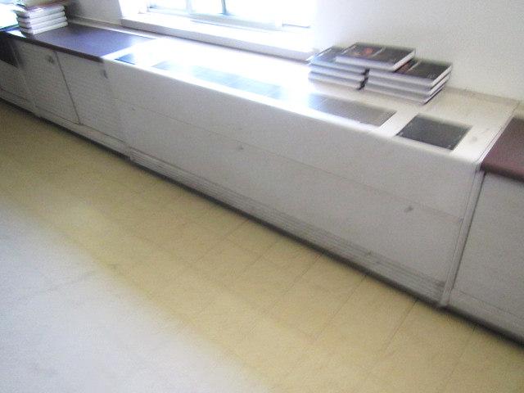
Vintage unit ventilator (univent)

Picture 2
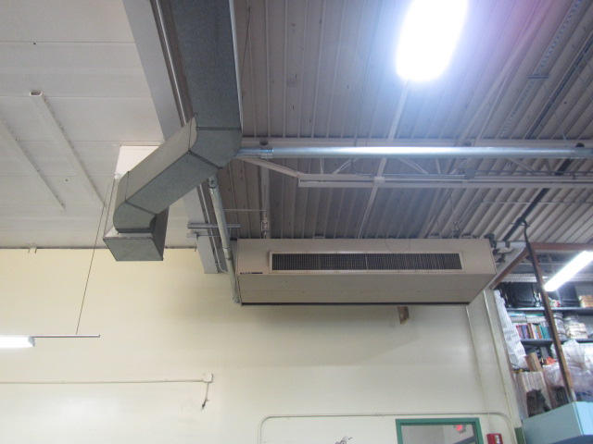
Ceiling-mounted univent
Picture 3
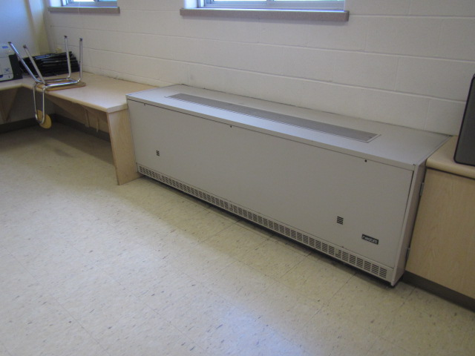
1980s era univent

Picture 4
Univent fresh air intakes and unit exhaust vents (arrows)
Picture 5
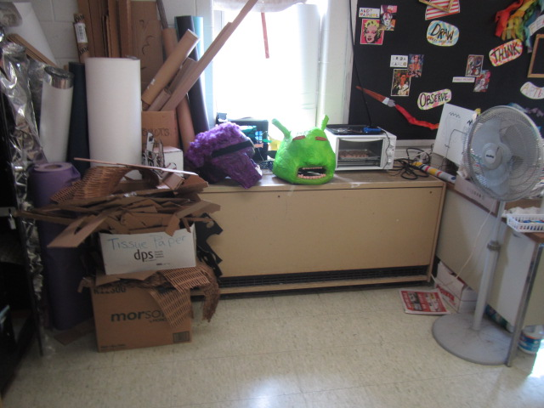
Classroom univent with items partially obstructing air diffuser (top) and return vent (bottom front)
Picture 6
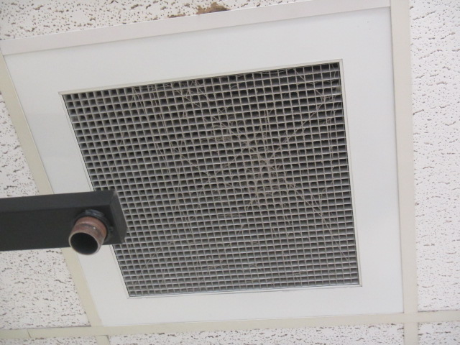
Ceiling-mounted exhaust vent, note cobwebs, dust/debris
Picture 7
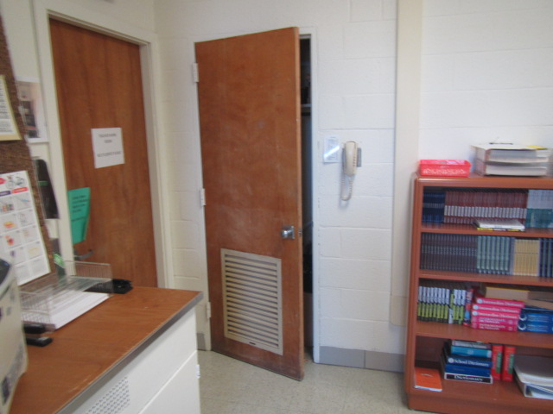
Classroom coat closet door, note passive door vent allowing airflow for classroom exhaust

Picture 8
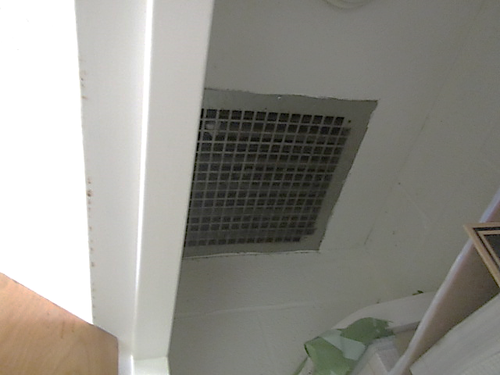
Exhaust vent in ceiling of classroom coat closet
Picture 9
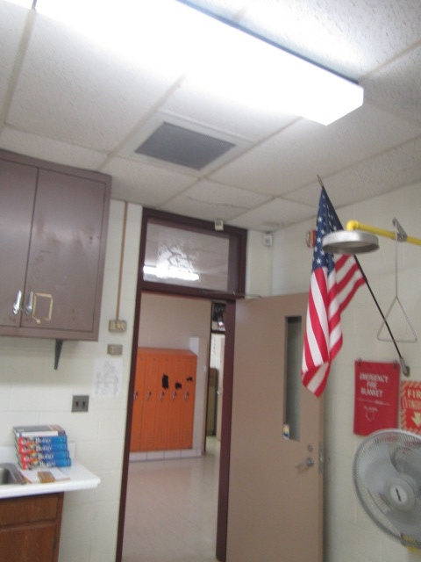
Exhaust vent proximity to open classroom/hallway door
Picture 10
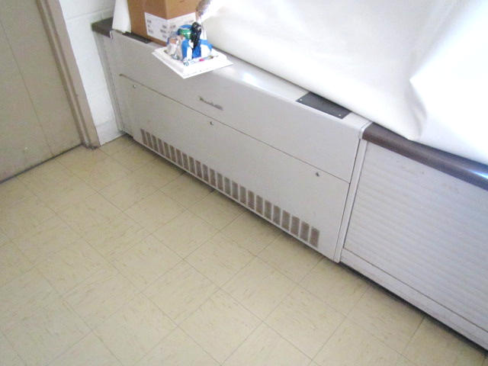
Unit exhaust vent in classroom wing 37-50
Picture 11
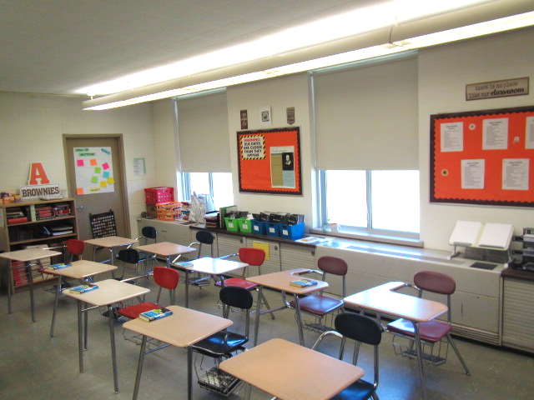
Position of unit exhaust and univent (arrows) on same/exterior wall of classroom
Picture 12
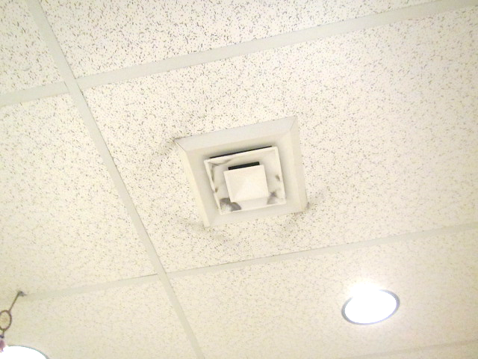
Ceiling-mounted supply diffuser, note dust/debris accumulation on vent

Picture 13
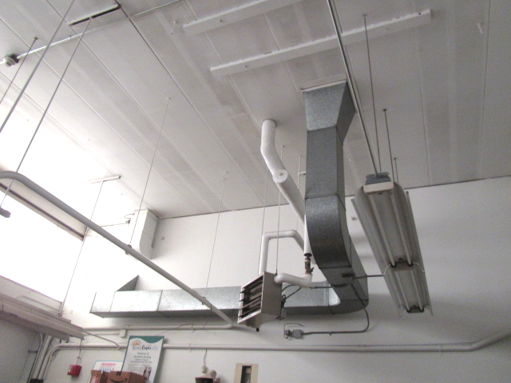
Ductwork in classroom 85, note no vents/openings in ductwork

Picture 14
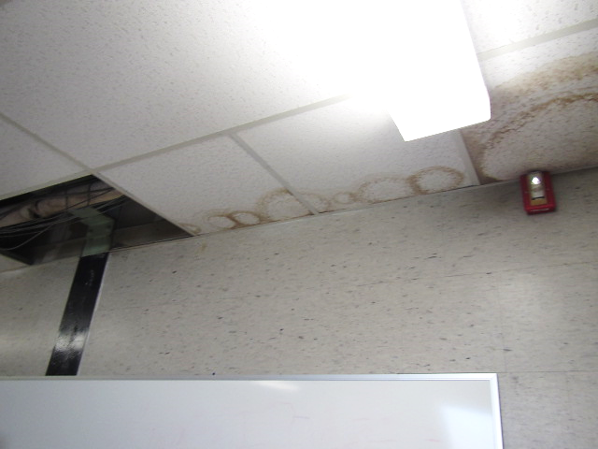
Water-damaged/missing suspended ceiling tiles in classroom
Picture 15
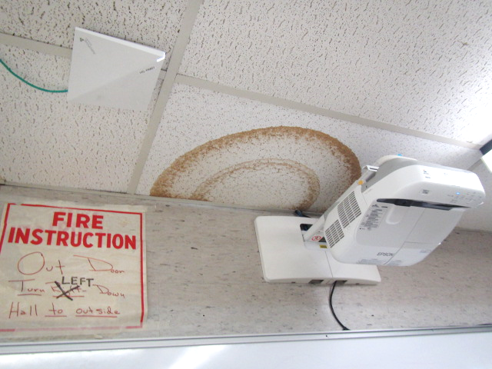
Water-damaged suspended ceiling tile in classroom

Picture 16
Water-damaged ceiling tiles adhered directly to ceiling substrate
Picture 17
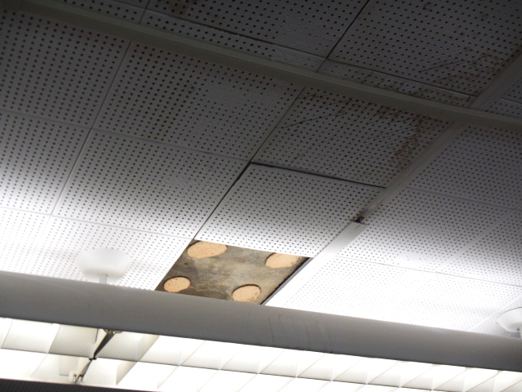
Water-damaged ceiling tiles adhered directly to ceiling substrate, note missing tile
Picture 18
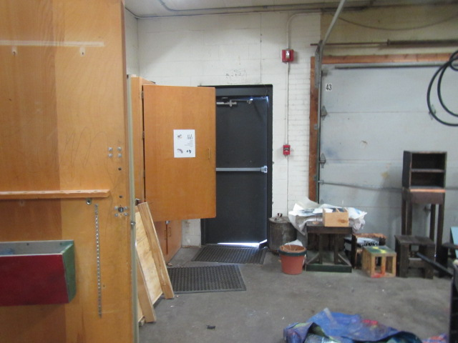
Light penetrating around exterior door in shop area

Picture 19
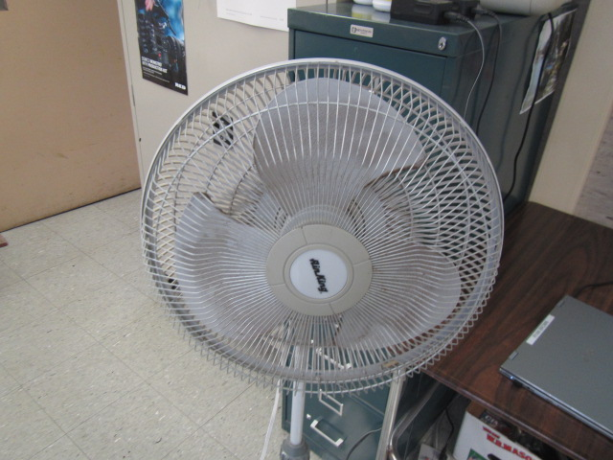
Personal fan in classroom, note dust/debris on blades/cage

Picture 20
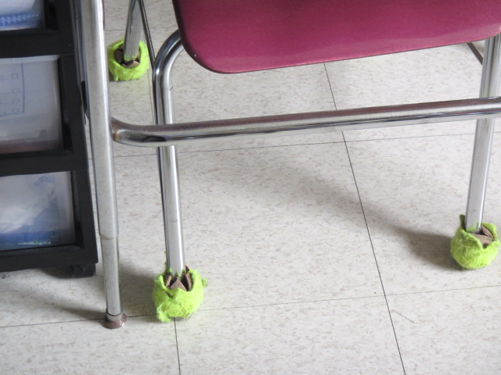
Tennis balls on chair legs in classroom
Picture 21
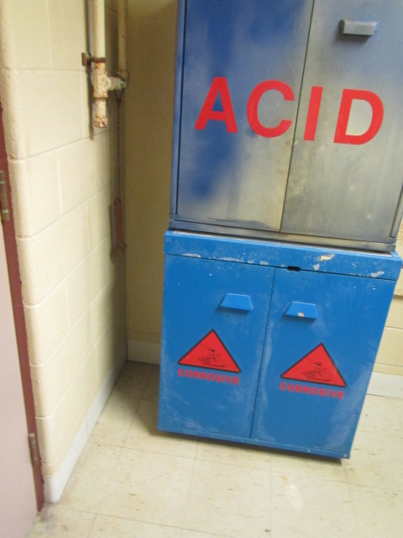
Corroded pipes and wrench (hanging) next to acid storage cabinet in chemical prep room 60/61
Picture 22
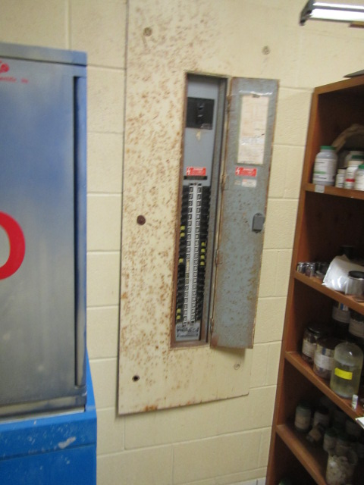
Corroded metal panel adjacent to acid storage cabinet in chemical prep room 60/61
Picture 23
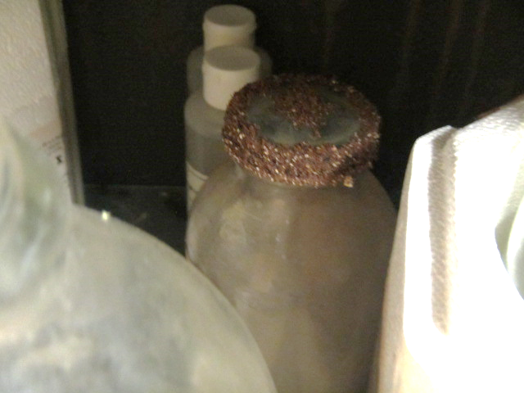
Crystallized material on cover of jar in acid cabinet

Picture 24
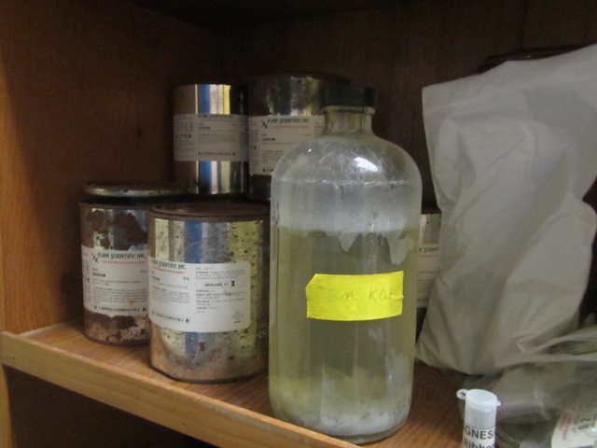
Material listed by chemical formula
Picture 25
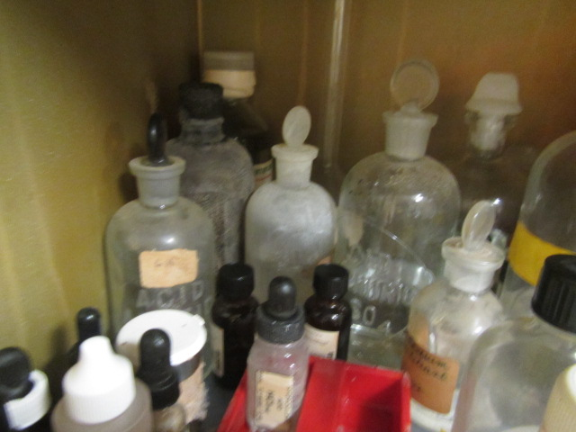
Items in acid storage locker with glass/rubber stoppers, note some labels corroded/unreadable
Picture 26
Corroded label on material in acid storage locker
Location | Carbon  Dioxide  (ppm) | Carbon Monoxide  (ppm) | Temp  (°F) | Relative  Humidity  (%) | PM2.5  (µg/m³) | Occupants  in Room | Windows  Openable | Ventilation |  | Remarks
 |  |  |  |  |  |  |  | Supply | Exhaust
Background | 389 | ND | 63 | 32 | 4 |  |  |  |  | Sunny, breezy, scattered clouds
Audio Visual/Band Storage Room |  |  |  |  |  |  | N | Y | N | Area of former mold growth, cleaned/painted, no current evidence of mold growth or water damage
4 | 794 | ND | 74 | 38 | 4 | 0 | Y | Y | Y | PF
5 | 580 | ND | 74 | 35 | 3 | 1 | Y | Y | Y | WD CT (exhaust vent)
6 | 529 | ND | 75 | 34 | 4 | 1 | Y  Open | Y | N | 6 WD CT
7 | 646 | ND | 74 | 37 | 2 | 0 | Y | Y | Y | Dust/debris on vents/ceiling tiles, TB
8 | 945 | ND | 74 | 38 | 2 | 12 | Y | Y | Y | PF
9 | 525 | ND | 74 | 35 | 4 | 9 | Y  Open | Y | Y | PF
10 | 587 | ND | 73 | 34 | 3 | 0 | Y | Y | Y | PF
13 | 525 | ND | 73 | 34 | 5 | 1 | Y  Open | Y | Y | WD CT
14 | 724 | ND | 74 | 34 | 3 | 2 | Y | Y | Y | Broken CT (corner), 2 WD CT
15 | 842 | ND | 71 | 26 | 3 | 8 | Y | Y | Y | PF
16 | 745 | ND | 73 | 27 | 3 | 10 | Y  Open | Y | Y | PF
17 | 1016 | ND | 73 | 30 | 3 | 7 | Y | Y  Off | Y | AC spilt unit, WD CT, TB
18 Copy Room | 714 | ND | 74 | 37 | 2 | 2 | Y | Y | Y
19 | 1153 | ND | 74 | 38 | 2 | 9 | Y | Y | Y | Ajar CT, PF
Auditorium | 593 | ND | 74 | 31 | 1 | 0 | N | Y | Y | Dust/debris on vents, WD ceiling plaster
20 | 1159 | ND | 74 | 38 | 4 | 12 | Y | Y | Y | PF
21 | 1560 | ND | 74 | 40 | 2 | 23 | Y | Y | Y
22 | 1109 | ND | 74 | 38 | 2 | 11 | Y | Y | Y | WD CT, PF
23 | 497 | ND | 74 | 31 | 1 | 0 | Y | Y | Y
24 | 793 | ND | 71 | 30 | 2 | 15 | Y | Y | Y  Off | PF, 2 WD CT
25 | 680 | ND | 71 | 28 | 5 | 13 | Y  Open | Y | Y  Off
26 | 922 | ND | 73 | 29 | 2 | 17 | Y | Y | Y | PF, DO
27 | 637 | ND | 74 | 26 | 5 | 18 | Y  Open | Y | Y | PF, DO
Media Center |  |  |  |  |  |  | Y  Open | Y | Y | Wall to wall carpeting
Library 1 | 849 | ND | 79 | 26 | 2 | 12 | Y | Y | Y | Wall to wall carpeting
Library 2 | 888 | ND | 76 | 28 | 2 | 15 | Y | Y | Y | Wall to wall carpeting
28 | 664 | ND | 74 | 25 | 5 | 26 | Y  Open | Y | Y | PF
29 | 824 | ND | 73 | 29 | 3 | 17 | Y | Y | Y | PF
30 | 694 | ND | 71 | 28 | 4 | 1 | Y | Y | Y
Copy Center | 700 | ND | 76 | 29 | 6 | 0 | N | Y | N | Photocopier
32 | 692 | ND | 73 | 28 | 4 | 8 | Y | Y | Y
33 | 669 | ND | 70 | 30 | 3 | 0 | Y | Y | Y  Off | TB, WD CT
37 | 695 | ND | 74 | 35 | 3 | 6 | Y  Open | Y | Y | PF, unit exhaust ventilator
38 | 1403 | ND | 75 | 37 | 1 | 15 | Y | Y | Y | Unit exhaust ventilator
39 | 849 | ND | 75 | 33 | 2 | 0 | Y | Y | Y | Unit exhaust ventilator
40 | 751 | ND | 75 | 33 | 2 | 1 | Y | Y | Y | Unit exhaust ventilator, 3 WD CT
41 | 835 | ND | 75 | 36 | 3 | 13 | Y | Y | Y | Unit exhaust ventilator, PF
42 | 733 | ND | 75 | 36 | 3 | 13 | Y  open | Y | Y | Unit exhaust ventilator
43 | 1204 | ND | 76 | 35 | 2 | 12 | Y  Open | Y | Y | PF, DO
44 | 636 | ND | 75 | 36 | 3 | 7 | Y  Open | Y | Y | PF
45 | 981 | ND | 75 | 35 | 3 | 18 | Y | Y | Y | PF, DO
46 | 556 | ND | 75 | 34 | 3 | 16 | Y  Open | Y | Y | DO
47 | 907 | ND | 75 | 35 | 3 | 7 | Y  Open | Y | Y | PF, DO
48 | 751 |  | 75 | 35 | 4 | 13 | Y  Open | Y | Y | DO
49 | 1016 | ND | 74 | 33 | 2 | 5 | Y | Y | Y | WD CT
50 | 857 | ND | 74 | 34 | 3 | 10 | Y | Y | Y | Unit exhaust ventilator
51 | 777 | ND | 73 | 29 | 4 | 2 | Y | Y  Off | Y | WD CT, dust/debris on vents
52 | 603 | ND | 72 | 29 | 4 | 0 | Y  Open | Y | Y | PF
53 | 536 | ND | 71 | 27 | 4 | 0 | Y | Y | Y | WD CT (near door)
54 | 624 | ND | 72 | 27 | 3 | 0 | Y | Y | Y | 4 WD CT
55 | 626 | ND | 74 | 26 | 3 | 2 | Y  Open | Y | Y | WD CT
56 | 922 | ND | 74 | 29 | 2 | 17 | Y | Y | Y | PF
57 | 770 |  | 74 | 27 | 1 | 0 | Y | Y | Y | 2 WD CT
58 | 1036 | ND | 73 | 31 | 2 | 1 | Y | Y | Y | 20 occupants gone several minutes, 3 WD CT
59 | 796 | ND | 73 | 29 | 2 | 1 | Y | Y | Y
60 | 794 | ND | 74 | 31 | 2 | 1 | Y | Y | Y | 8 WD CT
61 | 754 | ND | 74 | 31 | 2 | 1 | Y | Y | Y | WD CT, lab hood, PF
62 | 549 | ND | 73 | 29 | 4 | 2 | Y | Y  Off | y | PF, CT ajar
63 | 1041 | ND | 73 | 32 | 3 | 17 | Y | Y | Y | PF, dust/debris on vents
65 | 1173 | ND | 72 | 33 | 2 | 23 | Y | Y | Y | Dust/debris on vents, PF
66 | 923 | ND | 72 | 32 | 1 | 18 | Y | Y | Y | MT, PF
67 | 714 | ND | 71 | 32 | 2 | 11 | Y | Y | Y | Dust/debris on vents, PF
68 | 937 | ND | 72 | 33 | 3 | 11 | Y | Y | Y | MT, PF
69 | 970 | ND | 73 | 34 | 3 | 11 | Y | Y | Y | Dust/debris on vents, PF
70 | 677 | ND | 72 | 31 | 3 | 0 | Y | Y | Y | WD CT, PF
71 | 698 | ND | 79 | 28 | 2 | 10 | Y | Y | Y | PF, excessive heat reported from UV
72 | 842 | ND | 77 | 32 | 2 | 17 | Y | Y | Y | Dust/debris on vents
73 | 831 | ND | 74 | 33 | 2 | 7 | Y | Y | Y | PF
74 | 1081 | ND | 75 | 35 | 1 | 23 | Y | Y | Y | Dust/debris on vents, PF, DO
75 | 734 | ND | 75 | 35 | 3 | 16 | Y | Y | Y | DO, PF
76 | 776 | ND | 74 | 34 | 6 | 11 | Y | Y | Y | Dust/debris on vents
79 | 645 | ND | 74 | 32 | 2 | 11 | Y  Open | Y | Y | PF
80 | 532 | ND | 74 | 32 | 2 | 2 | Y | Y | Y | Dust/debris on vents, PF, broken CT
81 | 625 | ND | 74 | 26 | 4 | 3 | Y | Y | Y  Off | MT, 5 WD CT, PF, WD pipe insulation
82/Office | 657 | ND | 70 | 28 | 2 | 0 | Y | Y | N | PF, AP
83 | 902 | ND | 72 | 30 | 2 | 17 | Y | Y | Y  Off | PF
84 | 632 | ND | 73 | 26 | 14 | 17 | N | Y | Y | Space around exterior door
85 Shop | 528 | ND | 70 | 28 | 4 | 0 | N | ? | ? | Ducting present: supply and exhaust could not be identified, space around exterior door
86 | 668 | ND | 71 | 27 | 4 | 16 | N | Y  Off | Y | TB, UV off
87 | 517 | ND | 70 | 26 | 3 | 1 | N | Y | Y | PF, 11 WD CT, 2 ACs
91 | 548 | ND | 70 | 29 | 4 | 1 | Y | N | N | 2 WD CT, AC unit (not operable)
92 | 494 | ND | 68 | 28 | 5 | 0 | Y | N | N | WD CT, broken CT
Guidance Suite | 872 | ND | 73 | 37 | 2 | 2 | Y | Y | Y | 2 WD CT, wall to wall carpeting
Dromey Office | 783 | ND | 73 | 36 | 3 | 1 | Y | Y | N | Wall to wall carpeting
Galereave Office | 647 | ND | 73 | 34 | 2 | 0 | Y | Y | N | Wall to wall carpeting
Gym | 596 | ND | 73 | 33 | 3 | 0 | N | Y | Y
Faculty Cafeteria | 530 | ND | 73 | 35 | 3 | 0 | Y | Y | Y
Cafeteria | 533 | ND | 73 | 36 | 3 | 0 | Y | Y | Y
107 Mechanical Room |  |  |  |  |  |  |  |  |  | Air handling unit door open (filter bank)

The service life is the median time during which a particular system or component of …[an HVAC]… system remains in its original service application and then is replaced. Replacement may occur for any reason, including, but not limited to, failure, general obsolescence, reduced reliability, excessive maintenance cost, and changed system requirements due to such influences as building characteristics or energy prices (ASHRAE, 1991).

