INDOOR AIR QUALITY ASSESSMENT

Agawam Senior Center
954 Main Street
Agawam, Massachusetts



Prepared by:
Massachusetts Department of Public Health
Bureau of Environmental Health
Indoor Air Quality Program
July 2012

Background/Introduction
At the request of an anonymous individual, the Massachusetts Department of Public Health (MDPH), Bureau of Environmental Health (BEH) provided assistance and consultation regarding indoor air quality (IAQ) at the Agawam Senior Center (ASC), located at 954 Main Street, Agawam, Massachusetts. On June 22, 2012, a visit to conduct an indoor air assessment was made by Mike Feeney, Director of BEH’s IAQ Program and Kathleen Gilmore, Environmental Analyst/Regional Inspector within BEH’s IAQ Program. Concerns regarding IAQ in administrative offices prompted the assessment.
The ASC is a two-level, brick building constructed in 2008. The building contains office space, activity areas, conference/meeting rooms and a full cafeteria with a kitchen equipped with gas-fueled cooking equipment. Windows are openable throughout the building.
Methods
Air tests for carbon dioxide, temperature, relative humidity and carbon monoxide were conducted with the TSI, Q-Trak, IAQ Monitor, Model 7565. Air tests for airborne particle matter with a diameter less than 2.5 micrometers were taken with the TSI, DUSTTRAK™ Aerosol Monitor Model 8520. BEH staff also performed visual inspection of building materials for water damage and/or microbial growth.
Results
The ASC has an employee population of approximately 10 and is visited by up to 100 members of the public daily, most of them elderly. Tests were taken during normal operations and results appear in Table 1. Please note that the results of all IAQ measurements recorded in Table 1 correspond to the labels for each area represented on Blueprint 1.
Discussion
Ventilation
It can be seen from Table 1 that carbon dioxide levels were below 800 parts per million (ppm) in all areas assessed. It is important to note that several areas were empty/sparsely populated, which can greatly reduce carbon dioxide levels. Carbon dioxide levels would be expected to increase with higher occupancy.
The heating, ventilation and air-conditioning (HVAC) system consists of rooftop air handling units (AHUs), which draw outside air through air intakes and distribute it to occupied areas via ceiling-mounted air diffusers. Return air is drawn through grates and ducted back to the rooftop AHUs. All AHUs were operating during the assessment.
Please note that local airflow to each air diffuser is controlled by a variable air volume (VAV) box (Blueprint 1). Each VAV box has a set of thermostat-controlled dampers that open or close to regulate the amount of fresh air provided, depending on the temperature demand for a serviced area. Thermostats that control the VAV boxes (Picture 1) have a single button that appears to set its operation to a certain mode if the room is “occupied” or “vacant”. The “vacant” setting on the thermostat activates the HVAC system at a preset temperature. Once the thermostat detects that the preset temperature has been reached, the VAV box dampers close until heating or cooling is needed. During times that the temperature of a space is adequate, the VAV box damper is closed, which limits the amount of fresh air. If the thermostat calls for the HVAC system to provide heat, the AHU fresh air intake damper closes to increase the temperature of the air in the ductwork and occupied spaces. Airflow would be noted from the ceiling air diffusers because the VAV box dampers are open, but fresh the supply of fresh air would be limited by the closing of the rooftop fresh air intake damper, and heated air would be circulated.
While this operation mode has the advantage of energy conservation and lower operating costs, VAV box systems may result in suboptimal air quality due to insufficient outside air supply particularly if they are set to “vacant”. Once the temperature requirement is met, airflow drops. Airflow can drop to zero in poorly performing HVAC systems (Plog, Niland and Quinlan, 1996). Without proper ventilation, normally existing indoor pollutants as well as odors can accumulate, which can lead to complaints. The vacant setting would reduce fresh air supply to a space serviced by the VAV box. By pressing the button on the thermostat, the VAV box is set to the “occupied” setting which will increase fresh air supply and cooled/heated air. Each thermostat should be activated by the office occupant when the area is occupied.
At the time of the assessment, the door separating the director’s office and the outreach office was closed. It is important to note that the fresh air to the director’s office and the outreach office (Blueprint 1) are control by VAV box 3-4. The thermostat for VAV box 3-4 is located in the director’s office. It appears that the door separating the director’s office and the outreach office is intended to remain open during business hours, in order for the thermostat to measure temperature for both spaces. All of the other areas have separate VAV boxes/thermostats. As an example, the clerk’s office is serviced by VAV box 3-6, which has its own, separate thermostat (Blueprint 1).
The kitchen also has a large exhaust hood (Picture 2) for the purpose of ejecting products of combustion from the stove and moisture and odors from cooking from the building via a large exterior wall-mounted exhaust fan (Picture 3).
To maximize air exchange, the MDPH recommends that both supply and exhaust ventilation operate continuously during periods of occupancy. In order to have proper ventilation with a mechanical supply and exhaust system, the systems must be balanced to provide an adequate amount of fresh air to the interior of a room while removing stale air from the room. It is recommended that HVAC systems be re-balanced every five years to ensure adequate air systems function (SMACNA, 1994).
The Massachusetts Building Code requires that each room have a minimum ventilation rate of 20 cubic feet per minute (cfm) per occupant of fresh outside air or openable windows (SBBRS, 1997; BOCA, 1993). The ventilation must be on at all times that the room is occupied. Providing adequate fresh air ventilation with open windows and maintaining the temperature in the comfort range during the cold weather season is impractical. Mechanical ventilation is usually required to provide adequate fresh air ventilation.
Carbon dioxide is not a problem in and of itself. It is used as an indicator of the adequacy of the fresh air ventilation. As carbon dioxide levels rise, it indicates that the ventilating system is malfunctioning or the design occupancy of the room is being exceeded. When this happens, a buildup of common indoor air pollutants can occur, leading to discomfort or health complaints. The Occupational Safety and Health Administration (OSHA) standard for carbon dioxide is 5,000 parts per million parts of air (ppm). Workers may be exposed to this level for 40 hours/week, based on a time-weighted average (OSHA, 1997).
The MDPH uses a guideline of 800 ppm for publicly occupied buildings. A guideline of 600 ppm or less is preferred in schools due to the fact that the majority of occupants are young and considered to be a more sensitive population in the evaluation of environmental health status. Inadequate ventilation and/or elevated temperatures are major causes of complaints such as respiratory, eye, nose and throat irritation, lethargy and headaches. For more information concerning carbon dioxide, consult Appendix A.
Indoor temperature measurements ranged from 72ºF to 75ºF, which were within the MDPH recommended comfort range (Table 1). The MDPH recommends that indoor air temperatures be maintained in a range of 70ºF to 78ºF in order to provide for the comfort of building occupants. In many cases concerning indoor air quality, fluctuations of temperature in occupied spaces are typically experienced, even in a building with an adequate fresh air supply.
The relative humidity in the building ranged from 46 to 70 percent, which was within the MDPH recommended comfort range in the majority of areas evaluated on the day of the assessment (Table 1). The MDPH recommends a comfort range of 40 to 60 percent for indoor air relative humidity. Relative humidity levels in the building would be expected to drop during the winter months due to heating. The sensation of dryness and irritation is common in a low relative humidity environment. Low relative humidity is a very common problem during the heating season in the northeast part of the United States.
Microbial/Moisture Concerns
BEH staff examined building materials for water damage and/or microbial growth. In order for building materials to support mold growth, a source of water exposure is necessary. Identification and elimination of the source of water moistening building materials is necessary to control mold growth. BEH staff did not indentify water damage within the ASC, however conditions that may lead to water damage were observed during the assessment.
One window was found open while the HVAC system was operating in air-conditioning mode (Picture 4). The BEH recommends that windows be closed during hot, humid weather as a method to preventing mold growth within the building. If windows are opened during heat wave conditions, hot moist air enters the building, which can result in condensation, subsequently moistening building components and resulting in mold growth. These types of conditions conducive to mold growth may result in an indoor environment that could adversely affect the health of individuals with respiratory disease, asthma, immuno-suppression and/or sensitivity to fungal microorganisms. Given that the HVAC system is providing adequate fresh air to all locations examined by BEH staff, it is advised that these windows remain closed to maintain the integrity/function of the HVAC system.
Plants were observed in the handcraft room (Picture 5). Plants, soil and drip pans can serve as sources of mold growth. Plants should not be placed on porous materials, since water damage to porous materials may lead to microbial growth. Over-watering of plants should be avoided and drip pans should be inspected periodically for mold growth.
Other IAQ Evaluations
IAQ can be negatively influenced by the presence of respiratory irritants, such as products of combustion. The process of combustion produces a number of pollutants. Common combustion emissions include carbon monoxide, carbon dioxide, water vapor and smoke (fine airborne particle material). Of these materials, exposure to carbon monoxide and particulate matter with a diameter of 2.5 micrometers (μm) or less (PM2.5) can produce immediate, acute health effects upon exposure. To determine whether combustion products were present in the indoor environment, BEH staff obtained measurements for carbon monoxide and PM2.5.

Carbon Monoxide
Carbon monoxide is a by-product of incomplete combustion of organic matter (e.g., gasoline, wood and tobacco). Exposure to carbon monoxide can produce immediate and acute health effects. Several air quality standards have been established to address carbon monoxide and prevent symptoms from exposure to these substances. The MDPH established a corrective action level concerning carbon monoxide in ice skating rinks that use fossil-fueled ice resurfacing equipment. If an operator of an indoor ice rink measures a carbon monoxide level over 30 ppm, taken 20 minutes after resurfacing within a rink, that operator must take actions to reduce carbon monoxide levels (MDPH, 1997).
The American Society of Heating Refrigeration and Air-Conditioning Engineers (ASHRAE) has adopted the National Ambient Air Quality Standards (NAAQS) as one set of criteria for assessing IAQ and monitoring of fresh air introduced by HVAC systems (ASHRAE, 1989). The NAAQS are standards established by the US EPA to protect the public health from six criteria pollutants, including carbon monoxide and particulate matter (US EPA, 2006). As recommended by ASHRAE, pollutant levels of fresh air introduced to a building should not exceed the NAAQS levels (ASHRAE, 1989). The NAAQS were adopted by reference in the Building Officials & Code Administrators (BOCA) National Mechanical Code of 1993 (BOCA, 1993), which is now an HVAC standard included in the Massachusetts State Building Code (SBBRS, 1997). According to the NAAQS, carbon monoxide levels in outdoor air should not exceed 9 ppm in an eight-hour average (US EPA, 2006).
Carbon monoxide should not be present in a typical, indoor environment. If it is present, indoor carbon monoxide levels should be less than or equal to outdoor levels. The day of assessment, outdoor carbon monoxide concentrations were non-detect (ND) (Table 1). No measurable levels of carbon monoxide were detected in the building during the assessment (Table 1).
The kitchen uses a number of gas-fueled cooking appliances, including the stove which has continuously burning pilot lights (Picture 6). The kitchen is designed such that the products of combustion and cooking odors are to be drawn in and subsequently ejected from the building via a large exhaust hood. The exhaust hood is deactivated when the kitchen is not in use. The process of combustion produces a number of pollutants, depending on the composition of the material. In general, common combustion emissions can include carbon dioxide, carbon monoxide, water vapor and smoke. Of these constituents, carbon monoxide can produce immediate, acute health effects upon exposure. While no carbon monoxide was measured within the ASC during the assessment, the use of this type of stove would require that the exhaust hood operate continuously to vent pilot light emissions from the building.

Particulate Matter (PM2.5)
The US EPA has established NAAQS limits for exposure to particulate matter. Particulate matter is airborne solids that can be irritating to the eyes, nose and throat. The NAAQS originally established exposure limits to particulate matter with a diameter of 10 μm or less (PM10). According to the NAAQS, PM10 levels should not exceed 150 microgram per cubic meter (μg/m³) in a 24-hour average (US EPA, 2006). These standards were adopted by both ASHRAE and BOCA. Since the issuance of the ASHRAE standard and BOCA Code, US EPA established a more protective standard for fine airborne particles. This more stringent PM2.5 standard requires outdoor air particle levels be maintained below 35 μg/m³ over a 24-hour average (US EPA, 2006). Although both the ASHRAE standard and BOCA Code adopted the PM10 standard for evaluating air quality, MDPH uses the more protective PM2.5 standard for evaluating airborne particulate matter concentrations in the indoor environment.
Outdoor PM2.5 concentrations measured 48 μg/m³ on the day of the visit (Table 1), which were above the NAAQS PM2.5 limit of 35 μg/m³ possibly due to elevated pollen counts. PM2.5 levels measured inside the ASC ranged from 22 to 46 μg/m³ (Table 1); many of these were above the NAAQS PM2.5 level of 35 μg/m³ and close to background/outdoor levels (Table 1). Frequently, indoor air levels of particulates (including PM2.5) can be at higher levels than those measured outdoors. A number of mechanical devices and/or activities that occur in buildings can generate particulate during normal operations. Sources of indoor airborne particulates may include but are not limited to particles generated during the operation of fan belts in the HVAC system, use of stoves and/or microwave ovens in kitchen areas; use of photocopiers, fax machines and computer printing devices; operation of an ordinary vacuum cleaner and heavy foot traffic indoors.
Volatile Organic Compounds
Indoor air concentrations can be greatly impacted by the use of products containing volatile organic compounds (VOCs). VOCs are carbon-containing substances that have the ability to evaporate at room temperature. Frequently, exposure to low levels of total VOCs (TVOCs) may produce eye, nose, throat and/or respiratory irritation in some sensitive individuals. For example, chemicals evaporating from a paint can stored at room temperature would most likely contain VOCs. In an effort to identify materials that can potentially increase indoor VOC concentrations, BEH staff examined the office space for products containing respiratory irritants.
Scented candles (Picture 7) were noted in one administrative office. Scented candles contain chemicals that can be irritating to the eyes, nose and throat of sensitive individuals. Furthermore, deodorizing agents do not remove materials causing odors, but rather mask odors that may be present in the area.
IAQ staff noted that the outreach office appeared to be significantly darker than other work areas in the building. Low light conditions are associated with headaches, tired eyes, fatigue/lethargy and/or irritation (NIOSH, 1998). Lack of light has also been associated with seasonal affective disorder, which can contribute to excessive tiredness (NMHA, 2006). Some recommended illuminations standards exist. The Illumination Engineering Society (IES) of North America recommends a lighting range of 20-50 foot-candles (200-500 lux) (NIOSH, 1998). The Illuminating Engineering Society of North America (IESNA) recommends a lighting range of 30-50 foot-candles (300-500 lux) (Veitch, J.A. and Newsham, G.R. 1996). Increasing lighting would serve to alleviate/reduce the reported symptoms in dimly lit areas.
Conclusions/Recommendations
In view of the findings at the time of the assessment, the following recommendations are made to improve IAQ:
- Operate HVAC system throughout the building continuously during periods of occupancy. Set VAV boxes to the “occupied” setting in order to provide continuous airflow throughout the office space.
- Operate the kitchen hood continuously to provide exhaust ventilation for stove pilot lights. Consideration should be given to replacing the stove with an automatic ignition system.
- Keep windows closed when the building’s HVAC system is operating in air-conditioning mode.
- Consider adopting a balancing schedule of every 5 years for all mechanical ventilation systems, as recommended by ventilation industrial standards (SMACNA, 1994).
- For buildings in New England, periods of low relative humidity during the winter are often unavoidable. Therefore, scrupulous cleaning practices should be adopted to minimize common indoor air contaminants whose irritant effects can be enhanced when the relative humidity is low. To control for dusts, a high efficiency particulate arrestance (HEPA) filter equipped vacuum cleaner in conjunction with wet wiping of all surfaces is recommended. Avoid the use of feather dusters. Drinking water during the day can help ease some symptoms associated with a dry environment (throat and sinus irritations).
- Provide an adequate amount of light at workstations. In order to soften fluorescent lights, consider installing glare shields on all computer screens in this area. User-controlled task lighting may also be helpful.
- Refrain from having scented candles or using air fresheners/deodorizers to prevent exposure to VOCs.
- Ensure all plants are equipped with drip pans. Examine drip pans for mold growth and disinfect areas of water leaks with an appropriate antimicrobial where necessary.
- Refer to resource manual and other related IAQ documents located on the MDPH’s website for further building-wide evaluations and advice on maintaining public buildings. These materials are located on the MDPH’s website: http://mass.gov/dph/iaq.
References
ASHRAE. 1989. Ventilation for Acceptable IAQ. American Society of Heating, Refrigeration and Air Conditioning Engineers. ANSI/ASHRAE 62-1989.
BOCA. 1993. The BOCA National Mechanical Code/1993. 8th ed. Building Officials & Code Administrators International, Inc., Country Club Hills, IL.
MDPH. 1997. Requirements to Maintain Air Quality in Indoor Skating Rinks (State Sanitary Code, Chapter XI). 105 CMR 675.000. Massachusetts Department of Public Health, Boston, MA.
NIOSH. 1998. HETA 98–0224–2714, The Trane Company, Ft. Smith, Arkansas. National Institute for Occupational Safety and Health, Cincinnati, OH. http://www.cdc.gov/niosh/hhe/reports/pdfs/1998-0224-2714.pdf
NMHA. 2006. Seasonal Affective Disorder Fact Sheet. National Mental Health Association. http://www.nmha.org/infoctr/factsheets/27.cfm
OSHA. 1997. Limits for Air Contaminants. Occupational Safety and Health Administration. Code of Federal Regulations. 29 C.F.R 1910.1000 Table Z-1-A.
Plog, B., Niland, J. and Quinlan, P., eds. Fundamentals of Industrial Hygiene. 4th ed. Illinois: National Safety Council, 1996.
SBBRS. 1997. Mechanical Ventilation. State Board of Building Regulations and Standards. Code of Massachusetts Regulations. 780 CMR 1209.0
SMACNA. 1994. HVAC Systems Commissioning Manual. 1st ed. Sheet Metal and Air Conditioning Contractors’ National Association, Inc., Chantilly, VA.
US EPA. 2006. National Ambient Air Quality Standards (NAAQS). US Environmental Protection Agency, Office of Air Quality Planning and Standards, Washington, DC. http://www.epa.gov/air/criteria.html
Veitch, J. A. and Newsham, G. R. 1996. Determinants of Lighting Quality II: Research and Recommendations. American Psychological Association 10th Annual Conference, Toronto, Ontario, Canada August 12, 1996. National Research Council of Canada, Ottawa Ontario.
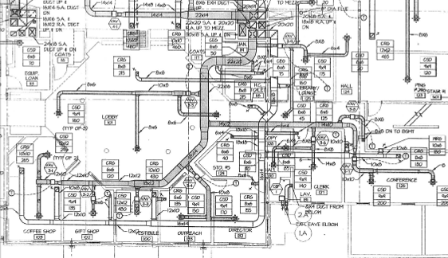

Gray Duct indicates fresh air supply duct
White Duct indicates return duct
Hexagon indicates VAV box with its number
T within a circle indicates thermostat controlling VAV box
Picture 1

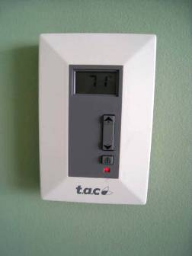

Thermostat, Note button and activated light (activated by BEH staff)

Picture 2

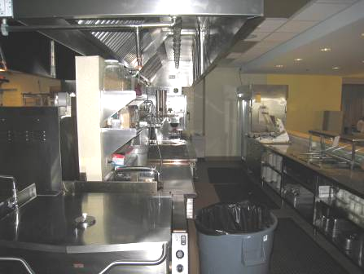

Kitchen Showing Stove with Hood

Picture 3

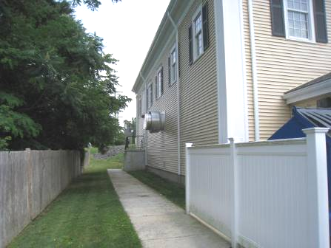

Kitchen Exhaust Vent (Arrow)

Picture 4

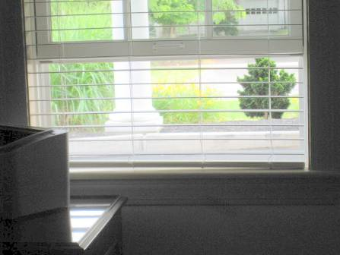

Open Window in Outreach Office with Air-Conditioning System Operating

Picture 5

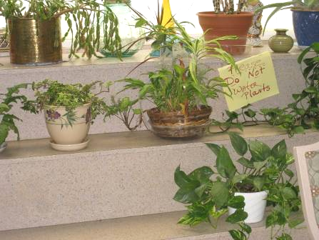

Plants in Handcraft Room

Picture 6

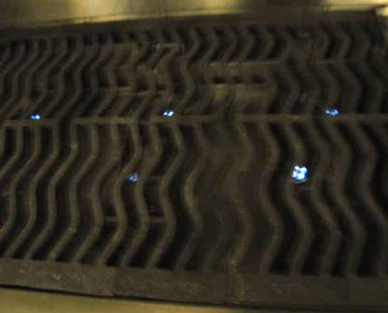

Stove with Continuously Burning Pilot Lights (Bright Spots)
Picture 7

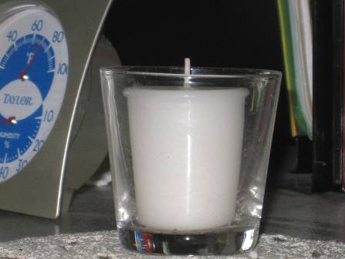

Scented Candle in an Administrative Office
Location/ Room | Occupants  in Room | Temp  (°F) | Relative  Humidity  (%) | Carbon  Dioxide  (ppm) | Carbon Monoxide  (ppm) | PM2.5  (µg/m³) | Windows  Openable | Ventilation |  | Remarks
 |  |  |  |  |  |  |  | Supply | Exhaust | Remarks
Background |  | 85 | 73 | 399 | ND | 48 |  |  |  | Sunny, humid, elevated pollen levels
Assistant Director’s Room | 0 | 72 | 63 | 570 | ND | 39 | Y | Y | Y
Billiard Room | 2 | 74 | 46 | 710 | ND | 22 | Y | Y | Y | DO
Cafeteria | 30 | 73 | 70 | 604 | ND | 44 | Y | Y | Y
Clerk’s office | 0 | 73 | 58 | 504 | ND | 44 | Y | Y | Y | Carpet
Computer Room | 0 | 73 | 57 | 541 | ND | 29 | Y | Y | Y | DO
Conference Room | 3 | 75 | 56 | 562 | ND | 41 | Y | Y | Y | DO, carpet
Copy/Fax Area | 0 | 75 | 58 | 538 | ND | 44 | N | Y | Y | PC, carpet
Director’s Office | 0 | 75 | 59 | 501 | ND | 46 | Y | Y | Y | DO, carpet
Fitness Room | 5 | 74 | 58 | 769 | ND | 32 | Y | Y | Y | DO, PC
Handcraft Room | 0 | 73 | 62 | 539 | ND | 26 | Y | Y | Y | Plants
Kitchen Office | 1 | 72 | 53 | 789 | ND | 40 | N | Y | Y | DO
Large Community Room | 25 | 73 | 49 | 794 | ND | 23 | Y | Y | Y | DO
Library | 1 | 74 | 54 | 682 | ND | 35 | N | Y | Y | DO, carpet
Main Lobby | 0 | 74 | 58 | 459 | ND | 39 | N | Y | Y | Craft Room
Men’s Rest  Room | 0 | 75 | 57 | 545 | ND | 42 | N | N | Y
Nurse’s Office | 0 | 72 | 56 | 607 | ND | 35 | Y | Y | Y
Outreach Office | 1 | 75 | 61 | 572 | ND | 46 | Y | Y | Y | Windows open, scented candles, carpet, overhead lights off
Storage Room | 0 | 75 | 60 | 604 | ND | 46 | N | Y | Y | DO, PC
Women’s Rest Room | 0 | 75 | 55 | 572 | ND | 36 | N | N | Y

