RCP INFORMATION NOTICE 2014-02 TITLE: Veterinary Regulation Waiver
The Commonwealth of Massachusetts
Executive Office of Health and Human Services
Department of Public Health
Bureau of Environmental Health
Radiation Control Program
Schrafft’s Center, Suite 1M2A
529 Main Street, Charlestown, MA 02129
Phone: 617-242-3035 Fax: 617-242-3457
www.mass.gov/dph/rcp

DEVAL L. PATRICK
GOVERNOR
JOHN W. POLANOWICZ
SECRETARY
EILEEN M. SULLIVAN
ACTING COMMISSIONER
December 17, 2014
ADDRESSEE: All Veterinary facilities

Dear Veterinary Registrant:

This notice from the Department of Public Health, Radiation Control Program, concerns the regulatory requirements for annual surveys by qualified medical physicists at veterinary service facilities.

The regulations that govern the safe use of machines that produce radiation specifically state under 105 CMR 120.403(A)(2), that:

The registrant of the facility shall ensure that the equipment is in safe operating condition:
(a) when it is first installed and prior to use on patients;
(b) after any major changes or replacement of parts and prior to use on patients:
(c) by having physics surveys, calibrations and preventative maintenance such physics surveys and preventative maintenance shall be made annually:
a. The physics surveys shall be performed by a qualified medical physicist;
b. The preventative maintenance or calibration shall be performed by a registered service provider as specified in 105 CMR 120.026.
(d) Physics surveys shall be reviewed and signed within a reasonable time of completion of the tests but no longer than 30 days of completion of the tests by a qualified medical physicist and a responsible person at the facility or responsible physician, and any necessary corrective action shall be implemented within 30 days…

After conducting a nationwide survey through the Conference of Radiation Control Program Directors (CRCPD) of other state Radiation Control Programs, as well as consulting with local veterinary service providers, the Radiation Control Program has decided to waive certain provisions of this section with regard to veterinary service providers only.

Specifically, the Department is hereby waiving the following requirements for veterinary facilities only:
A. an annual physics survey as stated in 105 CMR 120.403(A)(2)(c)(1), AND
B. physics survey review requirements as stated in 105 CMR 120.403(A)(2)(d)

HOWEVER, preventative maintenance, as stated in 105 CMR 120.403(A)(2)(c)(2), is still required on an annual basis.

Should you have any questions, please contact me at 617 242-3035 ext. 2001 or email at Jack.Priest@state.ma.us

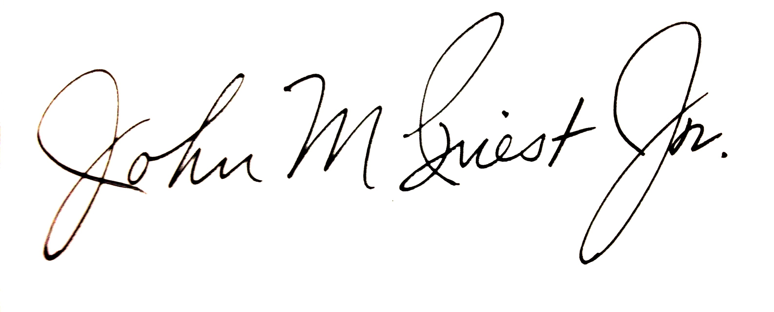
Sincerely,

John M Priest Jr., Director,
Radiation Control Program

