Commonwealth of Massachusetts
Executive Office of Health and Human Services
Virtual Gateway

Provider Data Management - Agency Provider Maintenance
User Manual Release 4.0

Table Of Contents

Introduction 3
Provider Application 3
Provider Qualification 3
Provider Management 3
Services Directory (SD) 3
Purpose 4
Accessing PDM 4.0 5
Modify Identification Information 8
Modify Address Information 9
Add an Address 9
Edit an Address 10
Delete an Address 11
Modify Contacts 12
View Services 13
Modify Services 15
Add Services 16
Complete Service 19
Remove Services 21
Edit Services 22
Modify Service Directory 24

2010 Massachusetts Executive Office of Health and Human Services (EOHHS)

Introduction

The PDM Business Service is intended to serve as a well-organized, user-friendly, easily navigated “filing system” of provider data. It is important to note that the application requires both web-based data entry and population of the PDM data from external source systems.

Provider Data Management 4 [PDM4] is an application built to manage providers servicing the Purchase of Service (POS) provider population. This enhanced functionality will support enrolling provider agencies and individual providers to provide different waiver program services.

In terms of scope, the Provider Data Management system solution will encompass the following business functions:

- Provider Application (PA)
- Provider Qualification (PQ)
- Provider Management (PM)
- Service Directory (SD)

Provider Application – Potential providers of services to the Autism and three additional adult waiver programs access the system to apply and be qualified as a provider. Potential providers enter their demographic data, Service Directory [SD] options and other service data. If it is an individual provider, the system prompts for license and educational information, résumé and additional individual information. If it is a provider agency, they just submit the application and attest to their qualifications electronically. Providers also mail required qualification materials to DDS Central Office, but will eventually be able to upload these documents to the system.
Provider Qualification – Reviewers start reviewing the assigned applications after potential providers submit their electronic applications and upload and/or mail in to DDS their qualification documents. The reviewers conduct interviews, compare professional licenses and check CORI results for qualifying individual providers. Provider Agencies go through a pre-defined set of service qualification criteria as well as any pre-qualification required for services provided through a DDS contract to become qualified providers.
Provider Management - Individual providers and provider agencies can update their demographic information; manage their services and qualifications in the system. Certain business rules apply in order to modify service related information especially when they are part of an existing plan and are currently providing services to consumers. Provider initiated service modifications and additions go through a review and approval process by the reviewers.
Services Directory (SD) - The Service Directory is a tool for consumers, their families, and circle of support to search for services and service providers in the Commonwealth of Massachusetts.

The high level business process for enrolling providers to participate in DDS waiver programs (Autism waiver and Adults Waivers) is shown below:

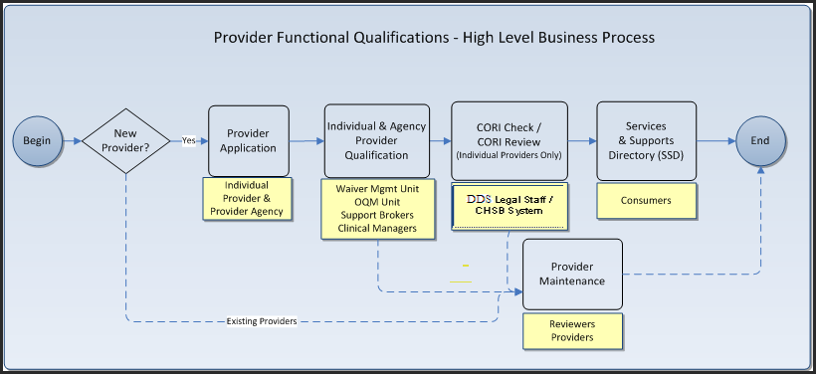

Purpose

This User Guide will show Qualified Agency providers of services to the Autism and three additional Adult Waiver programs how to access PDM4 and use the system to modify and update information which was collected during the application process. In addition, they are able to request qualification for additional program services or terminate currently qualified services. The scope of this document is the Agency Provider Management process.

Accessing PDM 4.0

The Qualified Provider accesses the PDM4 link on the Mass.gov or DDS websites. Once selected, the user will be directed to the ‘PDM4 Landing’ page. On this landing page, the welcoming screen is displayed.

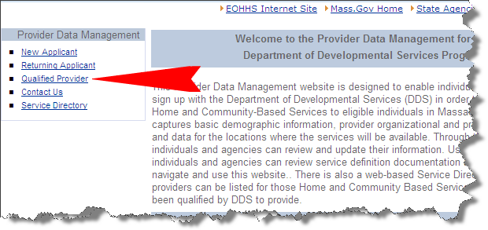

The user selects the ‘Qualified Provider’ link and they will be redirected to the ‘Virtual Gateway Login’ page:

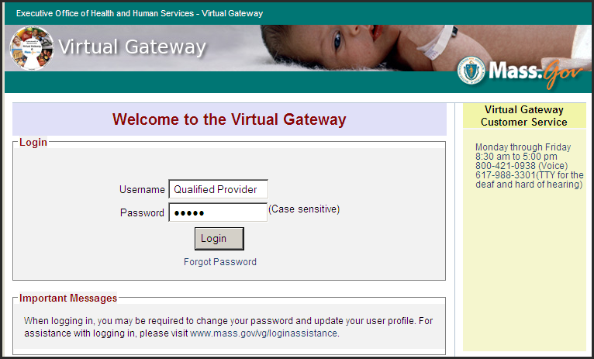

The user should enter their login credentials and select ‘Login’. The Qualified Provider will then be redirected to their ‘Virtual Gateway Home’ page.

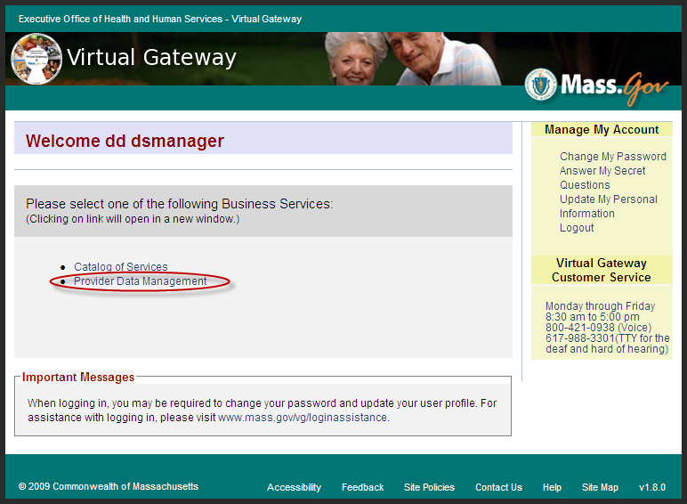

The user should then select the ‘Provider Data Management’ link which will redirect them to the ‘Qualified Provider Landing’ page.

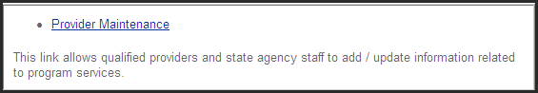

The Qualified Provider then clicks on the ‘Provider Maintenance’ link and will be redirected to the ‘PDM4 Home’ page:

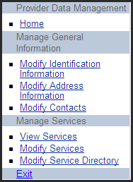

The options available from this Home Page are briefly described in the table below:

Menu Option | Description
Home | Returns the user to the ‘Qualified Provider Landing’ page.
Modify Identification Information | The Qualified Provider will have the ability to modify some of the identification information that was entered at the time of the application.
Modify Address Information | The Qualified Provider will have the ability to edit or delete address information.
Modify Contacts | The Qualified Provider will have the ability to edit or delete contact information.
View Services | This function allows the Qualified Provider to view information about the current services that are being provided.
Modify Services | The function allows the Qualified Provider to modify current Program/ Services. These modifications must go through a DDS review and approval process before they take effect.
Modify Service Directory | This function allows the Qualified Provider to view/edit or discontinue the use of the Service Directory Listing.
Exit | Exits PDM4 and redirects the user to the Virtual Gateway Home Page.

These Menu Options (with the exception of Home and Exit) are discussed in the pages that follow.

Modify Identification Information

The following screen is displayed when the user selects the ‘Modify Identification Information’ link:

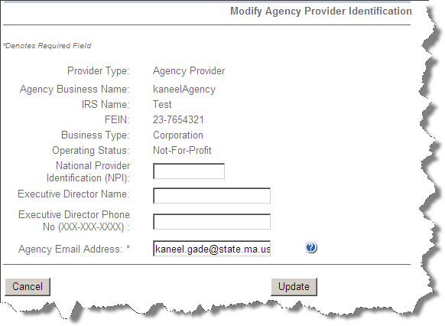

The user can only modify the following data fields:

- National Provider Identification
- Executive Director Name
- Executive Director Phone No
- Agency Email Address

The available buttons on this page are:

- ‘Cancel’ – returns the user to the previous screen without saving any changes that were entered.
- ‘Update’ – saves newly entered information.

Modify Address Information

The following screen is displayed when the user selects the ‘Modify Address Information’ link:

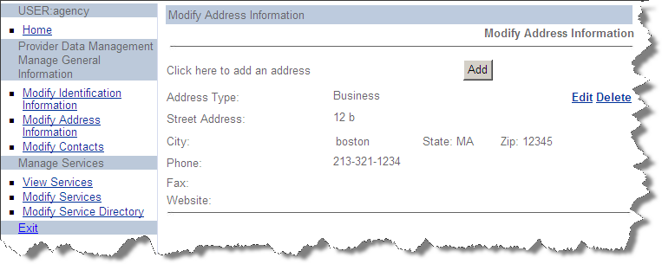

The available buttons and links on this screen are:

- ‘Add’ – to add a new address
- ‘Edit’ – to edit an existing address
- ‘Delete’ – to delete an existing address

Add an Address

When the user selects the ‘Add’ button, the following screen will be displayed:

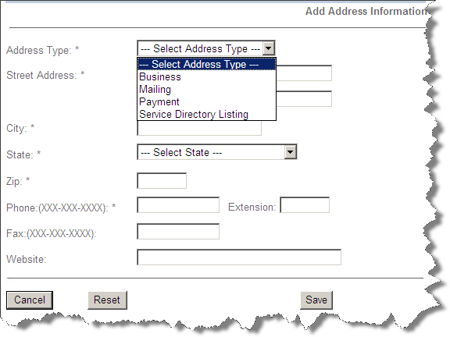

The available buttons on this screen are:

- ‘Cancel’ – returns to the ‘Modify Address Information’ page without saving the record.
- ‘Reset’ – clears all data that was entered.
- ‘Save’ – saves the information that was entered and returns to the ‘Modify Address Information’ page.

Note, the system will only allow one address per Address Type (i.e., only one Business Address is allowed).

Edit an Address

When the ‘Edit’ link is selected, the following screen will be displayed:

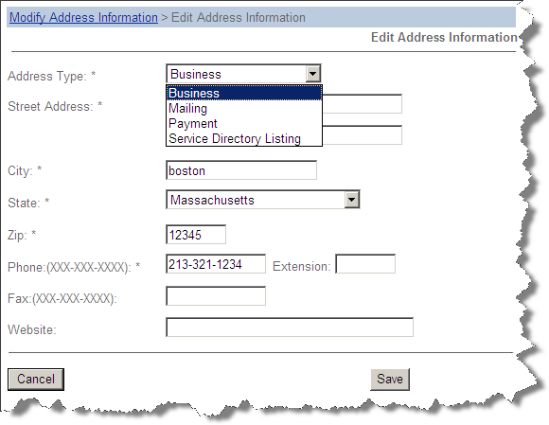

The available buttons on this screen are:

- ‘Cancel’ – returns to the ‘Modify Address Information’ page without saving the record.
- ‘Save’ – saves the information that was entered and returns to the ‘Modify Address Information’ page.

Delete an Address

When the ‘Delete’ link is selected, the following screen will be displayed:

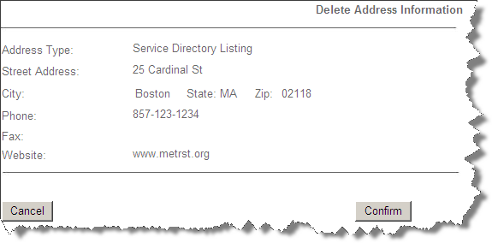

The available buttons on this screen are:

- ‘Cancel’ – returns to the ‘Modify Address Information’ page without deleting the address.
- ‘Confirm’ – deletes the address and returns the user to the ‘Modify Address Information’ page.

Modify Contacts

The following screen is displayed when the user selects the ‘Modify Contacts’ link:

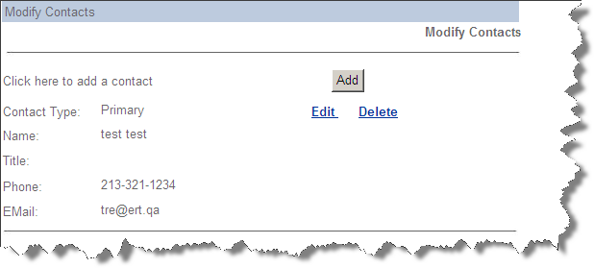

The process for modifying contacts is essentially the same as describe above for modifying addresses including the same action buttons and links:

- ‘Add’ – to add a new contact
- ‘Edit’ – to edit an existing contact
- ‘Delete’ to delete an existing contact

View Services

When the ‘View Services’ link is selected, the following screen is displayed:

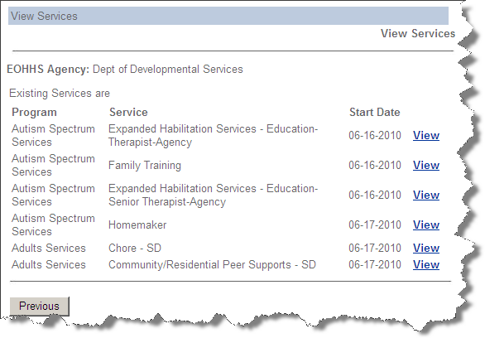

The available buttons and links on this screen are:

- ‘Previous’ – to return to the ‘PDM4 Home’ page
- ‘View’ – to view the Program/Service details
.
Clicking on a Program/Services ‘View’ link will cause the following screen to be displayed:

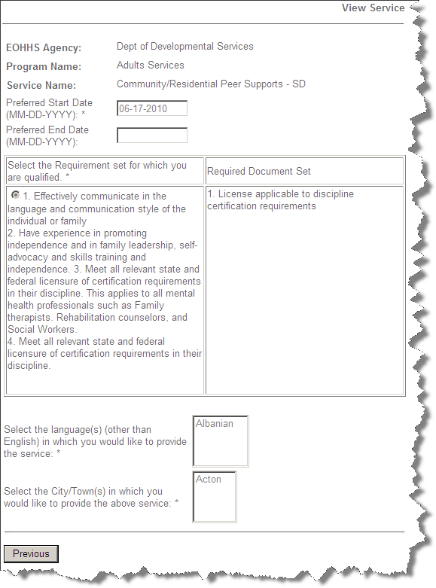

The available button on this screen is:

- Preview – to return to the previous screen

Note, information displayed here is read-only.

Modify Services

When the ‘Modify Services’ link is selected, the following screen is displayed:

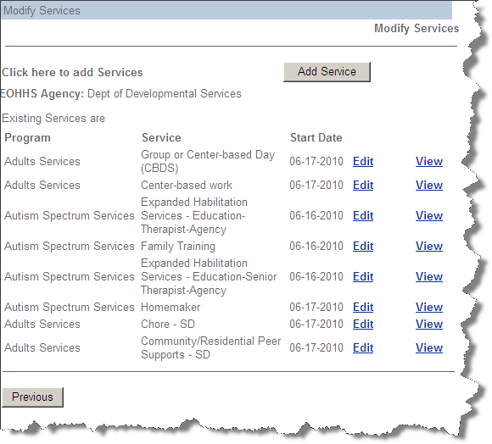

The available buttons and links on this screen are:

- ‘Add Services’ – to add new Program/Services
- ‘Edit’ – to make changes to an existing Program/Service
- ‘View’ – to view an existing Program/Service
- ‘Previous’ – to return to the ‘PDM4 Home’ page

Add Services

When the user selects the ‘Add Service’ button from the ‘Modify Services’ screen, they are directed to the ‘Program/Service Selection’ page:

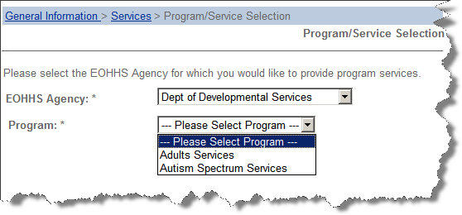

After selecting the EOHHS Agency and Program, the ‘Next’ button will appear on the page and should be clicked.

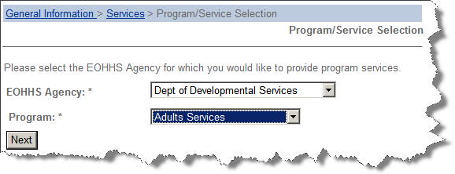

The ‘Service Selection’ page will then appear:

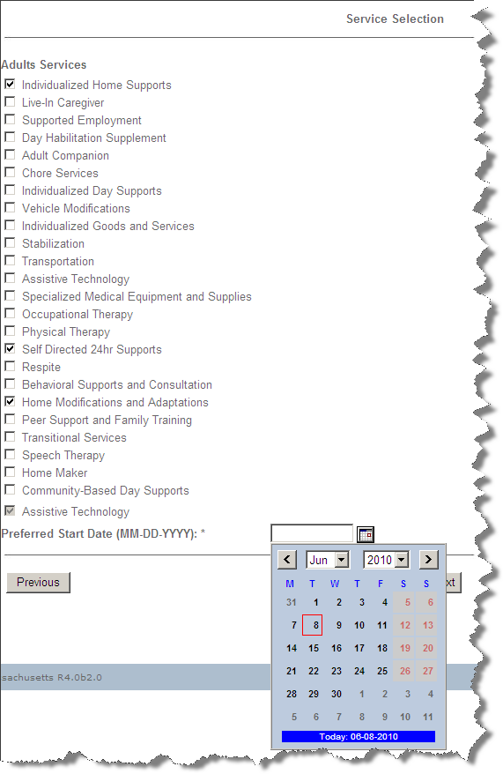

The user must supply the following information:

- Click the boxes next to the new services that will be offered. Note, any services that are already being provided will appear at he bottom of the list and can not be accessed from this screen

- Enter the ‘Preferred Start Date. The date entered must be greater than today and within one year of request date.

The available buttons on this page are:

- ‘Previous’ – returns to the ‘Program/Service Selection’ page.
- ‘Next’ – advances to the ‘Modify Services’ page

When the user clicks ‘Next’, the user will be returned to the ‘Modify Services’ screen. The new services that were just added will be included on a separate section of the screen labeled: “The following requested Services require additional Information” (See below).

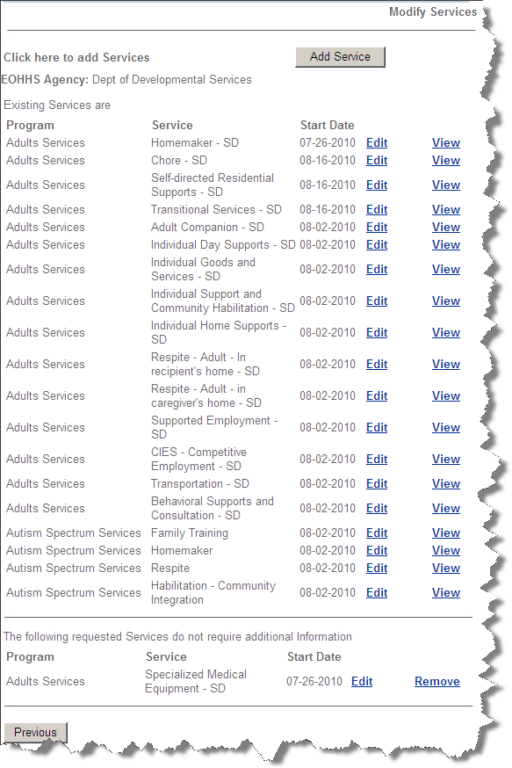

The following links will appear next to any new service that has been added:

- ‘Complete’ – to supply additional information regarding the new service
- ‘Remove’ – to delete the new service request

Complete Service

When the user selects ‘Complete’, the following screen will be displayed:

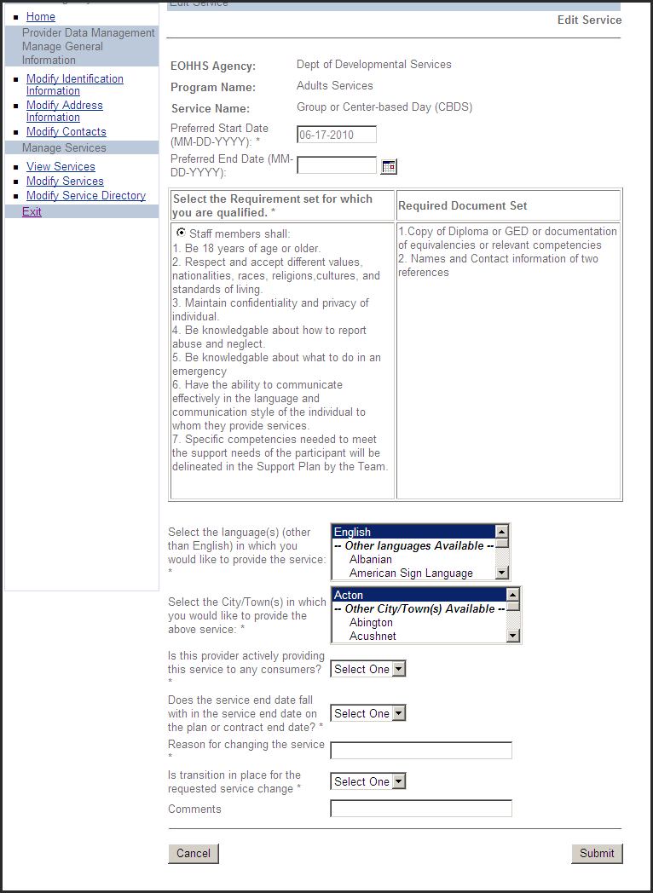

The following action buttons are available on this page:

- ‘Cancel’ – returns to the ‘Modify Services’ page without saving any data entry.
- ‘Submit’ – sends the request to the DDS Application manager to start the review process

In order to submit the change, the user must:

- Click the radio button that appears in the Requirements Section.
- Select Language(s) under which the Service will be offered.
- Select Cities/Towns wherein the Service will be offered.

Note the information displayed in the ‘Qualification Requirements’ and ‘Required Document Set’ sections will vary depending on the Program and Service being added.

Remove Services

When the user selects ‘Remove’, the following page will be displayed:

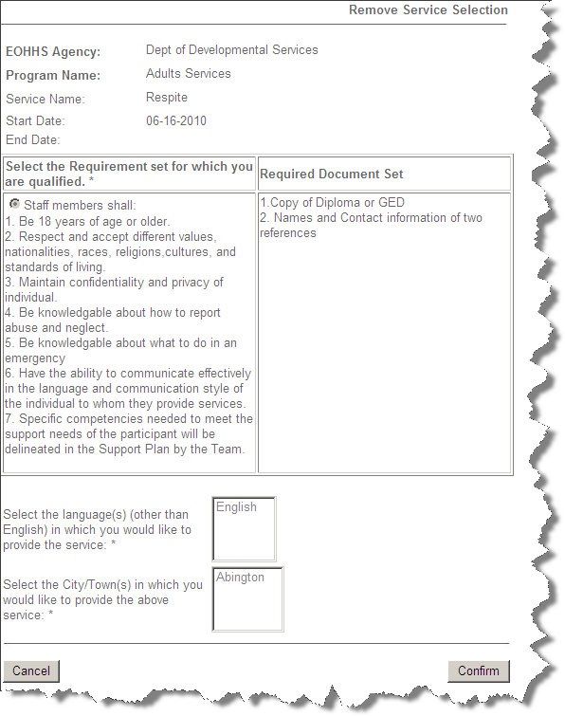

The available buttons on this page are:

- ‘Cancel’ – returns to the ‘Modify Services’ page without removing the service.
- ‘Confirm’ – removes the service from the application and returns to the ‘Modify Services’ page.

Edit Services

When the user clicks an ‘Edit’ link, the following screen will be displayed::

The following fields (which were included in the application) may be modified:

- Preferred Start Date
- Preferred End Date
- Language set – add or delete languages in which the Service is offered
- City/Towns - -add or delete City/Towns in which the Service is offered

The following three ‘Service Modification’ questions must be answered:

- Is the provider actively providing this service to any consumer?
- Does the service end date fall with in the service end date on the plan or contact end date?
- Is transition in place for the requested service change?

The following two additional test fields are also displayed on this page:

- Reason for changing the service (required)..
- Comments – for recording any supporting statements for the change to Service (optional).

The available buttons on this screen are:

- ‘Cancel’ – cancels the screen and returns to the ‘Modify Services’ screen.
- ‘Submit’ – sends the Qualified Provider’s application to the DDS Application manager to start the review process.

Modify Service Directory

When the ‘Modify Service Directory’ link is selected and the provider is currently being listed in the Service Directory, a screen listing the current information displayed in the Service Directory will appear. In order to modify the Contact or Address Information being displayed in the Service Directory or to discontinue being listed in the Service Directory, the user should click the ‘Edit’ button that appears on the bottom of the screen.

The following screen will then appear:

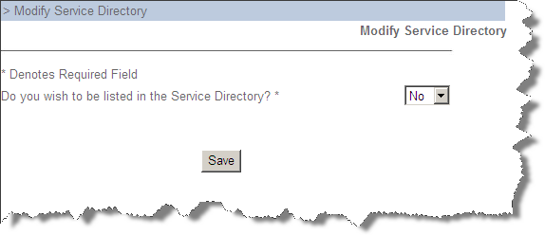

This screen also appears when the ‘Modify Service Directory’ link is selected and the provider is not currently listed in the Service Directory,

If the Qualified Provider selects ‘No’ and clicks the ‘Save’ button, then they no longer will be listed in the Service Directory. If the Qualified Provider selects ‘Yes”, the following screen will appear:

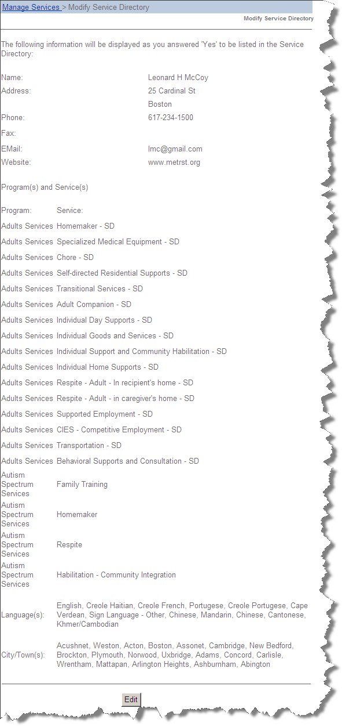

This screen will allow the Qualified Provider to choose the contact and address information that will be displayed in the Service Directory. Once this is done, the ‘Save’ button should be clicked. The information that was just entered will now appear in the Service Directory and the ‘Save’ button on the ‘Service Directory’ page will be replaced by an ‘Edit’ button.

