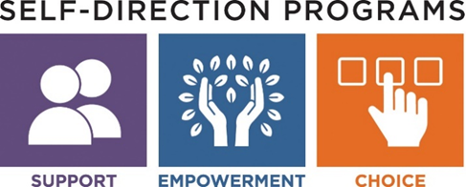

Agency with Choice

Agency with Choice offers the option to partner with an Agency. For those individuals who wish to share responsibility of selecting their support staff and directing their day-to-day activities, the Agency with Choice model may be an option to consider.
Individuals who choose this support model will have a budget allocation for the purchase of services to meet their needs. The participant/family is able to identify the people they wish to employ with the support of an agency to assist in the hiring process, payroll management, and other related tasks.

The Agency with Choice Program offers the following:
- A co-employment model in which the agency serves as the employer, partnering with the individual to help train and manage employees.
- The agency will support the individual to interview, hire, and negotiate a pay rate for the employees the participant/family identifies, subject to agency personnel policies.
- The participant/family has responsibility for daily supervision of employees.
- The agency assumes responsibility for paying employees, including withholding, filing and paying federal and state income and employment taxes, as well as providing a worker’s compensation policy.
- The agency provides the individual with a monthly financial report so the individual is aware that spending is occurring as planned and can make adjustments if necessary.
- Service options within Agency with Choice program model include:

  - Service Navigation
  - Individualized Home Supports
  - Individualized Day Supports
  - Flexible Funding

MASSACHUSETTS DEPARTMENT OF DEVELOPMENTAL SERVICES

