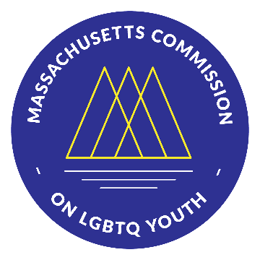 | Massachusetts Commission on LGBTQ Youth  “Working for a Commonwealth where all youth thrive” | 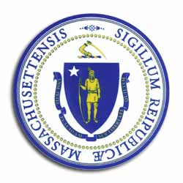
https://www.mass.gov/orgs/massachusetts-commission-on-lgbtq-youth

AGENDA
Executive Director Selection Committee Meeting
Wednesday March 2, 2022 @ 7:00 pm
Pursuant to Chapter 20 of the Acts of 2021, this meeting will be conducted via remote participation.

Register here to receive a personal link to join the Zoom meeting or to automatically join if the meeting has begun: https://us02web.zoom.us/meeting/register/tZUtdeutpjwiHNMuS-H6qZ_5FjACoLuzqt6r
-----------------------------------------------------------------------------------------------------

- Call to Order

- Presentation by Positively Partners
  - Search Process
  - Information about Finalists

- Remarks from interview group participants
  - Verbal Remarks
  - Written remarks to be read into the minutes

- Deliberation by Selection Committee (votes)
(2 Co-Chairs and 3 Vice Chairs)

- Adjournment

All meetings, with the exception of Special Meetings for Executive Session, are open to the public.
The items listed are those reasonably anticipated by the Chair to be discussed at the meeting. Not all items may in fact be discussed and other items not listed may also be brought up for discussion to the extent permitted by law. Meetings may be recorded for live stream and/or future posting to our website.

