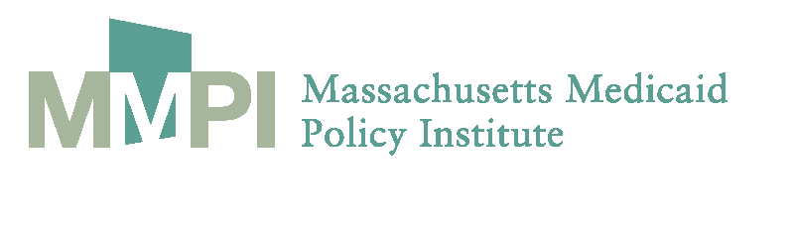

Risk Adjustment for Integrated Care:
Breaking New Ground for Dual Eligibles in Massachusetts
February 29, 2012

9:30 a.m. Welcome and Introduction Kate Nordahl,
Massachusetts Medicaid Policy Institute

9:40 a.m. Risk Adjustment for Dual Eligibles: Why and How
Tony Dreyfus, BD Group

10:10 a.m. Lessons Learned from the Field: State and Provider Experience
Patrick Roohan, Division of Quality
and Evaluation, Office of Health Insurance
Programs, NY State Department of Health

Alan Morse, The Jewish Guild for the Blind, New York, NY

Sandra Hunt and Eric Meinkow, Pricewaterhouse Coopers

11:00 a.m. Break

11:15 a.m. Panel Discussion Moderator
Ellen Breslin Davidson, BD Group

Panelists
Lisa Iezzoni, Harvard Medical School and Mongan Institute for Health Policy, Massachusetts General Hospital

Sally Bachman, BU School of Social Work and BU School of Public Health

Arlene Ash, Dept. of Quantitative Health Sciences, University of Massachusetts Medical School

11:55 a.m. Closing Kate Nordahl

