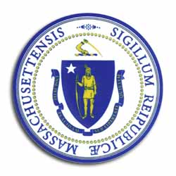
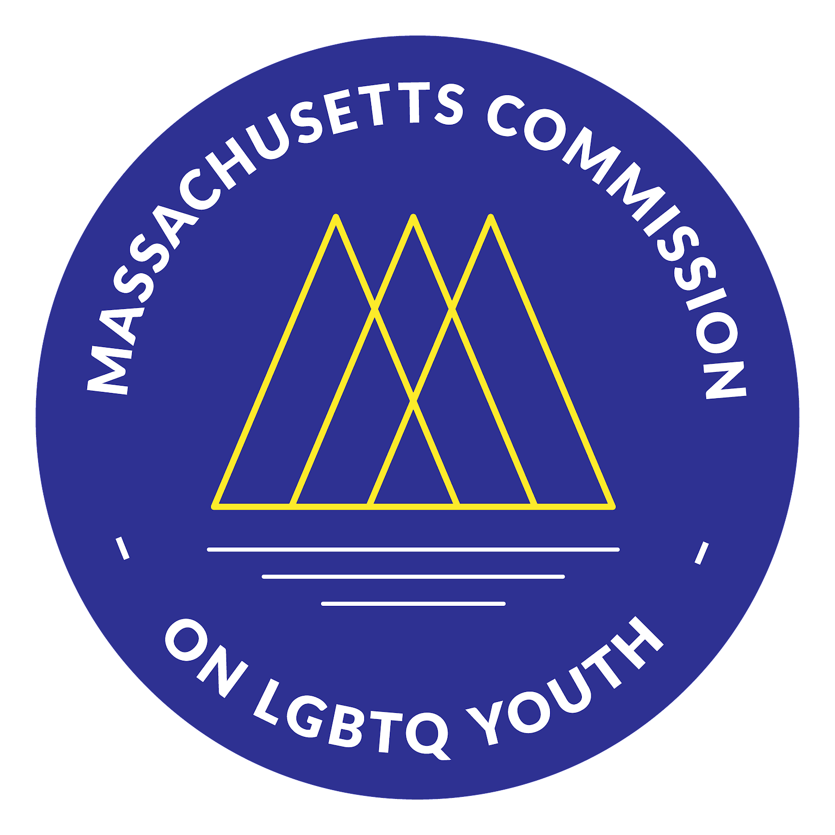
Massachusetts Commission

on LGBTQ Youth

“Working for a Commonwealth where all youth thrive”

AGENDA
Winter Quarterly Full Commission Meeting
Monday, March 2, 2026, @6:00 pm
https://www.mass.gov/orgs/massachusetts-commission-on-lgbtq-youth

Pursuant to Chapter 20 of the Acts of 2021, this meeting will be conducted via remote participation.
https://us02web.zoom.us/j/82036775542?pwd=SuPR0IKVPYFNnKey6TawJBoyLdD

Welcome and Approval of Minutes by Craig, Co-Chair
- Land Acknowledgement
- Public Comment
- Roberts Rule of Order Overview for New Commission Members
- Approval of the Minutes (December 2025)

Executive Director Update by Shaplaie

Co-Chairs Updates by Craig
- Annual Meeting 2026 Reflections
  - Annual Meeting Folder
  - Calendar
  - Committee Slide Deck
- Commissioner Expectations (Attendance, Participation, etc.)
- Speed Networking/Relationship Building

Announcements & Celebrations by Commission Members

Next Steps & Closing

Next Meetings:
  - June 1, 2026
  - September 14, 2026
  - December 14, 2026

All meetings, with the exception of Special Meetings for Executive Sessions, are open to the public.
The items listed are those reasonably anticipated by the Chair to be discussed at the meeting. Not all items may in fact be discussed and other items not listed may also be brought up for discussion to the extent permitted by law. Meetings may be recorded for live streaming and/or future posting to our website.

