

CCFA: Aging Up Placements


Updated: 2/10/2015

The program in which a child is placed is dependent upon the child' s age. When the age of an infant or toddler surpasses that of his or her current program, the system will attempt to age up the placement, and place the child into the correct program for his or her age. CCFA does not automatically age up preschool to school age placements as the school age definitions differ in every community. CCFA does not automatically age up placements for children with special needs.

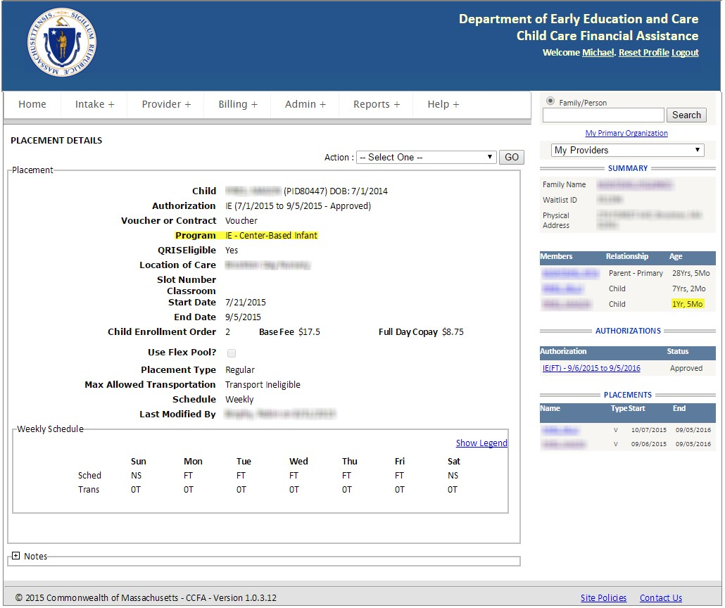

 | Start of Eligibility
Infant | 0 months
Toddler | 15 months  (1 year, 3 months)
Preschool | 33 months  (2 years, 9 months)
School Age | 60 months  (5+ years)

If you are ending a placement, the placement will end on the date of the start of eligibility for the next program.

The new placement will start on the following day.

- If the system is unable to complete the aging up of a placement, a notification will be displayed under the Notification tab of the Home page in CCFA.
- Aged Out Notifications are also generated during attendance validation after attendance has been submitted.
- A placement that has aged out must be resolved in order to avoid the automatic rejection of
billing when submitted.

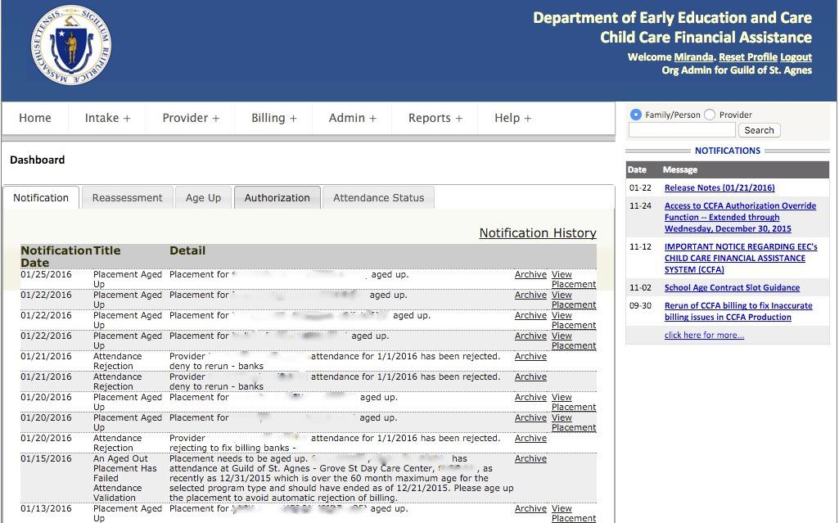

When you are notified that an Aged Out Placement has failed, you
need to perform one of two steps, to resolve the problem in CCFA

- Option 1: End the current placement and create a new, age appropriate placement
  - End the current placement on the date the child becomes eligible
    - For Toddlers, if the child becomes 33 months on 2/12, then end the toddler
placement on 2/12 and start the preschool placement on 2/13
    - You may need to remove attendance before you can end the placement
    - If you remove attendance, you will need to re-enter attendance when the placements have been modified and/or created
    - To make sure you do not enter attendance on an aged up placement, preview
Aging up placements on the Home Tab and age up before the required date

Cannot create a new placement?
  - What if a child ages up, but the flex pool is full?
    - The Admin should reach out the CCR&R to get that child a voucher
  - What if the provider doesn’t offer voucher care?
    - The child must be moved to another program
  - What if a child ages up and their provider doesn’t offer care in the next age group?
    - The child must be moved to another program
  - What if there are no vouchers available?
    - EEC regulations and policies ensure continuity of care

Option 2: If the child’s turns 5 in the calendar year they are eligible
for kindergarten:
  - If they turn 5 after the start of the school calendar year, the subsidy administrator can use the “exempt…” flag. This will allow the child to remain in the preschool program until the next school calendar year
  - The family may choose not to send the child to kindergarten if they are 5 before the start of the school calendar year, the subsidy administrator can use the “exempt…” flag. This will allow the child to remain in the preschool program until the next school calendar year
  - In these cases, you will exempt the child from placement by age
    - Go to the Authorization
    - Select Change Beneficiaries
    - Check the Exempt from placement by age checkbox and Save
  - If the school age placement dates are known, for example, the child becomes school age during the summer and the school age placement starts in September
    - Make sure the placement ends on the day before the new placement will start
    - Create a new placement for the September school age placement

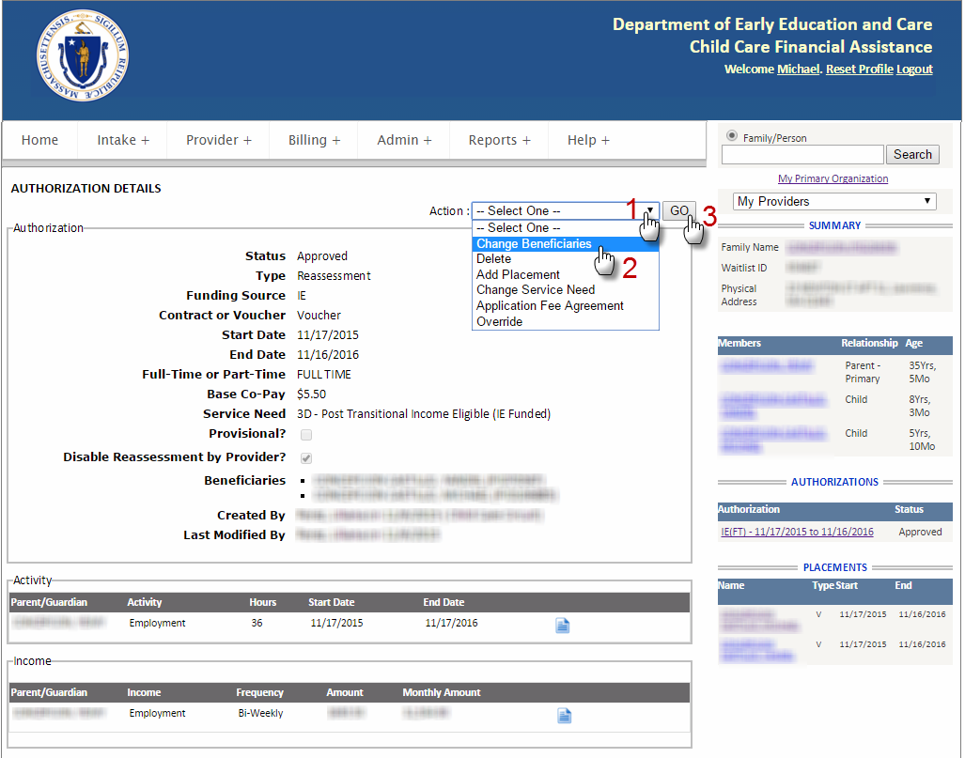

To exempt a placement from age up, navigate to the Authorization Details screen associated
with the child’s placement, and select “Change Beneficiaries” from the Action drop-down list.

Click on the button labeled “Go”.

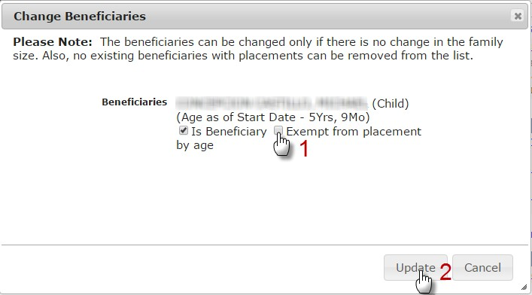
Next, on the “Change Beneficiaries” pop-up window, click on the “Exempt from placement by age” checkbox, and click on the button labeled “Update” to complete the age up exemption.

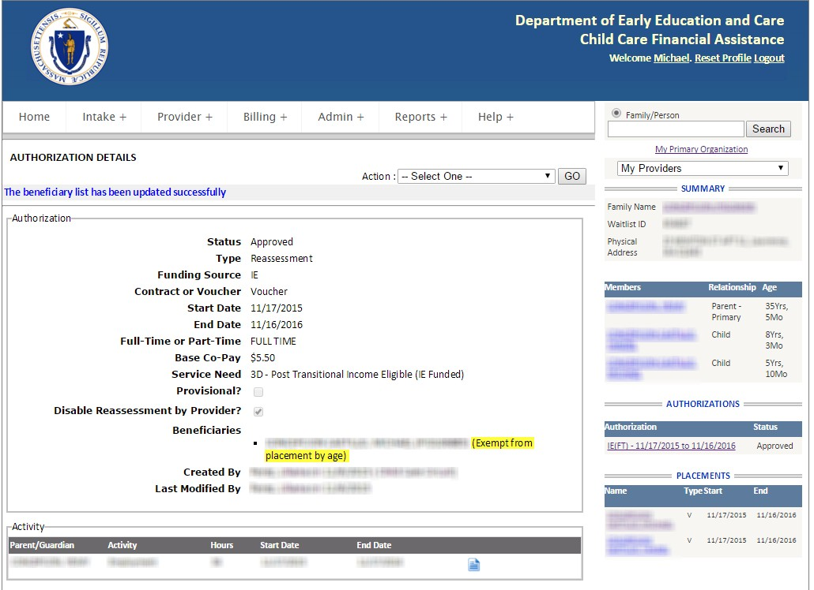

The system will indicate that the beneficiary list has been updated successfully, and that the selected child is now exempt from placement by age.

In this placement example the child is now 2 years and nine months old (33 months), in a toddler program that ages out after the completion of the 32nd month.

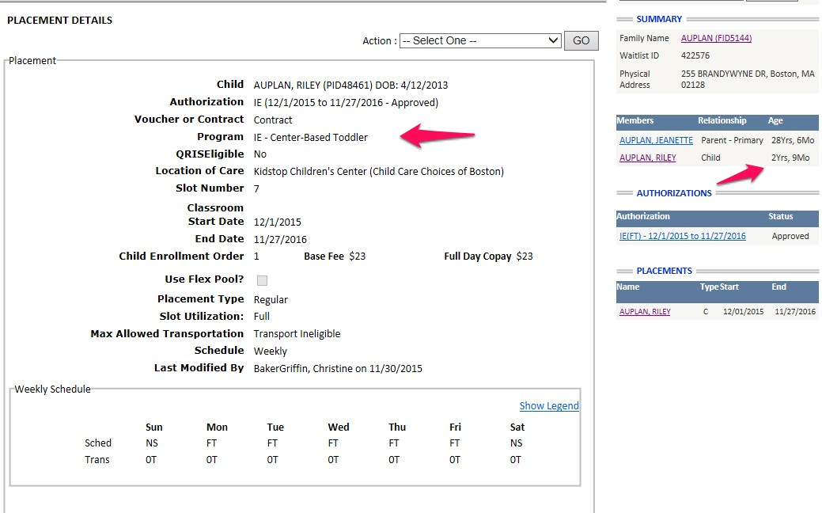

An aged out placement should be ended the day the child becomes eligible, this child’s birthdate is 4/12/2013. The child became 33 months on 1/12/2016. The toddler placement should end on 1/12/2016. The new placement should be created with the child' s new program starting on the day after he or she is eligible, 1/13/2016. This is different from aging up prior to CCFA.

Select the "Change End Date" function from the Action drop-down menu on the Placement Details page and click on the button labeled "Go".

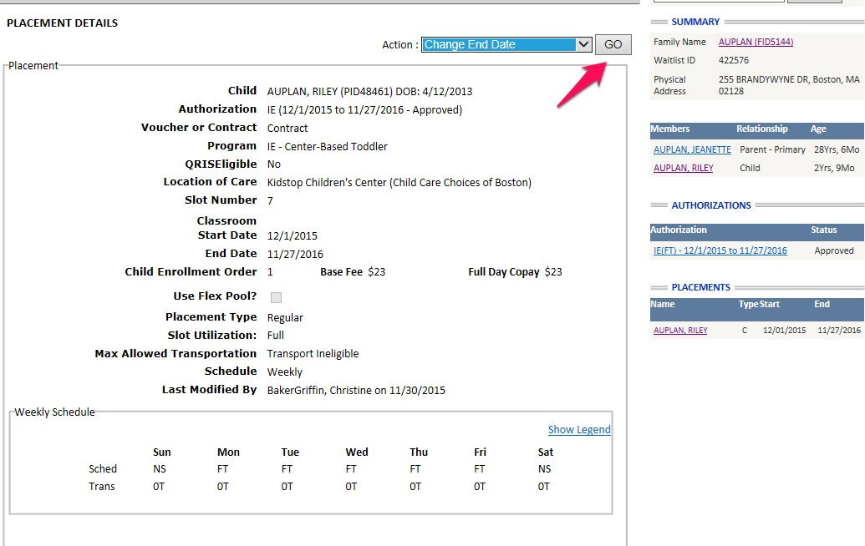

A Change Placement End Date dialog box will appear in which you will enter the updated end date in the provided End Date field, and click on the button labeled "Update".

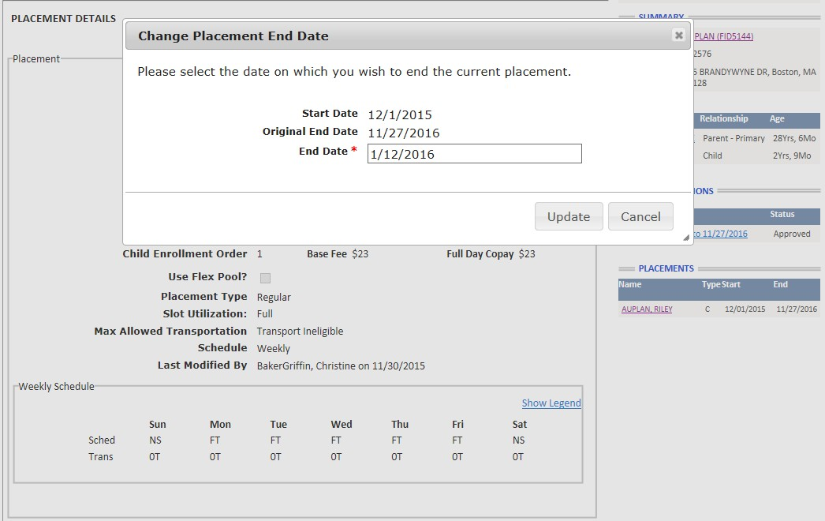

Note, if the end date entered for the placement is in the past, it will no longer be listed in the PLACEMENTS on the right side tool bar. You will find old placements under the Authorization on the Family Details page.

Select the Authorization and Select Add Placement

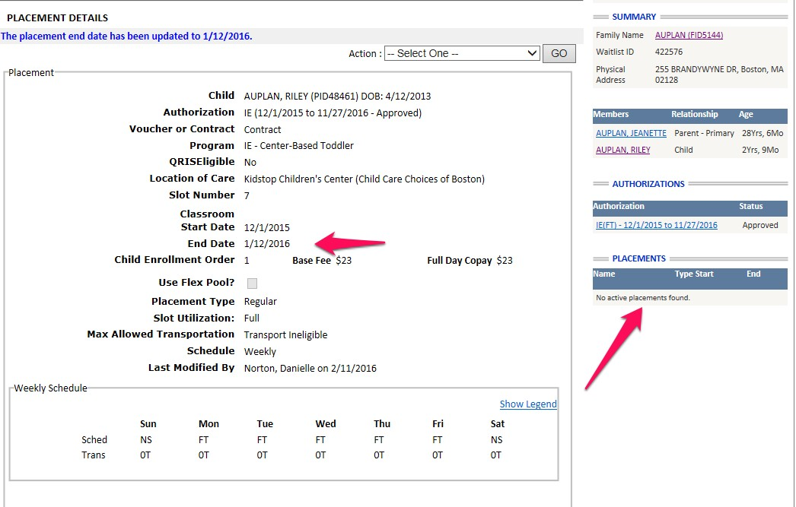

If there are attendance entries entered against the placement that extend beyond the newly entered end date a notification will be displayed alerting you to the fact that these attendance entries must first be removed. If the notification is displayed, note the last day of attendance, in this case 1/30/2015, and click on the button labeled OK. You will delete all attendance after the new end date . In this case, delete all attendance for January and reenter attendance for 1/1 – 1/12. The steps for deleting Attendance begin on slide 24.

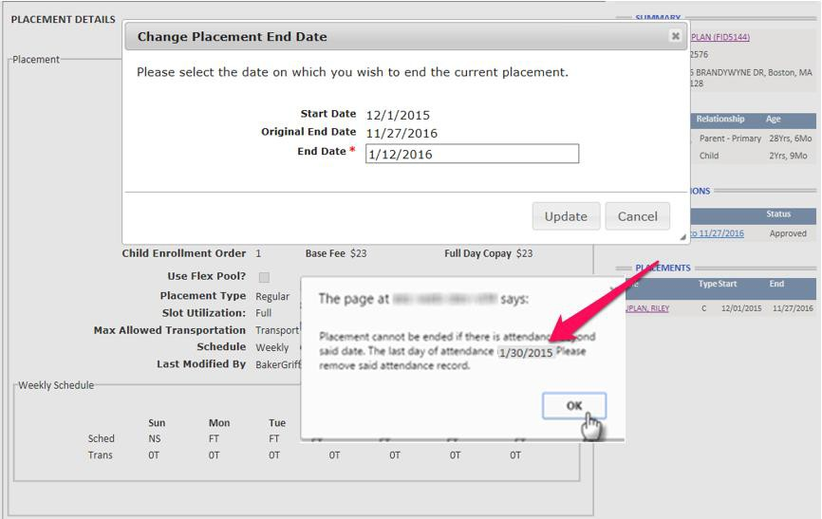
15

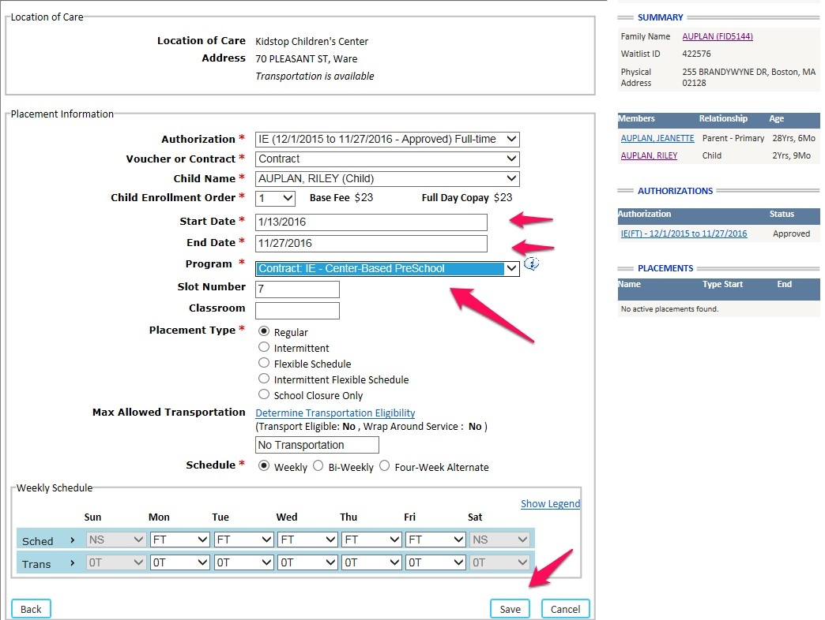Select Copy Placement from the old placement or select the Authorization and Add Placement. Make sure you have selected the correct program and the correct Start and End Dates. Select all required items, denoted with an asterisk and Save.

16

A new placement will be listed on the right side tool bar.

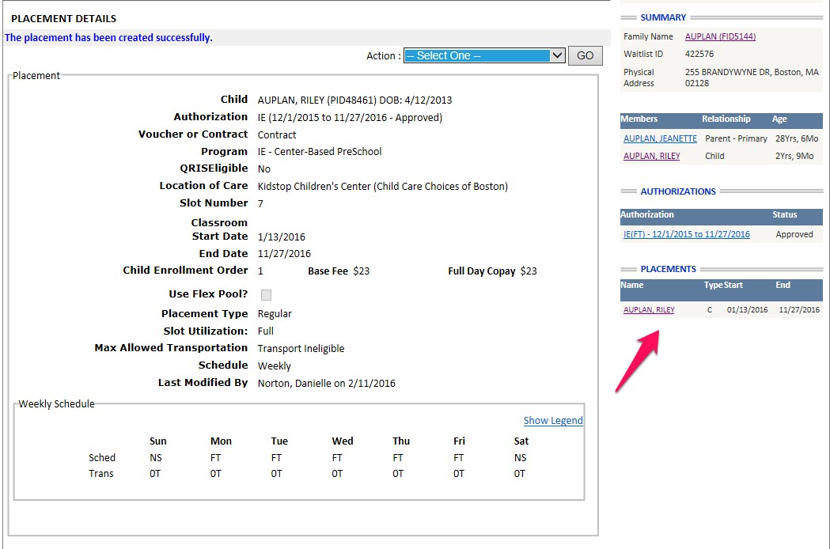

If there are attendance entries entered against the placement that extend beyond the newly entered end date a notification will be displayed alerting you to the fact that these attendance entries must first be removed. If the notification is displayed, note the last day of attendance, in this case 9/4/2015, and click on the button labeled OK. Note that the following example is not continued from the above, but shows the steps to delete attendance.

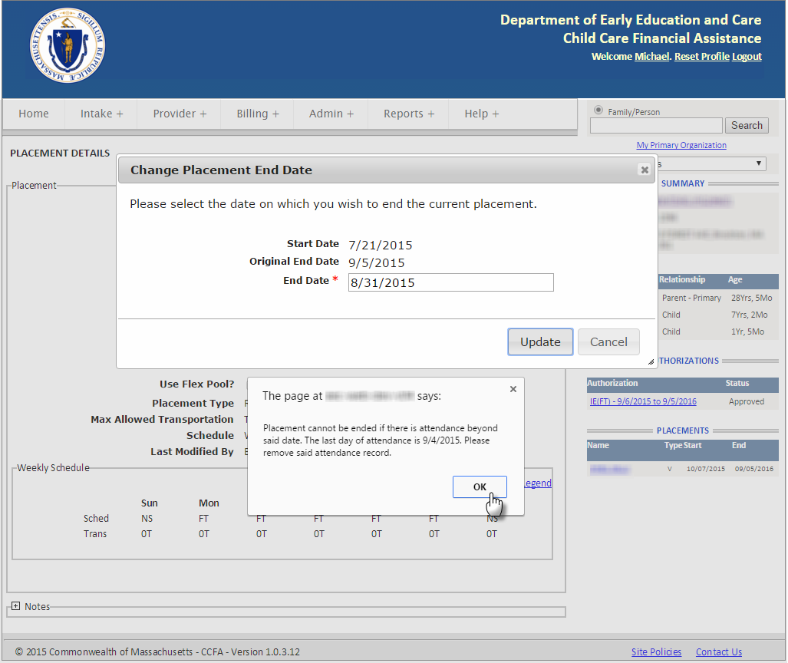

Begin removing attendance entries by selecting "Monthly View" from the Action drop-down menu on the Placement Details page, and click on the button labeled "Go".

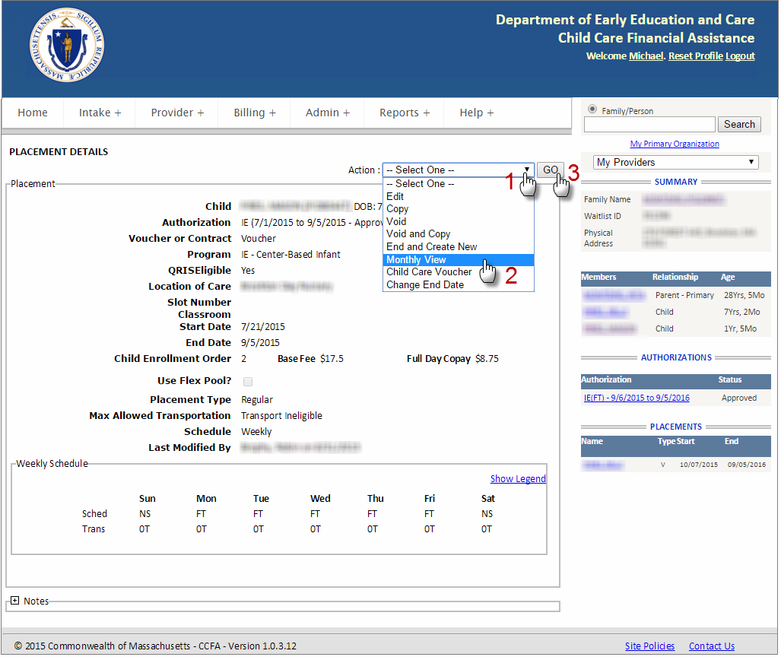

Next, click on the attendance date field to reveal the date selection dialog box. Only months with attendance entries will be available for selection. Attendance entries must be removed beginning with the last month entered. In this example we are only interested in attendance entries made in September since we intend to end the placement on August 31st.

Click on the latest available month. In our example, this is September.

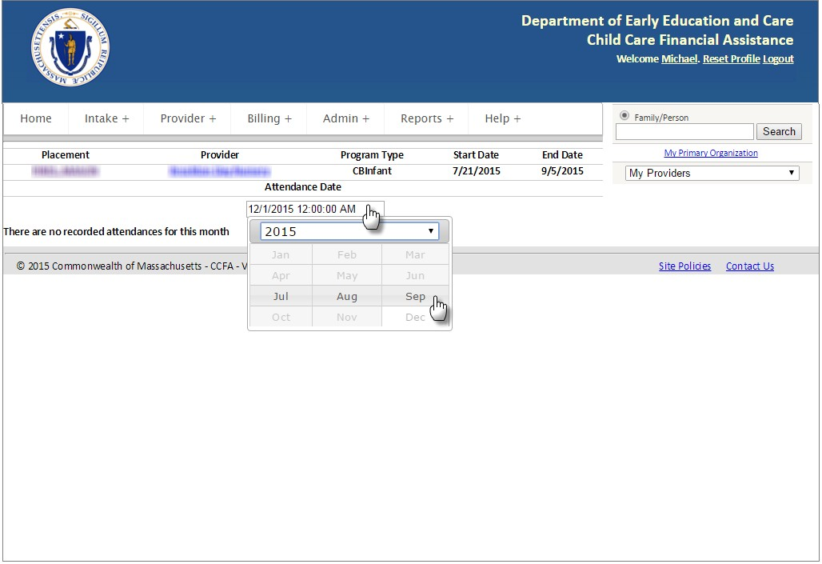

Click on the link labeled "Remove Attendances" near the upper right corner of the calendar.

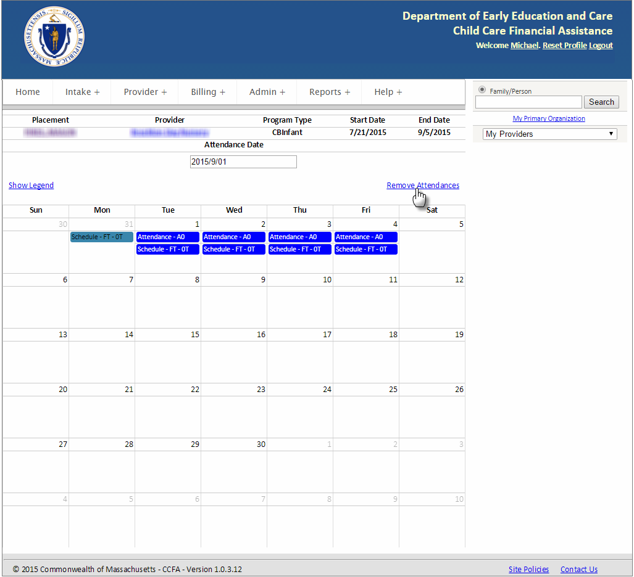

A confirmation box will be displayed asking you to verify that the selected month' s attendance should be removed. Click on the button labeled "Yes".

