Office of Massachusetts Attorney General
Maura Healey

Opioid Recovery and Remediation Fund Advisory Council

May 14, 2021

AG Enforcement

AG Support for the Fund

© 2021 Massachusetts Office of the Attorney General

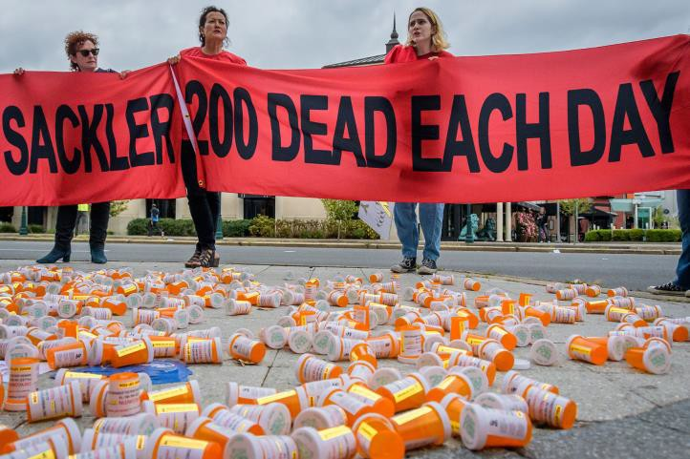
Purdue and the Sacklers

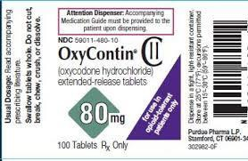
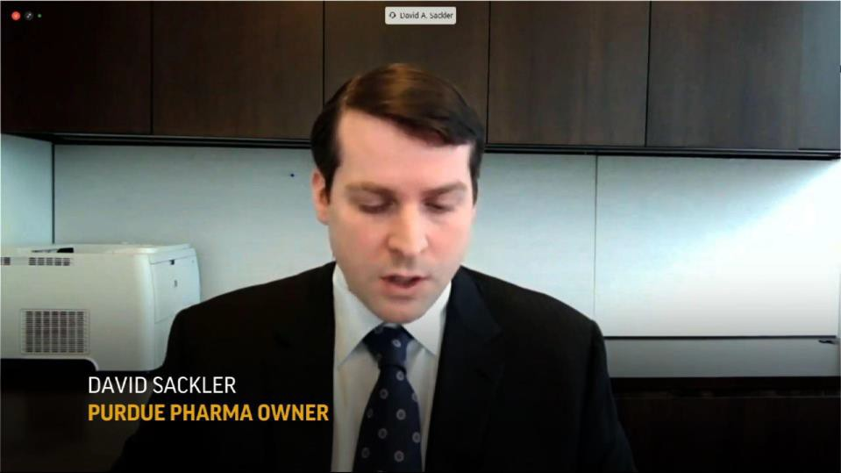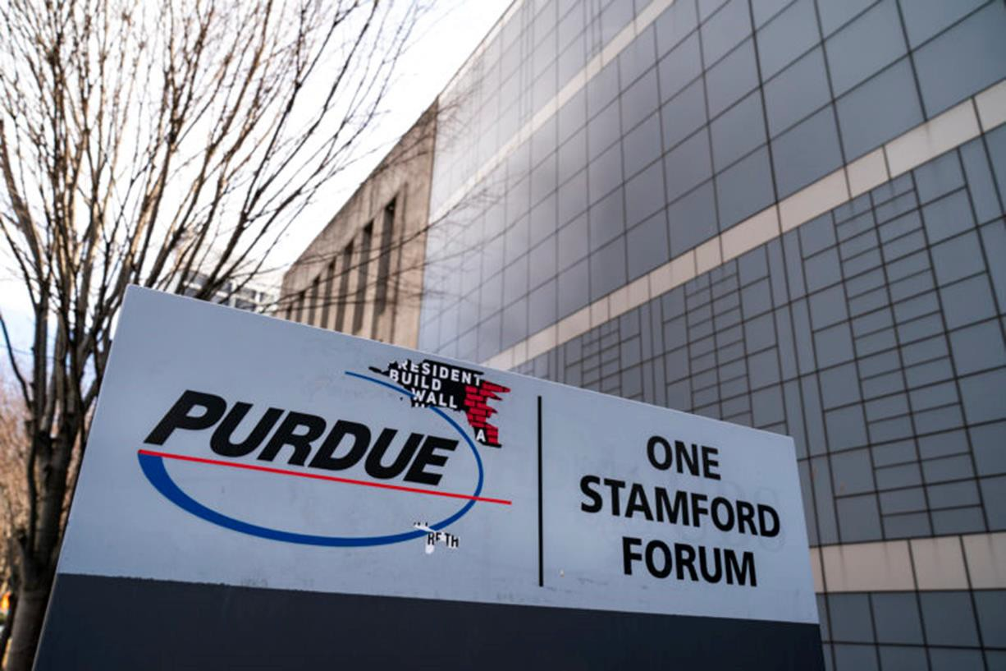

© 2021 Massachusetts Office of the Attorney General

Key Purdue Consultants

© 2021 Massachusetts Office of the Attorney General

Other Opioid Manufacturers and Distributors

© 2021 Massachusetts Office of the Attorney General

Opioid Recovery and Remediation Fund

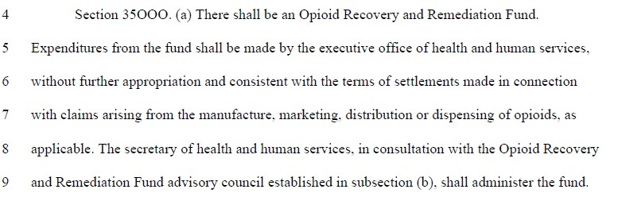
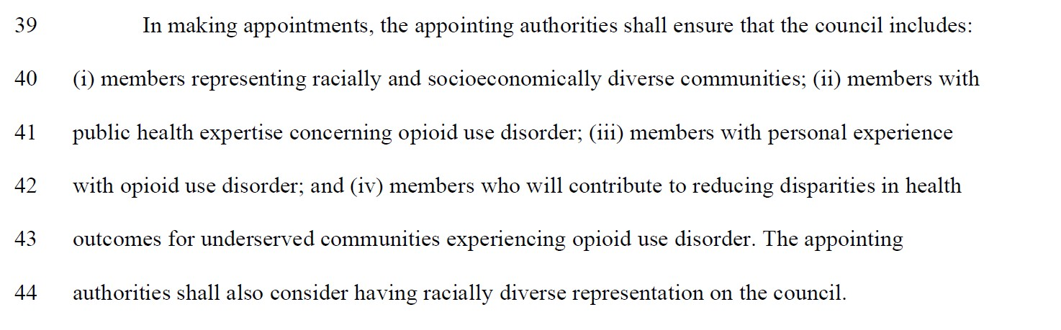

© 2021 Massachusetts Office of the Attorney General

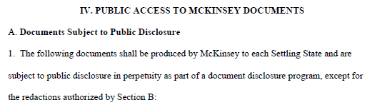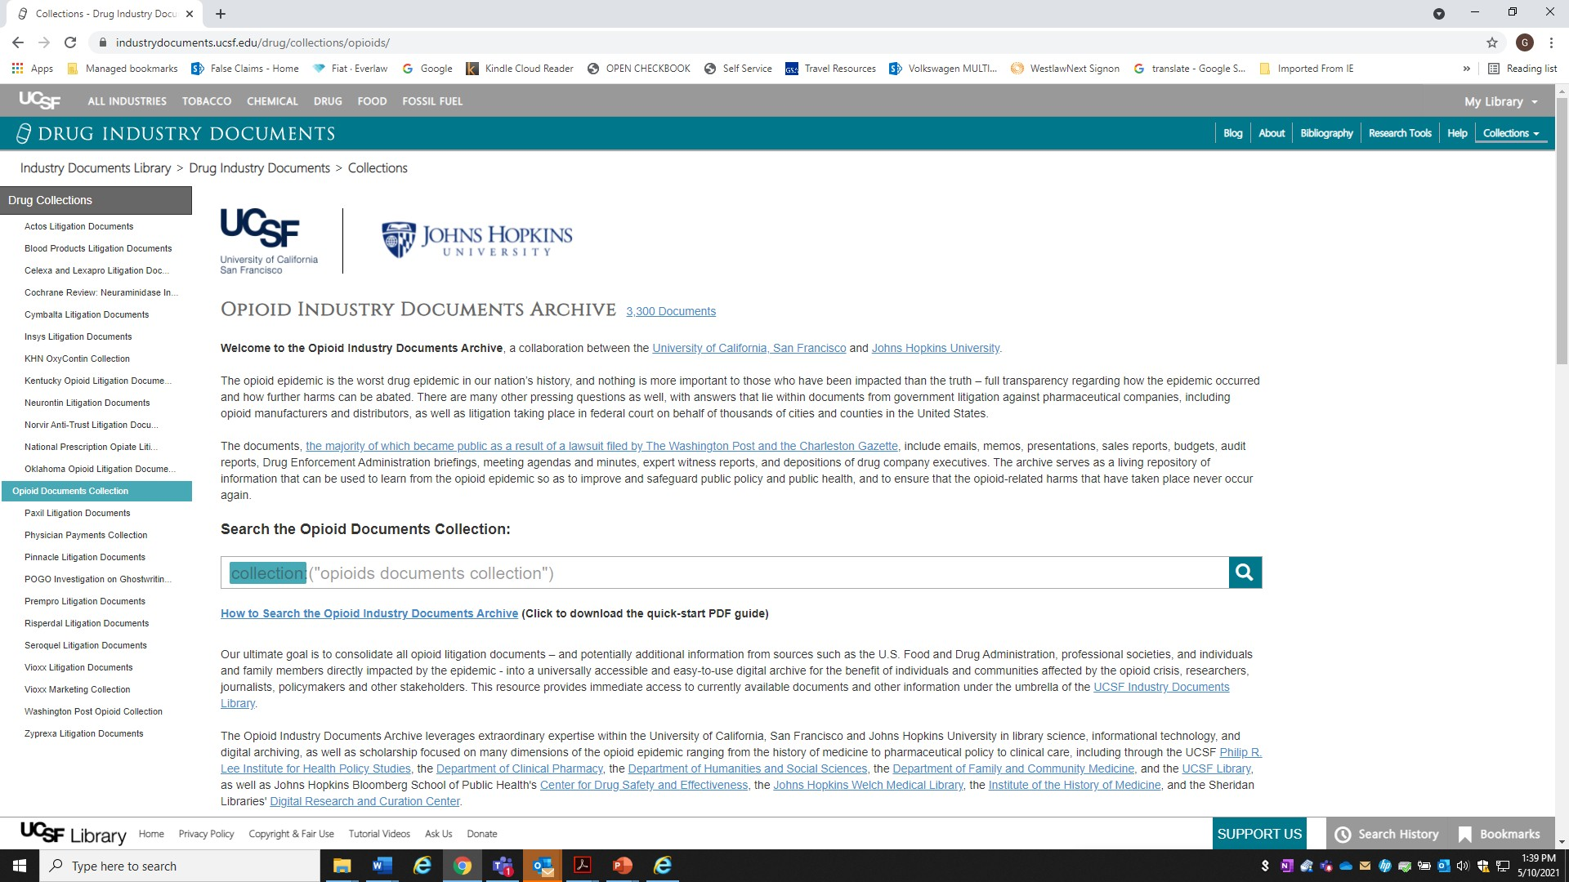Transparency

https://www.industrydocuments.ucsf.edu/drug/collections/opioids/
© 2021 Massachusetts Office of the Attorney General

The work to hold the industry accountable continues!
Thank you for your service.

Questions?
gillian.feiner@mass.gov

© 2021 Massachusetts Office of the Attorney General

