Original Article

A randomized, double-blind, active- controlled, double-dummy, parallel-group study to determine the safety and efficacy of oxycodone/naloxone prolonged-release tablets in patients with moderate/severe, chronic cancer pain

Sam H Ahmedzai School of Medicine and Biomedical Sciences, University of Sheffield, UK
Friedemann Nauck Department of Palliative Medicine, University of Go¨ttingen, Germany
Gil Bar-Sela Division of Oncology, Rambam HCC, Technion-Israel Institute of Technology, Haifa, Israel
Bjo¨ rn Bosse Mundipharma Research GmbH & Co. KG, Limburg, Germany
Petra Leyendecker Mundipharma Research GmbH & Co. KG, Limburg, Germany
Michael Hopp Mundipharma Research GmbH & Co. KG, Limburg, Germany
Palliative Medicine
26(1) 50–60
© The Author(s) 2011 Reprints and permissions:
sagepub.co.uk/journalsPermissions.nav DOI: 10.1177/0269216311418869
pmj.sagepub.com

Abstract
Objective: An examination of whether oxycodone/naloxone prolonged-release tablets (OXN PR) can improve con- stipation and maintain analgesia, compared with oxycodone prolonged-release tablets (OxyPR) in patients with moder- ate/severe cancer pain.
Methods: Randomized, double-blind, active-controlled, double-dummy, parallel-group study in which 185 patients were randomized to receive up to 120 mg/day of OXN PR or OxyPR over 4 weeks. Efficacy assessments included Bowel Function Index (BFI), Brief Pain Inventory Short-Form (BPI-SF), laxative and rescue medication use. Quality of life (QoL) and safety assessments were conducted.
Results: After 4 weeks, mean BFI score was significantly lower with OXN PR; mean total laxative intake was 20% lower with OXN PR. Mean BPI-SF scores were similar for both treatments and the average rate of analgesic rescue medication use was low and comparable. QoL assessments were stable and comparable with greater improvements in constipation- specific QoL assessments with OXN PR. Overall, rates of adverse drug reactions were similar.
Conclusions: OXN PR provides superior bowel function in cancer pain patients, compared with OxyPR, without compromising analgesic efficacy or safety. This study confirms that OXN PR is well tolerated and efficacious in cancer pain patients and results are in line with those seen in non-malignant pain patients.

Keywords
Analgesia, constipation, naloxone, neoplasms, oxycodone, pain

Introduction
Patients with cancer experience a wide variety of prob- lems related not only to the disease itself, but often to the treatments involved and their related side eﬀects.

Pain is a particular concern for cancer patients, having a signiﬁcant impact on quality of life.1,2 More than 80% of cancer patients with advanced metastatic disease experience pain caused largely by direct tumour

Corresponding author:
Dr Michael Hopp, Mundipharma Research GmbH & Co. KG, Ho¨ henstrasse 10, 65549 Limburg (Lahn), Germany Email: Michael.hopp@mundipharma-rd.eu

Ahmedzai et al. 51

inﬁltration.2 Opioids are recommended for the manage- ment of moderate/severe cancer pain by the WHO and current guidelines,1–4 and are recognized as the treat- ment of choice.2 The semi-synthetic opioid analgesic oxycodone has become a cornerstone of pain manage- ment in a wide range of settings,5 including cancer- related pain.6,7 However, successful management of pain with opioids requires that the beneﬁts of these agents outweigh the impact of treatment-related side eﬀects such as constipation.8,9 Up to 95% of patients with cancer experience constipation, with highest inci- dence observed in those who receive opioid therapy.10 This complication can cause further deterioration in the quality of life of patients with cancer.
The eﬀects of opioids are determined by the location of opioid receptors. Activation of opioid receptors in the central nervous system results in analgesia, but acti- vation of opioid receptors in the gut wall leads to reduced gut motility, delayed gastric emptying, increased sphincter tone and slower gut transit time.11 Consequently, patients can experience constipation, gastro-oesophageal reﬂux, abdominal cramping, spasm and bloating; collectively these symptoms are known as opioid-induced bowel dysfunction.12,13 Opioid-induced constipation (OIC) is the most fre- quently reported and persistent adverse event (AE) in patients receiving opioid analgesia.14
Current management strategies for OIC are non- speciﬁc, often ineﬀective and are largely lacking a good evidence base.15 Laxatives are frequently used and can be eﬀective, although many patients still do not achieve adequate symptom relief, as they fail to address the underlying opioid-related mechanisms.16,17 Use of peripherally acting opioid antagonists has been identiﬁed as a promising approach; these agents speci- ﬁcally target gastrointestinal (GI) receptors without limiting the central analgesic activity of opioids.18,19 Naloxone is a peripherally acting opioid antagonist with low systemic bioavailability (<3%) following oral administration, due to extensive ﬁrst-pass hepatic metabolism.20–22 Consequently, orally administered naloxone acts almost exclusively on opioid receptors in the GI tract.20,23 Targeting peripheral receptors whilst sparing central analgesic function through com- bining naloxone with oxycodone has emerged as a promising approach for managing OIC, and generated much academic and clinical interest.16,17,24
Three large, randomized, placebo-controlled Phase III trials in patients with non-cancer pain,25–27 plus a prospectively planned pooled analysis of two of these studies,28 have already conﬁrmed analgesic eﬃcacy of the combination of prolonged-release (PR) oxycodone/ naloxone (OXN PR), while also demonstrating beneﬁts in terms of bowel function versus oxycodone PR (OxyPR) alone. Importantly, OXN PR did not lead

to a reduction in analgesic eﬃcacy, compared with OxyPR. Moreover, high analgesic eﬃcacy and a posi- tive eﬀect on bowel function associated with OXN PR have been shown in a long-term study,29 and in a large observational study.30 The trials described above have demonstrated the beneﬁts of the combination of oxy- codone with naloxone in patients with chronic non- cancer pain. Because opioid drugs are recommended for the management of moderate/severe pain in cancer patients,1–4,31 the aim of the current study was to investigate whether OXN PR can also improve con- stipation and maintain analgesia, compared with OxyPR, in the cancer pain patient population.

Methods

Study design
The OXN2001 trial (ClinicalTrials.gov identiﬁer NCT00513656)32 was a 4-week, international, multicen- tre, randomized, double-blind, active-controlled, double-dummy, parallel-group, Phase II study, designed to evaluate the safety and eﬃcacy of OXN PR in patients with moderate/severe chronic cancer pain. The study was initiated on 2 November 2007 and the extension phase was completed on 17 August 2010. Following the screening period (3–10 days before randomization), eligible patients stopped their pre- study opioid and laxative medication and were ran- domized (on Day 1/Visit 2) to switch directly to either OXN PR or OxyPR during the 4-week double-blind treatment phase. During the core phase of the study, all subjects, investigators and sponsor personnel were blinded. Treatments were masked in a double-dummy fashion, whereby subjects randomized to receive OXN PR were given OXN PR and OxyPR placebo, and sub- jects randomized to receive OxyPR were given OxyPR and OXN PR placebo. Patients attended three further clinic visits (on Days 8, 15 and 29), and received four additional telephone calls (on Days 2, 4, 6 and 22). Patients could enter an open-label extension phase, the details and results of which will be reported sepa- rately. The study was performed in full compliance with applicable Good Clinical Practice33 and regulations, and in accordance with the Declaration of Helsinki.34
There were two primary objectives: (i) to determine whether patients with moderate/severe cancer pain taking OXN PR experience an improvement in symp- toms of constipation, as measured by the validated Bowel Function Index (BFI),35–37 compared with patients taking OxyPR alone; and (ii) to compare eﬃ- cacy for management of chronic cancer pain, as assessed by the Brief Pain Inventory–Short Form (BPI-SF).38 The secondary objectives included a comparison of eﬀects on laxative and rescue medication

52 Palliative Medicine 26(1)

use, quality of life (QoL) and safety. Regardless of treatment group, patients were titrated up to a maximum of 120 mg/day oxycodone PR (if required). Open-label oxycodone immediate-release capsules (OxyIR) were available to patients as rescue medica- tion, up to a maximum of six doses per 24 h. Patients who needed to titrate up to oxycodone PR 120 mg/day and who regularly required two or more rescue doses of OxyIR were withdrawn from the study. Bisacodyl tablets were available as laxative rescue medication, up to a maximum of ﬁve doses within seven consecutive days.

Study population
Eligible patients were aged ;:: 18 years, with a diagnosis of cancer and a documented history of moderate/ severe, chronic cancer pain, requiring round-the-clock opioid therapy (equivalent to OxyPR 20–80 mg/day at the start of the trial). Subjects had to be willing and able (e.g. mental and physical condition) to participate in all aspects of the study, including use of medication, com- pletion of subjective evaluations, attending scheduled clinic visits, completing telephone contacts, and compli- ance with protocol requirements as evidenced by pro- viding written, informed consent. Patients were excluded from the study for the following reasons: evi- dence of clinically unstable disease or signiﬁcant cardio- vascular, renal, hepatic or psychiatric disease; clinically signiﬁcant GI disease, or signiﬁcant structural abnor- malities of the GI tract; cyclic chemotherapy within 2 weeks before screening visit or planned during the core study (shown in the past to inﬂuence bowel function); radiotherapy that would inﬂuence bowel function or pain during the double-blind phase.

Study assessments
Evaluations of bowel function (BFI),35–37 pain control (BPI-SF),39 use of rescue medication and use of laxative medication during the last 7 days were performed at each clinic visit. The co-primary eﬃcacy variable was average pain over the last 24 h based on BPI-SF (non-inferiority bound 1.0). Co-primary eﬃcacy assessments were based on changes from baseline after 4 weeks of treatment.
Quality-of-life assessments, including the European QoL (EuroQoL) EQ-5D instrument40 and European Organization for Research and Treatment of Cancer QoL Questionnaire-Core 30 (EORTC QLQ-C30)41,42 were conducted at screening and study end. In addition, Patient Assessment of Constipation Symptoms (PAC- SYM) was conducted at screening, randomization and 4 weeks.43 Adverse events were noted at every assess- ment post-randomization. In addition, vital signs, clin- ical laboratory tests, physical examinations and 12-lead
electrocardiographs (ECGs) were conducted through- out the study. Patients were followed up regarding AEs and adverse drug reactions (ADRs) after study completion. At randomization, Days 2, 4, 6 and 8, patients were asked about symptoms of opiate with- drawal (using the modiﬁed Subjective Opiate Withdrawal Scale [SOWS]).27,44

Randomization and sample size calculation
Patients were assigned to treatments (1:1 allocation ratio) using a pseudo-random number generator in a computer program. During visit 2, eligible subjects were randomized to one of two treatment groups (i.e. OXN PR or OxyPR) according to a randomization schedule prepared by the Clinical Supplies Department of the Sponsor or an associated company. Treatment assignments were randomized within blocks of ﬁxed size. No stratiﬁcation was done. The study was designed to have a power of 80% to detect a treatment diﬀerence of 12 on the BFI on a two-sided level of sig- niﬁcance of a ¼ 0.05 assuming a common standard deviation (SD) of 26.
Non-inferiority of OXN PR to OxyPR regarding pain intensity could be concluded on a one-sided level of signiﬁcance of a ¼ 0.05 assuming a non-inferiority bound of 1.0 and a common SD of 2.0.

Statistical analysis
For the primary analyses, analysis of covariance (ANCOVA) was used to compare treatments regarding primary and co-primary endpoints at 4 weeks, adjusting for baseline observation, and using the last observation carried forward (LOCF) approach for missing values. For the BFI, the null hypothesis was a zero diﬀerence (on average) between treatment groups at the ﬁnal visit. The alternative hypothesis was that there is a diﬀerence between the treatment groups. Two-sided tests were per- formed at the 5% signiﬁcance level. For BPI-SF, the null hypothesis was a diﬀerence of -1 (on average) between treatment groups at the ﬁnal visit, in favour of Oxy PR (OXN PR inferior to OxyPR). The alterna- tive hypothesis was a diﬀerence greater than -1 (OXN PR non-inferior to Oxy PR). One-sided t-tests were per- formed at the 5% signiﬁcance level.
Additional sensitivity analyses were performed for co-primary endpoints using the same ANCOVA anal- yses on the non-LOCF data and baseline observation carried forward (BOCF) data. Mixed-eﬀects models for repeated measures (MMRM) analyses were also con- ducted, adjusting for visit and treatment 3 visit interac- tion, and assuming a constant treatment eﬀect over visits in respective MMRM analyses. For other eﬃcacy

Ahmedzai et al. 53

outcomes and safety data, summary statistics were produced.

Results

Patient disposition
Of 224 enrolled patients, 185 were randomized, 184 were part of the double-blind safety population and 183 were included in the full analysis population I; the full analysis population II consisted of 157 patients and the per-pro- tocol population of 133 patients. During the blinded data evaluation it was recognized that 28 patients ran- domized dropped out early but not due to AE constipa- tion and not due to lack of eﬀect. It was decided at a blinded stage to exclude those subjects from the full analysis population I as those patients would not give

valid information about the drug eﬀects regarding BFI if the distribution was not equal in both treatments arms. The primary analysis (superiority testing) of BFI was performed in an intention-to-treat manner on the full analysis II population. The patient dispositions and study populations are shown in Figure 1A and B. Overall, 133/184 (72.3%) patients completed the study. Rates of discontinuation were similar for OXN PR (26/ 92 [28.3%]) and OxyPR (25/92 [27.2%]). In both groups, the primary reason for discontinuation was AEs (OXN PR, n ¼ 20; OxyPR, n ¼ 12).

Patient demographics and baseline characteristics
Demographic characteristics were well balanced between treatment groups. The only exception to

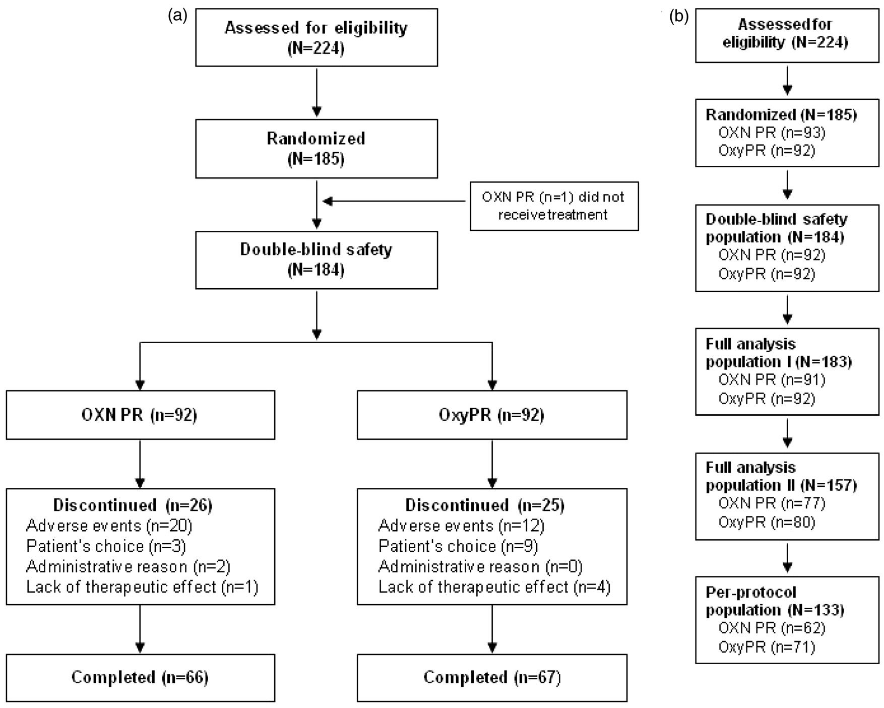

Figure 1. (a) Patient disposition; (b) study populations. The double-blind safety population included all patients who received any dose of study medication; the full-analysis population I excluded one patient from the double-blind safety population who did not receive treatment and was hence not included in the analysis; the full-analysis population II excluded those patients from the original full-analysis population who discontinued due to AEs other than constipation or lack of efficacy within the first 14 days (in order to obtain reliable BFI values and prevent possible skewing due to these early withdrawals); the per-protocol population included patients who received at least one dose of study medication during the double-blind phase and who sufficiently complied with the study protocol. OXN PR: oxycodone/ naloxone prolonged-release tablets, OxyPR: oxycodone prolonged-release tablets, AE: adverse event, BFI: Bowel Function Index.

54 Palliative Medicine 26(1)

this was a slightly higher percentage of patients aged ::: 65 years in the OXN PR group, compared with the OxyPR group (65.2 vs. 48.9%, respectively; Table 1). At the start of the study, 183/184 (99.5%) patients suﬀered from constipation induced or wors- ened by their opioid medication (OXN PR 92/92 [100%]; OxyPR 91/92 [98.9%], the one subject in the OxyPR group had constipation in their medical history but it was not recorded as ongoing at visit 1; Table 1). A similar number of subjects in each treatment group took laxatives (96.7% in the OxyPR group and 95.7% in the OXN PR group). The most frequently taken laxatives were lactulose, bisacodyl and sennoside. At baseline, the most fre- quently reported primary cancer sites were breast (19%), lung (13%) and prostate (10%). Twenty- six per cent of patients had bone metastases. Most frequently used pre-study opioids were fentanyl (29%), morphine (79%), oxycodone (85%) and trama-
dol (35%).

Exposure to study medication
The majority of patients in the OXN PR and OxyPR groups received study medication for ;:: 4 weeks (59.8 vs. 67.4%, respectively), and had similar mean (SD) durations of study participation (23.58 [9.54] vs. 25.05
[8.37] days, respectively) and daily doses (46.59 [22.58]
vs. 43.09 [19.31] mg/day, respectively).

Efficacy
Primary endpoints. Perception of constipation varies from patient to patient and results from three random- ized controlled trials have shown that the BFI is a val- idated, easy-to-use questionnaire for the measurement of opioid induced constipation.35 It is a three-item questionnaire that takes into account subjective criteria often reported by the patient. Using analysis of stan- dard error of measurements and one-half SD charac- teristics of each BFI component, Rentz et al. reported that changes in BFI score ;::12 points represent clini- cally meaningful changes while score changes of less than 7.5 points are unlikely to be clinically meaningful in patient’s perception of their bowel habits.35 At ran- domization, mean (SD) BFI values were high and com- parable in the OXN PR and OxyPR groups (63.97 [17.42] vs. 62.40 [23.56], respectively), and similar to baseline assessments in previous OXN PR Phase III trials,25–27 indicating that patients suﬀered from consti- pation caused or aggravated by opioid medication. The diﬀerence in change from baseline in BFI score (DBFI) between groups was statistically signiﬁcant (LOCF,

Table 1. Patient demographics and clinical characteristics (double-blind safety population)

 | OXN PR | OxyPR
Variable | n ¼ 92 | n ¼ 92
Age, years
Mean (SD) | 61.86 (10.93) | 64.30 (9.63)
Median (range) | 62.0 (36–84) | 66.0 (42–82)
Age group, n (%)
:::65 years | 60 (65.2) | 45 (48.9)
>65 years | 32 (34.8) | 47 (51.1)
Sex, n (%)
Male | 48 (52.2) | 46 (50.0)
Female | 44 (47.8) | 46 (50.0)
Race, n (%)
Caucasian | 92 (100.0) | 91 (98.9)
Black | 0 (0) | 1 (1.1)
Constipation induced or worsened by opioid medication, n (%) | 92 (100.0) | 91 (98.9)
 | n ¼ 90 | n ¼ 90
Body mass index, kg/m2
Mean (SD) | 25.34 (5.75) | 25.62 (5.13)
Median (range) | 24.7 (15–39) | 25.6 (16–41)
SD: standard deviation, OXN PR: oxycodone/naloxone prolonged-release tablets, OxyPR: oxycodone prolonged-release tablets.

Ahmedzai et al. 55

DBFI ¼ -11.14; 95% conﬁdence interval [CI]: -19.03 to -3.24; p < 0.01) These ﬁndings were underlined by the results of MMRM (with treatment by visit interac- tion, DBFI ¼ -10.8; 95% CI: -18.8 to -2.8; p ¼ 0.018),
MMRM (assuming a constant treatment eﬀect,
DBFI ¼ -12.36; 95% CI: -19.05 to -5.67; p < 0.01),
BOCF (DBFI ¼ -10.85; 95% CI: -18.63 to -3.073;
p < 0.01 and LOCF analyses (per-protocol population:
DBFI ¼ -14.78; 95% CI: -23.03 to -6.53; p < 0.01). A
statistically signiﬁcant diﬀerence between treatments in favour of OXN PR was observed already at week 1. Taking all analyses into account, OXN PR is both sta- tistically signiﬁcantly superior in respect to BFI and has also demonstrated a change that is clinically relevant.
At randomization, mean (SD) BPI-SF scores were comparable for OXN PR and OxyPR treatment groups (4.16 [1.87] vs. 4.18 [1.87]). There was a slight decrease in mean BPI-SF scores, which was similar between groups. After 4 weeks of treatment, mean (SD) BPI-SF scores remained comparable between OXN PR and OxyPR groups (3.50 [1.88]) and 3.52 [1.80]; Figure 2B). Results of the primary analysis con- ﬁrmed non-inferiority of OXN PR to OxyPR (LOCF, least squares [LS] mean diﬀerence -0.011; 90% CI:
-0.47 to 0.45, p < 0.01). Non-inferiority in pain was further supported by sensitivity analyses, including MMRM, LOCF and BOCF.

Secondary endpoints. After 4 weeks, mean (SD) total laxative (oral bisacodyl) intake was 20% lower in the OXN PR group than the OxyPR group (26.10 [27.60] vs. 32.69 [31.26] mg, respectively), but the diﬀerence was not statistically signiﬁcant (p ¼ 0.17). The need for rescue analgesic medication was generally low in both treatment groups throughout the double-blind phase, in terms of both frequency (less than one intake/day) and dose. Diﬀerences between groups were not signiﬁcant for either variable (p ¼ 0.4 and p ¼ 0.22, respectively). Over 4 weeks of treatment, PAC-SYM scores improved in both groups, but the degree of improvement at endpoint was signiﬁcantly greater for OXN PR than for OxyPR, in terms of total symptom score (p ¼ 0.014) and frequency of symp- toms (p < 0.01; Table 2). These results are in line with results of BFI analyses, conﬁrming better bowel eﬃcacy of OXN PR, compared with OxyPR.
At screening, mean EQ-5D index scores were com- parable between treatment groups. After 4 weeks, mean (SD) index score was 0.50 (0.33) for OXN PR and 0.49 (0.38) for OxyPR. All mean (SD) EORTC QLQ-C30 scores were comparable between treatment groups at randomization. Mean pain subscore improved in both groups. Importantly, the mean (SD) constipation subscore in the OXN PR group was 44.32 (35.16) after 4 weeks of treatment (mean

change from screening, -30.4), compared with a sub- score of 59.78 (35.13) in the OxyPR group (mean change, -13.1). The improvement in this quality of life measure correlates well with the improvement seen measured by the BFI (R ¼ 0.71)

Safety
The proportion of patients who experienced AEs or ADRs was generally similar for OXN PR and OxyPR groups (Table 3). Approximately 20% of AEs were due to progression of underlying cancer disease. The most frequently reported AEs were GI disorders and ‘general disorders and administration site condi- tions’. The proportions of each group with ADRs were comparable for OXN PR and OxyPR (38.0 vs. 34.8%, respectively).
The incidence of serious ADRs was low in both groups (Table 3). In total, 18 patients (9.8%) died during the study, with nine in each group. No death was considered related to study medication (progres- sion of malignant disease n ¼ 16; cardiac disorders n ¼ 2). There were no clinically important changes in vital signs, laboratory values, ECG assessments or modiﬁed SOWS observed. Mean (SD) SOWS values at baseline were 8.01 (7.76) and 8.90 (7.81) for OXN PR and OxyPR, respectively. These remained stable throughout the assessment period (OXN PR 6.64 [5.97]; OxyPR 7.29 [4.59] at last assessment).

Discussion
Opioids are widely recommended to relieve pain in cancer patients,3,4,31,45 but are associated with AEs such as constipation. Results from this study demon- strate that OXN PR provides comparable analgesia to OxyPR for patients with moderate/severe cancer pain, whilst signiﬁcantly improving bowel function and reducing symptoms of constipation.
OXN PR was superior to OxyPR with respect to bowel function, particularly reducing constipation, as measured by the BFI. Importantly, the diﬀerence between the two treatments was both statistically sig- niﬁcant and clinically relevant and, moreover, achieved with less laxative use with OXN PR (20% less). In fact, there was already a statistically signiﬁcant beneﬁt in BFI score for OXN PR, compared with OxyPR, after
1 week. Overall, achieving this improvement in BFI with reduced laxative use in the OXN PR group, in such a short time frame, is encouraging, considering the severity of underlying disease and the nega- tive impact of constipation on the lives of can- cer patients.9,10 Primary eﬃcacy ﬁndings were underlined by signiﬁcant diﬀerences in PAC-SYM domain scores in favour of OXN PR.

56 Palliative Medicine 26(1)

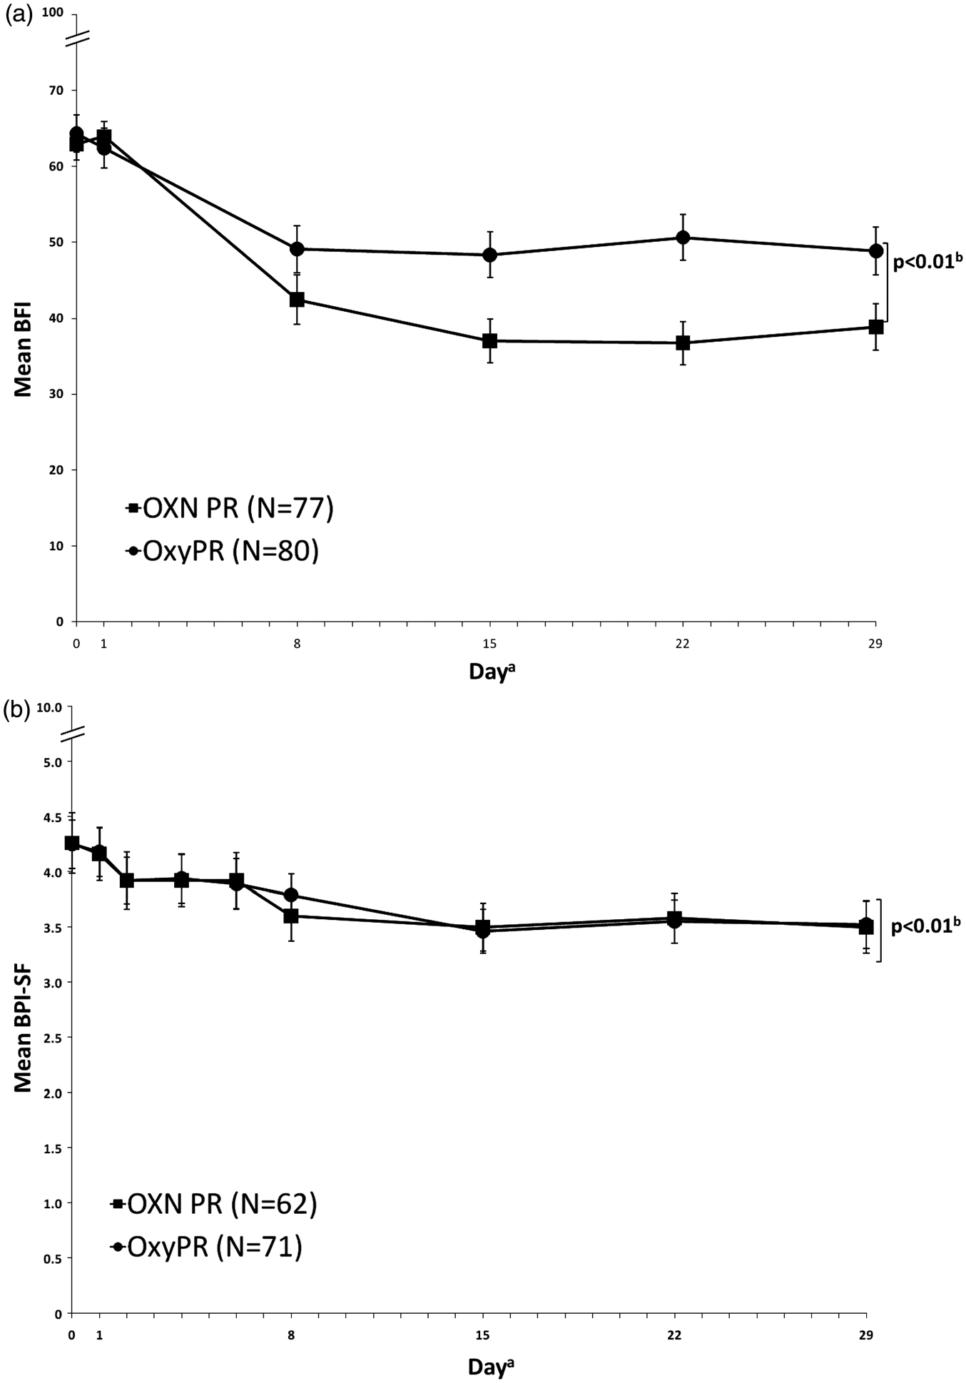

Figure 2. Effect of OXN PR and OxyPR treatment on (a) mean (6 standard error) BFI score (full analysis population II, LOCF); and
(b) mean (6 standard error) BPI-SF score (per-protocol population, LOCF), by study day. aPopulations varied at each day. Error bars represent standard error; OXN bp-value and confidence interval for treatment difference adjusted for baseline using an ANCOVA model. (a) BFI: 95% CI -19.03 to -3.24; (b) BPI-SF: 90% CI -0.47 to -0.45. OXN PR: oxycodone/naloxone prolonged-release tablets, OxyPR: oxycodone prolonged-release tablets, BFI: bowel function index. (Copyright for the BFI is owned by Mundipharma Research, 2002; the BFI is the subject of European Patent Application Publication No. EP 1 860 988 and corresponding patents and applications in other countries).

With respect to the co-primary endpoint of pain relief, OXN PR was non-inferior to OxyPR, as mea- sured by BPI-SF. Rescue analgesic use was low and comparable between groups throughout the double- blind phase, showing that patients were eﬀectively titrated to a stable dose of study medication, and that
comparable analgesic eﬃcacy of OXN PR and OxyPR was not inﬂuenced by diﬀerential use of rescue analge- sic medication.
General QoL results using EQ-5D and EORTC QLQ-C30 were similar for OXN PR and OxyPR treat- ments over time. However, results of the speciﬁc

Ahmedzai et al. 57

Table 2. Patient assessment of constipation using PAC-SYM (Full-Analysis II population)
Parameter OXN PR, n ¼ 77 OxyPR, n ¼ 80 Total symptoms score
Day 1
n 75 80
Mean (SD) 17.38 (6.99) 18.21 (8.28)
Median (range) 17.0 (2–32) 16.0 (0–42)
At 4 weeks
n 73 74
Mean (SD) 10.37 (8.57) 15.47 (9.83)
Median (range) 8.0 (0–37) 14.0 (0–37) OXN PR versus OxyPR p < 0.01
Frequency of symptoms Day 1
n 75 79
Mean (SD) 2.53 (1.09) 2.33 (1.07)
Median (range) 3.0 (0–4) 3.0 (0–4)
At 4 weeks
n 73 73
Mean (SD) 1.47 (1.07) 2.03 (1.29)
Median (range) 1.0 (0–4) 2.0 (0–4) OXN PR versus OxyPR p < 0.01

PAC-SYM: Patient Assessment of Constipation Symptoms, SD: standard deviation, OXN PR: oxycodone/naloxone prolonged-release tablets, OxyPR: oxycodone prolonged-release tablets.

EORTC QLQ-C30 constipation subscore indicated that OXN PR patients had a superior outcome, com- pared with OxyPR patients. This could contribute towards an improved quality of life for many patients with chronic cancer pain treated with OXN PR.
There were slightly more dropouts due to AEs in the OXN PR group, although the overall incidence of AEs was comparable between treatment groups. Most frequently reported ADRs were consistent with the known safety proﬁle of the opioid analgesic class of drugs, and with those seen in previous Phase III trials of OXN PR in patients with non-cancer pain.26,27 There were slightly more total GI disorders observed in the OXN PR group; however, the incidence of the most frequent AEs such as abdominal pain, worsened constipation, diarrhoea and vomiting were compara- ble, whilst nausea was reported less commonly in the OXN PR group. Therefore, the slightly higher number of total GI disorders in the OXN PR group is explained by the sum of less frequent AEs. It is pos- sible that GI-related AEs indicate return of more active bowel function (as is aimed for when treating constipated patients), which has also been documented after use of other peripherally acting opioid antago- nists, such as methylnaltrexone.46 In a study compar- ing methylnaltrexone with placebo, in patients receiving the active drug, abdominal pain also

occurred more frequently. In addition, more ﬂatulence and nausea were reported for methylnaltrexone;46 this was not seen with OXN PR in the study described here. There were no clinically relevant changes in lab- oratory values or vital signs related to study medica- tion. Mean modiﬁed SOWS values were low and comparable in both groups. In summary, the results suggest that switching from other opioids to oxyco- done – as either OXN PR or OxyPR – was generally safe and well tolerated by patients in this trial, with switching to OXN PR giving the added beneﬁt of reduced OIC complications.
The ﬁndings of this study should be interpreted within the context of the trial design and patient pop- ulation. The double-blind phase had a duration of 4 weeks to allow for assessment of analgesic eﬀect, con- sistent with European Medicines Agency guidelines on clinical studies of chronic moderate/severe cancer pain.47 This timeframe is also deemed adequate for observing diﬀerences in constipation based on previous Phase II48 and Phase III data.27
Although the demographic proﬁle of both treatment groups was generally similar there was a slightly higher percentage of patients aged ::: 65 years in the OXN PR group than in the OxyPR treatment group. However, this diﬀerence is not clinically relevant, as results from previous clinical studies have demonstrated that the eﬃcacy and safety of OXN PR in older patients is sim- ilar to that in younger patients.49 Additional assess- ments showed that there was no correlation between BFI score at study end (LOCF) and age (data not shown).
Opioid-induced bowel dysfunction is common and adds to the burden of living with chronic pain. Current oral and rectal laxatives are often ineﬀective and do not have a good evidence base.15 The new targeted approach of administering peripherally acting opioid antagonists is eﬀective and is supported by extensive clinical trial data. Previous attempts to use immedi- ate-release naloxone were unsuccessful because of reversal of analgesia; and the only other licensed peripherally acting opioid antagonist, methylnaltrex- one, has to be given by injection.15,46 The present trial has shown that oral OXN PR tablets are well tolerated and can eﬀectively and conveniently provide targeted treatment of OIC at a dose range which includes a substantial proportion of patients with cancer pain.

Conclusion
In this study of patients with OIC and moderate/severe cancer pain, patients who were switched directly from other opioids to OXN PR experienced a similar anal- gesic eﬀect as well as a statistically signiﬁcant and

58 Palliative Medicine 26(1)

Table 3. Summary of adverse events, including most commonly affected (;::10% in any group) system organ

classes (double-blind safety population)
Adverse events/organ classes | OXN PR, n ¼ 92 | OxyPR, n ¼ 92
Summary of adverse events
Total AEs
Total number, n | 270 | 243
Patients reporting, n (%) | 79 (85.9) | 71 (77.2)
AEs related to study medication* (ADR)
Total number, n | 77 | 62
Patients reporting, n (%) | 35 (38.0) | 32 (34.8)
Serious AEs related to study medication* (serious ADR)
Total number, n | 8 | 4
Patients reporting, n (%) | 5 (5.4) | 3 (3.3)
Most commonly affected SOC
Gastrointestinal disorders, n (%) | 34 (37.0) | 28 (30.4)
Abdominal pain | 7 (7.6) | 5 (5.4)
Nausea | 7 (7.6) | 12 (13.0)
Vomiting | 6 (6.5) | 5 (5.4)
Diarrhoea | 4 (4.3) | 4 (4.3)
Worsened constipation | 6 (6.5) | 6 (6.5)
General disorders and administration site conditions, n (%) | 27 (29.3) | 27 (29.3)
Investigations, n (%) | 25 (27.2) | 25 (27.2)
Metabolism and nutrition disorders, n (%) | 15 (16.3) | 12 (13.0)
Nervous system disorders, n (%) | 15 (16.3) | 14 (15.2)
Neoplasm, n (%) | 17 (18.5) | 22 (23.9)
*As assessed by the investigator.
OXN PR: oxycodone/naloxone prolonged-release tablets, OxyPR: oxycodone prolonged-release tablets, AE: adverse event, ADR: adverse drug reaction, SOC: system organ class.

clinically relevant improvement in bowel function, compared with those switched to OxyPR. Overall, these data are in line with results of previous Phase III trials demonstrating analgesic eﬃcacy and tolerabil- ity of OXN PR, suggesting that the combination of oxycodone and naloxone is suitable across the spec- trum of patients with cancer and non-cancer pain.

Acknowledgements
We would like to thank the investigators from all 64 study sites in Australia, Czech Republic, France, Germany, Hungary, Israel, Netherlands, Poland and UK for taking part in this study. The authors would like to thank Medicus International for providing editorial assistance.

Funding
This study, and the editorial assistance, was funded by Mundipharma Research GmbH & Co. KG.

Clinical trials number
ClinicalTrials.gov identiﬁer: NCT00513656 EudraCT Number: 2007-001313-42

Conflicts of interest
Professor S.H Ahmedzai has received research funding, hon- oraria, provided consultancies and participated in advisory boards for Archimedes, Cephalon, Gru¨ nenthal, Janssen- Cilag, Mundipharma, Pﬁzer, Prostrakan and Wyeth. Professor Dr Friedemann Nauck has received honoraria, pro- vided consultancies and/or participated in advisory boards for Archimedes, Cephalon, Gru¨ nenthal, Janssen, Mundipharma, Nycomed, Sanoﬁ-Aventis and Wyeth. Dr Michael Hopp, Dr Petra Leyendecker and Bjo¨ rn Bosse are employees of Mundipharma Research GmbH & Co. KG. Dr Gil Bar-Sela reports no conﬂict of interest.

References
- WHO Expert Committee. Cancer pain relief and palliative care. Geneva: World Health Organization, 1990.
- Jost L and Roila F. Management of cancer pain: ESMO Clinical Practice Guidelines. Ann Oncol 2010; 21(Suppl. 5): v257–v260.
- Scottish Intercollegiate Guidelines Network. 106. Control of pain in adults with cancer: A national clinical guideline. Edinburgh: Scottish Intercollegiate Guidelines Network, 2008.

Ahmedzai et al. 59

- NCCN. NCCN clinical practice guidelines in oncologyTM: adult cancer pain – V.1.2010, http://www.nccn.org/profes- sionals/physician_gls/f_guidelines.asp (accessed November 2010).
- Riley J, Eisenberg E, Mu¨ ller-Schwefe G, et al. Oxycodone: a review of its use in the management of pain. Curr Med Res Opin 2008; 24: 175–192.
- Reid CM, Martin RM, Sterne JA, et al. Oxycodone for cancer-related pain: meta-analysis of randomized con- trolled trials. Arch Intern Med 2006; 166: 837–843.
- Kalso E. Oxycodone. J Pain Symptom Manage 2005; 29: S47–S56.
- Cherny N, Ripamonti C, Pereira J, et al. Strategies to manage the adverse effects of oral morphine: an evi- dence-based report. J Clin Oncol 2001; 19: 2542–2554.
- Ballantyne JC. Opioid analgesia: perspectives on right use and utility. Pain Physician 2007; 10: 479–491.
- Woolery M, Bisanz A, Lyons HF, et al. Putting evidence into practice: evidence-based interventions for the pre- vention and management of constipation in patients with cancer. Clin J Oncol Nurs 2008; 12: 317–337.
- Holzer P. Opioid receptors in the gastrointestinal tract.
Regul Pept 2009; 155: 11–17.
- Pappagallo M. Incidence, prevalence, and management of opioid bowel dysfunction. Am J Surg 2001; 182: 11S–18S.
- Panchal SJ, Muller-Schwefe P and Wurzelmann JI. Opioid-induced bowel dysfunction: prevalence, patho- physiology and burden. Int J Clin Pract 2007; 61: 1181–1187.
- Coluzzi F and Pappagallo M. Opioid therapy for chronic noncancer pain: practice guidelines for initiation and maintenance of therapy. Minerva Anestesiol 2005; 71: 425–433.
- Ahemdzai SH and Boland J. Constipation in people prescribed opioids. Clin Evid (Online) 2010; 04: 2407.
- Reimer K, Hopp M, Zenz M, et al. Meeting the chal- lenges of opioid-induced constipation in chronic pain management – a novel approach. Pharmacology 2009; 83: 10–17.
- Mueller-Lissner S. Fixed combination of oxycodone with naloxone: a new way to prevent and treat opioid-induced constipation. Adv Ther 2010; 27: 581–590.
- Holzer P, Ahmedzai SH, Niederle N, et al. Opioid- induced bowel dysfunction in cancer-related pain: causes, consequences, and a novel approach for its man- agement. J Opioid Manag 2009; 5: 145–151.
- Holzer P. Opioid antagonists for prevention and treat- ment of opioid-induced gastrointestinal effects. Curr Opin Anaesthesiol 2010; 23: 616–622.
- Choi YS and Billings JA. Opioid antagonists: a review of their role in palliative care, focusing on use in opioid- related constipation. J Pain Symptom Manage 2002; 24: 71–90.
- Smith K, Hopp M, Mundin G, et al. Single- and multiple- dose pharmacokinetic evaluation of oxycodone and nal- oxone in an opioid agonist/antagonist prolonged release combination in healthy adult volunteers. Clin Ther 2008; 30: 2051–2068.

- Weinstein SH, Pfeffer M and Schor JM. Metabolism and pharmacokinetics of naloxone. Adv Biochem Psychopharmacol 1973; 8: 525–535.
- De Schepper HU, Cremonini F, Park MI, et al. Opioids and the gut: pharmacology and current clini- cal experience. Neurogastroenterol Motil 2004; 16: 383–394.
- Clemens KE and Mikus G. Combined oral prolonged- release oxycodone and naloxone in opioid-induced bowel dysfunction: review of efficacy and safety data in the treatment of patients experiencing chronic pain. Expert Opin Pharmacother 2010; 11: 297–310.
- Vondrackova D, Leyendecker P, Meissner W, et al. Analgesic efficacy and safety of oxycodone in combina- tion with naloxone as prolonged release tablets in patients with moderate to severe chronic pain. J Pain 2008; 9: 1144–1154.
- Simpson K, Leyendecker P, Hopp M, et al. Fixed-ratio combination oxycodone/naloxone compared with oxyco- done alone for the relief of opioid-induced constipation in moderate-to-severe noncancer pain. Curr Med Res Opin 2008; 24: 3503–3512.
- Lo¨ wenstein O, Leyendecker P, Hopp M, et al. Combined prolonged-release oxycodone and naloxone improves bowel function in patients receiving opioids for moder- ate-to-severe non-malignant chronic pain – a randomised controlled trial. Expert Opin Pharmacother 2009; 10: 531–543.
- Lowenstein O, Leyendecker P, Lux EA, et al. Efficacy and safety of combined prolonged-release oxycodone and naloxone in the management of moderate/severe chronic non-malignant pain: results of a prospectively designed pooled analysis of two randomised, double- blind clinical trials. BMC Clin Pharmacol 2010; 10: 12.
- Sandner-Kiesling A, Leyendecker P, Hopp M, et al. Long-term efficacy and safety of combined prolonged- release oxycodone and naloxone in the management of non-cancer chronic pain. Int J Clin Pract 2010; 64: 763–774.
- Schutter U, Grunert S, Meyer C, et al. Innovative pain therapy with a fixed combination of prolonged-release oxycodone/naloxone: a large observational study under conditions of daily practice. Curr Med Res Opin 2010; 26: 1377–1387.
- Leppert W. Role of oxycodone and oxycodone/naloxone in cancer pain management. Pharmacol Rep 2010; 62: 578–591.
- Mundipharma Research GmbH & Co. KG. A study com- paring oxycodone to oxycodone/naloxone in moderate to severe, chronic cancer pain. http://clinicaltrials.gov/ct2/ show/NCT00513656 (accessed October 2010).
- International conference on harmonization (ICH). Guidelines on good clinical practice, 1997. http://www. ema.europa.eu/.
- World Medical Association. Declaration of Helsinki – Ethical principles for medical research involving human sub- jects. http://www.wma.net/en/30publications/10policies/ b3/index.html (accessed November 2010).
- Rentz AM, Yu R, Muller-Lissner S, et al. Validation of the Bowel Function Index to detect clinically meaningful

60 Palliative Medicine 26(1)

changes in opioid-induced constipation. J Med Econ
2009; 12: 371–383.
- Rentz AM, van Hanswijck de Jonge P, Leyendecker P, et al. Observational, nonintervention, multicenter study for validation of the Bowel Function Index for constipa- tion in European countries. Curr Med Res Opin 2011; 27: 35–44.
- U¨ berall M, Mu¨ ller-Lissner S, Buschmann-Kramm C, et al. The Bowel Function Index for evaluating constipa-
tion in pain patients: definition of a reference range for a non-constipated population of pain patients. J Int Med Res 2011; 39: 41–50.
- van den Beuken-van Everdingen M, de Rijke J, Kessels A, et al. High prevalence of pain in patients with cancer in a large population-based study in The Netherlands. Pain 2007; 132: 312–320.
- Mendoza T, Mayne T, Rublee D, et al. Reliability and valid- ity of a modified Brief Pain Inventory short form in patients with osteoarthritis. Eur J Pain 2006; 10: 353–361.
- EuroQol Group. EQ-5D: a standardised instrument for use as a measure of health outcome. http://www.euroqol.org/ eq-5d/what-is-eq-5d.html (accessed November 2010).
- European Organization for Research and Treatment of Cancer. EORTC QLQ-C30. http://groups.eortc.be/qol/ questionnaires_qlqc30.htm on (accessed November 2010).
- Aaronson NK, Ahmedzai S, Bergman B, et al. The European Organization for Research and Treatment of Cancer QLQ-C30: a quality-of-life instrument for use in international clinical trials in oncology. J Natl Cancer Inst 1993; 85: 365–376.
- Slappendel R, Simpson K, Dubois D, et al. Validation of the PAC-SYM questionnaire for opioid-induced consti- pation in patients with chronic low back pain. Eur J Pain 2006; 10: 209–217.
- Handelsman L, Cochrane KJ, Aronson MJ, et al. Two new rating scales for opiate withdrawal. Am J Drug Alcohol Abuse 1987; 13: 293–308.
- Raphael J, Ahmedzai S, Hester J, et al. Cancer pain: part 1: Pathophysiology; oncological, pharmacological, and psychological treatments: a perspective from the British Pain Society endorsed by the UK Association of Palliative Medicine and the Royal College of General Practitioners. Pain Med 2010; 11: 742–764.
- Thomas J, Karver S, Cooney GA, et al. Methylnaltrexone for opioid-induced constipation in advanced illness. N Engl J Med 2008; 358: 2332–2343.
- Committee for Proprietary Medicinal Products (CPMP). Note for guidance on clinical investigation of medicinal prod- ucts for treatment of nociceptive pain. London: EMEA, 2002.
- Meissner W, Leyendecker P, Mueller-Lissner S, et al. A randomised controlled trial with prolonged-release oral oxycodone and naloxone to prevent and reverse opioid- induced constipation. Eur J Pain 2009; 13: 56–64.
- Lux EA, Leyendecker P, Kremers W, et al. Efficacy and safety of oxycodone and naloxone in a prolonged release fixed combination tablet in elderly patients (>65 years) with moderate to severe chronic pain. 19th World Congress of the International Association of Gerontology and Geriatrics, 2009, Paris, France. J Nutr Health Aging 2009; 13(Suppl 1): 471.

