Air Pollution and Pediatric Asthma in the Merrimack Valley

Final Report

February 2008

Prepared by
Bureau of Environmental Health
Environmental Epidemiology Program
Massachusetts Department of Public Health

Prepared for
The U.S. Department of Health and Human Services
Agency for Toxic Substances and Disease Registry
Cooperative Agreement No. U50/ATU187584-03

Disclaimer
Mention of the name of any company or product does not constitute endorsement by the U.S. Agency for Toxic Substances and Disease Registry, U.S. Department of Health and Human Services, or Massachusetts Department of Public Health.

TABLE OF CONTENTS

ACKNOWLEGDEMENTS…………………………………………………………….x
ABSTRACT……………………………………………………………………………. 1
BACKGROUND/INTRODUCTION…………………………………………………. 6
ASTHMA FACTS AND FIGURES………………………………………………. 7
AIR POLLUTION AND ASTHMA………………………………………………. 7
MEASURING THE PREVALENCE OF CHILDHOOD ASTHMA.................. 9
THE MERRIMACK VALLEY…………………………………………………... .10
THE MUNICIPAL SOLID WASTE INDUSTRY…………………………….. 11
COMMENCEMENT OF STUDY……………………………………………….. 12

PART A THE COMPARISON OF ASTHMA PREVALENCE IN MERRIMACK VALLEY COMMUNITIES WITH COMPARISON COMMUNITIES

PART A METHODS…………………………………………………………………. 14
MAIN OBJECTIVE………………………………………………………….…… . 14
STUDY COMMUNITIES……………………………………………………… 14
ASTHMA DATA SOURCE…………………………………………………… …..17
STUDY POPULATION……………………………………………………….. . 17
DATA COLLECTION…………………………………………………………. . 18
DATA ANALYSIS……………………………………………………………… 19
PART A RESULTS…………………………………………………………………….. …21
PART A DISCUSSION………………………………………………………………. 25
PART A CONCLUSIONS……………………………………………………………. . 29

PART B THE RELATIONSHIP BETWEEN THE PREVALENCE OF ASTHMA AND AIR POLLUTION IN THE MERRIMACK VALLEY

PART B METHODS…………………………………………………………………....... 30

MAIN OBJECTIVES………………………………………………………… … 30

STUDY COMMUNITIES……………………………………………………. … 30

ASTHMA DATA SOURCE…………………………………………………....... 31

ENVIRONMENTAL DATA SOURCE………………………………………… 31

STUDY POPULATION…………………………………………………………. 32

HEALTH DATA COLLECTION………………………………………………. 33

ENVIRONMENTAL DATA COLLECTION………………………………….. 35

DISPERSION MODELLING………………………………………………........ 37

TRAFFIC VOLUME DATA…………………………………………………….. 39

DATA ANALYSIS………………………………………………………………... 39

VERIFICATION…………………………………………………………………. 40

PART B RESULTS………………………………………………………………………. 43

STUDY POPULATION PREVALENCE………………………………………. 43

DIFFERENCE IN PREVALENCE IN PART A VERSUS PART B…………. 44

VERIFICATION……………………………………………………………......... 45

STUDY POPULATION CHARACTERISTICS……………………………….. 46

GEOCODING……………………………………………………………………. 48

AIR POLLUTION MODELING………………………………………………... 48

ASTHMA PREVALENCE BY PM10 EXPOSURE…………………………… 49

ASTHMA PREVALENCE BY VOC EXPOSURE……………………………. 49

ASTHMA PREVALENCE AND EXPOSURE TO
TRAFFIC EMISSIONS………………………………………………………….. 50

PART B DISCUSSION…………………………………………………………………... 51

PART B CONCLUSIONS……………………………………………………………….. 62

REFERENCES…………………………………………………………………………….63
Figures…………………………………………………………………………………..73
Tables……………………………………………………………………………………94
Appendices…………………………………………………………………………….154
List of Figures

Figure A Population and Economic Data for Study Towns.

FIGURE B 1998 Hospitalization Rate for Asthma and Pneumonia
in Study Towns.

FIGURE C Study Communities.

FIGURE D1 Emissions by Town/City.

FIGURE D2 Asthmagen Emissions.

FIGURE E Socio-Demographic Characteristics of Comparison
Communities.

FIGURE F List of Industrial Facilities Modeled

FIGURE G Map of Industrial Facilities Modeled

FIGURE H Cumulative Average Annual PM10 Concentration Isopleths, 1998-2001

FIGURE I Cumulative Average Spring PM10 Concentration Isopleths, 1998-2001

FIGURE J Cumulative Average Summer PM10 Concentration Isopleths, 1998-2001
FIGURE K Cumulative Average Fall PM10 Concentration Isopleths, 1998-2001

FIGURE L Cumulative Average Winter PM10 Concentration Isopleths, 1998-2001

FIGURE M Cumulative Average Annual VOC Concentration Isopleths, 1998-2001

FIGURE N Cumulative Average Spring VOC Concentration Isopleths, 1998-2001

FIGURE O Cumulative Average Summer VOC Concentration Isopleths, 1998-2001

FIGURE P Cumulative Average Fall VOC Concentration Isopleths, 1998-2001

FIGURE Q Cumulative Average Winter VOC Concentration Isopleths, 1998-2001
LIST OF TABLES

TABLES I A-F Asthma Prevalence by Demographic Characteristics.

TABLES II A-P Asthma Prevalence by Demographic Characteristics
for Individual Comparison Communities.

TABLES III A-F Asthma Prevalence For Comparison Communities
Matched to Individual Study Communities.

TABLES IV A-G Asthma Prevalence of Study Communities versus
Matched Comparison Communities.

TABLES V A-C Asthma Prevalence for all Study Communities and
Comparison Communities Combined.

TABLE VI Comparison of Prevalence Estimates from
Hospitalization Data and School Health Records.

TABLE VII Results of Informed Consent Procedures by Study Community
1999-2000 School Year.

TABLE VIII Classification of Asthma in School Health Records 1999-2000
School Year.

TABLE IX Prevalence of Asthma by Study Community Following School
Health Record Review 1999-2000 School Year.

TABLE X Difference in Prevalence between Part A and Part B 1999-2000
School Year.

TABLE XI A-C Verification Task Results.

TABLE XII Characteristics of Study Population by Asthma Status, Gender,
Race, and Grade 1999-2000 School Year.

TABLE XIII A-B Characteristics of Asthma Cases 1999-2000 School Year.

TABLE XIV Success of Residential Address Geocoding.

TABLE XV A-E Asthma Prevalence by PM10 Exposure.

TABLE XVI A-E Asthma Prevalence by VOC Exposure.

TABLE XVII Mean Traffic Volume by Distance for Asthma and Non-Asthma
Cases 1999-2000 School Year.

LIST OF APPENDICES

APPENDIX A Massachusetts Department of Public Health School Contact Letter

APPENDIX B Massachusetts Department of Education School Contact Letter

APPENDIX C Pediatric Asthma School Survey

APPENDIX D Abstraction Form

APPENDIX E KM Chng Air Quality Dispersion Modeling/Exposure Assessment
Report

APPENDIX F MassDEP Mobile Source Programs

ACKNOWLEDGEMENTS

The Massachusetts Department of Public Health wishes to thank the school nurses in each of the 184 schools for their help in demonstrating the value of the work they perform in public health surveillance. We wish to give special thanks the school nurse leaders in the study communities for their many contributions to the design of the project, as well as to the data collection. This project would not have been possible without their willingness to help us achieve the goals of this project. We also would like to thank staff at the Massachusetts Department of Public Health’s Center for Family and Community Health in helping us establish school-based surveillance of asthma. In addition, we would like to thank staff in the Massachusetts Department of Education for their support of this public health work. Finally, the efforts of Rich Rothstein of KM CHNG for his study design and analysis contributions on the modeling of air emissions are worthy of recognition.

ABSTRACT

In 1998, in response to community concerns related to air pollution and breast cancer, the Massachusetts Department of Public Health (MDPH) conducted an investigation of breast cancer incidence relative to community concerns over the possible relationship between elevated rates of asthma and opportunities for exposure to incinerator emissions in the Merrimack Valley region of Massachusetts. That investigation showed that the pattern of breast cancer was not likely associated with opportunities for exposure to incinerator emissions. The final report, however, recommended evaluating respiratory health status, as that might allow for a better determination of the effects of exposure to air pollution among residents of the Merrimack Valley. The Merrimack Valley has historically carried a disproportionate number of solid-waste incinerators in close proximity to one another.

An investigation of the respiratory health of the Merrimack Valley was designed and carried out by the Massachusetts Department of Public Health (MDPH) Center for Environmental Health’s Environmental Epidemiology Program in accordance with the peer reviewed protocol for conducting community-specific environmental health assessments developed by the Center for Environmental Health (CEH). The study was funded, in part, by the U.S. Agency for Toxic Substances and Disease Registry beginning in November, 1999. At the commencement of the study, a community advisory committee, termed the Merrimack Valley Advisory Committee (MVAC), was formed to assist the Department with the investigation. The MVAC was composed of local residents from the study communities, health care professionals, environmental advocates, local health agents/officers, school nurses, and staff from the Massachusetts Department of Environmental Protection and U.S. Environmental Protection Agency (USEPA). Their charge was to identify community health concerns to enable the MDPH to design a study to address such concerns.

The Merrimack Valley pediatric asthma study was composed of two parts. Part A utilized school health records through a survey of school health nurses (1) to ascertain asthma diagnoses among children aged 5-14 in 6 Merrimack Valley communities (Andover, Dracut, Haverhill, Lawrence, Methuen, and North Andover) and 15 comparison communities and (2) to determine if the prevalence of asthma was higher in the Merrimack Valley. Part B also utilized school health records, however, data collection was through record abstraction (1) to ascertain asthma diagnoses by residence among children in 6 Merrimack Valley communities and compare results with the school nurse survey findings; and (2) to evaluate the relationship between asthma prevalence and the potential for exposure to air emissions from major air pollution sources in the Merrimack Valley, based upon residential proximity to such sources. Verification of diagnostic information recorded in a sample of school health records was also carried out from information collected in Part B.

In Part A, the comparison communities were matched to the Merrimack Valley communities to be similar with respect to various socio-demographic characteristics but dissimilar in the potential for exposure to air pollutants (i.e., less emission of air pollutants and asthmagens by sources of air pollution in the communities). The study population consisted of about 37,000 students who were enrolled in grades K through 8 in public and private schools in the Merrimack Valley communities and 37,000 students who were enrolled in the same types of schools in the comparison communities. The number of asthmatics was determined by contacting school nurse or other school health contacts to complete a short survey and to return the aggregate data to the Massachusetts Department of Public Health.

There were 84 public and private schools with grades K-8 in the Merrimack Valley index communities and 100 in the comparison communities. All 184 schools participated in the study. The prevalence of asthma was found to be 9.4 percent for the 6 Merrimack Valley communities combined and 7.7 percent in the 15 comparison communities. This difference was statistically significant. Prevalence ranged from 6.5 to 12.2 percent in individual Merrimack Valley communities with the highest prevalence observed in Lawrence.

Pediatric asthma prevalence estimated from school health records was compared with that estimated from hospitalization data to assess the value of using school health data. Those comparisons showed that school health records provided a much more comprehensive picture of the occurrence of asthma on the local level than hospitalization data offers.

The findings of Part A suggested that school health records are a valuable and practical source of asthma prevalence data for school aged children. The findings also support further evaluation of the potential for a relationship between pediatric asthma and air pollution, given the statistically significantly higher prevalence rates in the Merrimack Valley versus comparison communities.

The estimate of prevalence in Part B for the Merrimack Valley communities was 8.7 percent. This figure is somewhat lower than the rate obtained from the nurse survey in Part A, primarily because student enrollment figures used in the prevalence calculations differed in each part for reasons related to limitations in school department data sources.. Verification efforts to validate the diagnostic information recorded in the school health record consistently supported the high quality and significant reliability of school health asthma data.

MDPH evaluated the potential relationship between the pattern of pediatric asthma and air emissions from major stationary air pollution sources in the Merrimack Valley because municipal waste combustors and other stationary sources of air pollution have raised environmental health concerns among residents living in the Merrimack Valley. To accomplish this goal, the MDPH collected individual-level information on students (e.g., home addresses) in order to geocode residential addresses and to model air emissions so that the potential for exposure at each residential address could be estimated. Students with a diagnosis of asthma were identified through the review of school health records. The modeling of air emissions focused on two groups of air contaminants considered to be possible asthmagens, PM10 and total VOCs. The prevalence of pediatric asthma was compared for each group of contaminants using different exposure levels. Proximity to traffic was also assessed to determine if pediatric asthma cases had greater exposure opportunities to motor vehicle emissions than non-cases, based upon the location of their residences.

The dispersion modeling of PM10 and total VOCs was conducted using actual stack emissions data from 39 major stationary air pollution sources located in the vicinity of the six community study area. USEPA's ISCST3 model and a grid of approximately 6,300 receptors with 250 meter spacing covering nearly 150 square miles was employed to estimate cumulative PM10 and VOC concentrations for each season, as well as annually.

Higher cumulative seasonal and annual PM10 concentrations were found to occur in portions of Haverhill, with the highest modeled cumulative seasonal PM10 concentrations ranging from 6.7 μg/m³ (spring season) to 17.0 μg/m³ (summer season) and the highest modeled cumulative annual PM10 concentration estimated at 9.1 μg/m³. Approximately 99 percent of the study area had cumulative seasonal and annual PM10 concentrations from stationary sources that did not exceed 2 μg/m³. Asthma prevalence was not found to be associated with potential exposure to PM10 emissions from stationary sources. Geographic areas estimated to receive the lowest concentrations of PM10 (0-1.5 ug/m³), regardless of season, were consistently those that were areas with the highest prevalence of asthma.

Modeled VOC concentrations showed that isopleth concentrations were more widely dispersed than PM10 concentrations due to the wider geographic coverage of these larger VOC-emitting sources. Higher cumulative seasonal and annual VOC concentrations were found to occur in portions of Haverhill, Lawrence, and Andover. The highest modeled cumulative seasonal VOC concentrations (and their corresponding locations) ranged from 20.8 μg/m³ (winter season, in Lawrence) to 39.2 μg/m³ (summer season, in Haverhill). The highest modeled cumulative annual VOC concentration was 21.2 μg/m³ (also in Haverhill). Approximately 99 percent of the study area had cumulative seasonal and annual VOC concentrations from stationary sources that did not exceed 8 μg/m³. Asthma prevalence was not found to be associated with potential exposure to VOC emissions from stationary sources. Areas estimated to receive the lowest concentrations of VOCs (0-1.5 ug/m³) were generally areas where prevalence is highest (9.5 percent), except for the emissions modeled using summer meteorology conditions. During the summer, VOC concentrations were the highest (>2.5 ug/m³) in areas where the proportion of children with asthma is the highest (9.3 percent). However, the relationship between estimated areas of highest VOC concentrations and asthma prevalence was not statistically significant.

Proximity to traffic (i.e., automobile, truck, and bus) was assessed for students with and without asthma. At each distance category from a student’s residence to roadways (25, 50, 100, 150, and 200 meters), students with a diagnosis of pediatric asthma were consistently found to live near a greater volume of traffic than students who did not. The findings were statistically significant.

The Merrimack Valley Pediatric Asthma Study suggests that contaminants from municipal waste combustors and other stationary sources do not seem to have played a major role in the prevalence of pediatric asthma in the Merrimack Valley. Rather, mobile sources, by virtue of their proximity to residences and their overall magnitude of emissions over time, may be contributing to greater numbers of asthma diagnoses. As such, the study reinforces the need to consider the role of various sources of air pollution in land use planning and other activities in the Merrimack Valley. The Merrimack Valley Pediatric Asthma Study also demonstrated the value of school health records as a reliable source of pediatric asthma data. The suggested relationship between asthma prevalence and proximity to roadways stresses the importance of programs to reduce gaseous and particulate pollutants from vehicles, such as those that are a part of the Massachusetts Department of Environmental Protection’s mobile source pollution reduction program.

BACKGROUND/INTRODUCTION

In March 1998, in response to community concerns about breast cancer and potential hazardous exposures from incinerators and related air pollutants in the Merrimack Valley, the Community Assessment Program (CAP) within the Massachusetts Department of Public Health’s (MDPH) Center for Environmental Health (CEH) conducted a descriptive study of breast cancer in Andover Massachusetts in relation to likely opportunities for exposure to incinerator emissions. In brief, the CAP found that elevated breast cancer rates in Andover were not likely to be associated with opportunities for exposure to incinerator emissions, given that the highest rates of breast cancer were not in the areas most likely impacted by incinerator emissions. Because of continuing community concerns over incinerator emissions, the CAP recommended that the Environmental Epidemiology Program evaluate the respiratory health of Merrimack Valley residents in relation to various sources of air pollution.

The Merrimack Valley region of the state carried a disproportionate number of existing solid-waste incinerators increasing the opportunity for potential exposures to emissions, including mercury and dioxin. In addition, hospitalization rates for asthma and pneumonia were elevated above the Massachusetts statewide rates in several area communities, in particular Lawrence, the 23rd poorest city in the nation (Figure A). Furthermore, the watershed topography of the Merrimack Valley was known to trap air pollutants.

In the United States, 40 percent of all asthma cases occur among children (USEPA 2001). In addition, children’s lungs are particularly sensitive to airborne particulate exposures (American Lung Association, 2001). In November 1999, the MDPH Center for Environmental Health’s Environmental Epidemiology Program, with funding support by the U.S. Agency for Toxic Substances and Disease Registry, initiated a scientific investigation designed to evaluate the potential association between exposure to hazardous air pollutants and pediatric asthma in the Merrimack Valley.

ASTHMA FACTS AND FIGURES

Asthma is the most common chronic respiratory disorder in the United States and has an impact on industrialized populations worldwide (CDC, 1996). Asthma causes substantial morbidity and mortality, as well as days lost from school and work (Miller, 1999). Children with asthma average three times as many absences and use significantly more health services than other children (Miller, 1999). The economic impact of asthma has been estimated in excess of $11 billion annually in the United States alone (American Lung Association, 2005).

Approximately 17.3 million Americans, including more than 5 million children, are currently suffering from asthma (Teague, 2001). The Centers for Disease Control and Prevention (CDC) have reported that asthma prevalence and incidence rates have been on the rise since the early 1980s (CDC, 1996; CDC, 2000), with the most substantial increases occurring among children from birth to four years of age. In this age group, the prevalence of asthma increased 160 percent between 1980 and 1994 (Carr, 1992; CDC, 1998). For children aged 5 to 14, asthma prevalence increased 74 percent during the same time period (CDC, 1998).

As the most prevalent chronic disease among American children (Teague, 2001), direct costs for asthma include more than 2.2 million pediatric visits each year, emergency services, hospitalizations, prescriptions, and other supplementary medical support (Kinney et al. 2002). Indirect costs include an estimated 10 million days of school lost per year and loss of parental productivity at work (American Lung Association, 2001). The prevalence of asthma has continued to increase for the last several decades among all races, sexes, and age groups in industrialized countries throughout the world (Leaderer, Belanger et al. 2002).

AIR POLLUTION AND ASTHMA

Ambient air pollution has been suggested as an important factor in the increased incidence of asthma. There has been widespread speculation among the public as well as within the scientific community that ambient air pollution may be the cause of the current asthma epidemic (Anderson, 1997). Environmental pollutants such as particulate matter, volatile organic compounds, sulfur dioxide, ozone, and nitrogen oxide can trigger bronchoconstriction, airway responsiveness, and allergic responses at concentrations found in heavily polluted areas. Thus, in theory, air pollution is strongly associated with asthma. Despite these observations, studies to date have not demonstrated a causal association between pollution and asthma (Dockery, 1999).

Several factors seem to suggest that air pollution is not likely to have played a primary role in the observed increase in asthma prevalence. First, the air quality in the United States has generally been improving for the last three decades as a result of the Clean Air Act (USEPA, 2000). Second, concentrations of criteria pollutants have remained stable or steadily declined for the last several years in many parts of the United States (USEPA, 2000). Interestingly, the highest prevalence of asthma has been found in areas with low concentrations of criteria pollutants (Koenig, 1999).

One problem for epidemiologic investigations that address the potential associations between asthma and environmental air pollutants is that polluted air is a complex mixture of volatile gases, suspended particles, bioaerosols, and irritants (Teague, 2001). Due to numerous potential confounders (known and unknown), studies that have tried to link the increase in asthma morbidity or mortality with ambient pollution have remained inconclusive (Maynard, 1993; Koenig, 1999).

Some research points to pollutants such as nitrogen oxides; levels of nitrogen oxides have increased over the last 10 years in urban areas. Nitrogen oxides damage the respiratory epithelium and are thus hypothesized to permit other antigens easy entry into the lungs (Maynard, 1993; Pierson, 1992). An investigation of two German cities, found that children in the eastern city of Leipzig, polluted with industrial smog, were more likely to suffer from bronchitis. In the abutting western city of Munich, polluted by heavy automobile traffic, children were more likely to suffer from asthma and allergies (von Mutius, 1992). Acute exposure to irritant gases in the workplace is known to induce long-lasting airway hyper-responsiveness (Chan-Yeung, 1995). These several clues together have led many investigators to speculate that asthma may be linked in some complex way with urbanization [Koenig, 1999; Miller, 2001; Tolbert, 2000].

In addition it was recently reported by the U.S. Environmental Protection Agency (USEPA) that 100 million U.S. children live in areas that exceed one or more federal air quality standard (IFCFS 2000). Moreover, background ambient outdoor pollution is most concentrated in urban areas (EHHI 2002).

It was also hypothesized by many researchers that the epidemic of asthma prevalence had occurred too quickly to be the result of genetic changes in the population, and instead reflected varying patterns in exposure to chemical, physical, and biological substances in the environment (EHHI 2002).

MEASURING THE PREVALENCE OF CHILDHOOD ASTHMA

Childhood asthma can be difficult to diagnose due to its heterogeneous presentation and the chronic nature of the disease (Werk, 2000). Children with occasional symptoms of wheezing triggered by upper respiratory tract infections, daily breathlessness, coughing, or occasional nighttime cough, can share the common diagnosis of asthma (Werk, 2000).

Complicating the problem is the episodic nature of the disease; in addition, wheezing and related symptoms in young children are common but can subside by the age of six (Peat, 2000). Some asthma is induced by allergens, other disease occurs with exercise; there is also substantial heterogeneity among clinicians on disease diagnosis. For all these reasons, measuring disease incidence is difficult and it has been estimated that as many as 14-50 percent of asthmatic children remain undiagnosed (Crain, 1994; Cunningham, 1996; Werk, 2000).

Much of the existing research on asthma has relied on hospitalization data, where only the acute and serious cases are seen. In Massachusetts as well as other parts of the country, there is limited understanding of the pattern of occurrence of the disease on both state and local levels. In order to address the emerging asthma epidemic, public health surveillance must be conducted to consider basic questions such as: how much asthma occurs, how severe is it, how well is it managed, what trends over time are observed, and, what the real costs of asthma are in terms of quality of life and medical services (Boss, 2001).

THE MERRIMACK VALLEY

The Merrimack River flows south through New Hampshire for nearly 100 miles before crossing into Massachusetts. It then winds through northeastern Massachusetts for another 44 miles before reaching the ocean in Newburyport, Massachusetts (EOEA 2002).

The watershed surrounding the Merrimack River is known as the Merrimack Valley, and is home to more than 600,000 Massachusetts residents among 24 diverse communities. Many of the towns and cities in the Merrimack Valley predate the revolutionary war. Originally settled as farmland, by the 18th century, sawmills, gristmills, tanneries, shoe factories, powder mills, and boat yards drove the local economy. These industries, in turn, led to paper manufacturing, shoe factories, lumber mills, powder mills, and other means of production.

New industry drew Irish and French Canadian immigrants to the Merrimack Valley in the 19th century. Lawrence, built in 1840, was the first planned industrial city in the United States. The City of Lawrence was designed so its mills would be powered by canal water from the Merrimack River. By the early 1900s, Lawrence was a world leader for cotton and woolen textile production.

The Merrimack Valley continues to attract industry with its affordable office space and proximity to major highways. It is known today for communications, software, and high tech companies, as well as many other types of industry. Some areas, however, remain very rural.

The demographic characteristics of the Merrimack Valley exhibit diversity in terms of racial and economic disparity, population densities, age distributions, and other social differences (Declercq, 1998).

THE MUNICIPAL SOLID WASTE INDUSTRY

In the 1970s and early 1980s, the incineration of solid waste was considered a useful alternative to municipal landfills in Massachusetts. Since that time, as many as five municipal solid and medical waste incinerators operated within 2.5 miles of each other in the Merrimack Valley.

The Greater Lawrence Sewer District incinerator in North Andover also burned sludge between 1977 and 1988. A 710-ton-per-day incinerator located in downtown Lawrence and owned by Ogden-Martin was operational between 1981 and 1998. A third facility, a 24-ton-per-day Browning-Ferris medical waste plant also located in downtown Lawrence, accommodated medical waste from all over New England between 1989-2000. At present, two modern large-scale trash-to-energy plants: an Ogden-Martin 1,650-ton-per-day facility in Haverhill and 1,500-ton-per-day Wheelabrator plant in North Andover, burn 37% of the municipal waste from communities in Massachusetts. In recent years, these two facilities were retrofitted with state-of-the-art air pollution control systems to comply with new state and federal regulations for large municipal waste combustors.

Although public opinion began to turn against the use of solid waste incinerators by the mid-1980s, the solid waste industry continued to expand in the Merrimack Valley (MacDougall 1998). Area residents have voiced concern that the close proximity of several incinerators could be responsible for higher rates of pediatric asthma.

In 1998, The Health of the Merrimack Valley (Declercq, 1998), a report that compared health statistics by community in the Valley, drew the attention of the local Community Health Network Area (CHNA 11). This report provided data on each community demonstrating stark differences on social, racial, and economic measures in the Valley towns and cities. Hospitalization rates for asthma and pneumonia were elevated above overall state rates in most urban areas of the Merrimack Valley (Figure B).

Concern was expressed that the cumulative emissions from the solid waste facilities, mobile vehicles (cars, trucks), and a wide variety of other industrial sources were together jeopardizing the public health of residents of the Merrimack Valley and elevating the rates of respiratory disease. The geographic configuration of the Valley was suspected of trapping pollutants for extended periods of time. CHNA members also reported that ozone alerts in Lawrence are common during the summer months.

Finally, the proposed construction of a new natural gas-fired energy facility to be sited in Dracut was seen as another potential health threat for residents of the Merrimack Valley. Local residents expressed greater concern about the cumulative effects from pre-existing sources in concert with those from the proposed facility. There was much concern that the combined effect of these several sources of pollution would further impact the public health of area residents.

COMMENCEMENT OF STUDY

In March1998, in response to community concerns about the incidence of breast cancer and potential hazardous exposures from incinerators in the Merrimack Valley, the MDPH Center for Environmental Health’s Community Assessment Program (CAP) conducted a descriptive study of breast cancer in Andover, Massachusetts. The CAP found that elevated breast cancer rates in Andover were not likely to be associated with opportunities for exposure to incinerator emissions. Given continuing community concerns over incinerator emissions and their possible public health impacts, the CAP recommended an evaluation of respiratory health and referred the project to the Center for Environmental Health’s Environmental Epidemiology Program. This referral process is in accordance with the peer reviewed protocol for conducting community-specific environmental health assessments developed by the MDPH in 1992. At the commencement of the Merrimack Valley Pediatric Asthma Study, a community advisory committee, termed the Merrimack Valley Advisory Committee (MVAC), was formed to assist the Department with the investigation. The MVAC was composed of local residents from the study communities, health care professionals, environmental advocates, local health agents/officers, school nurses, and staff from the Massachusetts Department of Environmental Protection (MDEP) and U.S. Environmental Protection Agency (USEPA). Their charge was to identify community health concerns to enable the MDPH to design a study to address such concerns.

The communities in closest proximity to the solid-waste incinerators (i.e., Andover, Dracut, Haverhill, Lawrence, Methuen, and North Andover) were selected as the study area for this investigation. Comparison communities, matched on socioeconomic status but not air quality, were chosen from across Massachusetts.

A scientific advisory committee comprised of well-known experts on asthma, air pollution, and exposure assessment/design was also established to review and comment on scientific protocols and draft reports. Financial support was secured from the Agency for Toxic Substances and Disease Registry (ATSDR) to conduct the investigation.
PART A
THE COMPARISON OF ASTHMA PREVALENCE IN MERRIMACK VALLEY COMMUNITIES WITH COMPARISON COMMUNITIES

PART A METHODS

MAIN OBJECTIVE

The specific aim of the project was to compare prevalence rates of pediatric asthma for children aged 5-14 in each study community (Andover, Dracut, Haverhill, Lawrence, Methuen, and North Andover) with prevalence rates in comparison communities within Massachusetts. Communities composed of demographically matched Massachusetts’ communities served as the comparison population.

STUDY COMMUNITIES

Index Communities
The communities chosen for this investigation were Andover, Dracut, Haverhill, Lawrence, Methuen, and North Andover. These communities were estimated to have the greatest potential to receive potentially hazardous exposures from the several solid waste incinerators in the Valley. In addition, these communities represented the full range of demographic and economic characteristics found in the Merrimack Valley today.

According to the most recent census data (2000), median family income in Lawrence was less than one-third that of Andover ($32K compared to $105K per year) and the City of Lawrence is 10 times the density of Andover (10,300 people per square mile compared to 1000 people per square mile) (Figure B) (U.S.C.B., 2002). Nearly 75 percent of the homes in Andover were single-family dwellings, while only 20 percent of the homes in Lawrence are single-family homes. The unemployment rate in Lawrence was triple that in Andover. Nearly 24 percent of the Lawrence population (14 percent of the children of Lawrence) was living in poverty, while only 4 percent of the population of Andover (3 percent of Andover children) was living below the poverty level (Figure A) (U.S.C.B., 2002).
The population densities of North Andover and Andover are similar, with Dracut, Haverhill, and Methuen being slightly denser (Figure A). The urban center of Lawrence is denser than the other study communities. Unemployment rates in Lawrence and Haverhill are among the highest in Massachusetts. Likewise, these municipalities are also the largest, most demographically diverse, and have the greatest number of people living in poverty (Figure B) in the study area.

Comparison Communities
In order to determine if the prevalence of asthma in the Merrimack Valley is different from other Massachusetts communities, comparison communities were selected that were be demographically similar to the Merrimack Valley index population. The communities were selected from among the other 345 Massachusetts cities/towns so that each community in the Merrimack Valley (i.e., the index or study communities) had one or more matched comparison communities. Comparison communities were chosen so that the number of students enrolled was at least equal to the number in the matched index community. A community could serve as a comparison community for more than one study community. However, when the analyses were conducted where all comparison communities are combined, each comparison community was counted only once.

Demographic and socioeconomic criteria were identified using 1990 U.S. Census Bureau data, since 2000 data were not available at the time of the comparison community selection. The criteria were:

Criterion | Range in Merrimack  Study Communities | Match Criteria
Percent of population <15 yrs of age | 20-27% | ±5%
Percent of population with HS education | 33-60% | ±10%
Percent of children living below 100% poverty | 3-42% | ±5%
Median household income | $22,000 - 60,000 | ±15%
Unemployment Rate | 2-7% | ±5%
Ethnic/Racial (five categories) | 49-95% | ±10%
Percent of community classified as urban | 80-100% | ±10%

In addition, communities that matched socio-demographically were further reviewed to ensure that the types of air pollution sources were not the same and the magnitude of air pollution was less than that existing in the index communities. In this way, the difference in prevalence between the index and comparison communities is intended to crudely represent the difference in possible exposure to ambient air pollution in the Merrimack Valley. For example, the Merrimack Valley study area at the time of the investigation was the site of five incinerators located within 2.5 miles of each other. None of the comparison communities had such a concentration of these major point sources of air pollution.

Ambient air quality data specific for each index and comparison community does not exist. Therefore, the level of asthmagens and level of total stack emissions in each index and possible comparison community were used as measures of air quality. The determination of these pollutant levels was made using the U.S. Environmental Protection Agency’s Toxic Release Inventory (TRI) and Aerometric Information Retrieval System (AIRS) air pollution source databases. Communities were eliminated as comparison communities if the levels of the two categories of air pollutants (i.e., asthmagens and total stack emissions) were more than one half the level in the index community that was a possible match based upon the socio-demographic criteria (unless the index community had essentially no emissions, in which case the comparison would also need to have no emissions). Figures D1 and D2 provide examples of how the emissions of a community were considered. Figure D1 shows the total emissions from facilities in Lawrence, Chelsea, and Holyoke (as reported in the AIRS database) and demonstrates the eligibility of Chelsea and ineligibility of Holyoke as comparison communities for Lawrence. Figure D2 shows asthmagen emissions (from the TRI database) again demonstrating why Holyoke was not an eligible comparison community for Lawrence.

Figure E shows the final 15 communities selected and their socio-demographic characteristics. Figure C depicts the geographic location of the comparison communities. Comparison communities were successfully identified for all of the index communities except for Lawrence. The Hispanic population of Lawrence represents a significant proportion of the city’s total population. Only one community, Holyoke, had a similar proportion but this city had air quality that was similar to that of Lawrence. Although it did not qualify as a comparison community because of its air quality, its asthma prevalence is included in this report in order to evaluate comparative data based upon ethnicity.

ASTHMA DATA SOURCE

Prevalence figures based upon hospitalization and emergency room data strongly reflect health care utilization patterns. As a result, data from these sources would provide an underestimation of prevalence. For this project and in order to obtain the most precise estimate of diagnosed asthma, school health records were selected as the source of health data. School health records are mandated by law (M.G.L. c.71, s.57) to document demographic and emergency information, immunization history, past medical history, and results of school physical exams. Additionally, each school where school personnel administer prescription medications is required under state law to maintain a medication administration record for each student (105 CMR 210.009). Therefore, it was believed that the use of school health records would permit an accurate estimation of the number of children who have been diagnosed with asthma, as well as to characterize them demographically.

STUDY POPULATION

Preliminary discussions with school health officials indicated that school health records and the reporting of prescribed medications are less reliable for high school aged children. Therefore, this project focused on children in grades Kindergarten through 8 during the 1999-2000 school year. Most children in these grades were ages 5-14. Approximately 37,000 children between the ages of 5 to 14 in the index communities were enrolled in school, with about 32,000 enrolled in public schools and 5,000 enrolled in private schools. Similarly, about 37,000 students were enrolled in schools in the comparison communities, with about 34,000 enrolled in public schools and about 3,000 in private schools. The number of students enrolled in each school was obtained from the Massachusetts Department of Education.
DATA COLLECTION

In November 1999, the school superintendent of each city or town included in this study, received a letter from the Massachusetts Commissioner of Education describing the purpose of this study and requesting participation from all schools with children in grades Kindergarten through eight (see Appendix A). Each school superintendent was then contacted by telephone to obtain the name of the school nurse leader for the community/school district. The school nurse was asked to distribute aggregate data requests to all public schools within the community/school district.

For private schools, the Assistant Commissioner/Director of the Center for Environmental Health contacted each private school with a similar letter describing the study (see Appendix B). A telephone call was then made to the headmaster or headmistress of each school to identify an individual who would provide the required data from each school. For most schools, a nurse was chosen for this work. When a nurse was not available, the headmaster or headmistress’s secretary was generally designated to complete the questionnaire.

Data collection by school nurses began in February 2000 and was completed within 60 days for the index communities. Data collection began later for the comparison communities and was not completed until June. Students in the index and comparison communities were enrolled in 143 public and 41 private schools. Data collection consisted of the completion of a fourteen-item survey that was sent to the nurse or school health contact at each school (see Appendix C). The survey requested aggregate information only by individual school and included the number of students enrolled by sex, grade, race/ethnic group and the number of students reported to have asthma by a parent or guardian, also by sex, grade, and race/ethnic group. When the survey forms were not returned within about three weeks, the contact received a reminder telephone call.

As forms were returned, surveys were checked for incomplete and missing information as well as other errors. Communication with the nurse or designated contact person was maintained until the survey data was considered complete and acceptable. The survey forms were data entered by Data Processing staff at the MDPH. Participation was 100% with all 184 schools providing a completed survey.

An important element of the study was to verify the information obtained from the school nurse and found in the school health record in order to validate the prevalence estimates obtained. The methods employed to accomplish the validation utilized individual-level rather than the aggregate-level data described in this Part A report. The methods to obtain the individual-level data and the results of the validation efforts will be fully described in the Part B section of this report. However, in brief, the approach taken had two components. The first had the purpose of confirming the information found in school health records among children reported to have asthma. The school nurse leader in each of five Merrimack Valley index communities (Dracut was excluded from the validation component of the study because access was largely restricted to only health record information not associated with personally identifying information.) and MDPH staff contacted the family physician for about 7 percent of the children that school nurses had identified as having a diagnosis of asthma. The physician was asked to confirm whether specific children had been diagnosed with asthma. The second component had the purpose of determining if children who had been diagnosed with asthma had not been reported in school health records. Two major pediatric practices were contacted and, following an informed consent procedure, physicians reported the names of children in their practice who had been diagnosed with asthma. These names were then cross-matched with the names compiled from school health records.

DATA ANALYSIS

A database was created using Microsoft Access software (version 9.03821 SR1, 2000). SAS programs (Release 8.1, SAS Institute, Cary, NC) were written to group aggregate data into index and comparison communities. Frequencies, prevalence, and 95% confidence intervals were derived by community, gender, race/ethnicity, and grade. Overall prevalence, 95% confidence intervals, and comparison of prevalence using t-tests were performed using SAS and Microsoft Excel (9.03821 SR1, 2000). The denominator for the estimation of rates was the total number of children ages 5-14 who were enrolled in one of the study communities during the 1999-2000 school year. Asthma prevalence was not calculated when cell counts were less than five.

Additional analyses were conducted in an attempt to compare the prevalence estimates on the community level that would have been derived using hospitalization data with the prevalence estimates derived using school health records. Since the number of children with asthma that is obtained from school health records is an estimate that includes children ever diagnosed with asthma, an approach was taken to derive the number of hospitalizations that ever occurred for index community children that would have been ages 5-14 in 1999. This required determining the number of hospitalizations with a mention of International Classification of Diseases (ICD) 493 for the period 1985 – 1999 for children who were residents of any of the six index communities at the time of hospital discharge. The Massachusetts Uniform Hospital Discharge Dataset System was the source of the hospitalization data. Hospitalizations were counted only for children who were the appropriate ages for a specific year of hospitalization. For example, 1999 hospitalizations were counted for children who were 5-14 in 1999, 1998 hospitalizations for counted for children who were 4-13 in 1998, etc. The hospitalizations were summed across each year to obtain the total number. The denominator for the calculation of rates is from the 2000 census data.

PART A RESULTS

Tables IA-IF provide asthma prevalence and 95% confidence intervals by gender, race, grade, and type of school (public or private) for each index community. Prevalence was lowest in Andover (6.5 percent, 95% CI 5.8-7.2) and highest in Lawrence (12.2 percent, 95% CI 11.6-12.8). Asthma prevalence for boys was higher than asthma prevalence for girls in all index communities. In general, prevalence was also higher for public school children than private school children. Race data was frequently incomplete across study communities.

Tables IIA-IIP provide similar statistics for each of the 15 individual comparison communities (plus Holyoke). These towns were Chelsea (Table IIA), East Bridgewater (Table IIB), East Hampton (Table IIC), Grafton (Table IID), Hingham (Table IIE), Holbrook (Table IIF), Holyoke (Table IIG), Leicester (Table IIH), Marshfield (Table II I), Medfield (Table IIJ), Melrose (Table IIK), Seekonk (Table IIL), Somerset (Table IIM), Somerville (Table IIN), Swansea (Table IIO), and Wakefield (Table IIP). Holyoke was included among the comparison communities overall (Table IIG), however Holyoke was not included as part of the Lawrence comparison population. Among the comparison communities, asthma prevalence was highest in Swansea, Wakefield, and Leicester, at 14.1 percent (95% CI 12.5-15.7), 11.2 percent (95% CI 10.1-12.4) and 10.4 percent (95% CI 8.7-12.0), respectively. Prevalence was lowest in Easthampton and Somerville, at 4.5 percent (95% CI 3.5-5.5) and 5.2 percent (95% CI 4.6-5.8), respectively. Boys demonstrated higher prevalence of asthma than girls in all but two comparison communities. For communities that had private schools, the prevalence of asthma was generally lower among private school children. Race data were often incomplete. As observed with the index communities, there was no consistent pattern of an increase or decease in asthma prevalence by grade.

Tables IIIA-IIIF provides similar statistics as the above tables but combined for all of the comparison communities that matched an index community. Table IIIA is the comparison population for Andover; Andover’s comparison population was based on Hingham and Medfield. Table IIIB combined East Bridgewater, Grafton, Leicester, Seekonk, and Swansea to create a comparison population for Dracut. Table IIIC combined East Hampton, Grafton, Holbrook, Somerset, and Swansea to create a comparison population for Haverhill. Table IIID combined Somerville and Chelsea to create a comparison population for Lawrence. Table IIIE combined East Hampton, Grafton, and Seekonk to create a comparison population for Methuen. Finally, Table IIIF grouped Marshfield, Melrose, and Wakefield to create a comparison population for North Andover.

The comparison population for Lawrence had the lowest prevalence of asthma (5.8 percent, 95% CI 5.4-6.3), while the comparison population for Dracut had the highest (9.6 percent, 95% CI 9.0-10.2). Boys had higher prevalence than girls in all comparison populations; public school students had higher prevalence than private school students as well. Race data was incomplete, and there was no pattern to prevalence when viewed by grade in any of the comparison populations.

Tables IVA-IVG provide for comparison the prevalence for each index community and its respective matched comparison communities combined (Holyoke is not included in the comparison town population). The overall prevalence of asthma in children in Andover (Table IVA) was statistically significantly (p<.05) less than the prevalence in its matched comparison communities. Table IVA shows that the significant difference is largely accounted for by the difference among females. Prevalence was lower in Andover for all grades except 8th.

Table IVB shows that prevalence was similar for the study community of Dracut and its comparison communities (9.8 percent vs. 9.6 percent, respectively). A large proportion of students in the comparison communities had an unknown race/ethnicity. Some differences were observed by grade, though there was no apparent consistent pattern.

The prevalence in Haverhill in relation to its comparison population (Table IVC) showed no overall statistically significant differences. As was the case in the Dracut comparison communities, a large proportion of children had an unknown race reported, which made the findings by race unclear.

In Lawrence, statistically significantly higher prevalence was seen for almost all categories considered (Table IVD). It's interesting to note than when the prevalence of asthma in Lawrence (Table ID) is compared with that in Holyoke (Table IIG), the difference in prevalence remains statistically significantly higher in Lawrence.

The overall prevalence of asthma in Methuen was not statistically significantly different from that observed for its comparison communities (Table IVE).

As observed in previous tables, the North Andover figures again showed some higher prevalence for individual grades, but these findings are not consistent across the study towns or specific grades. No other differences between North Andover and its comparison population are of special note (Table IVF).

Table IVG presents a summary of the overall prevalence findings from tables IVA-F. The prevalence in the study communities and the comparison communities was 9.4 percent and 7.7 percent, respectively, and the difference was statistically significant (p<.001). This observation appears largely due to the higher prevalence among Lawrence children.

Table VA shows the prevalence by demographic variables for all Merrimack Valley index communities combined. Table VB shows similar results for all comparison communities combined. The results of these two tables are combined in Table VC where a number of statistically significant differences between the Merrimack Valley and comparison communities are observed. Overall, the prevalence of asthma was statistically significantly higher (p<.001) in the index communities than the comparison population; 9.4 percent (95% CI 9.1-9.7) compared to 7.7 percent (95% CI 7.4-8.0). Statistically significant differences in prevalence were also noted for Hispanic children between the Merrimack Valley (12.3 percent, 95% CI 11.7-13.0) and the comparison communities (6.3percent 95% CI 5.7-7.0). Boys compared to girls and public school students compared to private school students all had a higher prevalence of asthma in both the index and comparison populations. In addition, the prevalence was higher among both boys and girls separately and public school students in the index communities than in the comparison communities. Again, there was no overall pattern demonstrating an increase or decrease in prevalence when examined by grade.

The results of the comparison between prevalence estimates based upon hospitalization data and school health data are shown in Table VI. The prevalence rate from hospitalization data is consistently less than that derived from school health records. The prevalence rates are most similar for Lawrence (9.9 percent from hospitalizations and 12.2 percent from school records). They are most dissimilar for Andover and North Andover, where the number of children with asthma and the rate using school health records was up to 4 times greater than that estimated from hospitalization data. Overall, the prevalence from school health records for the index communities was 9.4 percent, while it was 5.8 percent if hospitalization data were used to generate the estimate.

PART A DISCUSSION

In this report the effort to ascertain the prevalence of asthma among children in the Merrimack Valley from school health records is presented along with initial findings on whether the prevalence of asthma is higher in geographic areas with a greater potential for exposure to air pollutants. In order to assess the relationship between asthma and hazardous substances in air pollution, it was first necessary to identify a source of asthma data that is more complete than the usual sources. Except for special one-time surveys, hospitalization and emergency room data have been the typical sources of asthma prevalence data on the community level. However, these sources give a biased picture of prevalence because they largely reflect asthma cases that are more severe and/or are more poorly managed (Boss 2001). The possible relationship between asthma and air pollution can not be properly evaluated with only a partial ascertainment of cases.

School health records offered a source of asthma cases among school-aged children that utilized an existing disease reporting infrastructure. In the course of providing daily health care to most children in the U.S., school health nurses maintain records on or have access to a wide range of health outcome data. In addition to data collected by school nurses through school health screenings, health information is routinely reported from physicians and parents and guardians to school nurses. These offer a wealth of invaluable and under-utilized health surveillance data on children. The MDPH designed a survey form for the collection of aggregate asthma data from school nurses that required a minimum level of commitment. This effort was successful in 100% of the public and private schools contacted. In addition, the information collected from school health records was found to be reliable and valid. Data verification was conducted by confirming the information contained in the school record and by assessing whether diagnosed cases were not reported to the school nurse. These efforts will be fully described in Part B where the study methodology differed in that individual-level rather than aggregate-level asthma data was collected. However, in summary, this was accomplished by (1) contacting physicians for about 7 percent of the children identified as having asthma by the school nurse to confirm the diagnostic information in the school health record, and (2) contacting two major pediatric practices that serve the Merrimack Valley to determine if asthma had been identified in children but not reported in the school health record. The findings confirmed that the diagnostic information reported to the school nurse and contained in the school health record was accurate in 98 percent of the records evaluated (n = 222 records) and suggested that children with diagnosed asthma were usually identified as having asthma in the school health record (33 of 34 asthma cases managed by a major pediatric practice had been reported to the school nurse). These observations support the value of long-term surveillance of asthma prevalence, as well as of other measures of health outcomes, using school health.

In the Merrimack Valley index communities, the prevalence of asthma ranged from 6.5 percent to 12.2 percent and this is the first time such prevalence rates have been available on the local level. Behavioral Risk Factor Surveillance System (BRFSS) data, and that obtained from similar surveys, reflect, at best, state and regional rates because they depend on statistical sampling and not complete case ascertainment. With prevalence data available on the local level, patterns in prevalence and relationships with specific risk factors (e.g., air pollution sources) can be better evaluated.

When the Merrimack Valley data were compared with their matched comparison community data, the Merrimack Valley communities had a statistically significantly higher overall prevalence (9.4 percent vs. 7.7 percent). Review of the prevalence rates by gender, school type, race/ethnicity, and grade contribute toward the observed difference in prevalence. The difference in prevalence between males and females was observed in almost all communities. Because of the large proportion of children where race/ethnicity was unknown, the findings based upon this characteristic are not considered reliable.

The purpose of these comparisons of prevalence was to determine if, after controlling for socio-demographic factors that might account for differences in prevalence, the potential for exposure to air pollutants has some measurable level of effect. The findings of this study might initially suggest such an effect since the comparison communities had fewer opportunities for exposure to certain air pollutants than individuals residing in the Merrimack Valley communities. However, this conclusion is complicated by the lack of a significant difference in prevalence among white children for all communities combined. A significant difference in prevalence was observed only among Hispanic children. However, because an adequate comparison community could not be found for Lawrence, which, by far, had the largest percentage of Hispanic children, the difference in prevalence among Hispanics may not reflect a true difference in exposure potential. Nevertheless, because statistically significant differences in prevalence were observed among white children in some individual communities and because Lawrence children likely had a greater potential for exposure to air pollutants than children in the other Merrimack Valley communities, the association between air pollution and pediatric asthma cannot be dismissed based on these descriptive analyses. The analyses conducted in Part B utilizing modeled stationary source air emissions data will help to further address the possible relationship between air pollution and the prevalence of asthma among children in the Merrimack Valley.

It is important to note the differences observed between the estimate of prevalence from hospitalization data and from school health records. In order to best make this comparison, it was necessary to estimate the number of hospitalizations for asthma among 5-14 year olds by reviewing hospitalization data for all years that a 5 to 14 year old in 1999 might have been diagnosed. The resultant prevalence was consistently less than that estimated from school records and was up to 4 times lower.

Hospitalizations for asthma among children have been decreasing nationally since at least 1996 (American Lung Association, 2002). In Massachusetts it has been decreasing since 1989, based upon the Massachusetts Uniform Hospital Discharge Dataset System. However, changes in reporting over the years have also affected the number of hospitalizations recorded, especially during the 1980’s, when the numbers may not have been fully reported in Massachusetts. For all years, however, prevalence figures based upon hospitalization data generally do not represent the number of individuals with asthma but the number of hospital discharges for asthma. Some individuals can often have multiple hospitalizations for asthma in a lifetime and even within the same year. Multiple hospitalizations with a unique identification number utilized in the Massachusetts database were identified. But this number only allows for the identification of multiple admissions by an individual to the same hospital. It would not be possible to identify a child who was admitted to different hospitals. Furthermore, about 40 percent of the hospitalizations by children who met study criteria did not have this unique identification number in the database. As a result, the prevalence figures reported based upon hospitalization data are probably overestimates of the actual numbers of children discharged from a hospital with a diagnosis of asthma. This would make the differences in prevalence likely greater than shown in Table VI.

In addition to the large overall difference in prevalence, it’s also important to note the difference in rank order of prevalence by city/town. Lawrence has the highest prevalence and Andover the lowest using either hospitalization or school data. But the communities with the second, third, fourth, and fifth highest prevalence are not the same. The relative difference in prevalence between the communities is also different using hospitalization and school data. For example, the difference in prevalence between Lawrence and Andover shows that the prevalence in Andover is about half that in Lawrence using school data but more than 6 times lower using hospitalization data. These observations illustrate that different conclusions regarding the importance of public health intervention and even in etiology could result depending upon which type of data is used to determine the prevalence of asthma in children on the community level. This is further evidence of the value of school health data for the long-term surveillance of asthma in Massachusetts.
PART A CONCLUSIONS

- The prevalence of asthma was found to be 9.4 percent for the six Merrimack Valley communities combined and 7.7 percent in the 15 comparison communities and this difference was statistically significant.
- Prevalence ranged from 6.5 percent to 12.2 percent in individual Merrimack Valley communities with the highest prevalence in Lawrence.
- Prevalence from school health records was up to 4 times greater when compared with hospitalization data.
- The findings suggest that school health data are a valuable and practical source of estimated asthma prevalence for school aged children.
- The findings support further evaluation of the potential for a relationship between pediatric asthma and air pollution.
PART B
THE RELATIONSHIP BETWEEN THE PREVALENCE OF ASTHMA AND AIR POLLUTION IN THE MERRIMACK VALLEY

PART B METHODS

MAIN OBJECTIVE
The specific aims of Part B are:
1. To determine the prevalence of asthma in selected Merrimack
Valley communities through the abstraction of individual school health
records for students in grades Kindergarten through 8.
2. To evaluate the impact of air emissions from major air pollution
sources, including incinerators and other stationary sources, on the prevalence of
pediatric asthma through dispersion modeling of stack emissions using local
meteorological data and the geocoding of asthma cases.
3. To assess the relationship between proximity to roadways and the
prevalence of asthma.

The methods for determining prevalence were somewhat different than those used in Part A, because individual-level data rather than aggregate data were necessary. The residence of each case and non-case was geocoded and pediatric asthma rates from areas in the Merrimack Valley with greater opportunity for exposure to emissions to areas in the Merrimack Valley with a lesser opportunity for exposure were compared.

STUDY COMMUNITIES

The communities chosen for this investigation initially were the same as the index communities in the Part A analyses. Access to individual-level school health records was requested of all six index communities. Access was requested under the authority of state law (105 CMR 300.192), which, in compliance with the Health Insurance Portability and Accountability Act (HIPAA), permits access without informed consent for the purpose of public health surveillance. Access was also supported by the Commissioner of the Massachusetts Department of Education. However, the MDPH chose to follow a passive consent procedure with all communities in order to address concerns of some parents and residents who felt that parents should be informed that state health officials were reviewing their child’s health records. The agreed upon consent procedure involved school officials sending a letter to each parent/guardian of a child with asthma. The letter informed them of the MDPH surveillance program and indicated that if they chose not to permit the MDPH to review their child’s record, they should contact the MDPH. The records of those children whose parent/guardian contacted the MDPH would not be reviewed. The Dracut superintendent and school committee, however, refused to allow access to individual-level school health record data without the written informed consent or denial of all children identified by the school nurse as having a diagnosis of asthma. Therefore, the study communities for Part B analyses were Andover, Haverhill, North Andover, Methuen, and Lawrence. No comparison communities were necessary for meeting the Part B objectives.

ASTHMA DATA SOURCE

As in Part A, the school health record was used as the source of information regarding all asthma cases. Asthma data was obtained for students enrolled during the 1999-2000 school year in all private and public schools serving grades Kindergarten through 8.

ENVIRONMENTAL DATA SOURCES

Air Pollution Data
Air pollution emissions data was provided by the Massachusetts Department of Environmental Protection (MDEP) Stationary Source Emission Inventory System (SSEIS). Emission inventories can compile data from a variety of sources, but the SSEIS includes only stationary sources such as incinerators, boilers, and industrial facilities. PM10 (particulate matter at 10 u or less) and total volatile organic compound (VOC) emissions were selected for assessment as surrogates for particulate and gaseous air pollutants. While the emission sources for other particulates might be somewhat different than those for these two pollutants, both PM10 and VOCs are considered asthmagens and have been expressed as pollutants of concern to the community. Actual 1998 emissions data were used and represent the average rate (tons/year) at which a unit or stack actually emitted pollutants during 1998 and which represented normal production or activity levels. USEPA methodology and emissions factor guidance documents are used by the MDEP to estimate actual emissions. The estimation methodology involves multiplying an activity factor (e.g., fuel use) by an emission factor (e.g., pounds VOC/gallon). Actual stack test data results were also used from the larger sources whose permits required such testing to be performed periodically.

Information on the stack parameters necessary for computer modeling was obtained from the MDEP SSEIS database and from the USEPA National Emissions Trends Database.

Meteorological Data
Local meteorological data was also necessary for the computer modeling. Hourly surface data collected for the Lawrence Municipal Airport between 1998 and 2001 were used. Automated meteorological data collection did not begin at the airport until mid-1997 and no other adequate local sources of this type of data was available, therefore meteorological data for the years prior to 1998 could not be used. See Appendix E for additional information on the selection of meteorological data.

Traffic Volume Data
Electronic files on the daily volume of traffic for streets and highways in the study communities were obtained from the Massachusetts Highway Department (MHD) for 1999. Traffic includes all classes of motor vehicles, including automobiles, trucks, and buses.

STUDY POPULATION

As in Part A, children enrolled in grades Kindergarten through 8 during the 1999/2000 school year were the focus of this project. Approximately 37,000 children were enrolled in public or private schools in the six Part B study communities. Children were defined as cases if the school nurse reported a medical diagnosis of asthma, Reactive Airway Dysfunction Syndrome (RADS), exercise induced asthma, or use of an asthma medication. A list of all students enrolled during the school year in each school was obtained from the superintendent’s office for public schools and from each individual school for private schools.

HEALTH DATA COLLECTION

The initial contacts described in Part A provided the introduction to school nurses and administrative staff for both Part A and Part B activities. However, where Part A required only the completion of a brief survey on the total number of children with a diagnosis of asthma in a school, Part B required the completion of an abstract form for each child with asthma where personal identifying information was to be collected. To accomplish this task, the MDPH contracted with the school nurse leaders in each public school district, as well as the individual responsible for health at each private school (all public and private schools did not necessarily have a school nurse).

Before records could be abstracted, the MDPH agreed with parents and public school administrators that informed consent procedures would first be implemented. Private schools did not participate in this procedure. As described above, five towns authorized use of a passive consent method and one chose the use of an active consent method. The passive method employed a letter, prepared and signed by the Commissioner of Public Health and the project’s Principal Investigator, was sent by each school nurse to each student identified as having a diagnosis of asthma. The letter provided an overview of the project, MDPH contact information, and instructions for parents to call the MDPH if they chose not to have project staff view the portions of their child’s school health record pertaining to asthma. The letter was two-sided, with one side in English and the other in Spanish. The MVAC provided assistance in the translation to Spanish so that the letter could be appropriately understood by all Hispanic groups. With the passive informed consent procedure, parents were told that if they did not contact the MDPH within two weeks, it would be assumed that consent to review the record was given.

The active consent method was used only by the Dracut school system. This method required that a letter be mailed by the School Department that provided the project overview and requested the return of a signed form that indicated whether consent was granted or not. If a returned letter refused consent or if no form was received for a child, the MDPH was not be provided the name of that child or given access to the child’s school health record.

Following the implementation of consent procedures, a team of school nurses from the study communities was given two-hour training and began completing the abstract form for each child with a diagnosis of asthma. Abstraction began in May 2000 and was completed in July. It should be noted that data collection in Part B began after the completion of Part A data collection. During the Part A data collection nurses were not aware that the MDPH would be abstracting school health records for the children with a diagnosis of asthma. This provided an opportunity to establish if the number of abstracted cases matched the aggregate number reported by school nurses in Part A. The abstract form (see Appendix D) requested twenty-six items, including grade, sex, ethnicity, residential address, primary care physician, and medical diagnosis. Information was collected on whether the diagnosis was “asthma”, “recurrent bronchitis”, “bronchiolitis”, Reactive Airway Dysfunction Syndrome (RADS)”, or exercise induced asthma. In addition, information was collected on asthma medication, school absences, and health insurance. Completed forms were provided to the MDPH. In some cases, MDPH staff abstracted records rather than school nurses. The school nurses that abstracted records were reimbursed for working after hours to collect the requested information.

Enrollment information was also obtained at this time. The superintendent’s office for each of the six communities and the principal/headmaster for each private school were asked to submit an electronic file listing the name, residence, grade, and gender of all students enrolled in grades Kindergarten through 8 during the 1999/2000 school year. Although aggregate enrollment data had been collected in Part A, address information was required for each student in Part B. Therefore, electronic enrollment files were obtained.
ENVIRONMENTAL DATA COLLECTION

Air Pollution Data
Figure F lists the facilities included in the dispersion modeling study, and Figure G shows the locations of these facilities. The facilities included are those defined by MDEP as major stationary sources where: (1) total air pollution releases were 50 tons per year or greater and/or actual VOC emissions were reported to exceed 25 tons per year; and (2) the geographic location was within the six study communities or in an abutting community. The facility stack and emission rate parameters that were used in this computer modeling, as well as additional assumptions made regarding use of these facility operations and emissions data, are contained the full consultant’s report on the modeling in Appendix E. Although actual facility emissions data were available for 1998, similar data for other years relevant to this study (i.e., 1999-2001) could not be provided within the analysis period. Hence, the same 1998 actual facility emissions data were used for the other years modeled in this study to account for possible annual variations that may occur in the meteorological database.

Some facilities in the study region had been permanently shut down after the late 1990s. Other existing facilities in the study region recently had voluntarily opted to reduce their actual and/or allowable stack emissions as reflected by operating permit restrictions imposed by the MDEP. Other facilities (e.g., municipal solid waste combustors) had been retrofitted with additional pollution control equipment to reduce their emissions to comply with applicable USEPA and MDEP regulations. However, facilities had been evaluated in the dispersion modeling at their former (generally higher) actual emission levels that occurred during the late 1990s. Hence, the modeling approach provides for a more realistic appraisal of the exposure conditions that actually existed in the Merrimack Valley region during the period of greatest interest. Some facilities also had undergone name changes since the late 1990s, but their former names were used in this study for continuity with the emissions databases being used.

Meteorological Data
To demonstrate the importance of identifying and using representative local meteorological data for this dispersion modeling study, hourly quality assured meteorological data were acquired and evaluated for the following three locations: (1) National Weather Service meteorological data for Logan Airport for the period 1991-1995; (2) MDEP’s Storrow Park High Street site in Lawrence, MA for the period 1991-1995; and (3) Lawrence Municipal Airport for the period 1998-2001.

Hourly National Weather Service data collected at Logan Airport is representative of a flat, exposed coastal location setting. Logan Airport is located approximately 22 miles southeast of the study area.

MDEP’s Storrow Park site, which measures only wind direction and wind speed meteorological parameters, is located approximately one mile west-southwest of Lawrence Municipal Airport, and is located in the Merrimack River near Lawrence General Hospital.

Lawrence Municipal Airport is a General Aviation airport, and does not operate 24 hours per day. Until mid-1997, when automated meteorological data collection commenced at Lawrence Municipal Airport, daily meteorological observations were missing for a large block of hours. Hence, available meteorological data for Lawrence Municipal Airport prior to the calendar year 1998 were deemed unsuitable for long-term dispersion modeling purposes. The 1998-2001 hourly surface meteorological data for Lawrence Municipal Airport, and corresponding upper air meteorological data for the Portland, ME region were obtained from the National Climatic Data Center in Asheville, NC. These “raw” data records were then preprocessed using the most recent version of USEPA’s PCRAMMET meteorological preprocessor program (version dated 99169 available from the USEPA “SCRAM” Electronic Bulletin Board (PCRAMMET, 1999) to develop the appropriate formatted hourly meteorological database for subsequent use in the dispersion model.

To perform dispersion modeling using MDEP’s available 1991-1995 hourly meteorological database from Storrow Park (to properly account for local wind influences in the Merrimack Valley region) would have required the merging of hourly atmospheric stability and ambient air temperature data from Logan Airport with the corresponding Storrow Park hourly wind direction and wind speed data. Since the determination of hourly atmospheric stability class for use in the dispersion model is largely affected by wind speed, the higher anticipated wind speeds at Logan Airport could significantly bias the data, relative to the atmospheric stability conditions that had actually occurred in the Merrimack Valley region. The previous dispersion modeling study results also [MDEP, 1999; MDEP, 2000) demonstrated that preprocessed meteorological data from Logan Airport could affect the degree of stack plume rise and stack plume dilution (i.e., dispersion rates) due to higher wind speeds. This, in turn, could affect the locations and magnitudes of maximum modeled ground-level concentrations given the terrain in the study area. To assess these effects, and to confirm the selection of meteorological data for the dispersion modeling, annual wind roses were developed for each of the above meteorological monitoring locations, and a Pasquill Stability Class frequency analysis was also performed.

DISPERSION MODELLING

The USEPA’s Industrial Source Complex Short Term (ISCST3) dispersion model USEPA, 2002) was used to perform the modeling in this study. The most recent version of the ISCST3 model, available from the USEPA “SCRAM” Electronic Bulletin Board (model version dated 02035, or 4 February 2002), was used. The ISCST3 dispersion model calculates concentrations at each modeled receptor for every hour of each year. The ISCST3 model was applied using USEPA’s standard regulatory default options, as discussed in the “Guideline on Air Quality Models” (USEPA, 2003). These options include: stack downwash, final plume rise, buoyancy induced dispersion, default vertical potential temperature gradient and wind profile exponents, and calm wind processing.

The ISCST3 model is designed to run in either a rural or urban mode depending upon the land use setting in the modeled region. The selection of rural or urban mode affects the model's selection of dispersion coefficients and wind profile exponents that are used. It is beyond the model’s capability to change from urban to rural mode, or vice-versa, in the same model run if the land use happens to change at different locations between a source and receptor. While most of the land area being modeled in the study area where the stack plumes will be dispersing is in a rural environment, the urban areas of Lawrence and Haverhill are also in the modeling domain. A preliminary dispersion modeling sensitivity analysis was performed in order to select the appropriate dispersion model option for rural or urban mode in the final dispersion modeling.

A 250 meter-spaced Cartesian receptor grid with corresponding terrain heights determined at each receptor location was developed to cover the entire six community study region. This grid spacing resulted in 6,313 receptors being modeled. This receptor grid spacing density was sufficient for the purpose of showing the areas of maximum PM10 and VOC concentration predictions for the longer-term concentration averaging times used in this study. Receptor elevations were calculated using 3 meter interval contour data available from the MassGIS website (www.state.ma.us/mgis/massgis.htm) that is maintained by the Commonwealth of Massachusetts Executive Office of Environmental Affairs.

For the final dispersion modeling, actual 1998 PM10 and VOC stack emissions data provided by the MDEP for all 39 facilities listed in Figure F (and Table 2.1 of Appendix E) were modeled individually and cumulatively with ISCST3. Seasonal and annual average dispersion modeling for actual PM10 and VOC facility emissions was performed using the available, representative four year (1998-2001) meteorological database for Lawrence Municipal Airport. To help smooth out any year-to-year meteorological variability, composite four-year average seasonal and annual average concentration values were calculated at each modeled receptor for purposes of identifying long-term (chronic) impacts within the study area. No short-term average modeling (less than or equal to 24 hours) to assess potential acute exposure impacts from air pollutant emissions was performed in this study.

Plots of cumulative source four-year composite average seasonal and annual PM10 and VOC concentrations were developed that depicted isopleth bands showing the locations of maximum predicted PM10 and VOC concentrations. The purpose of the modeling was to determine the area of maximum impact of pollutants using concentration as the indicator for areas of maximum impact. The purpose of the modeling was not to predict actual concentrations that individuals might have been exposed to.
Traffic Volume Data

Daily traffic counts were estimated from monitoring data collected by the Massachusetts Highway Department (MHD) during 1999. The counts represent average annual daily values. Traffic counts are primarily estimated from continuous counting over a 24-48 hour period on weekdays at a number of street and highway locations within a community (usually at least 20 locations in each community). This monitoring is repeated every three years. About 25 percent of traffic count estimates are based on continuous traffic monitoring 365 days per year. This monitoring occurs on major routes. The MHD data cannot differentiate between automobiles, trucks, and buses.

DATA ANALYSIS

Analyses to descriptively characterize the study population were conducted as described in Part A. Prior to conducting the environmental analyses, all student residences were geocoded to determine the geographic location of each student’s residence. Geocoding was conducted using ARCView, a geographical information system software. The house number and street name obtained from each school was used to determine the latitude and longitude of a residence. Address cleaning was required as part of the process, which entailed using an independent information source to confirm questionable addresses, obtain legitimate street addresses (e.g., for post office box addresses), establish a house number when it is missing, or to correct street name spellings. That independent information source was often a resource that is unique to Massachusetts called the city/town residents list. These are listings, by city/town of adult residents by street address. They are compiled from an annual census that each city/town is required by state law to conduct. After cleaning, the geocode estimates are mostly accurate to within 50 meters of the true location. Accuracy is usually greater in urban than rural areas.

For the assessment of the relationship between potential exposure to VOC and PM10 air pollutants and asthma, Pearson’s chi-square analyses were performed. Statistically significant differences were assessed between children with and without asthma at the 5 percent level. The geocoded locations of all subjects were linked with the geocoded isopleth boundaries of each pollutant based upon results of the dispersion modeling. The linkage placed all subjects into one of three exposure categories for each set of analyses by pollutant. Analyses were performed using annual and seasonal (i.e., winter, spring, summer, and fall) exposure estimates. The categories for all PM10 analyses were “0 ug/m³”, “0-0.5 ug/m³”, and “>0.5ug/m³”. The exposure categories for the VOC analyses varied by season because concentration also varied by season. These exposure categories for the annual average concentration were “0-1.5”, “1.6-2.0”, and “>2.0 ug/m³”. For the spring average they were “0-1.0”, “1.1-1.5”, and “>1.5 ug/m³ “. For the summer average they were “0-1.5”, “1.6-2.5”, and “>2.5 ug/m³”. For the fall average they were “0-2.0”, “2.1-2.5”, and ">2.5 ug/m³”. For the winter average they were “0-1.5”, “1.6-2.5”, and “>2.5 ug/m³”. The incremental pollution concentration categories were selected based on the statistical distribution of the concentration values. The difference between the lowest and highest concentration values was approximately divided by three to create three categories for each pollutant and season.

The relationship between asthma and vehicular traffic was determined by examining the proximity of a student’s residence to streets and highways. The average daily number of vehicles from all roads was determined within five measures of distance from each subject’s residence. Spatial rings were placed around each subject’s residence in ARCView at 25, 50, 100, 150, and 200 meters, and the traffic counts were summed across all roads within each ring for which traffic counts were available. Differences between the mean traffic volume for students with and without asthma were compared using a t-test. The statistical distribution of the means, however, was determined to not be normally distributed. Therefore, the traffic counts were log-transformed and t –tests were performed on the differences in the geometric mean (i.e., mean of log transformed values).

VERIFICATION

In order to help establish the reliability of the school health record as a data source for the surveillance of pediatric asthma, verification was implemented of the information collected from school health records. The verification had two objectives: 1) to verify the diagnosis of asthma among a sample of children identified from school health records as having asthma, and 2) to determine whether any physician diagnoses of asthma failed to be reported in school health records.

The verification component consisted of three tasks, described below. The information collected in tasks 1 and 2 and the names submitted from task 3 were then matched to the project data set for verification. The purpose of tasks 1 and 2 was the same (i.e., to meet objective #1 and confirm the diagnostic information found in the school health record). The only difference between tasks 1 and 2 was the method of data collection. Two different methods were chosen because the likely success of each method was unknown at the start of the tasks.

Task 1 Verification by the project data coordinator: The data coordinator randomly selected 210 cases (7.1 percent) abstracted from school health records stratified by town. A letter, along with a self addressed stamped envelope, was sent to the parent/guardian seeking consent to contact the child’s pediatrician in order to ask about a diagnosis of asthma. Once consent forms were returned, these were forwarded to the pediatrician along with a cover letter and asthma information form requesting the pediatrician to provide information about the child’s asthma. Specific information included asthma diagnosis by a health care provider (i.e., yes/no), date of diagnosis, and date of last visit to the office.

Task 2 Verification by school nurses: School nurses were instructed to randomly select 5 school health records from the students known to have asthma. The nurse then telephoned the physician office and asked for verbal verification of a diagnosis of asthma. The date of diagnosis and date of last office visit was also collected. The school nurses provided the information to the project data coordinator. The names submitted were matched in the data set for verification.

Task 3 Verification by physician practice: Two independent pediatric practices were asked to participate because school health records indicated that these practices served a large proportion of children with asthma in the Merrimack Valley. One practice was a large community health center in Lawrence, and the other was an independent private practice in Andover. The two practices agreed to send a letter to all parents of children in their practice known to have a diagnosis of asthma and who were between the ages of 5-14 and living in zip codes within the boundaries of the study communities. If the parent returned the consent form giving consent, the pediatrician released to project staff information on the name, address, diagnosis, and date of diagnosis.

PART B RESULTS

Study Population Prevalence

As the initial step in identifying the population of children with asthma to be included in the Part B analyses, public schools contacted all families of children that the school nurse had reported a diagnosis of asthma in Part A. Families were informed of the surveillance project and given the option to not have their child’s school health record included in the project. The results of the consent procedures are shown in Table VII. The number of children for which consent to review records was denied was less than 1 percent in all study communities included in the Part B analyses.

As mentioned previously in Part B Methods, the MDPH was not given permission to receive abstract forms for Dracut. There were 30 cases where families informed Dracut school officials that permission was denied. Additionally, no response was received for 30 other cases, which was interpreted by school officials as a refusal to participate.

As a result of the consent procedures, 3,405 of the 3,472 students reported with asthma in Part A (98.1 percent) were eligible for Part B.

Table VIII shows the number of students found to have a diagnosis of asthma from the abstraction of school health records in the five remaining study communities. The table shows the number of students found to have a diagnosis of asthma based of one of three surveillance definitions for asthma. There were 2,752 children (8.1 percent, 95% CI 7.8-8.4) with asthma based upon a general statement of diagnosis in the health record, 2,093 children (6.2 percent, 95% CI 5.9-6.5) with a report of a diagnosis by a health professional, and 1,882 (5.6 percent, 95% CI 5.4-9.0) whose health record mentioned a medication prescribed for asthma. The percent of children meeting one or more of the definitions for asthma was 8.7 percent (n=2,954, 95% CI 8.4-9.0). This figure represents the prevalence of pediatric asthma estimate for Part B.

Table IX presents the number of children, by community, who met one or more of the definitions of asthma. The greater number of children with asthma resided in Lawrence (n=1,368)(Table IX). Lawrence also had the highest asthma prevalence among the study communities. About 11 percent of students enrolled in Lawrence public and private schools (95% CI 10.8-12.0) were reported to have a diagnosis of asthma in school health records. The prevalence of asthma in the other four study communities was 6.4 percent in Methuen (95% CI 5.8-7.0), 6.5 percent in Andover (95% CI 5.8-7.2), and 8.0 percent in both Haverhill and North Andover (95% CI 7.4-8.6 and 7.1-8.9, respectively). Table IX also shows that only a few students (n=10) that were residents of other communities but attending a school in the study area were found to have a diagnosis of asthma.

Differences in Prevalence in Part A versus Part B

Table X contrasts the prevalence figures, by study community, as reported by school nurse survey (Part A) and school record abstraction (Part B). In all communities except North Andover the number of students that met the definition of asthma was slightly lower than the number based on record abstraction determined from the nurse survey in Part A. The resultant prevalence estimates were also the same or lower after record abstraction. Enrollment figures derived from the file of individually enrolled students were also different and usually higher than the aggregate enrollment figures used in Part A (see Tables I A-F and IX). In both Andover and North Andover, the prevalence estimates obtained in Part B were almost the same as that obtained from the Part A survey. The Andover prevalence estimate was 6.5 percent in both Part A and Part B, but the number of students with asthma was lower in Part B (334 versus 306). In North Andover the prevalence estimate was slightly lower in Part B (8.1% versus 8.0%) because of the differences in enrollments figures used, even though the number of students identified with asthma was actually higher in Part B (285 versus 293). In Haverhill, Lawrence, and Methuen the prevalence estimates and number of students with asthma were lower in Part B.

As noted earlier, the overall prevalence estimate for the five Part B study communities was 8.7 percent (95% CI 8.4-9.0). The prevalence estimate for the same five communities that was estimated in Part A from the school nurse survey was 9.3 percent (95% CI 9.0-9.6).

Verification

Tables XI A-C show the results of the three tasks to verify the information found from abstracting the school health records.

Verification Task One (Table XI A) had the goal of confirming the diagnostic information found in the school health record. A random sample of about 7 percent of students identified as having a diagnosis of asthma from school health records was selected. Parental consent to contact the diagnosing physician noted in the school health record was required and only 39 percent (n=83) gave consent. Of these, the physicians confirmed more than 96 percent of the diagnoses. Physicians for the remaining 5 cases did not respond to inquiries. All cases that gave consent were found to have a diagnosis of asthma. Nineteen letters were received denying consent. Reasons for denying consent accompanied four of these letters. Three acknowledged that the child had asthma but that it was under control. One indicated that the child did not have asthma, though school health records indicated that the child had 4 asthma-related medications prescribed.

Verification Task Two (Table XI B) attempted to achieve the same goal as Task One but using a different approach (i.e., via direct school nurse to physician communication). Only public schools participated in this verification task. School nurses randomly selected 5 school health records of children reported in the school health record as having a diagnosis of asthma. To avoid duplicate contacts with families, the names selected by the nurses were checked against those contacted in Verification Task One by the project data coordinator. The family physician for 185 student health records (6.3 percent of total asthma cases) was contacted. About 75 percent of the physicians responded (n=140) and the asthma diagnoses for all cases (n=140) were confirmed. For the remaining 45 cases, the physician office refused to provide any information to the nurse without a written consent from a parent/guardian.

Verification Task Three (Table XI C) attempted to determine if physicians had made a diagnosis of asthma in students in which there was no notation of such a diagnosis in the school health record. Overall, about 71 percent of the cases that consented to participate matched the study database of students known to have a diagnosis of asthma from school health records (n=53). About 23 percent (n=17) did not match the database. Five cases (6.7 percent) could not be found in school enrollment files. However, less than half of the asthma cases known to the physicians from their medical records gave consent to share the information with the MDPH (41 percent).

Two physician practices participated. Practice A identified 141 patients with asthma who had initially met the inclusion criteria. Fifty consent forms were returned permitting the physician to share information with the MDPH. Sixteen were eliminated because they did not meet the inclusion criteria. They were determined either to be too young, too old or residing outside the study area. Of the 34 remaining cases, 33 names matched school enrollment files and also matched the project’s asthma database. One name could not be found in the school enrollment files.

Practice B identified 58 patients with asthma who met the inclusion criteria. A total of 41 consent forms were returned permitting the physician to share information with the MDPH. Twenty cases were confirmed in both the school enrollment files and the asthma database. Seventeen cases matched school enrollment files but were not known to be asthma cases. The remaining four cases were not found in school enrollment files.

Study Population Characteristics

Table XII describes the demographic characteristics of the students identified with asthma in Part B.

While there was only a slightly greater proportion of boys than girls enrolled in study community schools (51.1 percent versus 49.0 percent), boys had a disproportionately greater percent of asthma cases than girls (60.1 percent versus 39.9 percent).

There was a higher prevalence of asthma among students that were reported as Hispanic (12.5 percent) than in the other racial groups. However, race was unknown in a large proportion of students, both with asthma (34.2 percent) and without asthma (40.9 percent).

Prevalence was slightly higher in the upper grades. Prevalence ranged from 8.6 to 10 percent in grades fifth through eighth. In contrast, prevalence ranged from 6.8 to 9.4 percent in the lower grades.

Tables XIII A and B provide additional information on the students with asthma. It was found that most school health records had missing information on whether a child had health insurance. Less than 40 percent of the records of children reported to have asthma had some notation on health insurance. The vast majority of these cases stated that the child did have health insurance and only 5 records specifically reported that the child had no health insurance.

The number of days that a child with asthma was absent was requested and it was found that the mean number of days absent was 11.2 (standard deviation = 9.8). This information was not available for almost 25 percent of the children.

The number of visits to the school nurse during the school year was recorded in the school health record. The mean number of visits was 5.1 (standard deviation = 19.6). The health record for most students with asthma (59.8 percent) indicated that there were no visits to the nurse during the year.

In Table XIII B, the number of students with asthma having documentation of an asthma event during the school year is shown. About 25 percent of these students had an asthma event. The table also shows the number of asthma cases where activity was restricted due to their diagnosis of asthma. Only 4.2 percent of asthma cases were found to have activity restrictions. More than 85 percent of asthma cases, with information available on prescriptions in the school health record, had been prescribed asthma-related medications. Only 10 percent of the cases had no record of a prescription. However, this information was unknown in almost 30 percent of the cases. This table also shows the number of students with a lifetime history of asthma. It was found that 45.8 percent of the children reported with asthma had a record of lifetime history of asthma.

Geocoding

In order to conduct analyses on the relationship between asthma prevalence and air pollution, it was necessary to geocode the residential address of each student. Table XIV describes the results of geocoding the addresses for all enrolled students in the study communities (n=33,805). Overall, about 95 percent of the addresses were successfully geocoded. The results of geocoding were very similar for both students with asthma (95.6 percent) and those without asthma (95.0 percent). The percent of addresses geocoded by community ranged from 96.1 percent to 97.4 percent for 4 of the communities. The fifth community, Methuen, had about 86 percent of their student’s addresses successfully geocoded. However, the prevalence of asthma in each community based upon the number of students successfully geocoded remained almost identical to the prevalence based upon all students prior to geocoding.

Air Pollution Modeling

Appendix E provides the full consultant report on the results of modeling the dispersion of PM10 and VOC stack emissions data from major point sources in the Merrimack Valley area. The report details the seasonal and annual concentrations of the pollutants for all sources combined, as well as for individual facilities.

Of special note regarding the modeling of PM10, Tables 3.6 and 3.11 in Appendix E show that the highest cumulative annual PM10 concentration was 9.1 μg/m³ and this was observed to occur in Haverhill (see Figure H in the main report). Furthermore, 97 percent of the highest cumulative concentration was contributed by one facility. Approximately 96 percent of the 6,313 grid receptors modeled had cumulative annual PM10 concentrations below 1 μg/m³, and approximately 99 percent were below 2 μg/m³. The combined emissions from the incinerators were found to contribute about 0.2 ug/m³ of PM10. Some seasonal variation in the concentrations and locations of the pollutants were observed, with concentrations being higher in the summer and fall seasons. The highest concentrations always occurred in Haverhill, regardless of the season (see Figures H–L in this report).

The highest cumulative annual VOC concentration was 21.2 μg/m^{3.} As with PM10, this highest concentration also occurred in Haverhill, but the contributing sources of VOCs and where the VOCs were distributed was much more variable (see Figures M-Q in the main report). It was determined that approximately 94 percent of the 6,313 grid receptors modeled had cumulative annual VOC concentrations below 4 μg/m³, and approximately 99 percent were below 7 μg/m³.

Asthma Prevalence by PM10 Exposure

Tables XV A-E show the prevalence of asthma within categories of PM10 concentrations by season. For the annual exposure estimates (Table XV A), the lowest exposure category had the largest number of students. About 70 percent of students with asthma and without asthma had their residence located within the exposure category of “no PM10 exposure”. The highest exposure category of “greater than 0.5 ug/m³ “ had about 7.0 percent of students with asthma and 7.5 percent of students without asthma. There were no statistically significant differences between the students with and without asthma by exposure category (p=0.45). The prevalence of asthma in the category of “no exposure” was 8.8 percent (95% CI 8.4-9.2) and the prevalence in the highest exposure category was 8.3 percent (95% CI 7.2-9.4).

Similar findings were observed when modeled exposure was examined by season (Tables XV B-E). The prevalence of asthma in the category of “no exposure” was consistently higher than the prevalence in higher exposure categories. However, statistically significant differences in prevalence were observed for the winter exposure estimates (p<0.05); prevalence was found to be statistically significantly higher in the “no exposure” category.

Asthma Prevalence by VOC Exposure

Prevalence based on the annual average estimate of VOC concentrations (Table XVI A) shows that about 45 percent of students with asthma lived within the lowest exposure zone and 32 percent lived in the highest exposure zone. Among students without asthma, about 42 percent of the students lived within the lowest exposure area and 33 percent in the highest. Asthma prevalence was found to be statistically significantly greater in the lowest exposure category (p<0.01), with the prevalence in the lowest exposure category estimated at 9.5 percent (95% CI 9.0-10.0), and prevalence in the highest exposure category estimated at 8.4 percent (95% CI 8.0-8.9).

Similar results were found when looking at exposure to VOC air pollution during the spring, fall, and winter seasons. In each of these three seasons prevalence was statistically significantly higher for the lowest exposure category (Tables XVI B, D, and E). During the summer (Table XVI C), however, prevalence was highest in the highest exposure category (8.9 percent in the lowest exposure category versus 9.3 percent in the highest). This finding was not statistically significant (p=0.15).

Asthma Prevalence and Exposure to Traffic Emissions

Table XVII shows that the log-transformed mean traffic frequency was higher for students with asthma than students without asthma at all distance categories. Traffic volume was consistently lower at closer distances to traffic, as expected. But asthma cases were exposed to a greater traffic volume than non-cases and the differences in mean traffic volume between the asthma and non-asthma groups was statistically significant at each distance category.

PART B DISCUSSION

The estimation of pediatric asthma prevalence in Part B found that prevalence was 8.7 percent for students enrolled in grades K through 8 in five study communities. This estimate was lower than the 9.3 percent estimate found in Part A for the same communities. The prevalence difference was due to two reasons. One reason is that different enrollment information was used in Part B than in Part A. In Part A, the number of students enrolled in each school was obtained from the Massachusetts Department of Education (MDOE). The MDOE compiles enrollment information through a report provided by schools in the fall of each school year and no individual-level information is reported. In Part B, enrollment information was obtained directly from each school because individual addresses were required in order to assess exposure potential to air emissions. This enrollment figures reflected the enrollment in the spring of the school year when the data were requested. Therefore, it represents more accurate enrollment information than that available through the MDOE. The second reason for the difference in prevalence was that there were slightly fewer cases of asthma identified when the actual school health records were reviewed. However, there were only 220 fewer cases identified, representing about 7 percent of the total asthma cases reported in Part A. Therefore, it was concluded that (1) a survey completed by a school nurse/health contact is a reliable method for estimating the number of students with a diagnosis of asthma reported in the school health record and (2) the small differences in prevalence estimates obtained from the survey and record reviews was due to differences in enrollment data used in the prevalence calculation and not due to gross over-reporting of asthma cases through the survey data collection approach.

Through the review of school health records, it was possible to determine how the school nurse/health contact established that there was an asthma diagnosis. About 93 percent of the cases identified had a statement in the record of a diagnosis from a parent/guardian. About 71 percent had a specific statement of diagnosis by a health professional. Only about 63 percent of the cases were found to have a record of being prescribed asthma-related medications. These findings highlight the lack of information from a health professional in school health records on the diagnosis of this health condition and on the asthma action plan for the management of the student’s asthma.
The above findings raised the issues of whether the diagnostic information found in the school health records was accurate and whether the records captured all cases of diagnosed asthma in the student population. To address these issues, physicians were contacted to validate the information in the school health records. Two random samples of records noting an asthma diagnosis were evaluated and it was found that all diagnoses were confirmed by the family’s physician. Information on the confirmation of diagnosis was not successfully obtained for all sampled records due to lack of consent, therefore it cannot be concluded with certainty that all diagnostic information contained in the records is accurate. However, the findings of the two verification samples were consistent and no information obtained raised doubts about the validity of the diagnostic information found in the school health records.

A third approach to the verification of diagnostic information involved the identification of asthma cases not ascertained through school health records. Physicians in two major pediatric practices serving the Merrimack Valley were asked to report the names of children in their practice who met our study population criteria and had a diagnosis of asthma. There were 17 cases (22.7 percent) for which consent to share information with the MDPH was granted and that did not match the cases identified through school health records. The 17 cases that did not match the school record database all came from one practice. It was determined that this practice serves many children with special needs. School officials indicated that special needs students might not attend any of the schools in the study but still be listed in the enrollment files. This is because of the nature of public funding for special education. Therefore, it is possible that the 17 children that did not match the school record database may not have been missed cases because their health records were located with a different school outside the study area. Nevertheless, because confirmation of this hypothesis was beyond the scope of this project and because only 41 percent of the physician-identified cases gave consent to share information with the MDPH, a definitive conclusion cannot be reached regarding whether school health records exclude some diagnosed asthma cases.

It should be noted that much of the problem regarding obtaining medical information from physicians was due to the requirement at the time of obtaining informed consent from the family of the case in order to comply with the requirements of the Health Insurance Portability and Accountability Act of 1996 (HIPAA). However, since the completion of data collection, the MDPH clarified its legal authority to health care providers to access health records for the purpose of public health surveillance. Access to records without requesting informed consent of the family is consistent with HIPAA requirements because HIPAA is not intended to interfere with providing medical treatment or with government tracking the occurrence of health outcomes for public health monitoring purposes. The relevant state regulation regarding the MDPH authority to access medical records is 105 CMR 300.192.

Although access to confidential health information from a health care provider by the MDPH for the purposes of disease surveillance is not an issue, access to such information from a school health record is. A reinterpretation of the Family Educational Rights and Privacy Act (FERPA) by the United States Department of Education in 2004 prohibits the sharing of confidential educational and health information from a student’s records with health departments conducting disease surveillance and other public health activities unless it is a public health emergency. As a result, the surveillance activities described under Part A where aggregate health information is collected are permitted, but those described under Part B where name and address were collected are prohibited as of the date of this report.

The students identified with a diagnosis of asthma from school health records were characterized according to gender, race, and grade. The proportion of students with asthma that were males was greater than those who were female. This finding is consistent with other epidemiologic studies that report male gender as a risk factor for asthma. (Lwebuga-Mukasa, 2004).

Regarding race, the 2000 U.S. Health Interview Survey (Blackwell, 2003) found that lifetime prevalence among white children was 12 percent and among Hispanic children was 10 percent. The 2000 BRFSS for all New England states combined found that the prevalence of asthma among white children was 11 percent and among Hispanic children was 18 percent (ARC, 2004). These observations highlight that some epidemiologic studies have found that the occurrence of asthma varies for different Hispanic groups (Homa, 2000; Ledogar, 2000). The Merrimack Valley project found that the prevalence of asthma among white children was 7.3 percent and for Hispanic children was 12.5 percent. But whether this finding corresponds with those observed in other studies is unclear because the race of children with asthma in the Merrimack Valley was unknown for 34 percent of the students.

The prevalence of asthma appeared to be higher among children in the upper grade levels (i.e., 4th – 8th). This finding was also observed in a similar study conducted in Connecticut. In that study, the prevalence in elementary grades was 7.8 percent and in middle school grades it was 10.2 percent (EHHI, 2002). In the Merrimack Valley, the prevalence among elementary grade children was 8.1 percent and it was 9.6 percent among middle school grade children. The difference in prevalence by grade may be due to a true age-related difference but may also reflect a greater opportunity for asthma to be recognized.

Information was also compiled from the students identified with asthma on the number of days absent and visits to school nurses. The mean number of days absent was 11.2 days for the period between the beginning of the school year and May of 2000. The average number of days absent for all Massachusetts students is about 9.9 percent MDOE, 2000). It is worthwhile to note that a previous study of indoor air quality and asthma (MDPH, 1999) found that reasons for school absences are not well-documented. Students are considered absent similarly whether they are out due to asthma, the flu, or vacation trips. Neither school health nor administration records provide information on the reason for the absences. So it was not possible to determine if the additional absences among students with asthma were due to their disease or some other explanation.

Overall, the prevalence of asthma among school age children in the Merrimack Valley was found to be similar or slightly lower than other estimates of prevalence among children. The MDPH Pediatric Asthma Prevalence Tracking Program found that the prevalence of asthma, for the same age group and using similar methods as in Part A, was about 9.7 percent during the 2003-2004 school year (MDPH, 2005) The Behavioral Risk Factor Surveillance System (BRFSS ) estimated current asthma prevalence in Massachusetts children to be 8.8 percent during 2001 (ARC, 2004). However, a reason for some of the difference in prevalence is likely due to the more vigorous methods used to ascertain cases in Part B of the Merrimack Valley study. As in the comparison of prevalence with Part A, it appears likely that some small overestimation of cases may occur using a survey approach. The choice of denominator (or more precisely, the choice of where and when to obtain the denominator enrollment data) may also affect reported prevalence estimates.

In order to assess the relationship between asthma prevalence and air pollution MDPH geocoded the residential address for each of the 33,805 students in the study population. More than 95 percent of the addresses were successfully geocoded, with little difference in missing address information between students with and without asthma. The success in geocoding was greater for Lawrence students because urban addresses generally are more precise (e.g., fewer post office box addresses). The approximately 5 percent of students who were not successfully geocoded appeared to be distributed proportionally across most of the study communities. However, fewer Methuen addresses could be geocoded because of missing or unclear addresses contained in the enrollment database. The relatively small percentage of missing information coupled with the observed proportional distribution across the study communities suggests that the addresses not geocoded are unlikely to bias the findings of the air pollution analyses.

The air pollution modeling that was conducted examined two air pollutants, VOCs and PM10. The computer model itself does not differentiate between VOCs and PM10, but modeling process does because it takes into consideration different sources of the two air pollutants. Not all sources emit both VOCs and PM10, therefore, we chose these two different and important air pollutants to assess the exposure potential resulting from their different sources in the Merrimack Valley. In this way, we believe that our modeling and resultant exposure estimates capture the exposure potential that might come from both gaseous and particulate air pollutants. The modeling that was conducted did have several inherent limitations and/or uncertainties, though. First, only sources of air emissions that were permitted by the Massachusetts Department of Environmental Protection were included. Non-permitted emission sources, such as mobile sources (including heavy duty diesel vehicle emissions) may be important sources of air pollution for the Merrimack Valley. Although analyses of exposure to emissions from traffic were conducted as part of this project, actual mobile emission levels could not be included in the modeling because they are not systematically measured.

Dispersion modeling was performed using meteorological data for the 1998-2001 period to estimate seasonal and annual average cumulative contaminant concentrations. However, complete actual PM10 and VOC facility emissions were limited to one of the years modeled. The potential for variations in cumulative seasonal and annual source concentration patterns could be greater than modeled if actual facility emission rates were too varied significantly from year to year.

In addition, insufficient information was available regarding height of the stack used in modeling the emissions for 2 of the 39 facilities. In such instances, a representative 30 foot stack height, with no plume rise, was assumed for these facilities. Also, since some of the VOC emitting facilities had numerous small stacks, a simplifying assumption was made in which total emissions from these facilities was estimated as being emitted from a single representative stack. These assumptions could lead to an over-prediction of calculated concentrations in the immediate vicinity of these facilities. But it was found that maximum modeled concentrations tended to decrease quite rapidly within about the first 1,000 meters of facilities with short stacks. Therefore, it would not appear that these assumptions made about stack parameters would significantly affect the magnitudes of the cumulative source concentration results. A related potential limitation is that the model did not account for the formation of secondary of pollutants. However, the formation of secondary pollutants, especially of PM10, would likely not occur until the primary pollutants had moved outside of the study area. Importantly, any formation within the study area would only potentially affect the estimated concentration level and not the area of predicted maximum impact. And it is this area of maximum impact that was assessed relative to asthma prevalence, not quantitative estimates of the pollutants.

Another uncertainty relates to the meteorological data used in the modeling. In this study, the hourly meteorological data acquired for Lawrence Municipal Airport were assumed to be the most representative of the entire modeled region. Other multi-year hourly meteorological databases that could have been used included National Weather Service data from Logan Airport. However, after conducting sensitivity analyses, these data were determined not to be representative of the meteorological conditions for the study area. Use of Logan Airport meteorological data could have significantly biased the magnitudes and locations of maximum long-term concentrations.

Even with well-quantified stack and emission rate parameters, any potential variations in meteorological conditions that exist within the modeled region can significantly affect model results. Various model validation studies have shown that differences in the highest estimated 1-hour average concentrations of +10 to 40 percent are typically observed (USEPA, 2003). This is because the exact locations of maximum concentration predictions are very sensitive to wind direction, and stack plume height and dilution are very sensitive to wind speed.

Given the uncertainties that were inherent in the modeling of the Merrimack Valley stack emissions, the modeling of PM10 showed little seasonal variation and, most importantly, showed that facilities identified as the major point sources in the Merrimack Valley were not major contributors of PM10. The highest annual cumulative concentration estimated was 9.1 ug/m³. For reference, the annual mean National Ambient Air Quality Standard for PM10 is 50 ug/m³. (USEPA, 1990) The highest concentrations found were consistently located near one facility in Haverhill due to its relatively large actual PM10 emissions coupled with its lower stack height. As a result of the modeled distribution of PM10 air emissions from stack sources, children residing in the Merrimack Valley did not appear to have been exposed to elevated concentrations of PM10 from the sources examined.

The prevalence of asthma was consistently higher for the lowest PM10 exposure category, regardless of season. In the highest exposure category, the prevalence of asthma ranged from 7.6 to 8.8 percent. The range of prevalence for the group in the lowest exposure category was 8.8 to 9.0. These findings are not consistent with a relationship between asthma prevalence PM10 emissions from major stack sources in the Merrimack Valley. This finding, however, pertains only to the release of PM10 from major point sources, such as incinerators. The modeling did not take into account smaller sources of PM10, including mobile sources. Unlike smaller-sized particulates (i.e., PM2.5) where major sources include manufacturing processes, the major sources of PM10 are from fugitive dust from roads and mobile sources, especially from trucks and buses (USEPA, 2000b; Parnia, 2001; USEPA, 2005). Therefore, the finding of no apparent association between asthma prevalence and PM10 stack emissions does not necessarily mean that children living in the Merrimack Valley may not be exposed to higher levels of PM10 from non-stack sources.

PM10 is not a simple particle but a complex mixture of many particle types, including metals, hydrocarbons, and endotoxin. It is not known which characteristic(s) of a particle may lead to asthma exacerbation (Donaldson, 2000). Furthermore, researchers agree that air pollutants like PM10 can exacerbate asthma but most also agree that there is no clear evidence linking PM10 exposure as a cause of asthma (Lemanske, 2002; Solomon, 2004). This is partly due to the difficulty in pinpointing which air pollutant within a typically complex mixture of air pollutants might be associated with causing asthma (Delfino, 2002). However, some argue that data from USEPA shows particulates and other air pollutants decreasing in concentration over the past 20 years while asthma prevalence has increased and this may be evidence against air pollution as a cause of asthma (Schwartz, 2002). Most epidemiologic studies that have linked PM10 with asthma have done so demonstrating increased hospital admissions or decreased lung function correlated with increased exposures and not through studies linking population-based prevalence and PM10 levels (Boezen, 1999; Tolbert, 2000)

The modeling results for total VOC emissions were similar to the results of the PM10 modeling. The areas of estimated highest concentrations corresponded to the areas of lowest asthma prevalence for annual concentration estimates and all seasonal estimates except summer. The dispersion of VOCs was much more widespread across the study area than observed for PM10. It should be noted, however, that the modeling results represent total VOCs. It is not likely that all VOC emitters released the same type of VOC and it is known that certain types of VOCs are known asthmagens (Leikauf, 2002). However, it was beyond the scope of this project to speciate VOCs. Therefore, while no relationship was observed linking higher asthma prevalence with higher total VOC exposure opportunities from major stack sources, it is possible that a different picture could emerge if exposure to specific VOC asthmagens could be assessed. It is also important to note that, as with the modeled PM10 emissions, all sources of VOCs were not considered when modeling the dispersion of these air contaminants. In addition to mobile sources, such as automobiles, VOCs can be released into the ambient air from numerous small area sources such as auto body shops and dry cleaners. Exposures from these smaller sources would likely be limited to the immediate area of the source, but their contribution to the concentration of VOCs in the ambient Merrimack Valley environment is unknown.

Populations exposed to higher concentrations of VOCs have been observed to be at greater risk of asthma (Ware, 2003; Leikauf, 1995; Dales, 2004). A difficulty in assessing the link between VOCs and asthma has been that most ambient exposures to VOC have been mixtures. Since some VOCs are considered air toxics and asthmagens, the associations between these individual VOCs and asthma have often not been determined yet. Although the Merrimack Valley study did not find that asthma prevalence was linked to ambient VOC concentrations, the possible role of VOCs with the occurrence of asthma deserves continued research.

As discussed previously, while no association was observed between potential exposure to PM10 stack emissions and asthma prevalence, other sources of exposure to particulates may be important. In an attempt to assess the prevalence of asthma in relation to mobile emissions, proximity to roads and mean traffic volume was assessed. It is important to note, however, that associations observed may not necessarily be due to exposure to particulate matter but to any of a number of other contaminants found in vehicle emissions. Unlike the modeling approaches discussed above, no assumptions were made regarding the dispersion of the pollutants from mobile sources other than exposure potential would decrease with distance and not be affected by meteorology. It was also not possible to differentiate between trucks and cars or diesel and non-diesel vehicles, therefore traffic volume on all types of roads was assumed to be composed of the same mix of vehicles and related emissions.

The analyses found that the log-transformed mean volume of traffic was statistically significantly greater for asthma cases than students without asthma at each distance category. The average number of vehicles per day that traveled on all roads within the distance measurements was used to estimate the total mean traffic volume for each distance category, though traffic counts were only available for a small number of roadways. Therefore, the traffic volume estimates are underestimates of the actual vehicle counts. Unless traffic counts involving non-cases were systematically undercounted and counts for cases were not, the underestimates of traffic volume should not reduce the difference observed between cases and non-cases.

Distance to roads has been typically used as a proxy for exposure to traffic emissions. In epidemiologic studies of traffic exposures and asthma, usually individuals living beyond 150 to 200 meters from roadways are not considered to be greatly impacted by traffic emissions (Ferguson, 2004; Lin, 2002). But these studies have consistently found a higher risk of asthma among those living within about 150 meters of roadways and that the risk increased as distance decreased (Zmirou, 2004). Other traffic studies used traffic volume as a proxy for exposure to traffic emissions. Traffic volume is generally considered to be a more valid proxy for exposure to mobile source emissions (Wjst, 1993). As with the distance measures, these studies also have usually found relatively strong associations between the occurrence of asthma and traffic volume. One such study considered the approximately 20 percent drop in traffic volume in Atlanta during the 1996 Summer Olympic Games and found a corresponding 19 percent decrease in asthma hospitalizations and 11 percent decrease in emergency room visits due to asthma (Friedman, 2001). The drop in traffic volume and asthma-related events was linked to a 28 percent drop in ozone levels. The findings in the Merrimack Valley study appear to be consistent with those found in other epidemiologic studies.

In Massachusetts, some strategies to reduce emissions from on-road vehicles are in place (see Appendix F). Of particular note is the Commonwealth’s early adoption of the California Low Emission Vehicle Program for cars in 1994 and for gasoline and diesel-fueled medium duty and heavy duty trucks effective in 2005. Equally important is the state’s Enhanced Motor Vehicle Inspection and Maintenance Program initiated in 1999, which identifies and requires the repair of both gasoline and some diesel-fueled vehicles with failing emission control systems. It is worthwhile to also note that levels of particulate matter emitted into the air have been reduced with the federally required distribution and sale of ultra-low sulfur diesel fuel beginning in 2006.

This study examined the relationship between asthma prevalence and ambient air pollution. The many other possible factors that can affect the occurrence of asthma, such as exposure to cigarette smoke and indoor allergens like mites, could not be accounted for by the type of descriptive epidemiologic study conducted. Therefore, the results of this study suggest that exposure to higher traffic volume areas likely plays a role in asthma in the Merrimack Valley. The results also emphasize the need to have a better understanding of the occurrence of asthma in Massachusetts, particularly at the community level where little information has previously been available for public health intervention planning or causal research. To enhance the Massachusetts Department of Health’s capacity to track the occurrence of diseases like asthma, the MDPH has implemented a statewide pediatric asthma tracking system as part of the Center for Disease Control and Prevention’s (CDC) Environmental Public Health Tracking Program (EPHT). Many of the methods being employed are based upon the methods successfully developed in the Merrimack Valley Pediatric Asthma Study. The purpose of the tracking system is to learn about the occurrence of asthma statewide, as we learned about the occurrence of asthma in the Merrimack Valley. Higher asthma prevalence rates are but one measure of asthma that can result from air pollution (i.e., more serious environmental exposures can result in acute onset or exacerbation episodes). Therefore, the Massachusetts EPHT activities also include evaluating statewide hospitalization and Emergency Department data and linking these data with existing indoor air and ambient air databases.

PART B CONCLUSIONS

The major findings of Part B are:
- Stationary ambient air pollution sources, such as waste incinerators, did not appear to be major contributors of PM10 and total VOCs in the Merrimack Valley.
- The prevalence of pediatric asthma did not appear to be associated with PM10 levels from stationary sources. The geographic areas estimated to receive the highest PM10 concentrations were found to have the lowest asthma prevalence.
- The prevalence of pediatric asthma did not appear to be associated with total VOCs from stationary sources. Although VOCs were found to be more widely dispersed across the study area than PM10, which was largely confined to the Haverhill area, prevalence was usually lowest in the areas identified as being impacted by the highest concentrations of VOCs.
- Children with asthma were statistically significantly more likely to live in close proximity to a higher volume of traffic than children without asthma. This finding stresses the importance of programs to reduce gaseous pollutants and particulates from vehicles. The Massachusetts Department of Environmental Protection has been working on the development and implementation of a variety of mobile source programs (see Appendix F).
- Verification efforts demonstrated that nurse reports on school health records are a reliable source of pediatric asthma data.
- The prevalence of asthma following the abstraction of individual school health records was 8.7 percent, where it was slightly lower than in Part A. This was primarily because more accurate population enrollment data was used in the Part B prevalence calculations. Agreement in determining the number of children identified with asthma through record abstraction compared with a school nurse/health contact survey was about 95 percent.

REFERENCES

American Lung Association (2001). American Lung Association, Epidemiology and Statistics Unit. "Trends in asthma morbidity and mortality." http://www.lungusa.org/air/.
American Lung Association (2002). Trends in Asthma Morbidity and Mortality, Epidemiology and Statistics Unit, American Lung Association.
Anderson, H. Ross (1997). "Air pollution and trends in asthma" in The Rising Trends in Asthma. Wiley.
ARC (2004). "Asthma in New England: Part II Children. A report by the New England Asthma Regional Council.
Bell, M. L. and D. L. Davis (2001). "Reassessment of the Lethal London Fog of 1952: Novel Indications of Acute and Chronic Consequences of Acute Exposure to Air Pollution." Environ Health Perspect 109 (Suppl 3): 389-394.
Blackwell, DL, et al. (2003). "Summary health statistics for US children: National Health Interview Survey, 2000." National Center for Health Statistics. Vital Health Statistics 10/213.
Boezen, H.M., et al. (1999). "Effects of ambient air pollution on upper and lower respiratory symptoms and peak expiratory flow in children." Lancet 353/9156:874-78.
Boss, L. P., R. A. Kreutzer, et al. (2001). "The public health surveillance of asthma." Journal of Asthma 38: 83-9.
Brooks, A.-M., R. S. Byrd, et al. (2001). "Impact of low birth weight on early childhood asthma in the United States." Arch Pediatri Adolesc Med 155: 401-6.
Brunekreff, B., N. A. H. Janssen, et al. (1997). "Air pollution from truck traffic and lung function in children living near motorways." Epidemiology 8: 293-303.
Carr, W, et al. (1992). "Variations in asthma hospitalization and deaths in New York City." Am J Public Health 82: 58-65.
CDC (1996). "Asthma mortality and hospitalizations among children and young adults." MMWR Morb Mortal Wkly Rep 45: 350-3
CDC (1998). "CDC Surveillance summaries. Surveillance for asthma -- United States, 1960-95." Morb Mortal Wkly Rep. 47 (SS-1): 1-28.
CDC (1998). "Centers for Disease Control: Surveillance for asthma -- United States, 1960-1995." MMWR Morb Mortal Wkly Rep 47: 1022-5.
CDC (2000). "Measuring childhood asthma prevalence before and after the 1997 redesign of the National Health Interview Survey -- United States." MMWR Morbidity Mortality Weekly Rep. (49): 908-911.
Chan-Yeung, Moira, Jean-Luc Malo (1995). "Occupational Asthma." N E J Med 333: 107-12.
Clark, N. M., R. Brown, W., et al. (1999). "Childhood Asthma." Environ Health Perspect 107 (suppl 3): 421-429.
Crain, EF, et al. (1994). "An estimate of the prevalence of asthma and wheezing among inner city children." Pediatrics 94: 356-62.
Cunningham, J., G. T. O'Connor, et al. (1996). "Environmental tobacco smoke, wheezing, and asthma in children in 24 communities." Am J Resp Crit Care Med 153(1): 218-24.
Custovic, A., R. Green, et al. (1997). "Aerodynamic Properties of the Major Dog Allergen Can F I: distribution in homes, concentration and particle size of allergen in the air." Am J Respir Crit Care Med 155: 94-98.
Dales, R and Raizenne M (2004). "Residential exposure to volatile organic compounds and asthma. J Asthma 41/3:259-70.
Declercq, E. (1998). The health of the Merrimack Valley. Massachusetts Prevention Center. Lawrence.
Dekker, C., R. Dales, et al. (1991). "Childhood asthma and the indoor environment." Chest 100(4): 922-6.
Delfino, RJ (2002). "Epidemiologic evidence for asthma and exposure to air toxins: linkages between occupational, indoor, and community air pollution research. Env Health Perspectives 110/Suppl4:573-89.
Dockery, D.W. (1999). "Association between environmental factors and asthma." Presentation to Merrimack Valley Advisory Committee.
Donaldson, K, et al. (2000). "Asthma and PM10." Respir Research 1/1:12-15.
Duhme, H., S. K. Weiland, et al. (1996). "The association between self-reported symptoms of asthma and allergic rhinitis and self-reported traffic density on street of residence in adolescents." Epidemiology 7: 578-82.
EHHI (2002). Children's Exposure to Diesel Exhaust on School Buses. North Haven, Environment and Human Health, Inc.
English, P., R. Neutra, et al. (1999). "Examining associations between childhood asthma and traffic flow using a geographic information system." Environ Health Perspect 107(9): 761-7.
EOEA (2002). The Executive Office of Environmental Affairs, Massachusetts Watershed Initiative. http://www.state.ma.us/envir/mwi/watersheds.htm.
Evans, R. (1992). "Asthma among minority children: a growing problem." Chest 101(6): 368s-371s.
Ferguson, EC, et al. (2004). "Road-traffic pollution and asthma - using modeled exposure assessment for routine public health surveillance." Int J Health Geographics 3/1:24-31.
Friedman, MS, et al. (2001). "Impact of changes in transportation and community behavior during the 1996 Summer Olympic Games in Atlanta on air quality and childhood asthma." JAMA 285/7:897-905.
Gottlieb, D., A. S. Beiser, et al. (1995). "Poverty, Race, and Medication Use are Correlates of Asthma Hospitalization Rates." Chest 108: 28-35.
Homa, A, et al. (2000). "Asthma mortality in US Hispanics of Mexican, Puerto Rican, and Cuban heritage, 1990-1995." Am J Resp and Critical Care Med 161/2:504-509.
Hunting, K. L. and S. M. McDonald http://ooc-env-med.mc.duke.edu/oem/aoec.htm, accessed 12/01.
Hunting, K. L. and S. M. McDonald (1995). "Development of a hierarchical exposure coding system for clinic-based surveillance of occupational disease and injury." Appl Occup Environ Hyg 10: 317-22.
IFCFS (2000). Interagency Forum on Child and Family Statistics. America's children: key national indicators of well being.
Infante-Rivard, C., D. Amre, et al. (2001). "Family size, day-care attendance, and breastfeeding in relation to the incidence of childhood asthma." American Journal of Epidemiology 153: 653-8.
Jaysane, A. P. The community context of health in Lawrence, Massachusetts. Lawrence.
Kemp, T., N. Pearce, et al. (1996). "Problems of measuring asthma prevalence." Respirology 3: 183-8.
Kinney, P. L., M. E. Northridge, et al. (2002). "On the front lines: an environmental asthma intervention in New York City." Amer Journal of Public Health 92(1): 24-6.
Koenig, Jane Q. (1999). "Air pollution and asthma." J. Allergy Clinical Immunology 104: 717-22.
Kuster, P. A. (1996). "Reducing the risk of house dust mite and cockroach allergen exposure in inner-city children with asthma." Pediatric Nurse 22: 297-299.
Leaderer, B. P., K. Belanger, et al. (2002). "Dust mite, cockroach, cat, and dog allergen concentrations in homes of asthmatic children in northeastern United States: impact of socioeconomic factors and population density." Environ Health Perspect 110(4): 419-25.
Legogar, RJ, et al. (2000). "Asthma and Latino cultures: different prevalence reported among groups sharing the same environment." Am J Public Health 90/2:929-35.
Leikauf, GD, et al. (1999). "Evaluation of a possible association of urban air toxics and asthma." Env Health Perspectives 103/56:253-71.
Leikauf, GD (2002). "Hazardous air pollution and asthma". Env Health Perspectives 110/Suppl4:505-26.
Lemanski, RF (2002). "Issues in understanding pediatric asthma: epidemiology and genetics." J. Allergy Clin Immunol 109/6Suppl: S521-4.
Lin, S., J. P. Munsie, et al. (2002). "Childhood asthma hospitalization and residential exposure to state route traffic." Environmental Research 88(2): 73-81.
Lwebuga-Mukasa, JS et al. (2004). "Risk factors for asthma prevalence and chronic respiratory illnesses among residents of different neighborhoods in Buffalo, NY." Journal Epidemiology and Community Health 58/11:951-7.
MacDougall, J. (1998). Waste incinerators: strategies for community sustainability and social justice. Rethinking Sustainability. R. F. e. al. Lowell.
Mallory, G. B., H. Chaney, et al. (1991). "Longitudinal changes in lung function during the first three years of premature infants with moderate to severe bronchopulmonary dysplasia." Pediatric Pulmonology 11: 8-14.
Maynard, R.L. (1993). "Air pollution: should we be concerned." J R Soc Med 86: 63-4.
MDEP (1999). "Aggregate impact study for inhalation exposures to air toxics emitted from incinerators in the Merrimack Valley. Post retrofit case - final draft report." Massachusetts Department of Environmental Protection, Office of Research and Standards. Boston, MA.
MDEP (2000). "Nickel Hill Energy project - additional cumulative modeling per MDPH request." Memorandum from L. Hendrick and T. Barton, Epsilon Associates and D. Walters, Nickel Hill Energy to S. Condon and E. Krueger, MDPH.
MDOE (2000). "State Profile” Massachusetts Department of Education. http://profile.doc.mass.edu/state.asp.
MDPH (1999). "A report on issues related to indoor air quality among Massachusetts elementary schools." Massachusetts Department of Public Health, Center for Environmental Health.
MDPH (2005). "Pediatric asthma in Massachusetts, 2003-2004. Massachusetts Department of Public Health, Center for Environmental Health. http://www.mass.gov/dph/asthma.
Miller, J. E. (2000). "The effects of race/ethnicity and income on early childhood asthma prevalence and health care use." American Journal of Public Health 90(3): 428-30.
Miller, J. E. (2001). "Predictors of Asthma in Young Children: Does Reporting Source Affect Our Conclusions?" Am J Epidemiology 1(154): 245-50.
Miller, J. E., D. Gaboda, et al. (2001). "Early childhood chronic illness: comparability of maternal reports and medical records." Hyattsville, Centers for Disease Control and Prevention.
Miller, R. (1999). "Breathing freely: the need for asthma research on gene-environment interactions." American Journal of Epidemiology 89(6): 819-22.
NHLBI (1995). "Global initiation for asthma." Bethesda, National Heart, Lung, and Blood Institute.
NHLBI (1997). "Guidelines for the Diagnosis and Management of Asthma." National Asthma Education Program Expert Panel Report II. Bethesda, National Heart, Lung, and Blood Institute.
O'Driscoll, R. and L. C. Hopkinson (1998). "Mould allergy is common in patients with severe asthma [Abstract]." Am J Respir Crit Care Med 157(3): A623.
Parnia, S and Frew AJ (2001). "Is diesel the cause for the increase in allergic disease?" Ann Allergy Asthma J 87/Suppl6:18-23.
Peat, J. K., B. G. Toelle, et al. (2000). "Problems and possibilities in understanding the natural history of asthma." J Allergy Clin Immunol 106: S144-52.
Pierson, W.E., J.Q. Koenig (1992). "Respiratory effects of air pollution on allergic disease." J Allergy Clin Immunol 90: 557-66.
Pope, C. A. (1988). "Respiratory disease associated with community air pollution and a steel mill, Utah Valley." Am J Public Health 79: 623-8.
Ray, N. F., M. Thamer, et al. (1998). "Race, income, urbanicity, and asthma hospitalization in California." Chest 113: 1277-84.
Rijnders, E., N. A. H. Janssen, et al. (2001). "Personal and Outdoor Nitrogen Dioxide Concentrations in Relation to Degree of Urbanization and Traffic Density." Environ Health Perspect 109 (suppl 3): 411-17.
Rothman, K. J. and S. Greenland (1998). Modern Epidemiology. Philadelphia, Lippincott Williams, & Wilkins.
Schwartz, J. and L. M. Neas (2000). "Fine particles are more strongly associated than coarse particles with acute respiratory health effects in school children." Epidemiology 11: 6-10.
Schwartz, J (2002). "Breathe easier on asthma-air pollution link". National Center for Policy Analysis. http://www.NCPA.org/pub/ba/ba390.
Shapiro, G. G. and J. W. Stout (2002). "Childhood Asthma in the United States: Urban Issues." Pediatric Pulmonology 33: 44-57.
Solomon, Gina, et al. (2004). "Asthma and the environment: connecting the dots." Contemporary Pediatrics 21:73.
Teague, W. G. and C. W. Bayer (2001). "Outdoor air pollution, asthma and other concerns." Pediatric Clinics of North America 48(5): 1167-82.
Tolbert, PE, et al. (2000). "Air quality and pediatric emergency room visits for asthma in Atlanta, GA, USA." Am J Epidem 151/8:798-810.
Ungar, W. J. and P. Coyte (2001). "Prospective study of the patient-level cost of asthma care in children." Pediatric Pulmonology 32(2): 101-8.
US C B (2002). "2000 Census of Population and Housing, Demographic Profile." U.S. Census Bureau.
USDHHS (2000). National Institutes of Health, National Heart, Lung, Blood Institute. Data Fact sheet: asthma statistics. CDC. Measuring childhood prevalence before and after the 1997 redesign of the National Health Interview Survey -- U.S., MMWR.
USEPA (1990). "National Ambient Air Quality Standards." http://www.epa.gov/air/criteria.html.
USEPA (1999). "PCRAMMET meteorological preprocessor program, version dated 99169." TTN "SCRAM" Electronic Bulletin Board.
USEPA (2000). U.S. Environmental Health Protection Agency: The USEPA children's environmental health yearbook supplement.
USEPA (2000b). "Air quality trends summary report." http://www.epa.gov/ttn/chief/trends.
USEPA (2001). http://www.epa.gov/ttn/oarpg/naaqsfin/pie.txt.pdf.
USEPA (2002). "Users guide for the industrial source complex (ISC3) dispersion models, Vol I and II." USEPA, Research Triangle Park, NC. Reports Number EPA 454/B-95-003a and 003b.
USEPA (2003). "Guidelines on air quality models. 40CFR Part 51 Appendix W." USEPA TTN "SCRAM" Electronic Bulletin Board.
USEPA (2005). "The particle pollution report: current understanding of air quality and emissions through 2003." http://www.epa.gov/airtrends/pm.html.
Van Vliet, P. H. N., M. Knape, et al. (1997). "Motor vehicle exhaust and chronic respiratory symptoms in children living near freeways." Environmental Research 74: 122-32.
Venables, K. M. and M. Chan-Yeung (1997). "Occupational Asthma." Lancet 349: 1465-69.
Venn, A. J., S. A. Lewis, et al. (2000). "Local road traffic activity and the prevalence, severity, and persistence of wheeze in school children: combined cross sectional and longitudinal study." Occupational Environmental Medicine 57: 152-8.
Von Mutius, Erika (1992). "Prevalence of asthma and allergic disorders in united Germany; a descriptive comparison." Br Med J 305: 1395-99.
Waldbott, G. L. (1978). Health Effects of Environmental Pollutants. St. Louis, C. V. Mosby Company.
Ware, JH, et al. (1993). "Respiratory and irritant health effects of ambient volatile organic compounds. The Kanawha County Health Study." Am J Epi 137/12:1287-301.
Werk, L. N., S. Steinbach, et al. (2000). "Beliefs about diagnosing asthma in young children." Pediatrics 105: 585-90.
White, ML, et al. (2002). "Addressing community concerns about asthma and air toxics." Env Health Perspectives 110/Suppl4: 561-4.
Wjst, M., p. Peitmeir, et al. (1993). "Road traffic and adverse effects on respiratory health in children." BMJ 307: 596-600.
www.arb.ca.gov/kst/arb012/students/airpollu/airpollu.htm (2002). California Air Resources Board.
Zmirou, D, et al. (2004). "Traffic related air pollution and incidence of childhood asthma: results of the Vesta case-control study." J Epidemiology and Community Health 58/1:18-23.
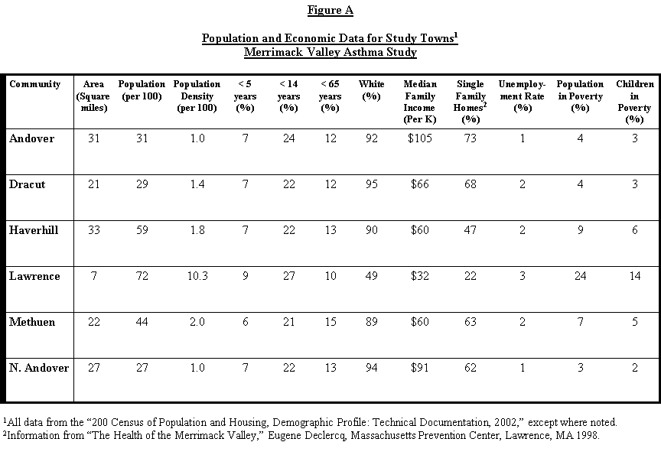

Figure B

1998 Hospitalization Rate for Asthma and Pneumonia in Study Towns¹
Merrimack Valley Asthma Study

Community | Asthma  Hospitalizations  1998  (per 100,000) | Pneumonia Hospitalizations  1998  (per 100,000)
Andover | 56 | 202
Dracut | 122 | 160
Haverhill | 257 | 254
Lawrence | 427 | 386
Methuen | 236 | 250
North Andover | 115 | 178
Massachusetts | 180 | 217

¹Source: “The Health of the Merrimack Valley”, Eugene Declercq, Massachusetts Prevention Center,
Lawrence, MA, 1998.
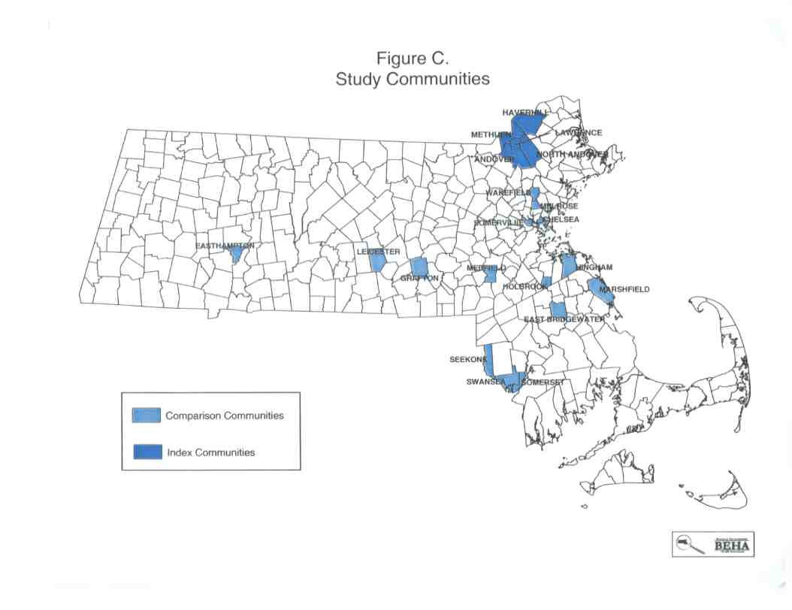

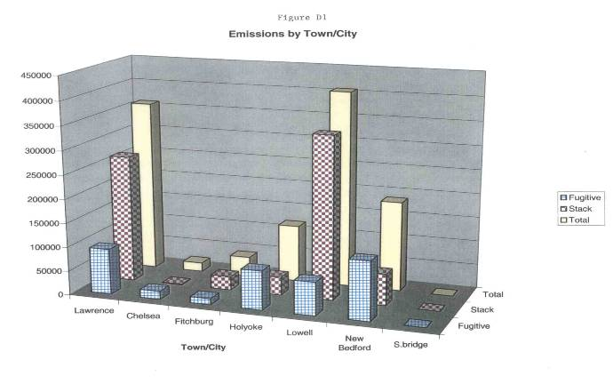

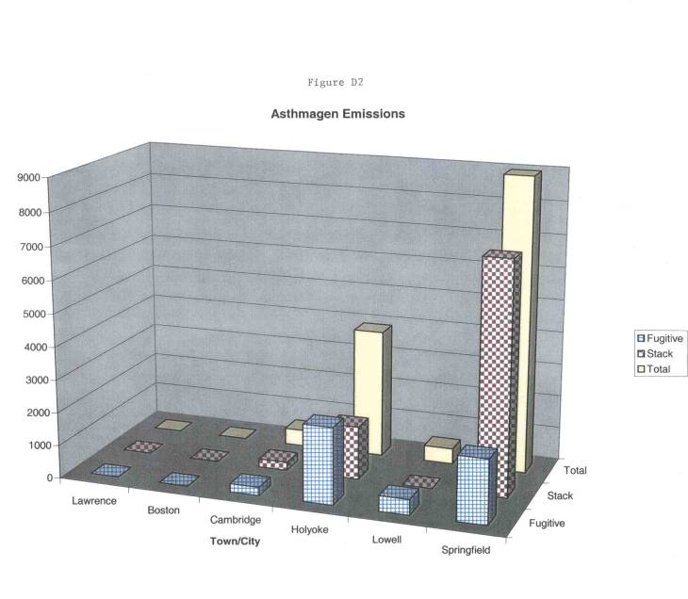
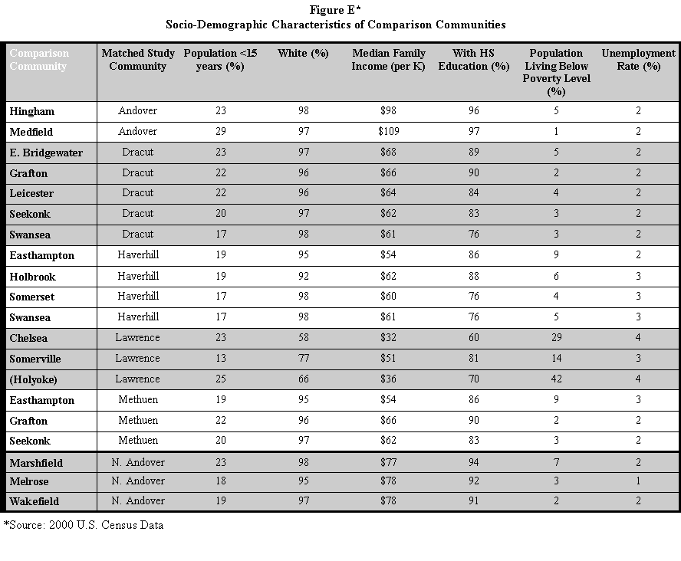

Figure F

Sources of VOC and PM-10 Emissions Considered
in Merrimack Valley Pediatric Asthma Study (MVPAS)
Massachusetts Department of Public Health
October 18, 2002

Name of Company | Town of Company
MA Refusetech | North Andover
Ogden Haverhill | Haverhill
Ogden Lawrence Incinerator | Lawrence
Ogden Lawrence Boiler | Lawrence
Newark Atlantic Paperboard | Lawrence
Lucent Technologies | North Andover
Lowell Cogen | Lowell
Baker Commodities | Tewksbury
Lowell General Hospital | Lowell
UMass South Campus | Lowell
Tewksbury Hospital | Tewksbury
Malden Mills | Lawrence
UMass North Campus | Lowell
Holy Family Hospital | Methuen
Merrimack Paper | Lawrence
L’Energia | Lowell
BNZ Materials | Billerica
Lawrence General Hospital | Lawrence
Merrimack Valley Industries | Lowell
Winstanley Enterprises Inc. | Lowell
Heffron Asphalt | Wilmington
Brox Industries | Dracut
Everett Mills | Lawrence
Brooks School | North Andover
Saint’s Medical Center | Lowell
Andrea Management Corporation | Lawrence
BFI Medical Waste Incinerator | Lawrence
Pacific Mills | Lawrence
Americraft Carton | Lowell
Haverhill Paperboard | Haverhill
Crown Cork & Seal | Lawrence
Ideal Tape Company | Lowell
Bradford Industries | Lowell
Hood Coatings | Georgetown
Vernon Plastics Inc. | Haverhill
Majilite Manufacturing | Lowell
Oak Finishers | Lowell
The Gillette Company | Andover
Raytheon Systems Company | Andover

Figure G

Facility Locations in the Merrimack Valley Study Region
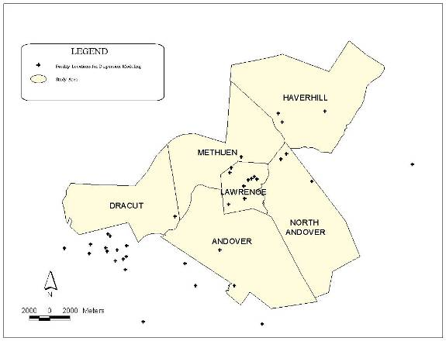

Figure H

Cumulative Average Annual PM₁₀ Concentration Isopleths, 1998-2001

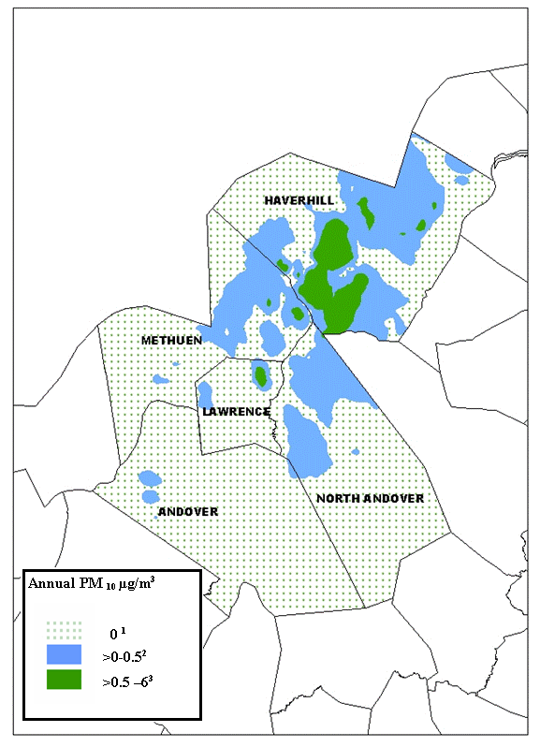
¹ asthma prevalence = 8.8%
² asthma prevalence = 8.6%
³ asthma prevalence = 8.3%
Figure I

Cumulative Average Spring PM₁₀ Concentration Isopleths, 1998-2001

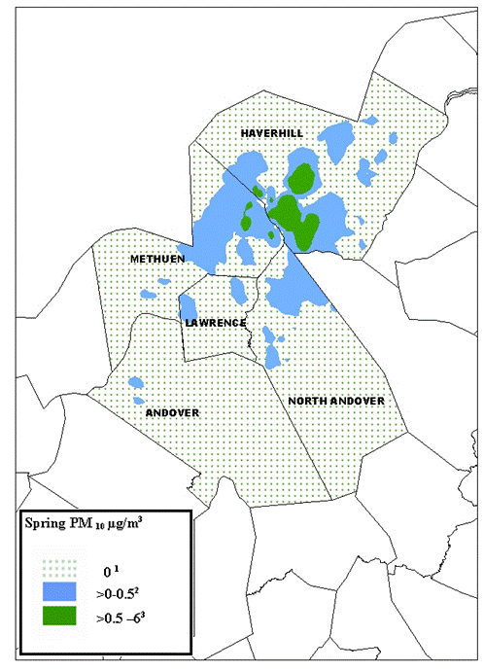

¹ asthma prevalence = 8.8%
² asthma prevalence = 8.7%
³ asthma prevalence = 8.5%
Figure J

Cumulative Average Summer PM₁₀ Concentration Isopleths, 1998-2001

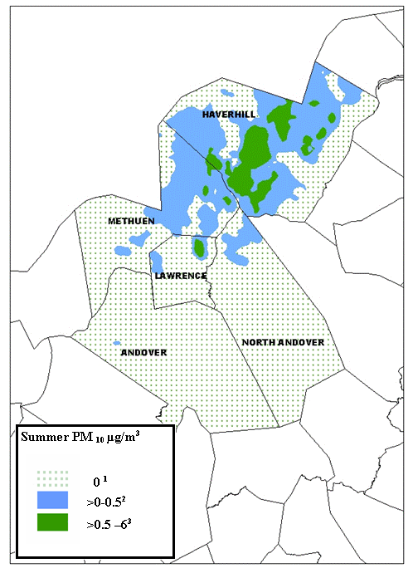

¹ asthma prevalence = 9.0%
² asthma prevalence = 8.1%
³ asthma prevalence = 8.8%
Figure K

Cumulative Average Fall PM₁₀ Concentration Isopleths, 1998-2001

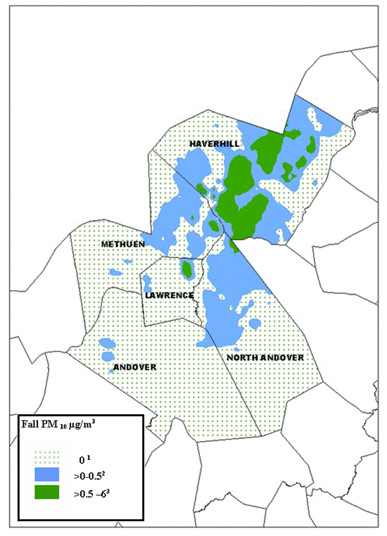

¹ asthma prevalence = 8.9%
² asthma prevalence = 8.5%
³ asthma prevalence = 8.6%
Figure L

Cumulative Average Winter PM₁₀ Concentration Isopleths, 1998-2001

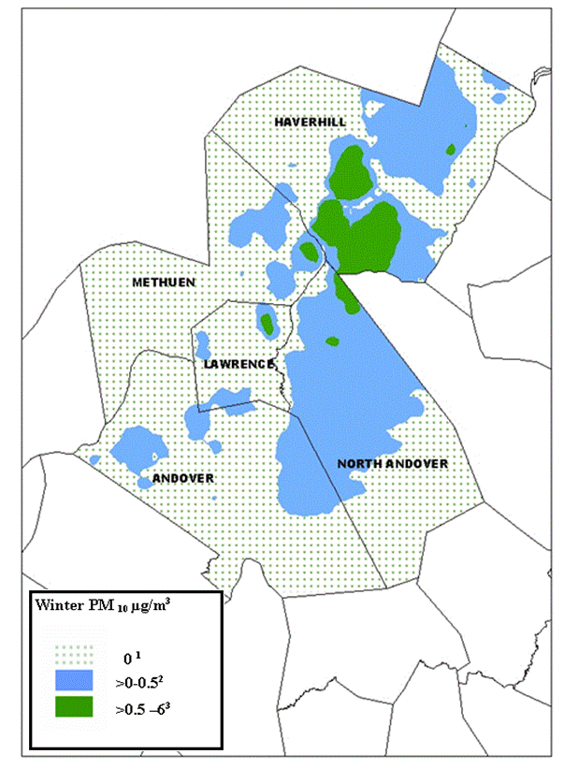

¹ asthma prevalence = 9.0%
² asthma prevalence = 8.5%
³ asthma prevalence = 7.6%
Figure M

Cumulative Average Annual VOC Concentration Isopleths, 1998-2001

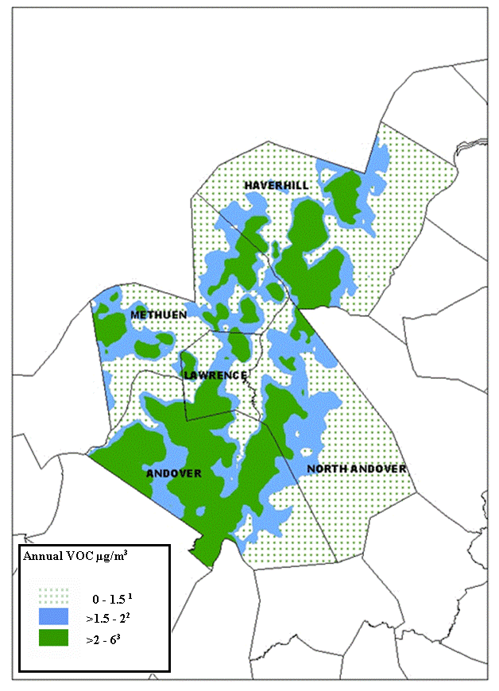

¹ asthma prevalence = 9.5%
² asthma prevalence = 8.1%
³ asthma prevalence = 8.4%
Figure N

Cumulative Average Spring VOC Concentration Isopleths, 1998-2001
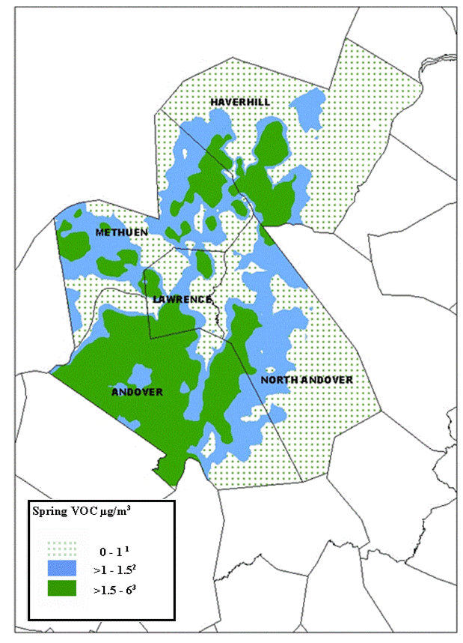

¹ asthma prevalence = 9.4%
² asthma prevalence = 8.3%
³ asthma prevalence = 8.2%

Figure O

Cumulative Average Summer VOC Concentration Isopleths, 1998-2001
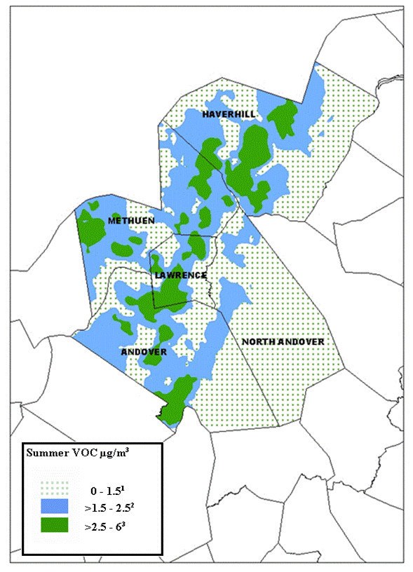

¹ asthma prevalence = 8.9%
² asthma prevalence = 8.5%
³ asthma prevalence = 9.3%
Figure P

Cumulative Average Fall VOC Concentration Isopleths, 1998-2001

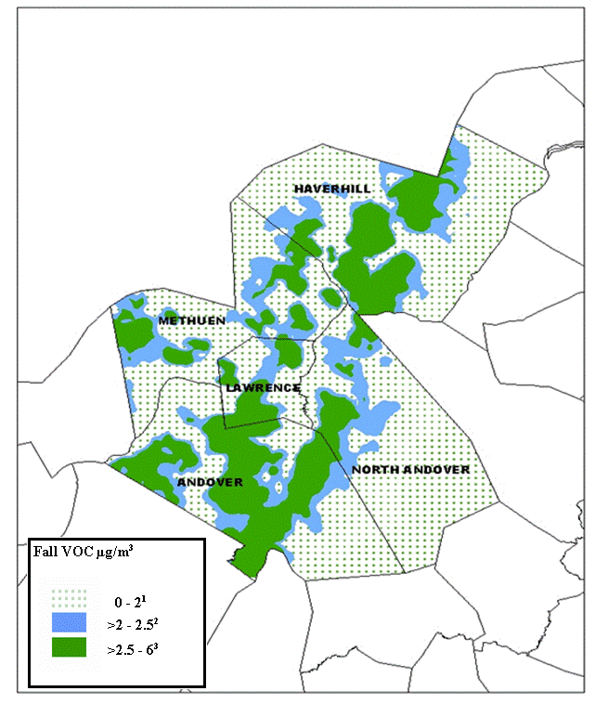

¹ asthma prevalence = 9.2%
² asthma prevalence = 8.1%
³ asthma prevalence = 8.6%
Figure Q

Cumulative Average Winter VOC Concentration Isopleths, 1998-2001

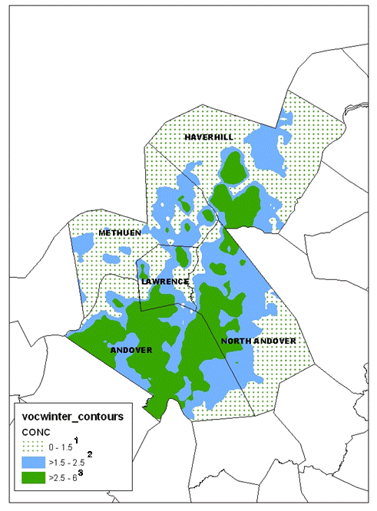

¹ asthma prevalence = 9.3%
² asthma prevalence = 8.8%
³ asthma prevalence = 7.9%
Table I A
Andover
Demographic Characteristics
Merrimack Valley Asthma Study
1999-2000

 | Asthma Cases  N | Total Students  N | Prevalence  (%) | 95%  Confidence Interval
TOTAL¹ | 334 | 5,130 | 6.5 | (5.8-7.2)
Gender²
Boys | 217 | 2,661 | 8.2 | (7.1-9.2)
Girls | 117 | 2,469 | 4.7 | (3.9-5.6)
Type²
Public | 296 | 4,219 | 7.0 | (6.2-7.8)
Private | 38 | 911 | 4.2 | (2.9-5.5)
Race²
White | 308 | 4,706 | 6.5 | (5.8-7.3)
Black | 5 | 44 | 11.4 | (2.0-20.7)
Asian | 13 | 287 | 4.5 | (2.1-6.9)
Native  American | 0 | 4 | -- | --
Hispanic | 8 | 93 | 8.6 | (2.9-14.3)
Unknown | -- | -- | -- | --
Grade²
Kindergarten | 20 | 513 | 3.9 | (2.2-5.6)
First | 27 | 561 | 4.8 | (3.0-6.6)
Second | 33 | 562 | 5.9 | (3.9-7.8)
Third | 21 | 576 | 3.6 | (2.1-5.2)
Fourth | 38 | 587 | 6.5 | (4.5-8.5)
Fifth | 35 | 598 | 5.9 | (4.0-7.7)
Sixth | 44 | 603 | 7.3 | (5.2-9.4)
Seventh | 55 | 569 | 9.7 | (7.2-12.1)
Eighth | 64 | 564 | 11.3 | (8.7-14.0)

¹Total prevalence based on gender
²Sums for gender, type, race, grade may not match due to reporting error

Table I B
Dracut
Demographic Characteristics
Merrimack Valley Asthma Study
1999-2000

 | Asthma Cases  N | Total Students  N | Prevalence  (%) | 95%  Confidence Interval
TOTAL¹ | 298 | 3054 | 9.8 | (8.7-10.8)
Gender²
Boys | 164 | 1,597 | 10.3 | (8.8-11.8)
Girls | 134 | 1,457 | 9.2 | (7.7-10.7)
Type²
Public | 298 | 3054 | 9.8 | (8.7-10.8)
Private | -- | -- | -- | --
Race²
White | 284 | 2887 | 9.8 | (8.8-10.9)
Black | 4 | 41 | -- | --
Asian | 5 | 85 | 5.9 | (0.9-10.9)
Native  American | 0 | 1 | -- | --
Hispanic | 4 | 34 | -- | --
Unknown | 5 | 6 | 83.3 | (53.5-113.2)
Grade²
Kindergarten | 18 | 278 | 6.5 | (3.6-9.4)
First | 31 | 380 | 8.2 | (5.4-10.9)
Second | 49 | 357 | 13.7 | (10.2-17.3)
Third | 34 | 373 | 9.1 | (6.2-12.0)
Fourth | 38 | 352 | 10.8 | (7.6-14.0)
Fifth | 51 | 354 | 14.4 | (10.7-18.1)
Sixth | 33 | 334 | 9.9 | (6.7-13.1)
Seventh | 23 | 323 | 7.1 | (4.3-9.9)
Eighth | 21 | 303 | 6.9 | (4.1-9.8)

¹Total prevalence based on gender
²Sums for gender, type, race, grade may not match due to reporting error

Table I C
Haverhill
Demographic Characteristics
Merrimack Valley Asthma Study
1999-2000

 | Asthma Cases  N | Total Students  N | Prevalence  (%) | 95%  Confidence Interval
TOTAL¹ | 654 | 7,399 | 8.8 | (8.2-9.5)
Gender²
Boys | 382 | 3,795 | 10.1 | (9.1-11.0)
Girls | 272 | 3,604 | 7.5 | (6.7-8.4)
Type²
Public | 611 | 6721 | 9.1 | (8.4-9.8)
Private | 43 | 678 | 6.3 | (4.5-8.2)
Race²
White | 538 | 5,793 | 9.3 | (8.5-10.0)
Black | 23 | 211 | 10.9 | (6.7-15.1)
Asian | 3 | 110 | -- | --
Native  American | 0 | 6 | -- | --
Hispanic | 84 | 950 | 8.8 | (7.0-10.6)
Unknown | 6 | 325 | 1.5 | (0.3-3.3)
Grade²
Kindergarten | 38 | 667 | 5.7 | (3.9-7.5)
First | 44 | 775 | 5.7 | (4.0-7.3)
Second | 54 | 757 | 7.1 | (5.3-9.0)
Third | 73 | 881 | 8.3 | (6.5-10.1)
Fourth | 88 | 821 | 10.7 | (8.6-12.8)
Fifth | 86 | 834 | 10.3 | (8.2-12.4)
Sixth | 69 | 762 | 9.1 | (7.0-11.1)
Seventh | 97 | 840 | 11.5 | (9.4-13.7)
Eighth | 75 | 779 | 9.6 | (7.6-11.7)

¹Total prevalence based on gender
²Sums for gender, type, race, grade may not match due to reporting error
Table I D
Lawrence
Demographic Characteristics
Merrimack Valley Asthma Study
1999-2000

 | Asthma Cases  N | Total Students  N | Prevalence  (%) | 95%  Confidence Interval
TOTAL¹ | 1,466 | 12,022 | 12.2 | (11.6-12.8)
Gender²
Boys | 875 | 6,193 | 14.1 | (13.3-15.0)
Girls | 591 | 5,829 | 10.1 | (9.4-10.9)
Type²
Public | 1,339 | 10,165 | 13.2 | (12.5-13.8)
Private | 127 | 1,857 | 6.8 | (5.7-8.0)
Race²
White | 207 | 2,168 | 9.5 | (8.3-10.8)
Black | 28 | 314 | 8.9 | (5.8-12.1)
Asian | 16 | 326 | 4.9 | (2.6-7.3)
Native  American | 0 | 1 | -- | --
Hispanic | 1,216 | 9,219 | 13.2 | (12.5-13.9)
Unknown | 0 | 17 | -- | --
Grade²
Kindergarten | 156 | 1,213 | 12.9 | (11.0-14.7)
First | 161 | 1,493 | 10.8 | (9.2-12.4)
Second | 192 | 1,459 | 13.2 | (11.4-14.9)
Third | 186 | 1,417 | 13.1 | (11.4-14.9)
Fourth | 183 | 1,435 | 12.8 | (11.0-14.5)
Fifth | 176 | 1,361 | 12.9 | (11.1-14.7)
Sixth | 148 | 1,203 | 12.3 | (10.4-14.2)
Seventh | 141 | 1,261 | 11.2 | (9.4-12.9)
Eighth | 129 | 1,195 | 10.8 | (9.0-12.6)

¹Total prevalence based on gender
²Sums for gender, type, race, grade may not match due to reporting error
Table I E
Methuen
Demographic Characteristics
Merrimack Valley Asthma Study
1999-2000

 | Asthma Cases  N | Total Students  N | Prevalence  (%) | 95%  Confidence Interval
TOTAL¹ | 435 | 5,961 | 7.3 | (6.6-8.0)
Gender²
Boys | 274 | 3,083 | 8.9 | (7.9-9.9)
Girls | 161 | 2,878 | 5.6 | (4.8-6.4)
Type²
Public | 393 | 5,100 | 7.7 | (7.0-8.4)
Private | 42 | 861 | 4.9 | (3.4-6.3)
Race²
White | 160 | 4,508 | 3.5 | (3.0-4.1)
Black | 3 | 60 | -- | --
Asian | 3 | 131 | -- | --
Native  American | 0 | 18 | -- | --
Hispanic | 50 | 733 | 6.8 | (5.0-8.6)
Unknown | 433 | 511 | 84.7 | (81.6-87.9)
Grade²
Kindergarten | 26 | 545 | 4.8 | (3.0-6.6)
First | 42 | 653 | 6.4 | (4.6-8.3)
Second | 35 | 637 | 5.5 | (3.7-7.3)
Third | 55 | 693 | 7.9 | (5.9-9.9)
Fourth | 52 | 679 | 7.7 | (5.7-9.7)
Fifth | 63 | 693 | 9.1 | (7.0-11.2)
Sixth | 53 | 700 | 7.6 | (5.6-9.5)
Seventh | 59 | 664 | 8.9 | (6.7-11.0)
Eighth | 50 | 664 | 7.5 | (5.5-9.5)

¹Total prevalence based on gender
²Sums for gender, type, race, grade may not match due to reporting error
Table I F
North Andover
Demographic Characteristics
Merrimack Valley Asthma Study
1999-2000

 | Asthma Cases  N | Total Students  N | Prevalence  (%) | 95%  Confidence Interval
TOTAL¹ | 285 | 3,518 | 8.1 | (7.2-9.0)
Gender²
Boys | 158 | 1,830 | 8.6 | (7.3-9.9)
Girls | 127 | 1,688 | 7.5 | (6.3-8.8)
Type²
Public | 262 | 3,139 | 8.3 | (7.4-9.3)
Private | 23 | 379 | 6.1 | (3.7-8.5)
Race²
White | 263 | 3,038 | 8.7 | (7.7-9.7)
Black | 3 | 31 | -- | --
Asian | 8 | 145 | 5.5 | (1.8-9.2)
Native  American | 0 | 0 | -- | --
Hispanic | 9 | 82 | 11.0 | (4.2-17.7)
Unknown | 2 | 222 | -- | --
Grade²
Kindergarten | 34 | 384 | 8.9 | (6.0-11.7)
First | 14 | 386 | 3.6 | (1.8-5.5)
Second | 27 | 407 | 6.6 | (4.2-9.1)
Third | 34 | 402 | 8.5 | (5.7-11.2)
Fourth | 41 | 414 | 9.9 | (7.0-12.8)
Fifth | 42 | 428 | 9.8 | (7.0-12.6)
Sixth | 25 | 381 | 6.6 | (4.1-9.0)
Seventh | 33 | 367 | 9.0 | (6.1-11.9)
Eighth | 37 | 344 | 10.8 | (7.5-14.0)

¹Total prevalence based on gender
²Sums for gender, type, race, grade may not match due to reporting error

Table II A
Chelsea
Demographic Characteristics
Merrimack Valley Asthma Study
1999-2000

 | Asthma Cases  N | Total Students  N | Prevalence  (%) | 95%  Confidence Interval
TOTAL¹ | 308 | 4,681 | 6.6 | (5.9-7.3)
Gender²
Boys | 169 | 2,436 | 6.9 | (5.9-7.9)
Girls | 139 | 2,245 | 6.2 | (5.2-7.2)
Type²
Public | 257 | 4,311 | 6.0 | (5.3-6.7)
Private | 51 | 370 | 13.8 | (10.3-17.3)
Race²
White | 54 | 883 | 6.1 | (4.5-7.7)
Black | 13 | 326 | 4.0 | (1.9-6.1)
Asian | 7 | 267 | 2.6 | (0.7-4.5)
Native  American | 0 | 15 | -- | --
Hispanic | 226 | 3,183 | 7.1 | (6.2-8.0)
Unknown | 8 | 7 | -- | --
Grade²
Kindergarten | 58 | 548 | 10.6 | (8.0-13.2)
First | 33 | 442 | 7.5 | (5.0-9.9)
Second | 29 | 567 | 5.1 | (3.3-6.9)
Third | 26 | 514 | 5.1 | (3.2-7.0)
Fourth | 20 | 548 | 3.6 | (2.1-5.2)
Fifth | 45 | 564 | 8.0 | (5.7-10.2)
Sixth | 48 | 540 | 8.9 | (6.5-11.3)
Seventh | 33 | 500 | 6.6 | (4.4-8.8)
Eighth | 16 | 449 | 3.6 | (1.8-5.3)

¹Total prevalence based on gender
²Sums for gender, type, race, grade may not match due to reporting error

Table II B
East Bridgewater
Demographic Characteristics
Merrimack Valley Asthma Study
1999-2000

 | Asthma Cases  N | Total Students  N | Prevalence  (%) | 95%  Confidence Interval
TOTAL¹ | 144 | 1761 | 8.2 | (6.9-9.5)
Gender²
Boys | 75 | 912 | 8.2 | (6.4-10.0)
Girls | 69 | 849 | 8.1 | (6.3-10.0)
Type²
Public | 144 | 1,761 | 8.2 | (6.9-9.5)
Private | 0 | 0 | -- | --
Race²
White | 140 | 1,710 | 8.2 | (6.9-9.5)
Black | 3 | 32 | -- | --
Asian | 1 | 9 | -- | --
Native  American | 0 | 1 | -- | --
Hispanic | 0 | 9 | -- | --
Unknown | 0 | 0 | -- | --
Grade²
Kindergarten | 14 | 179 | 7.8 | (3.9-11.8)
First | 21 | 203 | 10.3 | (6.2-14.5)
Second | 12 | 162 | 7.4 | (3.4-11.4)
Third | 19 | 189 | 10.1 | (5.8-14.3)
Fourth | 9 | 227 | 4.0 | (1.4-6.5)
Fifth | 20 | 208 | 9.6 | (5.6-13.6)
Sixth | 15 | 209 | 7.2 | (3.7-10.7)
Seventh | 22 | 194 | 11.3 | (6.9-15.8)
Eighth | 12 | 190 | 6.3 | (2.9-9.8)

¹Total prevalence based on gender
²Sums for gender, type, race, grade may not match due to reporting error

Table II C
East Hampton
Demographic Characteristics
Merrimack Valley Asthma Study
1999-2000

 | Asthma Cases  N | Total Students  N | Prevalence  (%) | 95%  Confidence Interval
TOTAL¹ | 75 | 1,667 | 4.5 | (3.5-5.5)
Gender²
Boys | 37 | 836 | 4.4 | (3.0-5.8)
Girls | 38 | 831 | 4.6 | (3.2-6.0)
Type²
Public | 50 | 1,283 | 3.9 | (2.8-5.0)
Private | 25 | 384 | 6.5 | (4.0-9.0)
Race²
White | 60 | 1,462 | 4.1 | (3.1-5.1)
Black | 3 | 26 | -- | --
Asian | 0 | 49 | -- | --
Native  American | 0 | 6 | -- | --
Hispanic | 4 | 33 | -- | --
Unknown | 8 | 91 | 8.7 | (2.9-14.6)
Grade²
Kindergarten | 3 | 147 | -- | --
First | 8 | 181 | 4.4 | (1.4-7.4)
Second | 10 | 170 | 5.9 | (2.4-9.4)
Third | 7 | 171 | 4.1 | (1.1-7.1)
Fourth | 11 | 192 | 5.7 | (2.4-9.0)
Fifth | 9 | 183 | 4.9 | (1.8-8.1)
Sixth | 10 | 201 | 5.0 | (2.0-8.0)
Seventh | 7 | 206 | 3.4 | (0.9-5.9)
Eighth | 10 | 217 | 4.6 | (1.8-7.4)

¹Total prevalence based on gender
²Sums for gender, type, race, grade may not match due to reporting error
Table IID
Grafton
Demographic Characteristics
Merrimack Valley Asthma Study
1999-2000

 | Asthma Cases  N | Total Students  N | Prevalence  (%) | 95%  Confidence Interval
TOTAL¹ | 138 | 1,793 | 7.7 | (6.5-8.9)
Gender²
Boys | 80 | 952 | 8.4 | (6.6-10.2)
Girls | 58 | 841 | 6.9 | (5.2-8.6)
Type²
Public | 134 | 1,661 | 8.1 | (6.8-9.4)
Private | 4 | 132 | -- | --
Race²
White | 85 | 764 | 11.1 | (8.9-13.4)
Black | 4 | 3 | -- | --
Asian | 1 | 11 | -- | --
Native  American | 0 | 5 | -- | --
Hispanic | 1 | 8 | -- | --
Unknown | 47 | 1,002 | 4.7 | (3.4-6.0)
Grade²
Kindergarten | 10 | 193 | 5.2 | (2.1-8.3)
First | 10 | 205 | 4.9 | (1.9-7.8)
Second | 15 | 232 | 6.5 | (3.3-9.6)
Third | 17 | 225 | 7.6 | (4.1-11.0)
Fourth | 25 | 228 | 11.0 | (6.9-15.0)
Fifth | 17 | 200 | 8.5 | (4.6-12.4)
Sixth | 16 | 222 | 7.2 | (3.8-10.6)
Seventh | 21 | 133 | 15.8 | (9.6-22.0)
Eighth | 7 | 156 | 4.5 | (1.2-7.7)

¹Total prevalence based on gender
²Sums for gender, type, race, grade may not match due to reporting error

Table II E
Hingham
Demographic Characteristics
Merrimack Valley Asthma Study
1999-2000

 | Asthma Cases  N | Total Students  N | Prevalence  (%) | 95%  Confidence Interval
TOTAL¹ | 258 | 3,090 | 8.3 | (7.4-9.3)
Gender²
Boys | 145 | 1,505 | 9.6 | (8.1-11.1)
Girls | 113 | 1,585 | 7.1 | (5.9-8.4)
Type²
Public | 225 | 2,509 | 9.0 | (7.8-10.1)
Private | 33 | 581 | 5.7 | (3.8-7.6)
Race²
White | 241 | 2,925 | 8.2 | (7.2-9.2)
Black | 9 | 45 | 20.0 | (8.3-31.7)
Asian | 5 | 76 | 6.6 | (1.0-12.2)
Native  American | 0 | 6 | -- | --
Hispanic | 1 | 36 | -- | --
Unknown | 2 | 2 | -- | --
Grade²
Kindergarten | 21 | 358 | 5.9 | (3.4-8.3)
First | 22 | 354 | 6.2 | (3.7-8.7)
Second | 26 | 341 | 7.6 | (4.8-10.4)
Third | 23 | 340 | 6.8 | (4.1-9.4)
Fourth | 37 | 348 | 10.6 | (7.4-13.9)
Fifth | 30 | 377 | 8.0 | (5.2-10.7)
Sixth | 39 | 357 | 10.9 | (7.7-14.2)
Seventh | 38 | 357 | 10.6 | (7.4-13.8)
Eighth | 22 | 318 | 6.9 | (4.1-9.7)

¹Total prevalence based on gender
²Sums for gender, type, race, grade may not match due to reporting error

Table II F
Holbrook
Demographic Characteristics
Merrimack Valley Asthma Study
1999-2000

 | Asthma Cases  N | Total Students  N | Prevalence  (%) | 95%  Confidence Interval
TOTAL¹ | 129 | 1,339 | 9.6 | (8.1-11.2)
Gender²
Boys | 81 | 700 | 11.6 | (9.2-13.9)
Girls | 48 | 639 | 7.5 | (5.5-9.6)
Type²
Public | 121 | 1,074 | 11.3 | (9.4-13.2)
Private | 8 | 265 | 3.0 | (1.0-5.1)
Race²
White | 7 | 27 | 25.9 | (9.4-42.5)
Black | 0 | 11 | -- | --
Asian | 0 | 3 | -- | --
Native  American | 0 | 0 | -- | --
Hispanic | 1 | 18 | -- | --
Unknown | 121 | 1,280 | 9.5 | (7.9-12.1)
Grade²
Kindergarten | 11 | 109 | 10.1 | (4.4-15.7)
First | 10 | 148 | 6.8 | (2.7-10.8)
Second | 12 | 152 | 7.9 | (3.6-12.2)
Third | 20 | 135 | 14.8 | (8.8-20.8)
Fourth | 16 | 173 | 9.2 | (4.9-13.6)
Fifth | 10 | 161 | 6.2 | (2.5-9.9)
Sixth | 19 | 155 | 12.3 | (7.1-17.4)
Seventh | 14 | 149 | 9.4 | (4.7-14.1)
Eighth | 17 | 166 | 10.2 | (5.6-14.9)

¹Total prevalence based on gender
²Sums for gender, type, race, grade may not match due to reporting error

Table II G
Holyoke
Demographic Characteristics
Merrimack Valley Asthma Study
1999-2000

 | Asthma Cases  N | Total Students  N | Prevalence  (%) | 95%  Confidence Interval
TOTAL¹ | 465 | 5,832 | 8.0 | (7.3-8.7)
Gender²
Boys | 251 | 2,961 | 8.5 | (7.5-9.5)
Girls | 214 | 2,871 | 7.5 | (6.5-8.4)
Type²
Public | 411 | 5,030 | 8.2 | (7.4-8.9)
Private | 54 | 802 | 6.7 | (5.0-8.5)
Race²
White | 91 | 1,402 | 6.5 | (5.2-7.8)
Black | 8 | 155 | 5.2 | (1.7-8.6)
Asian | 0 | 42 | -- | --
Native  American | 0 | 1 | -- | --
Hispanic | 286 | 3,433 | 8.3 | (7.4-9.3)
Unknown | 80 | 799 | 10.0 | (7.9-12.1)
Grade²
Kindergarten | 57 | 644 | 8.9 | (6.7-11.0)
First | 72 | 691 | 10.4 | (8.1-12.7)
Second | 62 | 655 | 9.5 | (7.2-11.7)
Third | 51 | 622 | 8.2 | (6.0-10.4)
Fourth | 51 | 681 | 7.5 | (5.5-9.5)
Fifth | 40 | 619 | 6.5 | (4.5-8.4)
Sixth | 47 | 653 | 7.2 | (5.2-9.2)
Seventh | 56 | 657 | 8.5 | (6.4-10.7)
Eighth | 43 | 585 | 7.4 | (5.2-9.5)

¹Total prevalence based on gender
²Sums for gender, type, race, grade may not match due to reporting error

Table II H
Leicester
Demographic Characteristics
Merrimack Valley Asthma Study
1999-2000

 | Asthma Cases  N | Total Students  N | Prevalence  (%) | 95%  Confidence Interval
TOTAL¹ | 137 | 1,322 | 10.4 | (8.7-12.0)
Gender²
Boys | 80 | 676 | 11.8 | (9.4-14.3)
Girls | 57 | 646 | 8.8 | (6.6-11.0)
Type²
Public | 137 | 1,322 | 10.4 | (8.7-12.0)
Private | 0 | 0 | -- | --
Race²
White | 52 | 402 | 12.9 | (9.7-16.2)
Black | 5 | 6 | 83.3 | (53.5-113.2)
Asian | 16 | 326 | 4.9 | (2.6-7.3)
Native  American | 0 | 1 | -- | --
Hispanic | 0 | 0 | -- | --
Unknown | 137 | 587 | 27.0 | (23.2-30.9)
Grade²
Kindergarten | 18 | 126 | 14.3 | (8.2-20.4)
First | 20 | 145 | 13.8 | (8.2-19.4)
Second | 19 | 146 | 13.0 | (7.5-18.4)
Third | 16 | 144 | 11.1 | (6.0-16.2)
Fourth | 8 | 145 | 5.5 | (1.8-9.2)
Fifth | 12 | 163 | 7.4 | (3.4-11.4)
Sixth | 13 | 165 | 7.9 | (3.8-12.0)
Seventh | 18 | 130 | 13.8 | (7.9-19.8)
Eighth | 13 | 158 | 8.2 | (3.9-12.5)

¹Total prevalence based on gender
²Sums for gender, type, race, grade may not match due to reporting error

Table II I
Marshfield
Demographic Characteristics
Merrimack Valley Asthma Study 1999-2000

 | Asthma Cases  N | Total Students  N | Prevalence  (%) | 95%  Confidence Interval
TOTAL¹ | 215 | 3,207 | 6.7 | (5.8-7.6)
Gender²
Boys | 135 | 1,687 | 8.0 | (6.7-9.3)
Girls | 80 | 1,520 | 5.3 | (4.1-6.4)
Type²
Public | 215 | 3,207 | 6.7 | (5.8-7.6)
Private | 0 | 0 | -- | --
Race²
White | 208 | 3,115 | 6.7 | (5.8-7.6)
Black | 2 | 21 | -- | --
Asian | 1 | 30 | -- | --
Native  American | 0 | 9 | -- | --
Hispanic | 4 | 31 | -- | --
Unknown | 0 | 1 | -- | --
Grade²
Kindergarten | 13 | 347 | 3.7 | (1.7-5.7)
First | 21 | 384 | 5.5 | (3.2-7.7)
Second | 15 | 340 | 4.4 | (2.2-6.6)
Third | 27 | 382 | 7.1 | (4.5-9.6)
Fourth | 30 | 345 | 8.7 | (5.7-11.7)
Fifth | 20 | 339 | 5.9 | (3.4-8.4)
Sixth | 31 | 359 | 8.6 | (5.7-11.5)
Seventh | 24 | 356 | 6.7 | (4.1-9.3)
Eighth | 34 | 355 | 9.6 | (6.5-12.6)

¹Total prevalence based on gender
²Sums for gender, type, race, grade may not match due to reporting error

Table II J
Medfield
Demographic Characteristics
Merrimack Valley Asthma Study
1999-2000

 | Asthma Cases  N | Total Students  N | Prevalence  (%) | 95%  Confidence Interval
TOTAL¹ | 150 | 2,173 | 6.9 | (5.8-8.0)
Gender²
Boys | 78 | 1,131 | 6.9 | (5.4-8.4)
Girls | 72 | 1,042 | 6.9 | (5.4-8.4)
Type²
Public | 150 | 2,173 | 6.9 | (5.8-8.0)
Private | 0 | 0 | -- | --
Race²
White | 148 | 2,114 | 7.0 | (5.9-8.1)
Black | 0 | 11 | -- | --
Asian | 0 | 36 | -- | --
Native  American | 0 | 2 | -- | --
Hispanic | 1 | 9 | -- | --
Unknown | 1 | 1 | -- | --
Grade²
Kindergarten | 4 | 235 | -- | --
First | 11 | 231 | 4.8 | (2.0-7.5)
Second | 12 | 257 | 4.7 | (2.1-7.3)
Third | 15 | 229 | 6.6 | (3.3-9.8)
Fourth | 17 | 245 | 6.9 | (3.8-10.1)
Fifth | 12 | 256 | 4.7 | (2.1-7.3)
Sixth | 27 | 268 | 10.1 | (6.5-13.7)
Seventh | 21 | 204 | 10.3 | (6.1-14.5)
Eighth | 31 | 248 | 12.5 | (8.4-16.6)

¹Total prevalence based on gender
²Sums for gender, type, race, grade may not match due to reporting error

Table II K
Melrose
Demographic Characteristics
Merrimack Valley Asthma Study
1999-2000

 | Asthma Cases  N | Total Students  N | Prevalence  (%) | 95%  Confidence Interval
TOTAL¹ | 230 | 2,896 | 7.9 | (7.0-8.9)
Gender²
Boys | 142 | 1,464 | 9.7 | (8.2-11.2)
Girls | 88 | 1,432 | 6.1 | (4.9-7.4)
Type²
Public | 220 | 2,507 | 8.8 | (7.7-9.9)
Private | 10 | 389 | 2.6 | (1.0-4.1)
Race²
White | 207 | 2,683 | 7.7 | (6.7-8.7)
Black | 16 | 119 | 13.4 | (7.3-19.6)
Asian | 6 | 55 | 10.9 | (2.7-19.1)
Native  American | 0 | 0 | -- | --
Hispanic | 1 | 31 | -- | --
Unknown | 0 | 8 | -- | --
Grade²
Kindergarten | 24 | 331 | 7.3 | (4.5-10.0)
First | 34 | 335 | 10.1 | (6.9-13.4)
Second | 21 | 302 | 6.9 | (4.1-9.8)
Third | 32 | 345 | 9.3 | (6.2-12.3)
Fourth | 29 | 301 | 9.6 | (6.3-13.0)
Fifth | 27 | 328 | 8.2 | (5.3-11.2)
Sixth | 22 | 247 | 8.9 | (5.4-12.5)
Seventh | 18 | 346 | 5.2 | (2.9-7.5)
Eighth | 16 | 305 | 5.2 | (2.7-7.7)

¹Total prevalence based on gender
²Sums for gender, type, race, grade may not match due to reporting error

Table II L
Seekonk
Demographic Characteristics
Merrimack Valley Asthma Study
1999-2000

 | Asthma Cases  N | Total Students  N | Prevalence  (%) | 95%  Confidence Interval
TOTAL¹ | 136 | 1,712 | 7.9 | (6.7-9.2)
Gender²
Boys | 87 | 873 | 10.0 | (8.0-12.0)
Girls | 49 | 839 | 5.8 | (4.3-7.4)
Type²
Public | 130 | 1,630 | 8.0 | (6.7-9.3)
Private | 6 | 82 | 7.3 | (1.7-13.0)
Race²
White | 132 | 1,602 | 8.2 | (6.9-9.6)
Black | 3 | 17 | -- | --
Asian | 0 | 12 | -- | --
Native  American | 0 | 10 | -- | --
Hispanic | 1 | 5 | -- | --
Unknown | 0 | 66 | -- | --
Grade²
Kindergarten | 13 | 157 | 8.3 | (4.0-12.6)
First | 11 | 171 | 6.4 | (2.8-10.1)
Second | 12 | 163 | 7.4 | (3.4-11.4)
Third | 16 | 169 | 9.5 | (5.1-13.9)
Fourth | 22 | 184 | 12.0 | (7.3-16.6)
Fifth | 14 | 211 | 6.6 | (3.3-10.0)
Sixth | 19 | 212 | 9.0 | (5.1-12.8)
Seventh | 20 | 226 | 8.8 | (5.1-12.6)
Eighth | 9 | 211 | 4.3 | (1.5-7.0)

¹Total prevalence based on gender
²Sums for gender, type, race, grade may not match due to reporting error

Table II M
Somerset
Demographic Characteristics
Merrimack Valley Asthma Study
1999-2000

 | Asthma Cases  N | Total Students  N | Prevalence  (%) | 95%  Confidence Interval
TOTAL¹ | 121 | 1,798 | 6.7 | (5.6-7.9)
Gender²
Boys | 71 | 930 | 7.6 | (5.9-9.3)
Girls | 50 | 868 | 5.8 | (4.2-7.3)
Type²
Public | 121 | 1,798 | 6.7 | (5.6-7.9)
Private | 0 | 0 | -- | --
Race²
White | 113 | 1,784 | 6.3 | (5.2-7.5)
Black | 0 | 5 | -- | --
Asian | 0 | 6 | -- | --
Native  American | 0 | 1 | -- | --
Hispanic | 0 | 2 | -- | --
Unknown | 8 | 0 | -- | --
Grade²
Kindergarten | 13 | 163 | 8.0 | (3.8-12.1)
First | 13 | 169 | 7.7 | (3.7-11.7)
Second | 12 | 155 | 7.7 | (3.5-11.9)
Third | 15 | 182 | 8.2 | (4.2-12.2)
Fourth | 17 | 232 | 7.3 | (4.0-10.7)
Fifth | 13 | 213 | 6.1 | (2.9-9.3)
Sixth | 8 | 226 | 3.5 | (1.1-5.9)
Seventh | 19 | 248 | 7.7 | (4.4-11.0)
Eighth | 11 | 210 | 5.2 | (2.2-8.3)

¹Total prevalence based on gender
²Sums for gender, type, race, grade may not match due to reporting error

Table II N
Somerville
Demographic Characteristics
Merrimack Valley Asthma Study
1999-2000

 | Asthma Cases  N | Total Students  N | Prevalence  (%) | 95%  Confidence Interval
TOTAL¹ | 287 | 5,548 | 5.2 | (4.6-5.8)
Gender²
Boys | 153 | 2,825 | 5.4 | (4.6-6.3)
Girls | 134 | 2,723 | 4.9 | (4.1-5.7)
Type²
Public | 257 | 4,772 | 5.4 | (4.7-6.0)
Private | 30 | 776 | 3.9 | (2.5-5.2)
Race²
White | 129 | 2,627 | 4.9 | (4.1-5.7)
Black | 32 | 624 | 5.1 | (3.4-6.9)
Asian | 5 | 285 | 1.8 | (0.2-3.3)
Native  American | 0 | 8 | -- | --
Hispanic | 58 | 1,326 | 4.4 | (3.3-5.5)
Unknown | 63 | 678 | 9.3 | (7.1-11.5)
Grade²
Kindergarten | 26 | 621 | 4.2 | (2.6-5.8)
First | 41 | 696 | 5.9 | (4.1-7.6)
Second | 32 | 638 | 5.0 | (3.3-6.7)
Third | 38 | 592 | 6.4 | (4.4-8.4)
Fourth | 47 | 602 | 7.8 | (5.7-10.0)
Fifth | 28 | 618 | 4.5 | (2.9-6.2)
Sixth | 23 | 557 | 4.1 | (2.5-5.8)
Seventh | 22 | 607 | 3.6 | (2.1-5.1)
Eighth | 30 | 584 | 5.1 | (3.3-6.9)

¹Total prevalence based on gender
²Sums for gender, type, race, grade may not match due to reporting error

Table II O
Swansea
Demographic Characteristics
Merrimack Valley Asthma Study
1999-2000

 | Asthma Cases  N | Total Students  N | Prevalence  (%) | 95%  Confidence Interval
TOTAL¹ | 246 | 1,747 | 14.1 | (12.5-15.7)
Gender²
Boys | 145 | 939 | 15.4 | (13.1-17.8)
Girls | 101 | 808 | 12.5 | (10.2-14.8)
Type²
Public | 224 | 1,599 | 14.0 | (12.3-15.7)
Private | 22 | 148 | 14.9 | (9.1-20.6)
Race²
White | 125 | 884 | 14.1 | (11.8-16.4)
Black | 1 | 19 | -- | --
Asian | 1 | 7 | -- | --
Native  American | 0 | 0 | -- | --
Hispanic | 0 | 3 | -- | --
Unknown | 119 | 834 | 14.2 | (11.8-16.5)
Grade²
Kindergarten | 18 | 187 | 9.6 | (5.4-13.9)
First | 19 | 194 | 9.8 | (5.6-14.0)
Second | 24 | 169 | 14.2 | (8.9-19.5)
Third | 27 | 192 | 14.1 | (9.1-19.0)
Fourth | 32 | 174 | 18.4 | (12.6-24.1)
Fifth | 26 | 192 | 13.5 | (8.7-18.4)
Sixth | 32 | 216 | 14.8 | (10.1-19.6)
Seventh | 33 | 190 | 17.4 | (12.0-22.8)
Eighth | 33 | 216 | 15.3 | (10.5-20.1)

¹Total prevalence based on gender
²Sums for gender, type, race, grade may not match due to reporting error

Table II P
Wakefield
Demographic Characteristics
Merrimack Valley Asthma Study
1999-2000

 | Asthma Cases  N | Total Students  N | Prevalence  (%) | 95%  Confidence Interval
TOTAL¹ | 303 | 2,694 | 11.2 | (10.1-12.4)
Gender²
Boys | 171 | 1,360 | 12.6 | (10.8-14.3)
Girls | 132 | 1,334 | 9.9 | (8.3-11.5)
Type²
Public | 292 | 2,453 | 11.9 | (10.6-13.2)
Private | 11 | 241 | 4.6 | (1.9-7.2)
Race²
White | 291 | 2,578 | 11.3 | (10.1-12.5)
Black | 7 | 36 | 19.4 | (6.5-32.4)
Asian | 3 | 33 | -- | --
Native  American | 1 | 1 | -- | --
Hispanic | 1 | 13 | -- | --
Unknown | 0 | 33 | -- | --
Grade²
Kindergarten | 12 | 284 | 4.2 | (1.9-6.6)
First | 28 | 317 | 8.8 | (5.7-12.0)
Second | 25 | 284 | 8.8 | (5.5-12.1)
Third | 24 | 279 | 8.6 | (5.3-11.9)
Fourth | 33 | 304 | 10.9 | (7.4-14.4)
Fifth | 43 | 316 | 13.6 | (9.8-17.4)
Sixth | 47 | 310 | 15.2 | (11.2-19.2)
Seventh | 37 | 280 | 13.2 | (9.2-17.2)
Eighth | 54 | 319 | 16.9 | (12.8-21.0)

¹Total prevalence based on gender
²Sums for gender, type, race, grade may not match due to reporting error

Table III A
Andover Comparison Population¹
Merrimack Valley Asthma Study
1999-2000

 | Asthma Cases  N | Total Students  N | Prevalence  (%) | 95%  Confidence Interval
TOTAL² | 408 | 5,263 | 7.8 | (7.0-8.5)
Gender³
Boys | 223 | 2,636 | 8.5 | (7.4-9.5)
Girls | 185 | 2,627 | 7.0 | (6.1-8.0)
Type³
Public | 375 | 4,682 | 8.0 | (7.2-8.8)
Private | 33 | 581 | 5.7 | (3.8-7.6)
Race³
White | 389 | 5,039 | 7.7 | (7.0-8.5)
Black | 9 | 56 | 16.1 | (6.5-25.7)
Asian | 5 | 112 | 4.5 | (0.6-8.3)
Native  American | 0 | 0 | -- | --
Hispanic | 2 | 45 | -- | --
Unknown | 3 | 11 | -- | --
Grade³
Kindergarten | 25 | 593 | 4.2 | (2.6-5.8)
First | 33 | 585 | 5.6 | (3.8-7.5)
Second | 38 | 598 | 6.4 | (4.4-8.4)
Third | 38 | 569 | 6.7 | (4.6-8.7)
Fourth | 54 | 593 | 9.1 | (6.8-11.4)
Fifth | 42 | 633 | 6.6 | (4.7-8.6)
Sixth | 66 | 625 | 10.6 | (8.2-13.0)
Seventh | 59 | 561 | 10.5 | (8.0-13.1)
Eighth | 53 | 566 | 9.4 | (7.0-11.8)

¹Hingham, Medfield
²Total prevalence based on gender
³Sums for gender, type, race, grade may not match due to reporting error

Table III B
Dracut Comparison Population¹
Merrimack Valley Asthma Study
1999-2000

 | Asthma Cases  N | Total Students  N | Prevalence  (%) | 95%  Confidence Interval
TOTAL² | 801 | 8,335 | 9.6 | (9.0-10.2)
Gender³
Boys | 467 | 4,352 | 10.7 | (9.8-11.7)
Girls | 334 | 3,983 | 8.4 | (7.5-9.2)
Type³
Public | 769 | 7,973 | 9.6 | (9.0-10.3)
Private | 32 | 362 | 8.8 | (5.9-11.8)
Race³
White | 534 | 5,362 | 10.0 | (9.2-10.8)
Black | 16 | 77 | 20.8 | (11.7-29.8)
Asian | 3 | 46 | -- | --
Native  American | 0 | 16 | -- | --
Hispanic | 2 | 27 | -- | --
Unknown | 246 | 2,807 | 8.8 | (7.7-9.1)
Grade³
Kindergarten | 73 | 842 | 8.7 | (6.8-10.6)
First | 81 | 918 | 8.8 | (7.0-10.7)
Second | 82 | 872 | 9.4 | (7.5-11.3)
Third | 95 | 919 | 10.3 | (8.4-12.3)
Fourth | 96 | 958 | 10.0 | (8.1-11.9)
Fifth | 89 | 974 | 9.1 | (7.3-10.9)
Sixth | 95 | 1,024 | 9.3 | (7.5-11.1)
Seventh | 114 | 873 | 13.1 | (10.8-15.3)
Eighth | 74 | 931 | 7.0 | (6.2-9.7)

¹East Bridgewater, Grafton, Leicester, Seekonk, Swansea
²Total prevalence based on gender
³Sums for gender, type, race, grade may not match due to reporting error

Table III C
Haverhill Comparison Population¹
Merrimack Valley Asthma Study
1999-2000

 | Asthma Cases  N | Total Students  N | Prevalence  (%) | 95%  Confidence Interval
TOTAL² | 709 | 8,344 | 8.5 | (7.9-9.1)
Gender³
Boys | 414 | 4,357 | 9.5 | (8.6-1.4)
Girls | 295 | 3,987 | 7.4 | (6.6-8.2)
Type³
Public | 650 | 7,415 | 8.8 | (8.1-9.4)
Private | 59 | 929 | 6.4 | (4.8-7.9)
Race³
White | 390 | 4,921 | 7.9 | (7.2-8.7)
Black | 8 | 64 | 12.5 | (4.4-20.6)
Asian | 2 | 76 | -- | --
Native  American | 0 | 12 | -- | --
Hispanic | 6 | 64 | 9.4 | (2.2-16.5)
Unknown | 303 | 3,207 | 10.0 | (8.9-11.1)
Grade³
Kindergarten | 55 | 799 | 6.9 | (5.1-8.6)
First | 60 | 897 | 6.7 | (5.1-8.3)
Second | 73 | 878 | 8.3 | (6.4-10.1)
Third | 86 | 905 | 9.5 | (7.6-11.4)
Fourth | 101 | 999 | 10.1 | (8.2-12.0)
Fifth | 75 | 949 | 7.9 | (6.2-9.6)
Sixth | 85 | 1,020 | 8.3 | (6.6-10.0)
Seventh | 94 | 926 | 10.2 | (8.2-12.1)
Eighth | 78 | 965 | 8.1 | (6.4-9.8)

¹Easthampton, Grafton, Holbrook, Somerset, Swansea
²Total prevalence based on gender
³Sums for gender, type, race, grade may not match due to reporting error

Table III D
Lawrence Comparison Population¹
Merrimack Valley Asthma Study
1999-2000

 | Asthma Cases  N | Total Students  N | Prevalence  (%) | 95%  Confidence Interval
TOTAL² | 595 | 10,229 | 5.8 | (5.4-6.3)
Gender³
Boys | 322 | 5,261 | 6.1 | (5.5-6.8)
Girls | 273 | 4,968 | 5.5 | (4.9-6.1)
Type³
Public | 513 | 9,083 | 5.7 | (5.2-6.1)
Private | 81 | 1,146 | 7.1 | (5.6-8.6)
Race³
White | 183 | 3,510 | 5.2 | (4.5-5.9)
Black | 45 | 950 | 4.7 | (3.4-6.1)
Asian | 12 | 552 | 2.2 | (1.0-3.4)
Native  American | 0 | 23 | -- | --
Hispanic | 284 | 4,509 | 6.3 | (5.6-7.0)
Unknown | 71 | 685 | 10.4 | (8.1-12.6)
Grade³
Kindergarten | 84 | 1,169 | 7.2 | (5.7-8.7)
First | 74 | 1,138 | 6.5 | (5.1-7.9)
Second | 61 | 1,205 | 5.0 | (3.8-6.3)
Third | 64 | 1,106 | 5.8 | (4.4-7.2)
Fourth | 67 | 1,150 | 5.8 | (4.5-7.2)
Fifth | 73 | 1,182 | 6.2 | (4.8-7.5)
Sixth | 71 | 1,097 | 6.5 | (5.0-7.9)
Seventh | 55 | 1,107 | 5.0 | (3.7-6.2)
Eighth | 46 | 1,033 | 4.5 | (3.2-5.7)

¹Somerville, Chelsea
²Total prevalence based on gender
³Sums for gender, type, race, grade may not match due to reporting error

Table III E
Methuen Comparison Population¹
Merrimack Valley Asthma Study
1999-2000

 | Asthma Cases  N | Total Students  N | Prevalence  (%) | 95%  Confidence Interval
TOTAL² | 349 | 5,172 | 6.7¹ | (6.1-7.4)
Gender³
Boys | 204 | 2,661 | 7.7 | (6.7-8.7)
Girls | 145 | 2,511 | 5.8 | (4.9-6.7)
Type³
Public | 314 | 4,574 | 6.9 | (6.1-7.6)
Private | 35 | 598 | 5.9 | (4.0-7.7)
Race³
White | 277 | 3,828 | 7.2 | (6.4-8.1)
Black | 10 | 46 | 21.7 | (9.8-33.7)
Asian | 1 | 72 | -- | --
Native  American | 0 | 21 | -- | --
Hispanic | 6 | 46 | 13.0 | (3.3-22.8)
Unknown | 55 | 1,159 | 4.8 | (3.5-6.0)
Grade³
Kindergarten | 26 | 497 | 5.2 | (3.3-7.2))
First | 29 | 557 | 5.2 | (3.4-7.1)
Second | 37 | 565 | 6.5 | (4.5-8.5)
Third | 40 | 565 | 7.1 | (5.0-9.2)
Fourth | 58 | 604 | 9.6 | (7.3-12)
Fifth | 40 | 594 | 6.7 | (4.7-8.7
Sixth | 45 | 635 | 7.1 | (5.1-9.1)
Seventh | 48 | 565 | 8.5 | (6.2-10.8)
Eighth | 26 | 584 | 4.5 | (2.8-6.1)

¹Easthampton, Grafton, Seekonk
²Total prevalence based on gender
³Sums for gender, type, race, grade may not match due to reporting error

Table III F
North Andover Comparison Population¹
Merrimack Valley Asthma Study
1999-2000

 | Asthma Cases  N | Total Students  N | Prevalence  (%) | 95%  Confidence Interval
TOTAL² | 748 | 8,797 | 8.5 | (7.9-9.1)
Gender³
Boys | 448 | 4,511 | 9.9 | (9.1-10.8)
Girls | 300 | 4,286 | 7.0 | (6.2-7.8)
Type³
Public | 727 | 8,167 | 8.9 | (8.3-9.5)
Private | 21 | 630 | 3.3 | (1.9-4.7)
Race³
White | 706 | 8,376 | 8.4 | (7.8-9.0)
Black | 25 | 176 | 14.2 | (9.0-19.4)
Asian | 10 | 118 | 8.5 | (3.4-13.5)
Native  American | 1 | 10 | -- | --
Hispanic | 6 | 75 | 8.0 | (1.9-1.4)
Unknown | 0 | 42 | -- | --
Grade³
Kindergarten | 49 | 962 | 5.1 | (3.7-6.5)
First | 83 | 1,036 | 8.0 | (6.4-9.7)
Second | 61 | 926 | 6.6 | (5.0-8.2)
Third | 83 | 1,006 | 8.3 | (6.6-10.0)
Fourth | 92 | 950 | 9.7 | (7.8-11.6)
Fifth | 90 | 983 | 9.2 | (7.4-11.0)
Sixth | 100 | 916 | 10.9 | (8.9-12.9)
Seventh | 79 | 982 | 8.0 | (6.3-9.7
Eighth | 104 | 979 | 10.6 | (8.7-12.6)

¹Marshfield, Melrose, Wakefield
²Total prevalence based on gender
³Sums for gender, type, race, grade may not match due to reporting error
Table IV A
Overall Prevalence Comparisons by Demographic Characteristics
Andover Versus Its Comparison Population¹
Merrimack Valley Asthma Study
1999-2000

 | Andover |  |  |  | Andover Comparison Population
 | Asthma Cases | Total Students  N | Prevalence  N | 95%  Confidence Interval | Asthma Cases | Total  Students  N | Prevalence  (%) | 95%  Confidence Interval
Gender
Boys | 217 | 2,661 | 8.2 | (7.1-9.2) | 223 | 2,636 | 8.5 | (7.4-9.5)
Girls² | 117 | 2,469 | 4.7 | (3.9-5.6) | 185 | 2,627 | 7.0 | (6.1-8.0)
Type
Public | 296 | 4,219 | 7.0 | (6.2-7.8) | 375 | 4,682 | 8.0 | (7.2-8.8)
Private | 38 | 911 | 4.2 | (2.9-5.5) | 33 | 581 | 5.7 | (3.8-7.6)
Race
White⁴ | 308 | 4,706 | 6.5 | (5.8-7.3) | 389 | 5,039 | 7.7 | (7.0-8.5)
Black | 5 | 44 | 11.4 | (2.0-20.7) | 9 | 56 | 16.1 | (6.5-25.7)
Asian | 13 | 287 | 4.5 | (2.1-6.9) | 5 | 112 | 4.5 | (0.6-8.3)
Native  American | 0 | 4 | -- | -- | 0 | 0 | -- | --
Hispanic | 8 | 93 | 8.6 | (2.9-14.3) | 2 | 45 | -- | --
Unknown | -- | -- | -- | -- | 3 | 11 | -- | --
Grade
Kindergarten | 20 | 513 | 3.9 | (2.2-5.6) | 25 | 593 | 4.2 | (2.6-5.8)
First | 27 | 561 | 4.8 | (3.0-6.6) | 33 | 585 | 5.6 | (3.8-7.5)
Second | 33 | 562 | 5.9 | (3.9-7.8) | 38 | 598 | 6.4 | (4.4-8.4)
Third⁴ | 21 | 576 | 3.6 | (2.1-5.2) | 38 | 569 | 6.7 | (4.6-8.7)
Fourth | 38 | 587 | 6.5 | (4.5-8.5) | 54 | 593 | 9.1 | (6.8-11.4)
Fifth | 35 | 598 | 5.9 | (4.0-7.7) | 42 | 633 | 6.6 | (4.7-8.6)
Sixth⁴ | 44 | 603 | 7.3 | (5.2-9.4) | 66 | 625 | 10.6 | (8.2-13.0)
Seventh | 55 | 569 | 9.7 | (7.2-12.1) | 59 | 561 | 10.5 | (8.0-13.1)
Eighth | 64 | 564 | 11.3 | (8.7-14.0) | 53 | 566 | 9.4 | (7.0-11.8)
TOTAL⁴ | 334 | 5,130 | 6.5 | (5.8-7.2) | 408 | 5,263 | 7.8 | (7.0-8.5)

¹Hingham, Medfield
²p<.001 for test of independent proportions (2-sided), comparing the proportion of asthma cases in study towns to the proportion of asthma cases in comparison towns.
³p<.01 for test of independent proportions (2-sided), comparing the proportion of asthma cases in study towns to the proportion of asthma cases in comparison towns.
⁴p<.05 for test of independent proportions (2-sided), comparing the proportion of asthma cases in study towns to the proportion of asthma cases in comparison towns.
Table IV B
Overall Prevalence Comparisons by Demographic Characteristics
Dracut Versus Its Comparison Population¹
Merrimack Valley Asthma Study
1999-2000

 | Dracut |  |  |  | Dracut Comparison Population
 | Asthma Cases | Total Students  N | Prevalence  N | 95%  Confidence Interval | Asthma Cases | Total  Students  N | Prevalence  (%) | 95%  Confidence Interval
Gender
Boys | 164 | 1,597 | 10.3 | (8.8-11.8) | 467 | 4,352 | 10.7 | (9.8-11.7)
Girls² | 134 | 1,457 | 9.2 | (7.7-10.7) | 334 | 3,983 | 8.4 | (7.5-9.2)
Type
Public | 298 | 3054 | 9.8 | (8.7-10.8) | 769 | 7,973 | 9.6 | (9.0-10.3)
Private | -- | -- | -- | -- | 32 | 362 | 8.8 | (5.9-11.8)
Race
White⁴ | 284 | 2887 | 9.8 | (8.8-10.9) | 534 | 5,362 | 10.0 | (9.2-10.8)
Black | 4 | 41 | -- | -- | 16 | 77 | 20.8 | (11.7-29.8)
Asian | 5 | 85 | 5.9 | (0.9-10.9) | 3 | 46 | -- | --
Native  American | 0 | 1 | -- | -- | 0 | 16 | -- | --
Hispanic | 4 | 34 | -- | -- | 2 | 27 | -- | --
Unknown | 5 | 6 | 83.3 | (53.5-113.2) | 246 | 2,807 | 8.8 | (7.7-9.1)
Grade
Kindergarten | 18 | 278 | 6.5 | (3.6-9.4) | 73 | 842 | 8.7 | (6.8-10.6)
First | 31 | 380 | 8.2 | (5.4-10.9) | 81 | 918 | 8.8 | (7.0-10.7)
Second | 49 | 357 | 13.7 | (10.2-17.3) | 82 | 872 | 9.4 | (7.5-11.3)
Third⁴ | 34 | 373 | 9.1 | (6.2-12.0) | 95 | 919 | 10.3 | (8.4-12.3)
Fourth | 38 | 352 | 10.8 | (7.6-14.0) | 96 | 958 | 10.0 | (8.1-11.9)
Fifth | 51 | 354 | 14.4 | (10.7-18.1) | 89 | 974 | 9.1 | (7.3-10.9)
Sixth⁴ | 33 | 334 | 9.9 | (6.7-13.1) | 95 | 1,024 | 9.3 | (7.5-11.1)
Seventh | 23 | 323 | 7.1 | (4.3-9.9) | 114 | 873 | 13.1 | (10.8-15.3)
Eighth | 21 | 303 | 6.9 | (4.1-9.8) | 74 | 931 | 7.0 | (6.2-9.7)
TOTAL⁴ | 298 | 3054 | 9.8 | (8.7-10.8) | 801 | 8,335 | 9.6 | (9.0-10.2)

1East Bridgewater, Grafton, Leicester, Seekonk, Swansea
²p<.001 for test of independent proportions (2-sided), comparing the proportion of asthma cases in study towns to the proportion of asthma cases in comparison towns.
³p<.01 for test of independent proportions (2-sided), comparing the proportion of asthma cases in study towns to the proportion of asthma cases in comparison towns.
⁴p<.05 for test of independent proportions (2-sided), comparing the proportion of asthma cases in study towns to the proportion of asthma cases in comparison towns.
Table IV C
Overall Prevalence Comparisons by Demographic Characteristics
Haverhill Versus Its Comparison Population¹
Merrimack Valley Asthma Study
1999-2000

 | Haverhill |  |  |  | Haverhill Comparison Population
 | Asthma Cases | Total Students  N | Prevalence  N | 95%  Confidence Interval | Asthma Cases | Total  Students  N | Prevalence  (%) | 95%  Confidence Interval
Gender
Boys | 382 | 3,795 | 10.1 | (9.1-11.0) | 414 | 4,357 | 9.5 | (8.6-1.4)
Girls² | 272 | 3,604 | 7.5 | (6.7-8.4) | 295 | 3,987 | 7.4 | (6.6-8.2)
Type
Public | 611 | 6721 | 9.1 | (8.4-9.8) | 650 | 7,415 | 8.8 | (8.1-9.4)
Private | 43 | 678 | 6.3 | (4.5-8.2) | 59 | 929 | 6.4 | (4.8-7.9)
Race
White⁴ | 538 | 5,793 | 9.3 | (8.5-10.0) | 390 | 4,921 | 7.9 | (7.2-8.7)
Black | 23 | 211 | 10.9 | (6.7-15.1) | 8 | 64 | 12.5 | (4.4-20.6)
Asian | 3 | 110 | -- | -- | 2 | 76 | -- | --
Native  American | 0 | 6 | -- | -- | 0 | 12 | -- | --
Hispanic | 84 | 950 | 8.8 | (7.0-10.6) | 6 | 64 | 9.4 | (2.2-16.5)
Unknown | 6 | 325 | 1.5 | (0.3-3.3) | 303 | 3,207 | 10.0 | (8.9-11.1)
Grade
Kindergarten | 38 | 667 | 5.7 | (3.9-7.5) | 55 | 799 | 6.9 | (5.1-8.6)
First | 44 | 775 | 5.7 | (4.0-7.3) | 60 | 897 | 6.7 | (5.1-8.3)
Second | 54 | 757 | 7.1 | (5.3-9.0) | 73 | 878 | 8.3 | (6.4-10.1)
Third⁴ | 73 | 881 | 8.3 | (6.5-10.1) | 86 | 905 | 9.5 | (7.6-11.4)
Fourth | 88 | 821 | 10.7 | (8.6-12.8) | 101 | 999 | 10.1 | (8.2-12.0)
Fifth | 86 | 834 | 10.3 | (8.2-12.4) | 75 | 949 | 7.9 | (6.2-9.6)
Sixth⁴ | 69 | 762 | 9.1 | (7.0-11.1) | 85 | 1,020 | 8.3 | (6.6-10.0)
Seventh | 97 | 840 | 11.5 | (9.4-13.7) | 94 | 926 | 10.2 | (8.2-12.1)
Eighth | 75 | 779 | 9.6 | (7.6-11.7) | 78 | 965 | 8.1 | (6.4-9.8)
TOTAL⁴ | 654 | 7,399 | 8.8 | (8.2-9.5) | 709 | 8,344 | 8.5 | (7.9-9.1)

¹Easthampton, Grafton, Holbrook, Somerset, Swansea
²p<.001 for test of independent proportions (2-sided), comparing the proportion of asthma cases in study towns to the proportion of asthma cases in comparison towns.
³p<.01 for test of independent proportions (2- sided), comparing the proportion of asthma cases in study towns to the proportion of asthma cases in comparison towns.
⁴p<.05 for test of independent proportions (2-sided), comparing the proportion of asthma cases in study towns to the proportion of asthma cases in comparison towns.
Table IV D
Overall Prevalence Comparisons by Demographic Characteristics
Lawrence Versus Its Comparison Population¹
Merrimack Valley Asthma Study
1999-2000

 | Lawrence |  |  |  | Lawrence Comparison Population
 | Asthma Cases | Total Students  N | Prevalence  N | 95%  Confidence Interval | Asthma Cases | Total  Students  N | Prevalence  (%) | 95%  Confidence Interval
Gender
Boys ² | 875 | 6,193 | 14.1 | (13.3-15.0) | 322 | 5,261 | 6.1 | (5.5-6.8)
Girls ² | 591 | 5,829 | 10.1 | (9.4-10.9) | 273 | 4,968 | 5.5 | (4.9-6.1)
Type
Public ² | 1,339 | 10,165 | 13.2 | (12.5-13.8) | 513 | 9,083 | 5.7 | (5.2-6.1)
Private | 127 | 1,857 | 6.8 | (5.7-8.0) | 81 | 1,146 | 7.1 | (5.6-8.6)
Race
White ² | 207 | 2,168 | 9.5 | (8.3-10.8) | 183 | 3,510 | 5.2 | (4.5-5.9)
Black ³ | 28 | 314 | 8.9 | (5.8-12.1) | 45 | 950 | 4.7 | (3.4-6.1)
Asian ⁴ | 16 | 326 | 4.9 | (2.6-7.3) | 12 | 552 | 2.2 | (1.0-3.4)
Native  American | 0 | 1 | -- | -- | 0 | 23 | -- | --
Hispanic ² | 1,216 | 9,219 | 13.2 | (12.5-13.9) | 284 | 4,509 | 6.3 | (5.6-7.0)
Unknown | 0 | 17 | -- | -- | 71 | 685 | 10.4 | (8.1-12.6)
Grade
Kindergarten ² | 156 | 1,213 | 12.9 | (11.0-14.7) | 84 | 1,169 | 7.2 | (5.7-8.7)
First ² | 161 | 1,493 | 10.8 | (9.2-12.4) | 74 | 1,138 | 6.5 | (5.1-7.9)
Second ² | 192 | 1,459 | 13.2 | (11.4-14.9) | 61 | 1,205 | 5.0 | (3.8-6.3)
Third ² | 186 | 1,417 | 13.1 | (11.4-14.9) | 64 | 1,106 | 5.8 | (4.4-7.2)
Fourth ² | 183 | 1,435 | 12.8 | (11.0-14.5) | 67 | 1,150 | 5.8 | (4.5-7.2)
Fifth ² | 176 | 1,361 | 12.9 | (11.1-14.7) | 73 | 1,182 | 6.2 | (4.8-7.5)
Sixth ² | 148 | 1,203 | 12.3 | (10.4-14.2) | 71 | 1,097 | 6.5 | (5.0-7.9)
Seventh ² | 141 | 1,261 | 11.2 | (9.4-12.9) | 55 | 1,107 | 5.0 | (3.7-6.2)
Eighth ² | 129 | 1,195 | 10.8 | (9.0-12.6) | 46 | 1,033 | 4.5 | (3.2-5.7)
TOTAL ² | 1,466 | 12,022 | 12.2 | (11.6-12.8) | 595 | 10,229 | 5.8 | (5.4-6.3)
¹Somerville, Chelsea
²p<.001 for test of independent proportions (2-sided), comparing the proportion of asthma cases in study towns to the proportion of asthma cases in comparison towns.
³p<.01 for test of independent proportions (2-sided), comparing the proportion of asthma cases in study towns to the proportion of asthma cases in comparison towns.
⁴p<.05 for test of independent proportions (2-sided), comparing the proportion of asthma cases in study towns to the proportion of asthma cases in comparison towns.

Table IV E
Overall Prevalence Comparisons by Demographic Characteristics
Methuen Versus Its Comparison Population¹
Merrimack Valley Asthma Study
1999-2000

 | Methuen |  |  |  | Methuen Comparison Population
 | Asthma Cases | Total Students  N | Prevalence  N | 95%  Confidence Interval | Asthma Cases | Total  Students  N | Prevalence  (%) | 95%  Confidence Interval
Gender
Boys | 274 | 3,083 | 8.9 | (7.9-9.9) | 204 | 2,661 | 7.7 | (6.7-8.7)
Girls² | 161 | 2,878 | 5.6 | (4.8-6.4) | 145 | 2,511 | 5.8 | (4.9-6.7)
Type
Public | 393 | 5,100 | 7.7 | (7.0-8.4) | 314 | 4,574 | 6.9 | (6.1-7.6)
Private | 42 | 861 | 4.9 | (3.4-6.3) | 35 | 598 | 5.9 | (4.0-7.7)
Race
White⁴ | 160 | 4,508 | 3.5 | (3.0-4.1) | 277 | 3,828 | 7.2 | (6.4-8.1)
Black | 3 | 60 | -- | -- | 10 | 46 | 21.7 | (9.8-33.7)
Asian | 3 | 131 | -- | -- | 1 | 72 | -- | --
Native  American | 0 | 18 | -- | -- | 0 | 21 | -- | --
Hispanic | 50 | 733 | 6.8 | (5.0-8.6) | 6 | 46 | 13.0 | (3.3-22.8)
Unknown | 433 | 511 | 84.7 | (81.6-87.9) | 55 | 1,159 | 4.8 | (3.5-6.0)
Grade
Kindergarten | 26 | 545 | 4.8 | (3.0-6.6) | 26 | 497 | 5.2 | (3.3-7.2))
First | 42 | 653 | 6.4 | (4.6-8.3) | 29 | 557 | 5.2 | (3.4-7.1)
Second | 35 | 637 | 5.5 | (3.7-7.3) | 37 | 565 | 6.5 | (4.5-8.5)
Third⁴ | 55 | 693 | 7.9 | (5.9-9.9) | 40 | 565 | 7.1 | (5.0-9.2)
Fourth | 52 | 679 | 7.7 | (5.7-9.7) | 58 | 604 | 9.6 | (7.3-12)
Fifth | 63 | 693 | 9.1 | (7.0-11.2) | 40 | 594 | 6.7 | (4.7-8.7)
Sixth⁴ | 53 | 700 | 7.6 | (5.6-9.5) | 45 | 635 | 7.1 | (5.1-9.1)
Seventh | 59 | 664 | 8.9 | (6.7-11.0) | 48 | 565 | 8.5 | (6.2-10.8)
Eighth | 50 | 664 | 7.5 | (5.5-9.5) | 26 | 584 | 4.5 | (2.8-6.1)
TOTAL⁴ | 435 | 5,961 | 7.3 | (6.6-8.0) | 349 | 5,172 | 6.7 | (6.1-7.4)

¹Easthampton, Grafton, Seekonk
²p<.001 for test of independent proportions (2-sided), comparing the proportion of asthma cases in study towns to the proportion of asthma cases in comparison towns.
³p<.01 for test of independent proportions (2- sided), comparing the proportion of asthma cases in study towns to the proportion of asthma cases in comparison towns.
⁴p<.05 for test of independent proportions (2-sided), comparing the proportion of asthma cases in study towns to the proportion of asthma cases in comparison towns.
Table IV F
Overall Prevalence Comparisons by Demographic Characteristics
North Andover Versus Its Comparison Population¹
Merrimack Valley Asthma Study
1999-2000

 | North Andover |  |  |  | North Andover Comparison Population
 | Asthma Cases | Total Students  N | Prevalence  N | 95%  Confidence Interval | Asthma Cases | Total  Students  N | Prevalence  (%) | 95%  Confidence Interval
Gender
Boys | 158 | 1,830 | 8.6 | (7.3-9.9) | 448 | 4,511 | 9.9 | (9.1-10.8)
Girls² | 127 | 1,688 | 7.5 | (6.3-8.8) | 300 | 4,286 | 7.0 | (6.2-7.8)
Type
Public | 262 | 3,139 | 8.3 | (7.4-9.3) | 727 | 8,167 | 8.9 | (8.3-9.5)
Private | 23 | 379 | 6.1 | (3.7-8.5) | 21 | 630 | 3.3 | (1.9-4.7)
Race
White⁴ | 263 | 3,038 | 8.7 | (7.7-9.7) | 706 | 8,376 | 8.4 | (7.8-9.0)
Black | 3 | 31 | -- | -- | 25 | 176 | 14.2 | (9.0-19.4)
Asian | 8 | 145 | 5.5 | (1.8-9.2) | 10 | 118 | 8.5 | (3.4-13.5)
Native  American | 0 | 0 | -- | -- | 1 | 10 | -- | --
Hispanic | 9 | 82 | 11.0 | (4.2-17.7) | 6 | 75 | 8.0 | (1.9-1.4)
Unknown | 2 | 222 | -- | -- | 0 | 42 | -- | --
Grade
Kindergarten | 34 | 384 | 8.9 | (6.0-11.7) | 49 | 962 | 5.1 | (3.7-6.5)
First | 14 | 386 | 3.6 | (1.8-5.5) | 83 | 1,036 | 8.0 | (6.4-9.7)
Second | 27 | 407 | 6.6 | (4.2-9.1) | 61 | 926 | 6.6 | (5.0-8.2)
Third⁴ | 34 | 402 | 8.5 | (5.7-11.2) | 83 | 1,006 | 8.3 | (6.6-10.0)
Fourth | 41 | 414 | 9.9 | (7.0-12.8) | 92 | 950 | 9.7 | (7.8-11.6)
Fifth | 42 | 428 | 9.8 | (7.0-12.6) | 90 | 983 | 9.2 | (7.4-11.0)
Sixth⁴ | 25 | 381 | 6.6 | (4.1-9.0) | 100 | 916 | 10.9 | (8.9-12.9)
Seventh | 33 | 367 | 9.0 | (6.1-11.9) | 79 | 982 | 8.0 | (6.3-9.7)
Eighth | 37 | 344 | 10.8 | (7.5-14.0) | 104 | 979 | 10.6 | (8.7-12.6)
TOTAL⁴ | 285 | 3,518 | 8.1 | (7.2-9.0) | 748 | 8,797 | 8.5 | (7.9-9.1)

¹Marshfield, Melrose, Wakefield
²p<.001 for test of independent proportions (2-sided), comparing the proportion of asthma cases in study towns to the proportion of asthma cases in comparison towns.
³p<.01 for test of independent proportions (2-sided), comparing the proportion of asthma cases in study towns to the proportion of asthma cases in comparison towns.
⁴p<.05 for test of independent proportions (2-sided), comparing the proportion of asthma cases in study towns to the proportion of asthma cases in comparison towns.
Table IV G
Overall Prevalence Comparisons
Study Towns and Comparison Populations
Merrimack Valley Asthma Study
1999-2000

 | Study Towns |  |  |  | Comparison Towns
 | Asthma Cases  N | Total Students  N | Prevalence  (%) | 95%  Confidence Interval | Asthma Cases  N | Total Students  N | Prevalence  (%) | 95%  Confidence Interval
Overall¹ | 3,472 | 37,084 | 9.4 | (9.1-9.7) | 2,877 | 37,428 | 7.7 | (7.4-8.0)
Andover³ | 334 | 5,130 | 6.5 | (5.8-7.2) | 408 | 5,263 | 7.8 | (7.0-8.5)
Dracut | 298 | 3,054 | 9.8 | (8.7-10.8) | 801 | 8,335 | 9.6 | (9.0-10.2)
Haverhill¹ | 654 | 7,399 | 8.8 | (8.2-9.5) | 709 | 3,344 | 8.5 | (7.9-9.1)
Lawrence¹ | 1,466 | 12,022 | 12.2 | (11.6-12.8) | 595 | 10,229 | 5.8 | (5.4-6.3)
Methuen¹ | 435 | 5,961 | 7.3 | (6.6-8.0) | 349 | 5,172 | 6.7 | (6.1-7.4)
North Andover | 285 | 3,518 | 8.1 | (7.2-9.0) | 748 | 8,797 | 8.5 | (7.9-9.1)

¹p<.001 for test of independent proportions (2-sided), comparing the proportion of asthma cases in study towns to the proportion of asthma cases in comparison towns.
²p<.01 for test of independent proportions (2-sided), comparing the proportion of asthma cases in study towns to the proportion of asthma cases in comparison towns.
³p<.05 for test of independent proportions (2-sided), comparing the proportion of asthma cases in study towns to the proportion of asthma cases in comparison towns.

Table V A
All Study Towns Combined
Merrimack Valley Asthma Study
1999-2000

 | Asthma Cases  N | Total Students  N | Prevalence  (%) | 95%  Confidence Interval
TOTAL¹ | 3,472 | 37,084 | 9.4 | (9.1-9.7)
Gender²
Boys | 2,070 | 19,159 | 10.8 | (10.4-11.2)
Girls | 1,402 | 17,925 | 7.8 | (7.4-8.2)
Type²
Public | 3,199 | 32,398 | 9.9 | (9.5-10.2)
Private | 273 | 4,686 | 5.8 | (5.2-6.5)
Race²
White | 1,760 | 23,100 | 7.6 | (7.3-8.0
Black | 66 | 701 | 9.4 | (7.3-11.6)
Asian | 48 | 1,084 | 4.4 | (3.2-5.7)
Native  American | 0 | 30 | -- | --
Hispanic | 1,371 | 11,111 | 12.3 | (11.7-13.0)
Unknown | 227 | 1,058 | 21.5 | (19.0-23.9)
Grade²
Kindergarten | 292 | 3,600 | 8.1 | (7.2-9.0)
First | 319 | 4,248 | 7.5 | (6.7-8.3)
Second | 390 | 4,179 | 9.3 | (8.5-10.2)
Third | 403 | 4,342 | 9.3 | (8.4-10.1)
Fourth | 440 | 4,288 | 10.3 | (9.4-11.2)
Fifth | 453 | 4,268 | 10.6 | (9.7-11.5)
Sixth | 372 | 3,983 | 9.3 | (8.4-10.2)
Seventh | 408 | 4,024 | 10.1 | (9.2-11.1)
Eighth | 376 | 3,849 | 9.8 | (8.8-10.7)

¹Total prevalence based on gender
²Sums for gender, type, race, grade may not match due to reporting error

Table V B
All Comparison Populations Combined
Merrimack Valley Asthma Study
1999-2000

 | Asthma Cases  N | Total Students  N | Prevalence  (%) | 95%  Confidence Interval
TOTAL¹ | 2,877 | 37,428 | 7.7 | (7.4-8.0)
Gender²
Boys | 1,649 | 19,226 | 8.6 | (8.2-9.0)
Girls | 1,228 | 18,202 | 6.7 | (6.4-7.1)
Type²
Public | 2,677 | 34,060 | 7.9 | (7.6-8.1)
Private | 200 | 3,368 | 5.9 | (5.1-6.7)
Race²
White | 1,992 | 25,560 | 7.8 | (7.5-8.1)
Black | 98 | 1,301 | 7.5 | (6.1-9.0)
Asian | 30 | 886 | 3.4 | (2.2-4.6)
Native  American | 1 | 64 | -- | --
Hispanic | 299 | 4,709 | 6.3 | (5.7-7.0)
Unknown | 457 | 4,908 | 9.3 | (8.5-10.1)
Grade²
Kindergarten | 258 | 3,985 | 6.5 | (5.7-7.2)
First | 302 | 4,175 | 7.2 | (6.4-8.0)
Second | 276 | 4,078 | 6.8 | (6.0-7.5)
Third | 322 | 4,088 | 7.9 | (7.1-8.7)
Fourth | 353 | 4,248 | 8.3 | (7.5-9.1)
Fifth | 326 | 4,329 | 7.5 | (6.7-8.3)
Sixth | 369 | 4,244 | 8.7 | (7.8-9.5)
Seventh | 347 | 4,126 | 8.4 | (7.6-9.3)
Eighth | 315 | 4,102 | 7.7 | (6.9-8.5)

¹Total prevalence based on gender
²Sums for gender, type, race, grade may not match due to reporting error
Table V C
Overall Prevalence Comparisons by Demographic Characteristics
Study Town Versus Comparison Populations
Merrimack Valley Asthma Study
1999-2000
 | Study Towns |  |  |  | Comparison Towns
 | Asthma Cases  N | Total Students  N | Prevalence  (%) | 95%  Confidence Interval | Asthma Cases  N | Total Students  N | Prevalence  (%) | 95%  Confidence Interval
Gender
Boys¹ | 2,070 | 19,159 | 10.8 | (10.4-11.2) | 1,649 | 19,226 | 8.6 | (8.2-9.0)
Girls¹ | 1,402 | 17,925 | 7.8 | (7.4-8.2) | 1,228 | 18,202 | 6.7 | (6.4-7.1)
Type
Public¹ | 3,199 | 32,398 | 9.9 | (9.5-10.2) | 2,677 | 34,060 | 7.9 | (7.6-8.1)
Private | 273 | 4,686 | 5.8 | (5.2-6.5) | 200 | 3,367 | 5.9 | (5.1-6.7)
Race
White | 1,760 | 23,100 | 7.6 | (7.3-8.0) | 1,992 | 25,560 | 7.8 | (7.5-8.1)
Black | 66 | 701 | 9.4 | (7.3-11.6) | 98 | 1,301 | 7.5 | (6.1-9.0)
Asian¹ | 48 | 1,084 | 4.4 | (3.2-5.7) | 30 | 64 | -- | --
Native  American | 0 | 30 | -- | -- | 1 | 64 | -- | --
Hispanic¹ | 1,371 | 11,111 | 12.3 | (11.7-13.0) | 299 | 4,709 | 6.3 | (5.7-7.0)
Unknown¹ | 227 | 1,058 | 21.5 | (19.0-23.9) | 457 | 4,908 | 9.3 | (8.5-10.1)
Grade
Kindergarten² | 292 | 3,600 | 8.1 | (7.2-9.0) | 258 | 3,985 | 6.5 | (5.7-7.2)
First | 319 | 4,248 | 7.5 | (6.7-8.3) | 302 | 4,175 | 7.2 | (6.4-8.0)
Second¹ | 390 | 4,179 | 9.3 | (8.5-10.2) | 276 | 4,078 | 6.8 | (6.0-7.5)
Third³ | 403 | 4,342 | 9.3 | (8.4-10.1) | 322 | 4,088 | 7.9 | (7.1-8.7)
Fourth² | 440 | 4,288 | 10.3 | (9.4-11.2) | 353 | 4,248 | 8.3 | (7.5-9.1)
Fifth¹ | 453 | 4,268 | 10.6 | (9.7-11.5) | 326 | 4,329 | 7.5 | (6.7-8.3)
Sixth | 372 | 3,983 | 9.3 | (8.4-10.2) | 369 | 4,244 | 8.7 | (7.8-9.5)
Seventh² | 408 | 4,024 | 10.1 | (9.2-11.1) | 347 | 4,126 | 8.4 | (7.6-9.3)
Eighth¹ | 376 | 3,849 | 9.8 | (8.8-10.7) | 315 | 4,102 | 7.7 | (6.9-8.5)
TOTAL¹ | 3,472 | 37,084 | 9.4 | (9.1-9.7) | 2,877 | 37,428 | 7.7 | (7.4-8.0)

¹p<.001 for test of independent proportions (2-sided), comparing the proportion of asthma cases in study towns to the proportion of asthma cases in comparison towns.
²p<.01 for test of independent proportions (2-sided), comparing the proportion of asthma cases in study towns to the proportion of asthma cases in comparison towns.
³p<.05 for test of independent proportions (2-sided), comparing the proportion of asthma cases in study towns to the proportion of asthma cases in comparison towns.
Table VI
Comparison of “Even diagnosed with Asthma: Prevalence Rate:
Hospitalization Vs. School Health Records

Community | Hospitalizations |  | School Records
 | # | %* | # | %**
Andover | 82 | 1.5 | 334 | 6.5
Dracut | 149 | 3.5 | 298 | 9.8
Haverhill | 493 | 5.7 | 654 | 8.8
Lawrence | 1,302 | 9.9 | 1,466 | 12.2
Methuen | 267 | 4.2 | 435 | 7.3
North Andover | 111 | 2.8 | 285 | 8.1
Total | 2,404 | 5.8 | 3,472 | 9.4

* % of total 5-14 2000 population (41,738)
** % of Total 5-14 2000 population (37,084)
Table VII
Results of Informed Consent Procedures
by Study Community
1999-2000 School Year

 | Students Identified with Asthma in Part A  N | Consent Not Granted
 | Students Identified with Asthma in Part A  N | N | (%)
Andover | 334 | 3 | (0.9)
Dracut | 298 | 60 | (20.1)
Haverhill | 654 | 1 | (0.2)
Lawrence | 1,466 | 1 | (0.1)
Methuen | 435 | 1 | (0.2)
North Andover | 285 | 1 | (0.4)
TOTAL | 3,472 | 67 | (1.9)

Table VIII
Classification of Asthma in School Health Record
1999-2000 School Year

Classification of  Asthma in School Health Record | Students  Classified  N | Total  Students  Enrolled  N | Prevalence  percent | 95% Confidence Interval
Statement of Diagnosis of Asthma | 2,752 | 33,805 | 8.1 | (7.8-8.4)
Record of Diagnosis by a Health Professional | 2,093 | 33,805 | 6.2 | (5.9-6.5)
Record of Medication Prescribed for Asthma | 1,882 | 33,805 | 5.6 | (5.4-5.9)
One or More of Above | 2,954 | 33,805 | 8.7 | (8.4-9.0)
Table IX
Prevalence of Asthma by Study Community Following School Health Record Review¹
1999-2000 School Year

 | Asthma Cases  N | Total Students  N | Prevalence  % | 95% Confidence Interval
Andover | 306 | 4,712 | 6.5 | (5.8-7.2)
Haverhill | 617 | 7,686 | 8.0 | (7.4-8.6)
Lawrence | 1,368 | 11,954 | 11.4 | (10.8-12.0)
Methuen | 370 | 5,795 | 6.4 | (5.8-7.0)
North Andover | 293 | 3,658 | 8.0 | (7.1-8.9)
Total Study Communities | 2,954 | 33,805 | 8.7 | (8.4-9.0)
Other Communities | 10 | 374 | NA | NA
All Communities | 2,964 | 34,179 | NA | NA

¹Excludes the community of Dracut
NA = Not Applicable

Table X
Difference in Prevalence Between Part A and Part B
1999-2000 School Year

 | Part A Asthma Cases  N | Part A Prevalence  % | Part B Asthma Cases  N | Part B Prevalence  %
Andover | 334 | 6.5 | 306 | 6.5
Haverhill | 654 | 8.8 | 617 | 8.0
Lawrence | 1,466 | 12.2 | 1,368 | 11.4
Methuen | 435 | 7.3 | 370 | 6.4
North Andover | 285 | 8.1 | 293 | 8.0
Total | 3,174 | 9.3 | 2,954 | 8.7

Table XI A
Verification Task One
Confirmation of Asthma Diagnosis Found in School Health Records
1999-2000 School Year
Project Staff-Requested Confirmation

Sample of Students Identified with Asthma in School Records  N sample  percent | Parental Consent Granted  N (%) | Parental Consent Not Granted  N (%) | No Response  from Parent  N (%) | Confirmation of Diagnosis by Physician  N (%) | Diagnosis Not Confirmed by Physician  N (%) | No Response  From Physician  N (%)
210 7.1% | 83 (39.0) | 19 (9.0) | 109 (51.9) | 78 (96.4) | 0 (0.0) | 5 (6.1)

Table XI B
Verification Task Two
Confirmation of Asthma Diagnosis Found in School Health Records
1999-2000 School Year
School Nurse-Requested Confirmation

Sample of Students Identified with Asthma in School Records  N sample  percent | Physician Refused  N (%) | Conformation of Diagnosis by Physician  N (%) | Diagnosis Not Confirmed by Physician  N (%)
185 6.3% | 45 (24.3) | 140 (75.7) | 0 (0.0)

Table XI C
Verification Task Three
Evaluation of Missed Cases
1999-2000 School Year

Physician-Identified Children With  Asthma¹  N | Parental Consent Granted to Share Records with MDPH  (percent  N of total) |  | Records Matched Study Database  (percent of  N consents) |  | Names Did Not Match Enrollment Files  (percent of  N consents) |  | Records Not Matched to Database  (percent  N of consents)
183 | 75 | (41.0) | 53 | (70.7) | 5 | (6.7) | 17 | (22.7)

¹Source is 2 major pediatric practices that served the study communities. Figure excludes 16 patients that did not meet the study eligibility criteria.
Table XII
Characteristics of Study Population
by Asthma Status, Gender, Race, and Grade
1999-2000 School Year

 | Asthma Cases |  | Students Without Asthma |  | Total Students  N | Prevalence  % | 95% Confidence Interval
 | N | (%) | N | (%) | Total Students  N | Prevalence  % | 95% Confidence Interval
TOTAL | 2,954 | (100) | 30,851 | (100) | 33,805 | 8.7 | 8.4-9.0
Gender
Boys | 1,775 | (60.1) | 15,728 | (51.0) | 17,503 | 10.1 | 9.7-10.6
Girls | 1,179 | (39.9) | 15,123 | (49.0) | 16,302 | 7.2 | 6.8-7.6
Race
White | 720 | (24.4) | 9,136 | (29.6) | 9,856 | 7.3 | 6.8-7.8
Black | 36 | (1.2) | 332 | (1.1) | 368 | 9.8 | 6.8-12.8
Asian | 39 | (1.3) | 670 | (1.3) | 709 | 5.5 | 3.8-7.2
Native  American | 1 | (0.0) | 22 | (0.0) | 23 | NC | NC
Hispanic | 1,147 | (38.8) | 8,060 | (26.1) | 9,207 | 12.5 | 11.8-13.2
Other | 2 | (0.1) | 16 | (0.0) | 18 | NC | NC
Unknown | 1,009 | (34.2) | 12,615 | (40.9) | 13,624 | 7.4 | 7.0-7.8
Grade
Kindergarten | 264 | (8.9) | 3,297 | (10.7) | 3,561 | 7.4 | 6.5-8.3
First | 264 | (8.9 | 3,619 | (11.7) | 3,883 | 6.8 | 6.0-7.6
Second | 329 | (11.1) | 3,524 | (11.4) | 3,853 | 8.5 | 7.6-9.4
Third | 337 | (11.4) | 3,662 | (11.9) | 3,999 | 8.4 | 7.5-9.3
Fourth | 370 | (12.5) | 3,587 | (11.6) | 3,957 | 9.4 | 8.5-10.3
Fifth | 393 | (13.3) | 3,490 | (11.3) | 3,883 | 10.1 | 9.2-11.1
Sixth | 314 | (10.6) | 3,321 | (10.8) | 3,635 | 8.6 | 7.7-9.5
Seventh | 361 | (12.2) | 3,186 | (10.3) | 3,547 | 10.2 | 9.2-11.2
Eighth | 322 | (10.9) | 3,165 | (10.3) | 3,487 | 9.2 | 8.2-10.2

NC = Not calculated because of small cell sizes
Table XIII A
Characteristics of Asthma Cases
1999-2000 School Year

 | Asthma Cases
 | N | (%)
TOTAL | 2,954 | (100)
Health Insurance
Yes | 1,168 | (39.5)
No | 5 | (0.2)
Unknown | 1,783 | (60.0)
Days Absent
0 | 70 | (2.4)
1-10 | 1,274 | (43.1)
11-20 | 621 | (21.0)
>20 | 298 | (10.1)
Unknown | 691 | (23.4)
Mean | 11.2
Std dev | 9.
Visits to School Nurse
0 | 1,766 | (59.8)
1-10 | 507 | (17.2)
11-20 | 79 | (2.7)
>20 | 157 | (5.3)
Unknown | 445 | (15.1)
Mean | 5.1
Std dev | 19.6

Table XIII B
Characteristics of Asthma Cases (continued)
1999-2000 School Year

 | Asthma Cases
 | N | (%)
TOTAL | 2,954 | (100)
Documentation of an Asthma Event at School
Yes | 734 | (24.8)
No | 2,220 | (75.2)
Documentation of Lifetime History of Asthma
Yes | 1,353 | (48.8)
No | 1,601 | (54.2)
Activity Restriction due to Asthma
Yes | 124 | (4.2)
No | 2,830 | (95.8)
Student has Asthma-related Prescription Medication
Yes | 1,791 | (60.6)
No | 295 | (10.0)
Unknown | 868 | (29.4)

Table XIV
Success of Residential Address Geocoding

 | Before Geocoding |  |  |  | After Geocoding
 | Asthma Cases | Students Without Asthma | Total Students | Prevalence | Asthma Cases |  | Students Without Asthma |  | Total Students |  | Prevalence
 | N | N | N | % | N | % Geocoded | N | % Geocoded | N | % Geocoded | %
Andover | 306 | 4,406 | 4,712 | 6.5 | 293 | 95.8 | 4,236 | 96.1 | 4,529 | 96.1 | 6.5
Haverhill | 617 | 7,069 | 7,686 | 8.0 | 598 | 96.9 | 6,886 | 97.4 | 7,484 | 97.4 | 8.0
Lawrence | 1,368 | 10,586 | 11,954 | 11.4 | 1,345 | 98.3 | 10,286 | 97.2 | 11,631 | 97.3 | 11.6
Methuen | 370 | 5,425 | 5,795 | 6.4 | 311 | 84.1 | 4,655 | 85.8 | 4,966 | 85.7 | 6.3
North Andover | 293 | 3,365 | 3,658 | 8.0 | 276 | 94.2 | 3,250 | 96.6 | 3,526 | 96.4 | 7.8
Total | 2,954 | 30,851 | 33,805 | 8.7 | 2,823 | 95.6 | 29,313 | 95.0 | 32,136 | 95.1 | 8.8

Table XV A
Asthma Prevalence by Exposure
PM10 – Annual Average¹

Exposure Category  (ug/m³) | Asthma Cases  N (%) |  | Students Without  Asthma  N (%) |  | Total Students  N | Prevalence  % | 95% Confidence Interval
0 | 1,986 | (70.4) | 20,325 | (69.3) | 22,311 | 8.8 | 8.4-9.2
0.1 – 0.5 | 639 | (22.6) | 6,780 | (23.1) | 7,419 | 8.6 | 8.0-9.2
>0.5 | 198 | (7.0) | 2,208 | (7.5) | 2,406 | 8.3 | 7.2-9.4
Total | 2,823 | (100) | 29,313 | (100) | 32,136 | - | -

¹Chi-Square = 1.5782 (2 df) p=0.4543
Table XV B
Asthma Prevalence by Exposure
PM10 – Spring Average¹

Exposure Category  (ug/m³) | Asthma Cases  N (%) |  | Students Without  Asthma  N (%) |  | Total Students  N | Prevalence  % | 95% Confidence Interval
0 | 2,207 | (88.8) | 22,829 | (77.9) | 25,036 | 8.8 | 8.5-9.2
0.1 – 0.5 | 564 | (20.0) | 5,922 | (20.2) | 6,486 | 8.7 | 8.0-9.4
>0.5 | 52 | (1.8) | 562 | (1.9) | 614 | 8.5 | 6.3-10.7
Total | 2,823 | (100) | 29,313 | (100) | 32,136 | - | -

¹Chi-Square = 0.1698 (2 df) p=0.9186
Table XV C
Asthma Prevalence by Exposure
PM10 – Summer Average¹

Exposure Category  (ug/m³) | Asthma Cases  N (%) |  | Students Without  Asthma  N (%) |  |  | Total Students  N | Prevalence  % | 95% Confidence Interval
0 | 1,994 | (70.6) | 20,157 |  | (68.8) | 22151 | 9.0 | 8.6-9.4
0.1 – 0.5 | 555 | (19.7) | 6,314 | (21.5) |  | 6,869 | 8.1 | 7.5-8.8
>0.5 | 274 | (9.7) | 2,842 | (9.7) |  | 3,116 | 8.8 | 7.8-9.8
Total | 2,823 | (100) | 29,313 | (100) |  | 32,136 | - | -

¹Chi-Square = 5.5636 (2 df) p=0.0619
Table XV D
Asthma Prevalence by Exposure
PM10 – Fall Average¹

Exposure Category  (ug/m³) | Asthma Cases |  | Students Without  Asthma |  | Total Students  N | Prevalence  % | 95% Confidence Interval
Exposure Category  (ug/m³) | N | (%) | N | (%) | Total Students  N | Prevalence  % | 95% Confidence Interval
0 | 1,919 | (68.0) | 19,620 | (66.9) | 21,539 | 8.9 | 8.5-9.3
0.1 – 0.5 | 546 | (19.3) | 5,871 | (20.0) | 6,417 | 8.5 | 7.8-9.2
>0.5 | 358 | (12.7) | 3,822 | (13.0) | 4,180 | 8.6 | 7.8-9.5
Total | 2,823 | (100) | 29,313 | (100) | 32,136 | - | -

¹Chi-Square = 1.2811 (2 df) p=0.5270
Table XV E
Asthma Prevalence by Exposure
PM10 – Winter Average¹

Exposure Category  (ug/m³) | Asthma Cases |  | Students Without  Asthma |  | Total Students  N | Prevalence  % | 95% Confidence Interval
Exposure Category  (ug/m³) | N | (%) | N | (%) | Total Students  N | Prevalence  % | 95% Confidence Interval
0 | 1,861 | (65.9) | 18,753 | (64.0) | 20,614 | 9.0 | 8.6-9.4
0.1 – 0.5 | 780 | (27.6) | 8,358 | (28.5) | 9,138 | 8.5 | 7.9-9.1
>0.5 | 182 | (6.4) | 2,202 | (7.5) | 2,384 | 7.6 | 6.5-8.7
Total | 2,823 | (100) | 29,313 | (100) | 32,136 | - | -

¹Chi-Square = 0.1655 (2 df) p=0.0458

TABLE XVI A
Asthma Prevalence by Exposure
VOC – Annual Average¹

Exposure Category  (ug/m³) | Asthma Cases |  | Students Without  Asthma |  | Total Students  N | Prevalence  % | 95% Confidence Interval
Exposure Category  (ug/m³) | N | (%) | N | (%) | Total Students  N | Prevalence  % | 95% Confidence Interval
0 – 1.5 | 1,280 | (45.3) | 12,249 | (41.8) | 13,529 | 9.5 | 9.0-10.0
1.6 – 2.0 | 641 | (22.7) | 7,279 | (24.8) | 7,920 | 8.1 | 7.5-8.7
>2.0 | 902 | (32.0) | 9,785 | (33.4) | 10,687 | 8.4 | 8.0-8.9
Total | 2,823 | (100) | 29,313 | (100) | 32,136

¹Chi-Square = 14.0324 (2 df) p=0.0009
TABLE XVI B
Asthma Prevalence by Exposure
VOC – Spring Average¹

Exposure Category  (ug/m³) | Asthma Cases  N (%) |  | Students Without  Asthma  N (%) |  |  | Total Students  N | Prevalence  % | 95% Confidence Interval
0 – 1.0 | 1,399 | (49.6) | 13,448 |  | (45.9) | 14,847 | 9.4 | 8.9-9.9
1.1 – 1.5 | 733 | (26.0) | 8,115 | (27.7) |  | 8,848 | 8.3 | 7.7-8.9
>1.5 | 691 (24.5) |  | 7,750 (26.4) |  |  | 8,441 | 8.2 | 7.6-8.8
Total | 2,823 (100) |  | 29,313 (100) |  |  | 32,136 | - | -

1. Chi-Square = 14.0813 (2 df) p=0.0009
TABLE XVI C
Asthma Prevalence by Exposure
VOC – Summer Average¹

Exposure Category  (ug/m³) | Asthma Cases |  | Students Without  Asthma |  | Total Students  N | Prevalence  % | 95% Confidence Interval
Exposure Category  (ug/m³) | N | (%) | N | (%) | Total Students  N | Prevalence  % | 95% Confidence Interval
0 – 1.5 | 1,115 | (39.5) | 11,454 | (39.1) | 12,569 | 8.9 | 8.4-9.4
1.6 – 2.5 | 1,078 | (38.2) | 11,681 | (39.9) | 12,759 | 8.5 | 8.1-8.9
>2.5 | 630 | (22.3) | 6,178 | (21.1) | 6,808 | 9.3 | 8.6-10.0
Total | 2,823 | (100) | 29,313 | (100) | 32,136 | - | -

¹Chi-Square = 3.7818 (2 df) p=0.1509
TABLE XVI D
Asthma Prevalence by Exposure
VOC – Fall Average¹

Exposure Category  (ug/m³) | Asthma Cases |  | Students Without  Asthma |  | Total Students  N | Prevalence  % | 95% Confidence Interval
Exposure Category  (ug/m³) | N | (%) | N | (%) | Total Students  N | Prevalence  % | 95% Confidence Interval
0 – 2.0 | 1,455 | (51.1) | 14,374 | (49.0) | 15,829 | 9.2 | 8.8-9.7
2.1 – 2.5 | 462 | (16.4) | 5,243 | (17.9) | 5,705 | 8.1 | 7.4-8.8
>2.5 | 906 | (32.1) | 9,696 | (33.1) | 10,602 | 8.6 | 8.1-9.1
Total | 2,823 | (100) | 29,313 | (100) | 32,136 | - | -

¹Chi-Square = 7.3895 (2 df) p=0.0249
TABLE XVI E
Asthma Prevalence by Exposure
VOC – Winter Average¹

Exposure Category  (ug/m³) | Asthma Cases |  | Students Without  Asthma |  | Total Students  N | Prevalence  % | 95% Confidence Interval
Exposure Category  (ug/m³) | N | (%) | N | (%) | Total Students  N | Prevalence  % | 95% Confidence Interval
0 – 1.5 | 1,266 | (44.9) | 12,371 | (42.2) | 13,637 | 9.3 | 8.8-9.8
1.6 – 2.5 | 947 | (35.6) | 9,812 | (33.5) | 10,759 | 8.8 | 8.3-9.3
>2.5 | 610 | (21.6) | 7,130 | (24.3) | 7,740 | 7.9 | 7.3-8.5
Total | 2,823 | (100) | 29,313 | (100) | 32,136 | - | -

¹Chi-Square = 12.1257 (2 df) p=0.0023
TABLE XVII
Mean Traffic Volume¹ by Distance for Asthma and Non-Asthma Cases
1999-2000 School Year

Distance | Asthma Cases |  |  |  | Non-Asthma Cases |  |  |  |  |  | p-Value²
(meters) | Traffic Volume |  | Traffic Volume |  | Traffic Volume |  |  | Traffic Volume
(meters) | Mean | (SD) | Log Transformed Mean | (SD) | Mean |  | (SD) | Log Transformed Mean |  | (SD)
25 | 2,727 | (4,423) | 6.79 | (1.91) | 2,651 | (5,078) |  | 6.71 | (1.94) |  | p = .0297
50 | 3,608 | (5,701) | 7.25 | (1.64) | 3.627 | (6,672) |  | 7.15 | (1.77) |  | p = .0038
100 | 7,596 | (10,494) | 8.19 | (1.53) | 7,309 | (12,397) |  | 8.04 | (1.65) |  | p < .0001
150 | 12,771 | (18,566) | 8.79 | (1.42) | 12,136 | (20,054) |  | 8.61 | (1.55) |  | p < .0001
200 | 18,410 | (25,367) | 9.22 | (1.36) | 17,695 | (27,277) |  | 9.05 | (1.48) |  | p < .0001

¹Mean Traffic Volume represents the average number of total vehicles per day.
²p-Values are based upon the difference in log-transformed means.
SD = Standard Deviation

APPENDICES
Appendix A
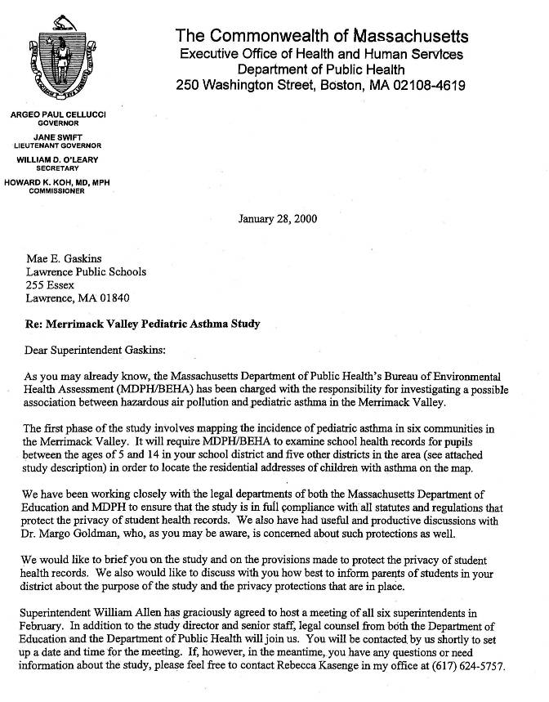
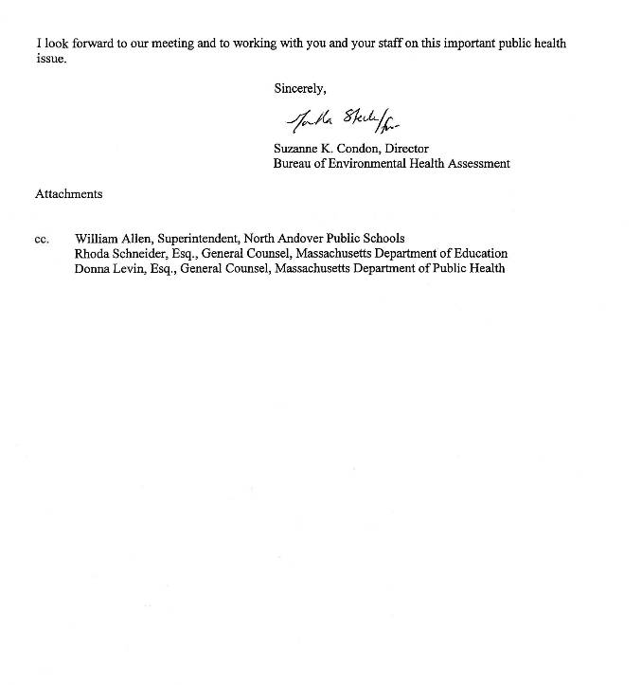
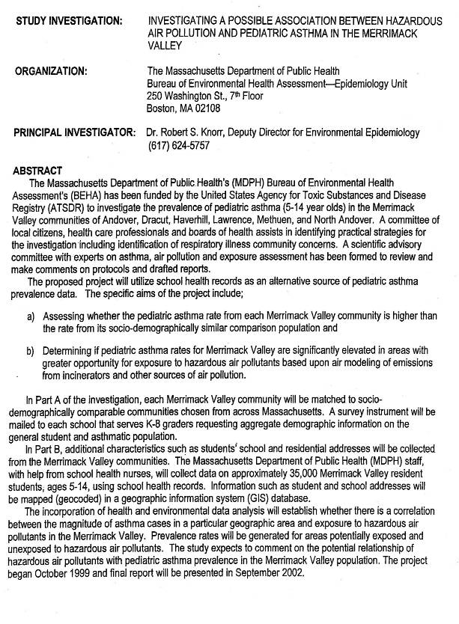
Appendix B
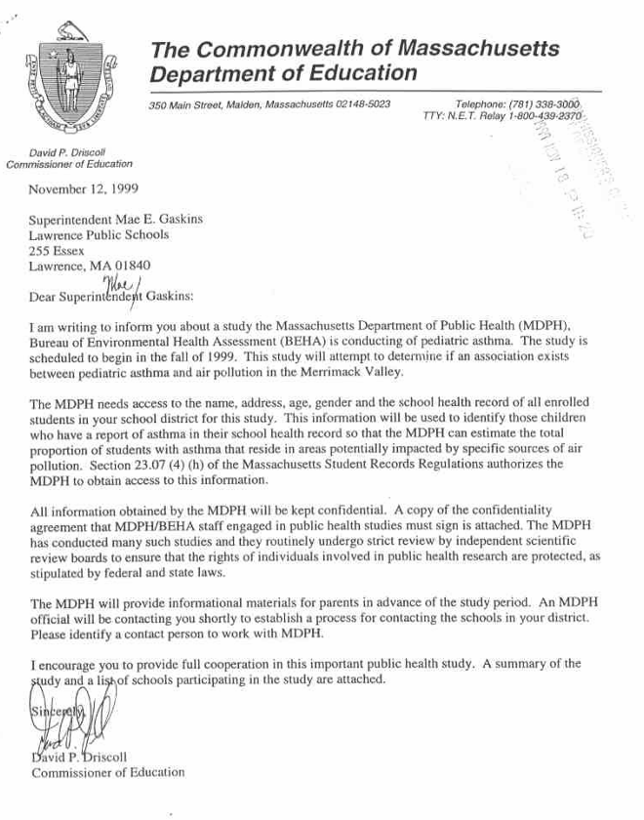
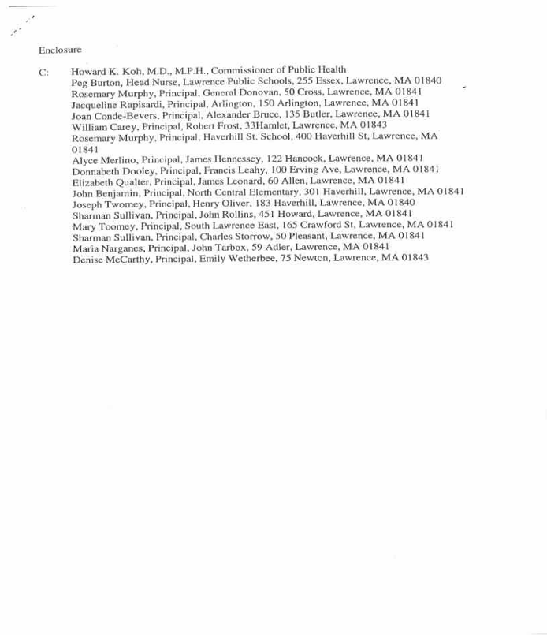
Appendix C
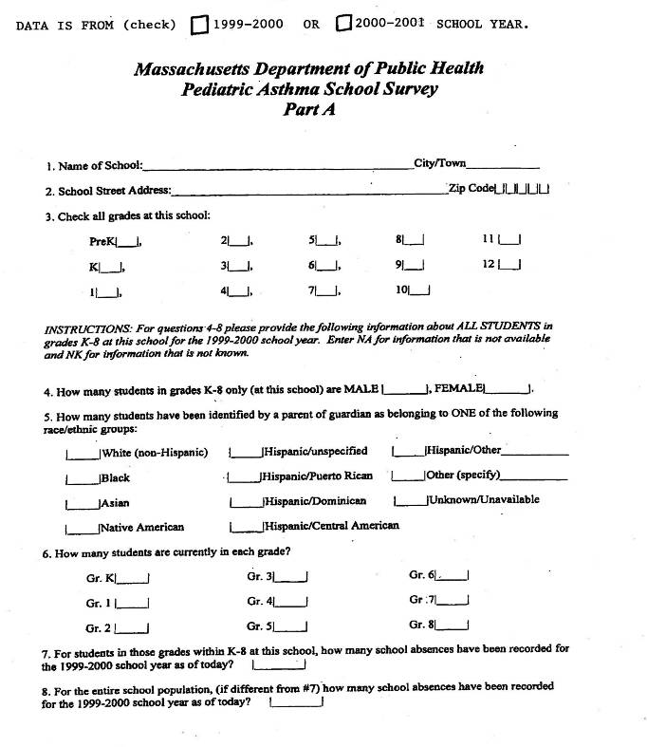

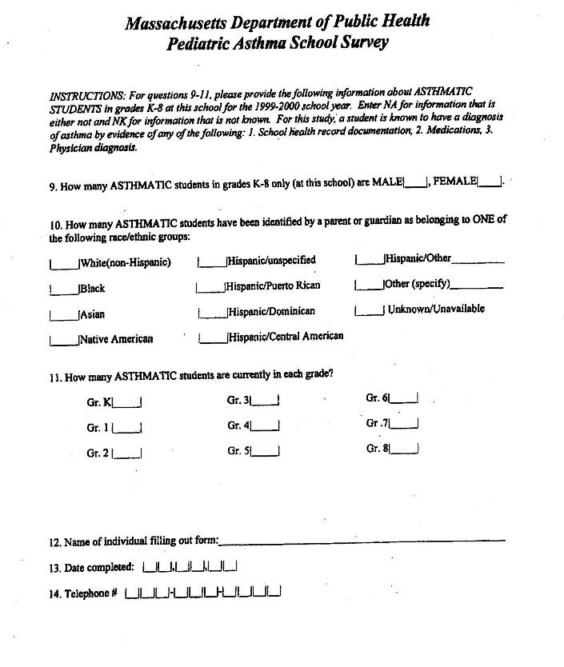
Appendix D
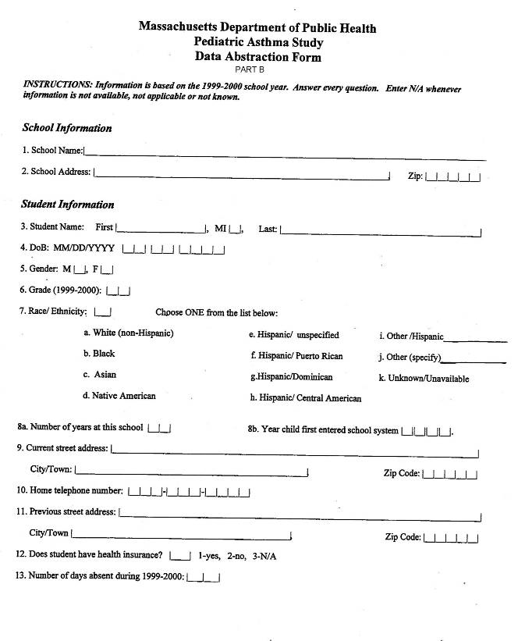
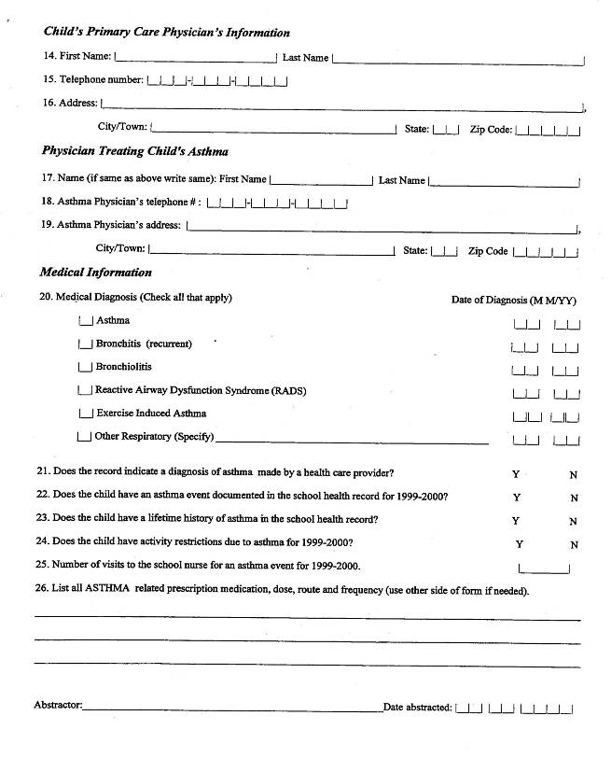
Appendix E

