INDOOR AIR QUALITY ASSESSMENT

Albert E. Labbee Senior Center
Hatfield Town Hall
59 Main Street
Hatfield, Massachusetts

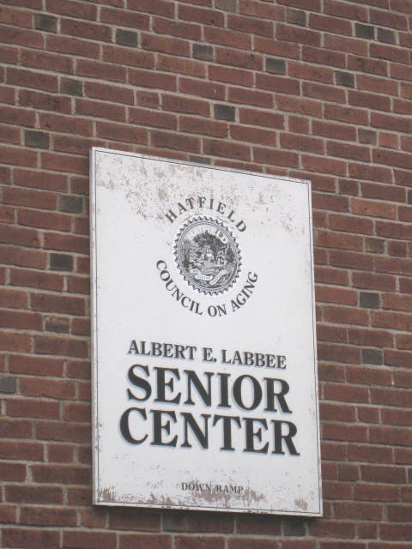

Prepared by:
Massachusetts Department of Public Health
Bureau of Environmental Health
Indoor Air Quality Program
January 2014

Background/Introduction
At the request of Dr. Ellen Bokina, Hatfield Board of Health, the Massachusetts Department of Public Health (MDPH), Bureau of Environmental Health (BEH) provided assistance and consultation regarding indoor air quality (IAQ) at the Albert E. Labbee Senior Center (SC). The SC located in the basement of Hatfield Town Hall (the town hall), 59 Main Street, Hatfield, Massachusetts. On November 1, 2013, a visit to conduct an IAQ assessment was made by Mike Feeney, Director of BEH’s IAQ Program.
At the time of assessment, the town hall was undergoing renovations to its first floor. Office space was being constructed/erected in the former auditorium/gymnasium above the SC. Concerns about the impact of pollutants from the renovation prompted the assessment.
The town hall is a two-story, red brick building with a finished basement (the ground floor) that was constructed in 1930. The ground floor contains the boiler room, the SC, as well as additional town offices and serves as the police and fire department headquarters. The first floor contains various town offices and the auditorium. The second floor contains meeting rooms and the auditorium balcony. Windows throughout the building are openable and consist of single-paned glass set in wooden window frames.

Methods
Air tests for carbon monoxide, carbon dioxide, temperature and relative humidity were conducted with the TSI, Q-Trak, IAQ Monitor, Model 7565. Air tests for airborne particle matter with a diameter less than 2.5 micrometers were taken with the TSI, DUSTTRAK™ Aerosol Monitor, Model 8520. BEH/IAQ staff also performed visual inspection of building materials for water damage and/or microbial growth. Test results are listed in Table 1.

Results

Ventilation
It can be seen from Table 1 that carbon dioxide levels were above 800 parts per million (ppm) in nine of eleven areas surveyed, indicating less than optimal air exchange in over half of the areas of the SC surveyed. No general mechanical ventilation system exists in the building. Heat is provided by radiators that are located beneath windows in each room. The sole source of fresh air is through openable windows. No exhaust ventilation systems are present, apart from motorized vents in restrooms. With the lack of supply and exhaust ventilation, general pollutants in the interior space can build-up and lead to IAQ/comfort complaints.
During summer months, ventilation in the town hall is controlled by the use of openable windows. The town hall was configured in a manner that uses cross-ventilation to provide comfort for building occupants. The building is equipped with windows on opposing exterior walls. This design allows for airflow to enter an open window (windward side), pass through a room, pass through the open door, enter the hallway, pass through the opposing open room door, into the opposing room and exit the building on the leeward side (opposite the windward side) (Figure 1). With all windows and doors open, airflow can be maintained in a building regardless of the direction of the wind. This system fails if the windows or doors are closed (Figure 2).
To maximize air exchange, the MDPH recommends that both supply and exhaust ventilation operate continuously during periods of occupancy. Minimum design ventilation rates are mandated by the Massachusetts State Building Code (MSBC). Until 2011, the minimum ventilation rate in Massachusetts was higher for both occupied office spaces and general classrooms, with similar requirements for other occupied spaces (BOCA, 1993). The current version of the MSBC, promulgated in 2011 by the State Board of Building Regulations and Standards (SBBRS), adopted the 2009 International Mechanical Code (IMC) to set minimum ventilation rates. Please note that the MSBC is a minimum standard that is not health-based. At lower rates of cubic feet per minute (cfm) per occupant of fresh air, carbon dioxide levels would be expected to rise significantly. A ventilation rate of 20 cfm per occupant of fresh air provides optimal air exchange resulting in carbon dioxide levels at or below 800 ppm in the indoor environment in each area measured. MDPH recommends that carbon dioxide levels be maintained at 800 ppm or below. This is because most environmental and occupational health scientists involved with research on IAQ and health effects have documented significant increases in indoor air quality complaints and/or health effects when carbon dioxide levels rise above the MDPH guidelines of 800 ppm for schools, office buildings and other occupied spaces (Sundell et al., 2011). The ventilation must be on at all times that the room is occupied. Providing adequate fresh air ventilation with open windows and maintaining the temperature in the comfort range during the cold weather season is impractical. Mechanical ventilation is usually required to provide adequate fresh air ventilation.
Carbon dioxide is not a problem in and of itself. It is used as an indicator of the adequacy of the fresh air ventilation. As carbon dioxide levels rise, it indicates that the ventilating system is malfunctioning or the design occupancy of the room is being exceeded. When this happens, a buildup of common indoor air pollutants can occur, leading to discomfort or health complaints. The Occupational Safety and Health Administration (OSHA) standard for carbon dioxide is 5,000 parts per million parts of air (ppm). Workers may be exposed to this level for 40 hours/week, based on a time-weighted average (OSHA, 1997).
The MDPH uses a guideline of 800 ppm for publicly occupied buildings. A guideline of 600 ppm or less is preferred in schools due to the fact that the majority of occupants are young and considered to be a more sensitive population in the evaluation of environmental health status. Inadequate ventilation and/or elevated temperatures are major causes of complaints such as respiratory, eye, nose and throat irritation, lethargy and headaches. For more information concerning carbon dioxide, please see Appendix A.
Temperature readings during the assessment ranged from 68 °F to 71 °F, which were within or near the MDPH recommended comfort guidelines. The MDPH recommends that indoor air temperatures be maintained in a range of 70 °F to 78 °F in order to provide for the comfort of building occupants. In many cases concerning indoor air quality, fluctuations of temperature in occupied spaces are typically experienced, even in a building with an adequate fresh air supply.
The relative humidity at the time of assessment ranged from 53 to 59 percent, which was within the MDPH recommended comfort range. The MDPH recommends a comfort range of 40 to 60 percent for indoor air relative humidity. Relative humidity levels in the building would be expected to drop during the winter months due to heating. The sensation of dryness and irritation is common in a low relative humidity environment. Low relative humidity is a very common problem during the heating season in the northeast part of the United States.

Microbial/Moisture Concerns
In order for building materials to support mold growth, a source of water exposure is necessary. No water damage, visible mold growth or associated odors were observed/detected at the time of assessment.

Other Indoor Air Evaluations
Indoor air quality can be negatively influenced by the presence of respiratory irritants, such as products of combustion. The process of combustion produces a number of pollutants. Common combustion emissions include carbon monoxide, carbon dioxide, water vapor, and smoke (fine airborne particle material). Of these materials, exposure to carbon monoxide and particulate matter with a diameter of 2.5 micrometers (μm) or less (PM2.5) can produce immediate, acute health effects upon exposure. To determine whether combustion products were present in the indoor environment, BEH/IAQ staff obtained measurements for carbon monoxide and PM2.5.

Carbon Monoxide
Carbon monoxide is a by-product of incomplete combustion of organic matter (e.g., gasoline, wood and tobacco). Exposure to carbon monoxide can produce immediate and acute health effects. Several air quality standards have been established to address carbon monoxide and prevent symptoms from exposure to these substances. The MDPH established a corrective action level concerning carbon monoxide in ice skating rinks that use fossil-fueled ice resurfacing equipment. If an operator of an indoor ice rink measures a carbon monoxide level over 30 ppm, taken 20 minutes after resurfacing within a rink, that operator must take actions to reduce carbon monoxide levels (MDPH, 1997).
The American Society of Heating Refrigeration and Air-Conditioning Engineers (ASHRAE) has adopted the National Ambient Air Quality Standards (NAAQS) as one set of criteria for assessing indoor air quality and monitoring of fresh air introduced by HVAC systems (ASHRAE, 1989). The NAAQS are standards established by the US EPA to protect the public health from six criteria pollutants, including carbon monoxide and particulate matter (US EPA, 2006). As recommended by ASHRAE, pollutant levels of fresh air introduced to a building should not exceed the NAAQS levels (ASHRAE, 1989). The NAAQS were adopted by reference in the Building Officials & Code Administrators (BOCA) National Mechanical Code of 1993 (BOCA, 1993), which is now an HVAC standard included in the Massachusetts State Building Code (SBBRS, 2011). According to the NAAQS, carbon monoxide levels in outdoor air should not exceed 9 ppm in an eight-hour average (US EPA, 2006).
Carbon monoxide should not be present in a typical, indoor environment. If it is present, indoor carbon monoxide levels should be less than or equal to outdoor levels. On the day of assessment, outdoor carbon monoxide concentrations were non-detect (ND) (Table 1). No measurable levels of carbon monoxide were detected inside the building (Table 1).

Particulate Matter
The US EPA has established NAAQS limits for exposure to particulate matter. Particulate matter includes airborne solids, which can result in eye and respiratory irritation if exposure occurs. The NAAQS originally established exposure limits to particulate matter with a diameter of 10 μm or less (PM10). According to the NAAQS, PM10 levels should not exceed 150 micrograms per cubic meter (μg/m³) in a 24-hour average (US EPA, 2006). These standards were adopted by both ASHRAE and BOCA. Since the issuance of the ASHRAE standard and BOCA Code, US EPA established a more protective standard for fine airborne particles. This more stringent PM2.5 standard requires outdoor air particle levels be maintained below 35 μg/m³ over a 24-hour average (US EPA, 2006). Although both the ASHRAE standard and BOCA Code adopted the PM10 standard for evaluating air quality, MDPH uses the more protective PM2.5 standard for evaluating airborne particulate matter concentrations in the indoor environment.
Outdoor PM2.5 concentrations the day of assessment were measured at 1 μg/m³. PM2.5 levels measured inside the building ranged from 18 to 283 μg/m³ (Table 1), with more than half of the measurements above the PM2.5 standard. The airborne particles indoors appear to be from two sources: the renovation of the first floor auditorium and the operation of a new automated dishwasher in the kitchen of the SC.
BEH/IAQ staff noted that plastic containment barriers between the renovation and occupied area were not complete/sealed (Pictures 1 through 3) and that no mechanical exhaust ventilation was in use in the renovation area (Picture 4). Completely sealed/airtight barriers and use of exhaust ventilation to remove renovation-related pollutants are necessary to minimize the potential impact of particulate exposure in occupied areas of the building. The BEH/IAQ guidance “Methods Used to Reduce/Prevent Exposure to Construction/Renovation Generated Pollutants in Occupied Buildings” is attached as Appendix B for additional information.
As mentioned previously, high PM2.5 measurements were also traced to the operation of a newly-installed automated dishwasher. A potential source of the measured particulate (up to 283 ppm) could be the burning-off of plastics that can occur with the operation of new electric equipment, or airborne detergent released from the dishwasher. In addition, the kitchen does not have any mechanical exhaust ventilation that would remove airborne pollutants. Kitchens should be equipped with mechanical exhaust ventilation that vents directly outdoors to remove smoke, water vapor, particulates and odors generated by cooking and other kitchen activities.

Conclusions/Recommendations
In view of the findings at the time of the visit, the following recommendations are made to improve indoor air quality:
- Use windows as originally designed to provide cross-ventilation during temperate weather.
- Use open windows with a box fan to vent the kitchen during dishwasher and other heavy use. Examine the feasibility of installing appropriate mechanical exhaust ventilation in the kitchen.
- Containment of the renovation should be done in a manner consistent with the most current edition of the IAQ Guidelines for Occupied Buildings under Construction published by the Sheet Metal and Air Conditioning Contractors National Association, Inc. (SMACNA, 1995).
- Establish communications between all parties involved with building renovations to prevent potential IAQ problems. Develop a forum for occupants to express concerns about renovations as well as a program to resolve IAQ issues.
- Develop a notification system for building occupants to report construction/renovation related odors and/or dust problems to the building administrator. Have these concerns relayed to the contractor in a manner to allow for a timely remediation of the problem.
- If possible, relocate susceptible persons and those with pre-existing medical conditions (e.g., hypersensitivity, asthma) away from areas of renovations.
- Implement prudent housekeeping and work site practices to minimize exposure to renovation pollutants. Consider increasing resources to accommodate increase in dirt, dust accumulation due to construction/renovation activities. This may include constructing barriers, sealing off areas, and temporarily relocating furniture and supplies. To control for dusts, a high efficiency particulate air filter (HEPA) equipped vacuum cleaner in conjunction with wet wiping of all surfaces is recommended.
- When possible, schedule projects which produce large amounts of dusts, odors and emissions during unoccupied periods or periods of low occupancy.
- Disseminate scheduling itinerary to all affected parties, this can be done in the form of meetings, newsletters or weekly bulletins.
- Obtain Material Safety Data Sheets (MSDS) for all construction materials used during renovations and keep them in an area that is accessible to all individuals during periods of building operations as required by the Massachusetts Right-To-Know Act (MGL, 1983).
- Consult MSDS’ for any material applied to the affected area during renovation(s) including any sealant, carpet adhesive, tile mastic, flooring and/or roofing materials. Provide proper ventilation and allow sufficient curing time as per the manufacturer’s instructions concerning these materials.
- Use local exhaust ventilation and isolation techniques to control for renovation pollutants. Precautions should be taken to avoid the re-entrainment of these materials into the building.
- Seal utility holes, pipe chases, spaces in floor decking and temporary walls to eliminate pollutant paths of migration. Inspect these areas regularly (e.g., daily) to ensure integrity is maintained.
- Refer to resource manuals and other related indoor air quality documents for further building-wide evaluations and advice on maintaining public buildings. Copies of these materials are located on the MDPH’s website: http://mass.gov/dph/iaq.

References
ASHRAE. 1989. Ventilation for Acceptable Indoor Air Quality. American Society of Heating, Refrigeration and Air Conditioning Engineers. ANSI/ASHRAE 62-1989.
BOCA. 1993. The BOCA National Mechanical Code-1993. 8th ed. Building Officials & Code Administrators International, Inc., Country Club Hills, IL.
MGL. 1983. Hazardous Substances Disclosure by Employers. Massachusetts General Laws. M.G.L. c. 111F.
MDPH. 1997. Requirements to Maintain Air Quality in Indoor Skating Rinks (State Sanitary Code, Chapter XI). 105 CMR 675.000. Massachusetts Department of Public Health, Boston, MA.
OSHA. 1997. Limits for Air Contaminants. Occupational Safety and Health Administration. Code of Federal Regulations. 29 C.F.R 1910.1000 Table Z-1-A.
SBBRS. 2011. Mechanical Ventilation. State Board of Building Regulations and Standards. Code of Massachusetts Regulations, 8th edition. 780 CMR 1209.0
SMACNA. 1995. IAQ Guidelines for Occupied Buildings Under Construction. 1st ed. Sheet Metal and Air Conditioning Contractors’ National Association, Inc., Chantilly, VA.
Sundell. 2011. Sundell, J., H. Levin, W. W. Nazaroff, W. S. Cain, W. J. Fisk, D. T. Grimsrud, F. Gyntelberg, Y. Li, A. K. Persily, A. C. Pickering, J. M. Samet, J. D. Spengler, S. T. Taylor, and C. J. Weschler. 2011. Ventilation rates and health: multidisciplinary review of the scientific literature. Indoor Air, Volume 21: pp 191–204.
US EPA. 2006. National Ambient Air Quality Standards (NAAQS). US Environmental Protection Agency, Office of Air Quality Planning and Standards, Washington, DC. http://www.epa.gov/air/criteria.html.
Picture 1
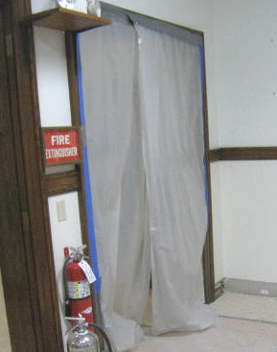
Open space in plastic containment

Picture 2
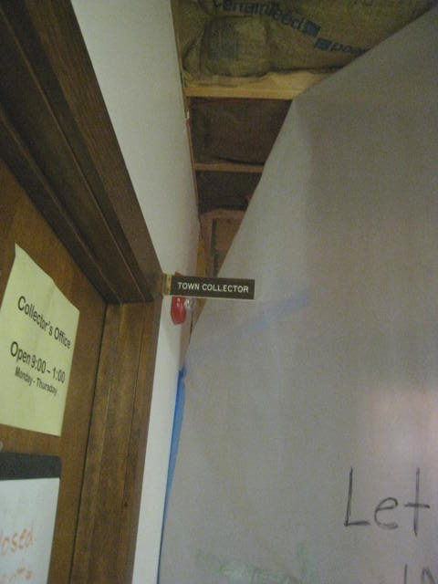
Incomplete seal around plastic containment
Picture 3
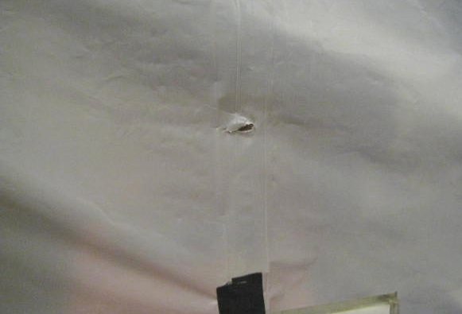
Hole in plastic containment
Picture 4
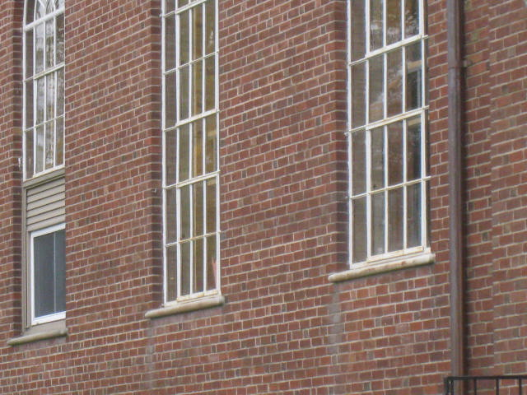
Windows with no exhaust fans
Location/ Room | Carbon  Dioxide  (ppm) | Carbon Monoxide  (ppm) | Temp  (°F) | Relative Humidity  % | PM2.5  (µg/m³) | Occupants  In Room | Windows  Openable | Ventilation |  | Remarks
 |  |  |  |  |  |  |  | Supply | Exhaust | Remarks
Background | 453 | ND | 68 | 65 | 1 | 0 | Y | N | N
Senior Center (Main Area) | 1053 | ND | 68 | 56 | 199 | 1 | Y | N | N
Kitchen | 1066 | ND | 70 | 57 | 283 | 12 | Y | N | N | Particulates from new dishwasher, which was operating
Kitchen (30 minutes after dishwasher off) | 1099 | ND | 71 | 56 | 30 | 0 | Y | N | N
Cafeteria | 1181 | ND | 70 | 55 | 58 | 2 | N | N | N
Fire Office | 901 | ND | 71 | 53 | 79 | 0 |  | N | N
Basement Hallway | 932 | ND | 71 | 54 | 48 | 0 | N | N | N
First Floor Hallway | 805 | ND | 69 | 55 | 18 | 1 | Y | N | N
Second Floor Meeting Room | 811 | ND | 69 | 53 | 24 | 0 | Y | N | N
Second Floor Meeting Room | 752 | ND | 69 | 55 |  | 0 | Y | N | N
Men’s Room Hallway | 585 | ND | 68 | 56 | 41 | 0 | Y | N | N
Men’s Room | 960 | ND | 69 | 59 | 30 | 0 | Y | N | N

