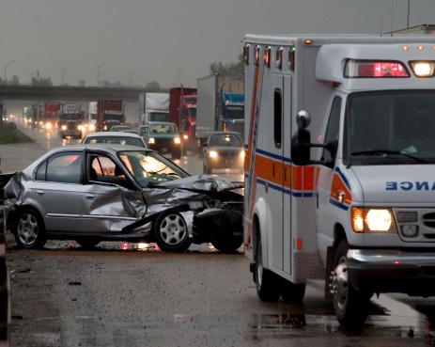
Massachusetts Crash-Related Injury Surveillance System
The Massachusetts (MA) Crash-Related Injury Surveillance System (CRISS) includes data for persons who were treated at a MA acute care hospital for motor vehicle crash injuries whose hospital record linked with a MA Crash report. These data do not include all crashes involving injuries in MA, as they do not include cases in which crash victims were transported to out-of-state hospitals, police were not involved, crash reports were not submitted to the Registry of Motor Vehicles (RMV), or missing or incorrect data prevented data linkage. Data may contain some duplicate records and/or linkages of some hospital records with the wrong crash records.
MA Hospital Discharge data are compiled by the Center for Health Information and Analysis. Crash data are compiled by the MA RMV. Data linkage and analysis were supported by Federal Highway Administration funds from the MA Department of Transportation (MassDOT) and CDC grant #NU17CE924835-01-00.
Acknowledgements: Data linkage and analyses were conducted by Catherine Rahilly-Tierney, MD, MPH and Arman Altincatal, MS, of Strategic Research Partners, LLC, on behalf of the MA Department of Public Health Injury Surveillance Program.
Data Brief:
Alcohol and Drug Involvement in Massachusetts Motor Vehicle
Crashes Resulting in Hospitalization, 2012 – 2015
Massachusetts Crash-Related Injury Surveillance System
Injury Surveillance Program, Massachusetts Department of Public Health May 2020
In 2017, over one-third (34%) of all motor vehicle (MV) fatalities in Massachusetts (MA) involved an alcohol-impaired driver, which was higher than the national rate of 29%.¹ However, less is known about alcohol or drug use in drivers and non-motorists who are hospitalized for MV crash injuries. This report presents data on alcohol and drug use by drivers and non-motorists hospitalized as a result of a MV crash in MA. Findings are based on linked MA Crash and Hospital Discharge data of crashes that occurred between January 1, 2012 and September 30, 2015. Of the 6,294 hospitalized drivers and non-motorists in the linked data, 1,423 (22.6%) were identified as being under the influence of alcohol or drugs at the time of the crash.

Alcohol and Drug Use by Person-Type²
Figure 1 shows the percent of hospitalized drivers and non-motorists with positive indicators for use of alcohol, drugs, or any alcohol and/or drug use³.
MA Linked Crash-Hospital Discharge Data
Figure 1. Alcohol and Drug Use in Hospitalized Drivers and Non-motorists, by Person-Type, Massachusetts, 2012-2015 (N = 6,290)⁴

Abbreviations: N = number of cases in analysis; n = number of cases in subgroup; p = 95% probability; CI = confidence interval
¹State Alcohol-Impaired-Driving Estimates: https://crashstats.nhtsa.dot.gov/Api/Public/ViewPublication/812724
²Person-types include car/truck drivers, motorcyclists, pedestrians and bicyclists. Passengers were excluded from all analyses.
³Includes alcohol use, drug use, and cases of operating or being “under the influence” that did not specify whether alcohol or drugs were used.
⁴Excludes four cases where person-type was “other driver”.

- Alcohol use was significantly higher in hospitalized car/truck drivers than other person-types (p < .0001). Nearly one in five drivers (19.3%) was identified as being under the influence of alcohol at the time of the crash.
- Drug use was identified in about one in ten hospitalized car/truck drivers (9.8%), motorcyclists (8.2%), and bicyclists (9.9%). Fewer hospitalized pedestrians were positive for drug use (6.9%, p = 0.03).
- One in four (25.1%) hospitalized car/truck drivers, and one in six hospitalized motorcyclists (17.8%), pedestrians (18.9%), and bicyclists (17.0%) were under the influence of alcohol or drug use at the time of the crash.

Alcohol and Drug Use by Data Source
Alcohol and drug use in drivers and non-motorists was identified from indicators in Crash and Hospital Discharge (HD) data; see Table 1. Sometimes both data sources provided similar information, but often the information came from just one data source, usually Hospital Discharge data.
There were some limitations to using Crash data to identify alcohol and drug use, as it contained many incomplete violation codes that could not be used to identify impaired driving violations. In addition, some indicators in Crash data did not distinguish between alcohol and drug use.

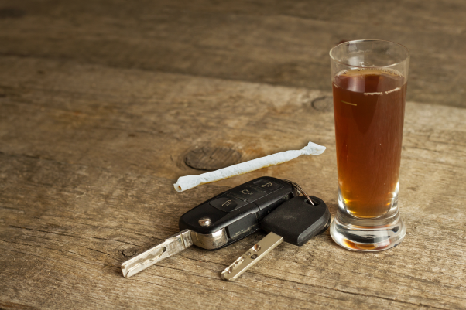

Use of Multiple Substances
Many hospitalized drivers and non-motorists were identified as being under the influence of both alcohol and drugs. Use of a second substance (for example, cannabis use in a patient intoxicated with alcohol) may be under-captured in hospital data due to use of non-specific diagnosis codes or a single, broad code to represent multiple substances.⁵
- Of hospitalized drivers and non-motorists positive for any substance use, 59.0% were positive for alcohol use alone, 25.1% for drug use alone, and 15.9% for both alcohol and drug use (Figure 3).
- Of drivers and non-motorists positive for any alcohol use, over one in five (21.3%) also had a positive drug use indicator.
- Of drivers and non-motorists positive for any drug use, over one in three (38.9%) also had a positive alcohol use indicator.

MA Linked Crash-Hospital Discharge Data
Figure 2. Alcohol and Drug Use in Hospitalized Drivers and Non-motorists, by Data Source, Massachusetts, 2012-2015 (N = 6,294)

Figure 2 shows the percent of hospitalized drivers and non-motorists positive for alcohol or drug use in Crash data, Hospital Discharge data, and either data source.
- Crash data identified 70.6% fewer cases of any alcohol and/or drug use than Hospital Discharge data (6.1% vs. 20.6%). Cases involving drug use may appear particularly low in Crash data due to violation codes and other indicators that do not distinguish between alcohol and drug use.
- Crash data, however, identified some alcohol/drug use not captured in Hospital Discharge data. Hospital data would not capture patients who did not get a toxicology screen, or were screened, but the results were not included in the discharge diagnoses.
- Due to the limitations described above, rates of alcohol and drug use identified in the linked Crash-Hospital Discharge data are likely underestimates.

Figure 3. Use of Alcohol, Drugs, or Both among Hospitalized Drivers and Non-motorists Positive for Any Substance Use, Massachusetts, 2012-2015 (n = 1,394)⁶

MA Linked Crash-Hospital Discharge Data

⁵Di Rico et al. Drug overdose in the ED: a record linkage study examining emergency department ICD-10 coding practices in a cohort of people who inject drugs. BMC Health Services Research. 2018; 18:945.
⁶Excludes cases of operating or being “under the influence” that did not specify whether alcohol or drugs were used.

Drug Types and Use of Multiple Substances⁸
Information about types of drugs used by drivers and non-motorists came only from Hospital Discharge data, as drug use indicators in Crash data do not indicate specific drug types. The frequency of specific drug use may therefore be underestimated.
Figure 4 shows the frequency of the most commonly identified types of drugs used by hospitalized drivers and non-motorists, and whether each drug was used alone or in combination with other substances. Drivers’ use of multiple substances, especially combinations involving alcohol, is more dangerous than use of a single substance.⁹
- Cannabis was the most frequently identified drug. Overall, 4.1% of hospitalized drivers and non-motorists were positive for cannabis use (n = 257).¹⁰
- Over half (56%) of cannabis users also had positive indicators for alcohol or other drugs.
- Stimulants and opioids were the next most commonly identified drugs. Most cases (83%) involving stimulants and about half (52%) of cases involving opioids also had positive indicators for alcohol or other drugs.
(n = 257) 257)
(n = 137)
(n = 119)
(n = 111)
MA Linked Crash-Hospital Discharge Data
Figure 4. Drug Use by Hospitalized Drivers and Non-motorists, by Drug Type⁸ and Use with Other Substances, Massachusetts, 2012-2015 (N = 6,294)

Were drivers impaired?
Drivers aged 21 or over are defined as legally impaired if they fail a Standardized Field Sobriety Test (SFST) or have a BAC (blood alcohol concentration) of .08% or higher. Drivers under age 21 are not permitted to drive with a BAC of .02 or greater. Currently MA does not have specific limits for substances other than alcohol.
The only indicator of alcohol use in this study that provided drivers’ BAC was the “BAC Test Result” in Crash data, but this information was missing for most drivers in this study. Hospitals may have measured patients’ BAC, but test results are not included in Hospital Discharge data. Therefore, we were not able to determine whether drivers met the legal standards for impairment in most cases.

Crash Data |  |  | Hospital Discharge Data
Variable | Values |  | Diagnosis Category | ICD-9-CM Codes
Law enforcement suspects alcohol use | Yes, alcohol used |  | Elevated blood alcohol | 790.3
Law enforcement suspects drug use | Yes, drugs used |  | Alcohol withdrawal or alcohol-induced mental disorder | 291.0, 291.81, 291.3-291.5, 291.9
BAC Test Result | 0.08 or greater
Non-motorist condition code | under the influence of alcohol/drugs/medications |  | Alcoholic intoxication, abuse, or poisoning | 303.00-303.02, 305.00-305.02, 980, E860.0-E860.1
Violation Codes
Open container of alcohol in MV | 90/24I |  | Drug withdrawal or drug-induced mental disorder | 292.0, 292.11, 292.12, 292.2, 292.81, 292.84, 292.9
OUI liquor offenses | 90/24/(J,K,L,M,V); 90/24L/ D,E,F); 90/24G/ (F,G,H)
OUI drug offenses | 90/24/(F,G,H,I,U); 90/24L/(A,B,C); 90/24G/(C,D,E) |  | Drug abuse or poisoning | 305.2 -305.9 (0,1,2), 960.0-977.9, E850.0-E858.9, E950 (.0- .5), E962.0, E980 (.0-.5)
Other OUI offenses (alcohol or drugs not specified) | 90/23/J; 90/24V/(A,B); 90/24/(1)(A)(1)
Table 1. Alcohol and Drug Use Indicators in the MA Crash-Related Injury Surveillance System

⁸Drug categories are not mutually exclusive. A person positive for cannabis and stimulants would be included in both categories.
⁹Movig et al. Psychoactive substance use and the risk of motor vehicle accidents. Accid Anal Prev. 2004; 36(4):631-6.
¹⁰These data were collected before Massachusetts legalized adult marijuana use in December 2016.

MA Traffic Safety Activities
The Executive Office of Public Safety and Security, MA Department of Transportation, and MA Department of Public Health work together to reduce motor vehicle crash injuries and deaths in the Commonwealth.
The Executive Office of Public Safety and Security (EOPSS) Highway Safety Division works with MassDOT, DPH, and other partners to develop public awareness campaigns and other traffic safety initiatives. EOPSS funds traffic safety activities by law enforcement and others through its Office of Grants and Research. The Highway Safety Division also facilitates the MA Traffic Records Coordinating Committee and Traffic Records Assessments.
The Massachusetts Department of Transportation (MassDOT) works to reduce MV crash injuries through driver licensing, traffic planning, highway infrastructure improvements, public education, and policy development. MassDOT also maintains Crash data and a public access portal to crash and other traffic data.

The Massachusetts Department of Public Health (DPH) works with a broad network of injury prevention partners to prevent MV injuries through program and policy development and implementation, public education, maintaining state emergency medical services, and maintaining and analyzing key MV injury data sources.

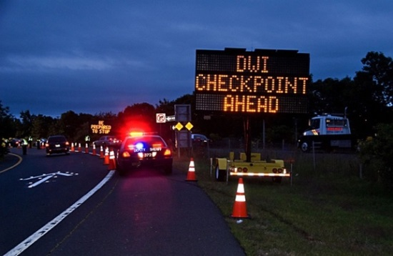
Massachusetts Department of Public Health, Injury Surveillance Program,
Office of Statistics and Evaluation, Bureau of Community Health and Prevention
www.mass.gov/injury-surveillance-program

The DPH Injury Prevention and Control Program (IPCP) focuses on the prevention of unintentional injuries, including MV-related injuries. IPCP co-chairs the MA Traffic Safety Coalition and chairs the SHSP Young Driver and Impaired Driving workgroups.
The DPH Injury Surveillance Program (ISP) uses multiple data sources to track fatal and nonfatal injuries among MA residents, including MV-related injuries. ISP developed the MA Crash-Related Injury Surveillance System (CRISS) with funding from MassDOT and the CDC.
The DPH Bureau of Healthcare Safety and Quality (BHCSQ) licenses and regulates MA emergency medical services personnel and local and regional ambulance services, and maintains the MA Ambulance Trip Record Information System (MATRIS) and MA Trauma Registry.
IPCP, ISP, and BHCSQ all participate in planning and implementation of the MA Strategic Highway Safety Plan, and the Executive Level Traffic Records Coordinating Committee.

National Resources

National Highway Traffic Safety Administration
www.nhtsa.gov

Centers for Disease Control and Prevention
www.cdc.gov/motorvehiclesafety

Governors Highway Safety Association
www.ghsa.org

Insurance Institute for Highway Safety
www.iihs.org

AAA Foundation for Traffic Safety
aaafoundation.org

MA Strategic Highway Safety Plan (SHSP) 2018
MassDOT works with a broad coalition of stakeholders to develop a comprehensive MA Strategic Highway Safety Plan every five years, and oversees over 20 Emphasis Area workgroups.
Federal Fiscal Year 2020 MA Highway Safety Plan
The EOPSS Highway Safety Division produces an annual MA Highway Safety Plan, which includes crash data and descriptions of initiatives funded by the EOPSS Office of Grants and Research.

MASSACHUSETTS DEPARTMENT OF PUBLIC HEALTH, HEALTH SURVEY PROGRAM
www.mass.gov/dph/hsp | Released August 2014

