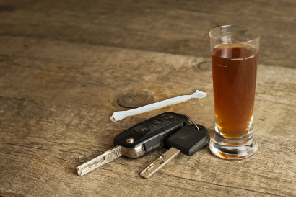
In 2018, one-third (33%) of all motor vehicle (MV) fatalities in Massachusetts (MA) involved an alcohol-impaired driver, which was higher than the national rate of
December 2021
Massachusetts Crash-Related Injury Surveillance System

Alcohol & Drug Intoxication in Drivers Hospitalized
for Motor Vehicle Crash Injuries, Massachusetts, 2012 – 2015

29%.¹
Of fatal crashes in MA in 2016, 80% of drivers were male and 45% were

between ages 21 to 34.² Less is known about alcohol and drug intoxication in drivers who are hospitalized for MV crash injuries. A study of trauma center patients in California in 2003 found that 26% of MV occupants had a blood alcohol concentration of .08 or higher. Alcohol intoxication was more prevalent in males, younger patients (ages 19-45), and Hispanic patients.³ A previous report on road
users involved in motor vehicle crashes identified approximately one in four hospitalized car/truck drivers, one in five
hospitalized pedestrians, and one in six hospitalized motorcyclists and bicyclists in MA as intoxicated by alcohol/drugs at the time of the crash.
This fact sheet on car/truck drivers identified as intoxicated at the time of the crash is one of a series of three fact sheets on the demographic characteristics of people hospitalized for motor vehicle crash injuries in MA. The other fact sheets focus on motorcyclists and pedestrians.ª While most hospitalized drivers in the current analysis were not identified as intoxicated at the time of the crash, it is important to consider all modifiable risk factors in drivers and crash circumstances to reduce crash-related injuries and deaths.

This analysis used linked 2012-2015 data from the MA Crash-Related Injury Surveillance System (MA CRISS). These data do not include all car/truck drivers hospitalized for MV crash injuries during this period. b Intoxication data were obtained from crash reports and hospital charge data. See Alcohol and Drug Involvement in MA Motor Vehicle Crashes for further information about MA CRISS and the alcohol and drug indicators used.

Intoxication Rates in Hospitalized Drivers Figure 1. Intoxication Rates in Hospitalized Drivers,

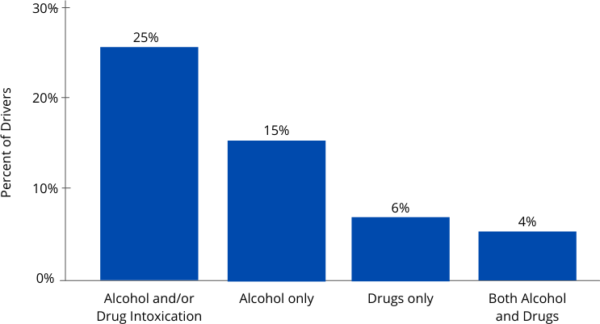
Alcohol intoxication was identified over two times as often as drug intoxication in hospitalized drivers. Of the 4,060 hospitalized drivers in the 2012-2015 MA CRISS data (Figure 1):
One in four (25%, n=1,019) was identified as intoxicated by any alcohol and/or drugs^{c} at the time of the crash.
15% were identified as intoxicated by alcohol only, 6% by drugs only, and 4% by both alcohol and drugs at the time of the crash.

MA CRISS Data, 2012-2015 (n=4,060)

a Counts were too low for a fact sheet on intoxicated bicyclists.
b MA CRISS data do not include cases in which crash victims were transported to out-of-state hospitals, police were not involved, crash reports were not submitted to the Registry of Motor Vehicles (RMV), or missing or incorrect data prevented data linkage. Data may contain some duplicate records and/or linkages of some hospital records with the wrong crash records.
c Alcohol and/or drug intoxication includes use of unspecified substances.

Intoxication Rates by Sex
Male drivers were significantly more likely to be identified as intoxicated than female drivers. Of hospitalized drivers in the 2012-2015 MA CRISS data (Figure 2):
Male drivers were nearly twice as likely as female drivers to be identified as intoxicated by alcohol/drugs (31% vs. 17%; p < 0.001).

Intoxication Rates by Age Group
The frequency of alcohol/drug intoxication in hospitalized drivers differed by age group. Of hospitalized drivers in the 2012-2015 MA CRISS data (Figure 3):
Drivers in the age groups 21-24, 25-34, and 35-44 had the highest rates of alcohol/drug intoxication (39- 43%). On average, approximately two in five drivers (42%) between age 21 and 44 were identified as intoxicated by alcohol or drugs at the time of the crash.
Intoxication rates were significantly lower in hospitalized drivers ages 55 and older than in drivers under age 55 (p < 0.001). When age groups were combined, 9% of drivers ages 55 and older were intoxicated compared to 37% of drivers under age 55 (data not shown).

Intoxication Rates by Race/Ethnicity
Rates of alcohol/drug intoxication among hospitalized drivers differed significantly by race/ethnicity.d Of hospitalized drivers in the 2012-2015 MA CRISS data (Figure 4):
Over one in three Hispanic drivers who were hospitalized was identified as intoxicated. Hispanic drivers were 40% more likely than White, non-Hispanic or Black, non-Hispanic drivers to be identified as intoxicated at the time of the crash (p = 0.004).
Figure 2. Intoxication Rates in Hospitalized Drivers by Sex, MA CRISS Data, 2012-2015 (n=4,060)
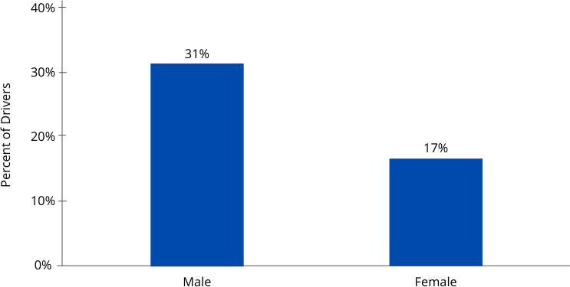

Figure 3. Intoxication Rates in Hospitalized Drivers by Age Group, MA CRISS Data, 2012-2015 (n=4,060)

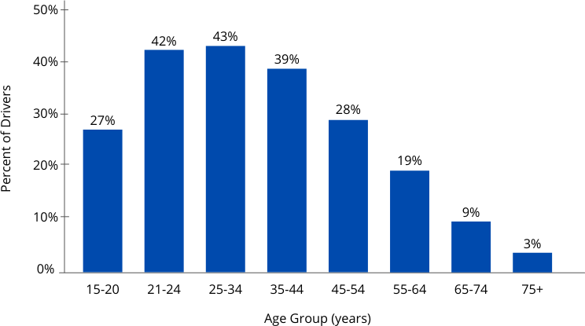

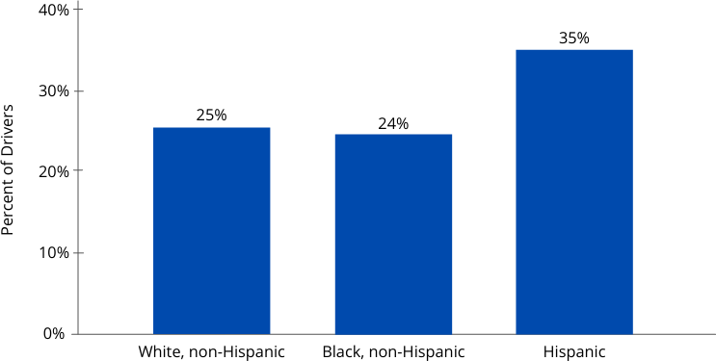
Figure 4. Intoxication Rates in Hospitalized Drivers by Race/Ethnicity, MA CRISS Data, 2012-2015 (n = 4,060)

d Intoxication rates for Asian/Pacific Islanders were suppressed due to low counts

Intoxication Rates by Race/Ethnicity (continued)
These results may be biased if healthcare providers or police were more likely to test Hispanic drivers for alcohol or drugs than non-Hispanic drivers. A prior study found that Hispanic males treated for injuries in U.S. trauma centers were tested for alcohol and drugs more frequently than white males.⁴

Other studies have also found that Hispanic drivers are at higher risk for alcohol-impaired crashes than drivers of other race/ethnicities. Potential reasons for this include: socioeconomic factors that can lead to a focus on immediate concerns over driving safety, and access to older or less expensive cars with fewer or less advanced safety features); cultural factors such as belief in fatalism, or machismo; language and education barriers that lead to less information on safe driving and driving laws; and increased alcohol advertising in minority communities.5,6

Intoxication Rates by County
Among hospitalized drivers, alcohol/drug intoxication rates also varied significantly by the country where the crash occurred (p < 0.001). (Figure 5)
Counties with the highest rates of intoxication were Berkshire (36%), Hampshire (34%) and Suffolk (32%) counties. Bristol county had the lowest rate of intoxication (16%).
Reasons for differences in intoxication rates by county are unclear. Much of Berkshire and Hampshire counties are rural and other studies have found that rural areas have higher rates of alcohol-related MV crashes.7,8 Factors that may contribute to higher rates of driving while intoxicated in rural areas include fewer or more expensive ride-sharing options, longer travel distances, and less consistent traffic enforcement.7 It is unclear why Franklin county, which is also rural had low rates of intoxication in hospitalized drivers. Differences in intoxication rates may be biased if healthcare providers or police in different counties test drivers for alcohol/drugs at difference times.

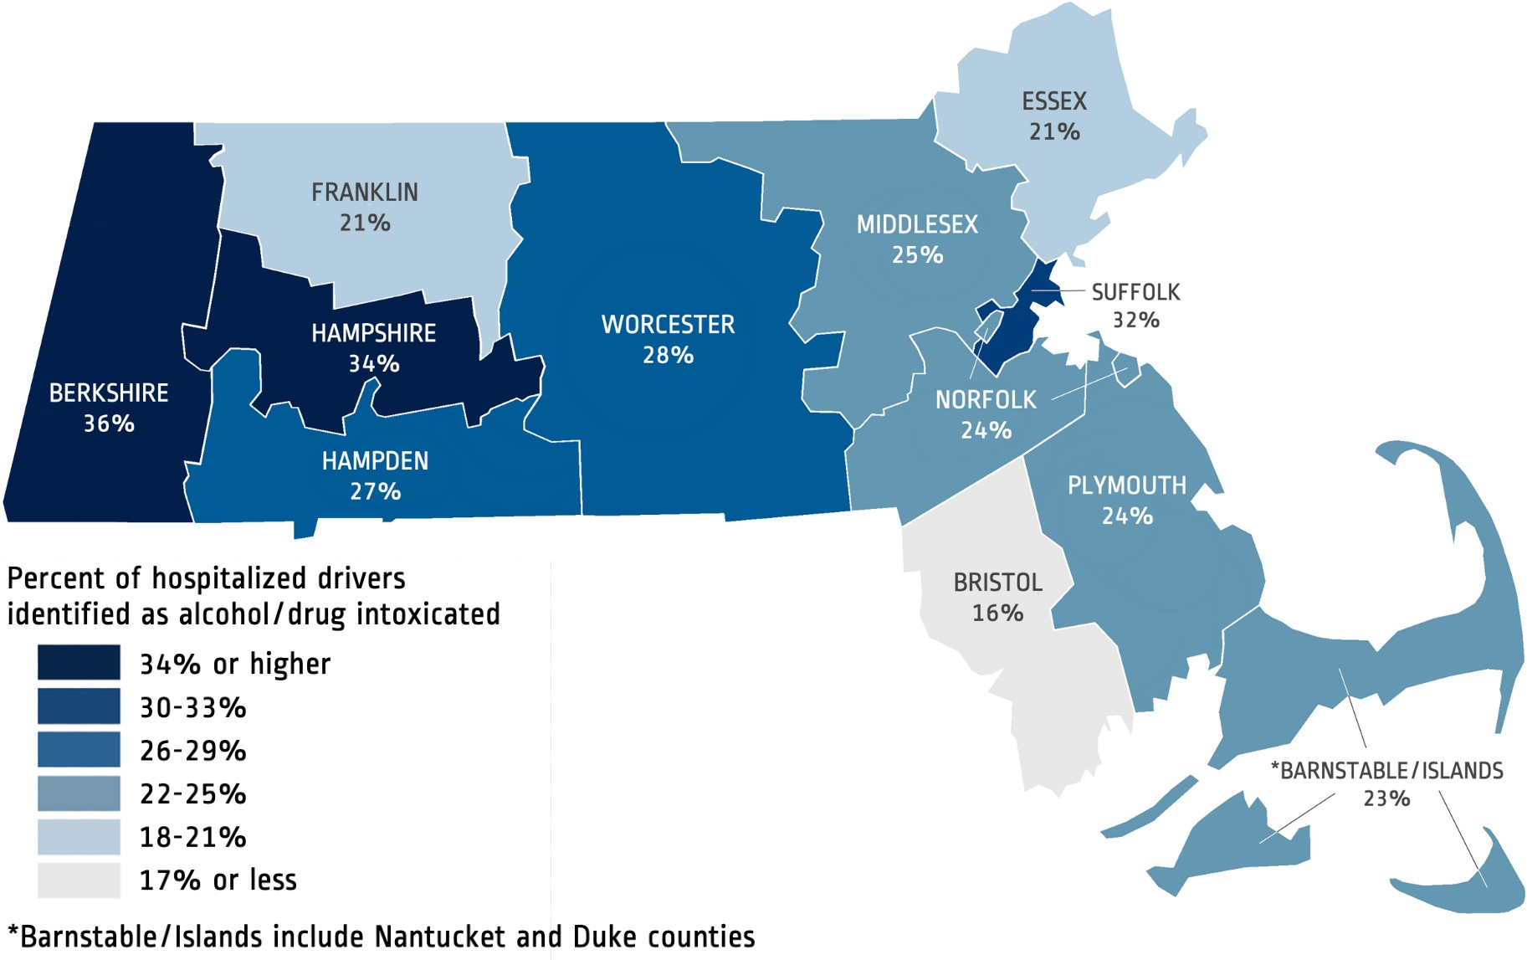
Figure 5. Intoxication Rates in Hospitalized Drivers by County where Crash Occurred, MA CRISS Data, 2012-2015 (n = 4,060)

Limitations
Intoxication rates may be underestimated if drivers were not tested for alcohol/drugs, intoxication was not documented in the medical record or crash report, or due to incomplete violation codes in crash data. Intoxication rates may be biased by whether health care providers and police test for alcohol/drugs and how soon after the crash they are tested. Low numbers of hospitalized drivers in some demographic groups also limited the analysis. More recent hospital discharge data were not available for linkage with crash data at the time of the analysis.

Injury Surveillance Program | Massachusetts Department of Public Health Office of Statistics and Evaluation, Bureau of Community Health and Prevention
mass.gov/injury-surveillance-program

Strategies to Reduce Impaired Driving Injuries
These results underscore the critical need to monitor and reduce impaired driving in Massachusetts. Strategies to reduce impaired driving include:
Driving under the influence of alcohol programs operated by the MA Department of Public Health Bureau of Substance Addiction Services as alternatives to loss of license or incarceration:
First Offender Driver Alcohol Education (DAE): 40-hour educational program to help drivers identify and understand alcohol addiction and drinking-and-driving behaviors.
Second Offender Driving Under the Influence of Liquor (DUIL) Program: 14-day residential program that includes medical evaluation, individual and group counseling, educational sessions, and assignment to a Second Offender Aftercare Program.
Second Offender Aftercare (SOA) Program: one-year program of individual, group, and family services individually designed to meet the needs of the client.
All-offender Ignition Interlock legislation proposed in the MA Strategic Highway Safety Plan (SHSP) 2018. Strategies to reduce impaired driving described in the Federal Fiscal Year 2020 MA Highway Safety Plan. Additional outreach as warranted to high-risk populations in impaired driving prevention programs and public awareness campaigns, including:
male drivers, drivers ages 21-44,
Hispanic drivers (both sexes and ages 16-54), and drivers in Berkshire, Hampshire, and Suffolk counties.
Efforts to sustain, analyze, and disseminate data related to intoxication from the MA Crash-Related Injury Surveillance System (MA CRISS).

Data Sources & References
MA Crash-Related Injury Surveillance System data:
Inpatient Hospital Discharge data (Jan. 2012 – Sep. 2015), Center for Health Information and Analysis Crash Data System (Jan. 2012 – Sep. 2015), MA Registry of Motor Vehicles

1 State Alcohol-Impaired-Driving Estimates: https://crashstats.nhtsa.dot.gov/Api/Public/ViewPublication/812917
² 2018 MA Strategic Highway Safety Plan: https://www.mass.gov/doc/massachusetts-shsp-2018/download
3 Plurad D, et al. Motor vehicle crashes: The association of alcohol consumption with the type and severity of injuries and outcomes. J Emerg Med. 2010; 38(1): 12-17.
4 Kon AA, Pretslaff RK, Marcin JP. The association of race and ethnicity with rates of drug and alcohol among US trauma patients. Health
Policy. 2004; 69(2):159-67.
5 Harper JS, Marine WM, Garrett CJ, Lezotte D, Lowenstein SR. Motor vehicle crash fatalities: A comparison of Hispanic and non-Hispanic motorists in Colorado. Ann Emerg Med. 2000; 36(6): 589-96.
6 Torres P, Romano E, Voas RB, de la Rosa M, Lacey JH. The relative risk of involvement in fatal crashes as a function of race/ethnicity and
blood alcohol concentration. J Safety Res. 2014; 48:95-101.
7 Pressley JC, et al. Using rural-urban continuum codes (RUCCS) to examine alcohol-related motor vehicle crash injury and enforcement in New York state. Int J Environ Res Public Health. 2019; 16(8): 1346.
8 Borgialli DA, Hill EM, Maio RF, Compton CP, Gregor MA.Effects of alcohol on the geographic variation of driver fatalities in motor vehicle
crashes. Acad Emerg Med. 2000; 7(1): 7-13.

This document was supported by the National Center for Injury Prevention and Control of the Centers for Disease Prevention and Control (CDC)
under award number NU17CE924835. The content is solely the responsibility of the authors and does not necessarily represent the official views of the CDC.

