In 2018, 59 motorcyclist fatalities in Massachusetts (MA) accounted for 14% of all traffic deaths in the state that year. 1 In national data, 44% of motorcyclist fatalities in MA were identified as alcohol-impaired, a which was higher than the national average of 29%.² Another study found that compared to motorcycle (MC) operators who were not impaired, the odds of death or incapacitating injury for MC operators who were impaired was 4.5 times as high in a single vehicle crash and 2.9 times as high in a multiple vehicle crash. 3 In fiscal year 2018, there were 506 hospital stays of MA residents for motorcycle crash-related injuries.4 Furthermore, a previous report on road users involved in motor vehicle crashes identified approximately 1 in 6 hospitalized motorcyclists and bicyclists, 1 in 5 hospitalized pedestrians, and 1 in 4 car/truck drivers in MA as intoxicated by alcohol and/or drugs (alcohol/drugs) at the time of the crash. 5 In the report, the term "intoxicated" refers to intoxication by alcohol and/or drugs unless otherwise specified.
December 2021
Massachusetts Crash-Related Injury Surveillance System

Alcohol and Drug Intoxication in Motorcycle Operators Hospitalized for Crash Injuries, Massachusetts, 2012 – 2015

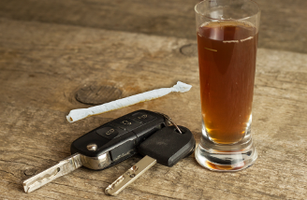
This is one of a series of three fact sheets on the demographic characteristics of people hospitalized for motor vehicle crash injuries in MA who were identified as intoxicated at the time of the crash. The other fact sheets focus on car/truck drivers
and pedestrians.b Demographic information can be used to focus prevention
strategies on motorcyclists at greater risk of intoxicated riding. While most hospitalized MC operators in the current analysis were not identified as intoxicated at the time of the crash, it is important to consider all the modifiable risk factors in MC operators, drivers of other vehicles, and other crash circumstances to reduce motorcyclist injuries and deaths.
This analysis used linked 2012-2015 data from the MA Crash-Related Injury Surveillance System (MA CRISS). These data do not include all motorcyclists hospitalized for motor vehicle crash injuries during this period.c Intoxication data were obtain from crash reports and hospital discharge data. See Alcohol and Drug Involvement in MA Motor Vehicle Crashes for further information about MA CRISS and the alcohol and drug indicators used.

Approximately 1 in 6 hospitalized motorcycle operators were identified as intoxicated at the time of the crash.

a Blood alcohol concentration of 0.08 g/dl
b Counts were too low for a fact sheet on intoxicated bicyclists.
c MA CRISS data do not include cases in which crash victims were transported to out-of-state hospitals, police were not involved, crash reports were not submitted to the Registry of Motor Vehicles (RMV), or missing or incorrect data prevented data linkage. Data may contain some duplicate records and/or linkages of some hospital records with the wrong crash records.

Intoxication Rates in Hospitalized MC Operators Alcohol intoxication was identified more often than drug intoxication in hospitalized MC operators (Figure 1). Of
the 1,053 hospitalized motorcyclists in 2012-2015 MA
CRISS data:
Approximately 1 in 6 (18%, n=187) were identified as intoxicated by any alcohol and/or drugs at the time of the crash.
10% were identified as intoxicated by alcohol only, 6% by drugs only, and 3% by both alcohol and drugs at the time of the crash.^{d}
We found few prior studies of intoxication in hospitalized MC operators, so it is difficult to provide comparable national data. One study of 2012-2014 National Trauma Data Bank data found that 21% of MC operators tested for alcohol were above the legal limit.⁶

Figure 1. Intoxication Rates in Hospitalized Motorcyclists, MA CRISS Data, 2012-2015 (n=1,053)d
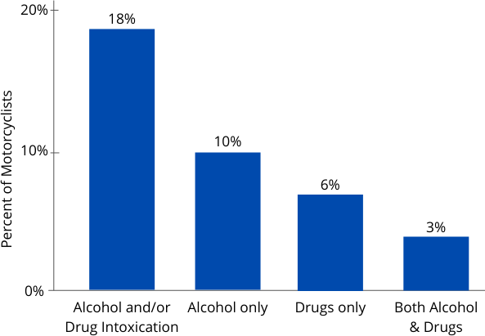

Intoxication Rates by Sex
Nearly all hospitalized MC operators in the analysis were male (96%). Due to the small number of hospitalized female motorcyclists, it is difficult to identify if intoxication rates differ significantly between males and females. The high percentage of hospitalized MC operators in this study who were male is consistent with MA data on motorcyclist fatalities. Of motorcyclist fatalities in MA between 2014-2018, 97% were male.¹

Intoxication Rates by Age Group
The frequency of alcohol/drug intoxication in hospitalized MC operators differed by age group (Figure 2). Of hospitalized MC operators:
Nearly 1 in 4 MC operators ages 25-34 and 35-44 were identified as intoxicated at the time of the crash. This rate was significantly higher than in MC operators under age 25 and over age 44 when age groups were combined (p=0.0003).
Among MA motorcyclists fatalities from 2014-2018, motorcyclists ages 25-34 accounted for 35% of alcohol- impaired fatalities. Specific rates of impairment by age group in MA fatality data were not available.¹

Figure 2. Intoxication Rates in Hospitalized Motorcyclists by Age Group, MA CRISS Data, 2012-2015 (n=1,053)

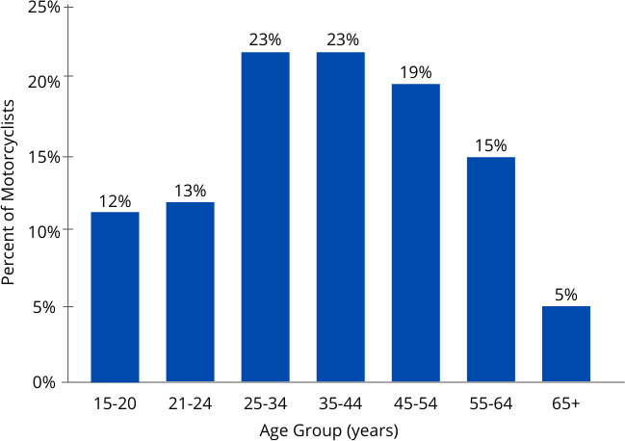
Intoxication Rates by Race/Ethnicity
There were no significant differences in intoxication rates by race/ethnicity among hospitalized MC operators. We were unable to find comparable data on intoxication rates in MC operators by race/ethnicity in studies of fatal or non-fatal MC crashes.

d Percentages do not add to 18% due to rounding.

Intoxication Rates by County
Among hospitalized MC operators, alcohol/drug intoxication rates varied significantly by county of where the crash occurred (p < 0.001). Some counties with low counts were combined with neighboring counties if their intoxication rates were similar (Franklin and Hampshire counties). Counts for Barnstable/Islands, Berkshire, Bristol and Norfolk counties were not included because their counts were too low to release and their intoxication rates differed from neighboring counties. (Figure 3)
Franklin and Hampshire counties had the highest rate of intoxication in hospitalized MC operators, where over 1 in 3 (35%) were identified as intoxicated at the time of the crash.
The second highest intoxication rates were among hospitalized MC operators who crashed in Worcester (26%) and Hampden (23%) counties, where approximately 1 in 4 were identified as intoxicated at the time of the crash.
Reasons for differences in intoxication rates by county are unclear. Much of Berkshire and Hampshire counties are rural and other studies have found that rural areas have higher rates of alcohol-related motor vehicle crashes. 7,8 Factors that may contribute to higher rates of driving while intoxicated in rural areas include fewer or more expensive ride-sharing options, driving longer distances, and less consistent traffic enforcement.10 In addition, intoxication rates may be biased if healthcare providers or police in different counties test MC operators for alcohol/drugs at different rates. MA fatality data show a somewhat different pattern. Between 2014-2018, Worcester, Plymouth, and Middlesex counties had higher levels of impairment among fatally injured motorcyclists than other counties. 1

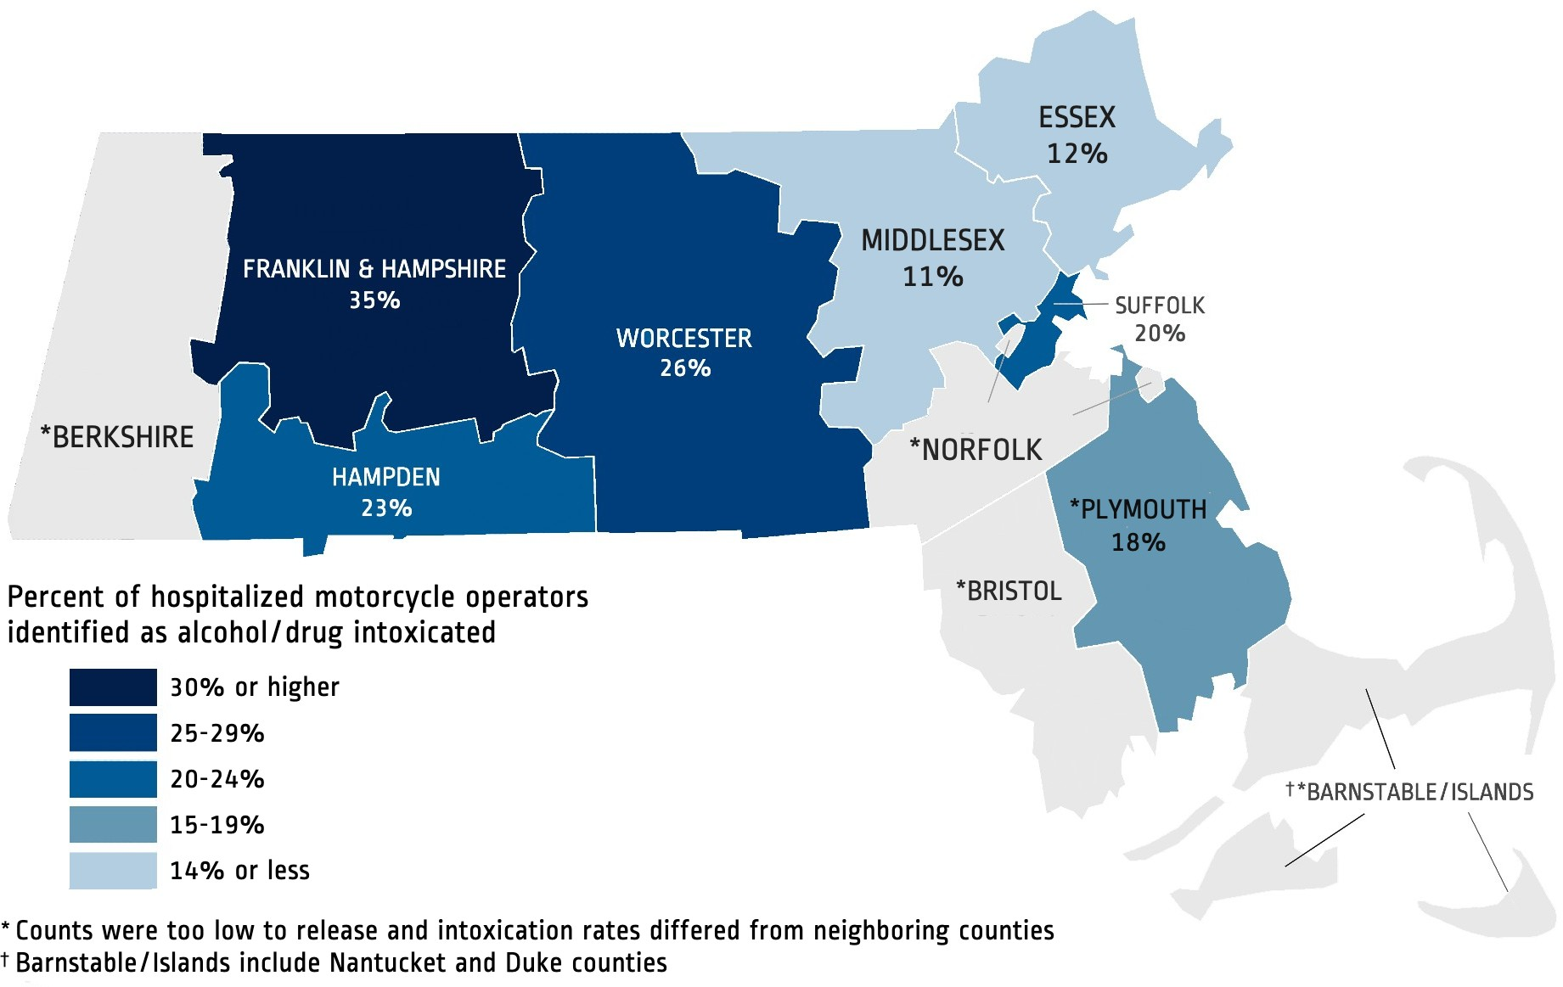
Figure 3. Intoxication Rates in Hospitalized MC Operators by County where Crash Occurred, MA CRISS Data, 2012-2015 (n=1,053)

Limitations
Intoxication rates may be underestimated if MC operators were not tested for alcohol/drugs, intoxication was not documented in the medical record or crash report, or due to incomplete violation codes in crash data. Intoxication rates may be biased by whether health care providers and police test for alcohol/drugs and how soon after the crash they were tested. Low numbers of hospitalized MC operators in some demographic groups and MC crashes in some counties also limited the analysis. More recent hospital discharge data were not available for linked with crash data at the time of the analysis. Intoxication rates in different demographic groups and counties may have changed since then.

Injury Surveillance Program | Massachusetts Department of Public Health Office of Statistics and Evaluation, Bureau of Community Health and Prevention
mass.gov/injury-surveillance-program

Strategies to Reduce Impaired Motorcycle Riding Injuries
Improve access to substance use disorder prevention, intervention, treatment, and recovery support services in Massachusetts.
Develop and implement motorcycle safety media campaigns targeting males ages 25-44 that educate motorcyclists about the importance of rider safety, proper and consistent helmet use, and the dangers of alcohol and substance use impaired riding and speeding.1
Partner with motorcycle education programs to implement Riders Helping Riders (RHR), an instructional program designed to encourage motorcyclists to intervene with their motorcyclist peers to prevent them from drinking and riding.⁹

Data Sources & References
MA Crash-Related Injury Surveillance System data:
Inpatient Hospital Discharge data (Jan. 2012 – Sep. 2015), Center for Health Information and Analysis Crash Data System (Jan. 2012 – Sep. 2015), MA Registry of Motor Vehicles

1 FFY 2021 Massachusetts Highway Safety Plan
2 NHTSA Traffic Safety Facts, 2019 Data, Motorcycles. DOT HS 813 112
3 Farid A, Ksaibati K. Modeling severities of motorcycle crashes using random parameters. J Transportation Engineering (English Edition), https://doi.org/10.1016/j.jtte.2020.01.001.
4 Injury-Related Hospital Stays among Massachusetts Residents, 2018
5 Alcohol and Drug Involvement in Massachusetts Motor Vehicle Crashes
6 Ahmed N, Kuo YH, Sharma J, Kaul S. Elevated blood alcohol impacts hospital mortality following motorcycle injury: A National Trauma Data Bank analysis. Injury. 2020; 51(1):91-96.
⁷ Pressley JC, et al. Using rural-urban continuum codes (RUCCS) to examine alcohol-related motor vehicle crash injury and enforcement in New York state. Int J Environ Res Public Health.2019; 16(8): 1346.
⁸ Borgialli DA, Hill EM, Maio RF, Compton CP, Gregor MA.Effects of alcohol on the geographic variation of driver fatalities in motor vehicle crashes. Acad Emerg Med. 2000; 7(1): 7-13.
9 2008 NHTSA Volume I: Riders Helping Riders Evaluation. DOT HS 811 023.
10 Insurance Institute for Highway Safety: Motorcycle Helmet Use Laws by State, November 2021; accessed 11/1/21.

This document was supported by the National Center for Injury Prevention and Control of the Centers for Disease Prevention and Control (CDC)
under award number NU17CE924835. The content is solely the responsibility of the authors and does not necessarily represent the official views of the CDC.

