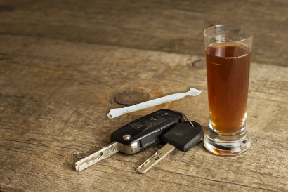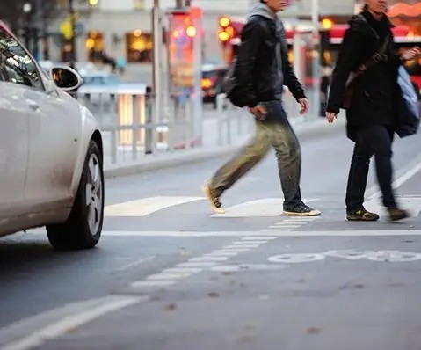In 2017, 72 pedestrian fatalities in Massachusetts (MA) accounted for 21% of all traffic deaths in the state. 1 In addition, there were 477 hospital stays for nonfatal pedestrian injuries in MA acute care hospitals in fiscal year (FY) 2017. ª In the U.S., 38% of pedestrians killed in motor vehicle (MV) crashes were identified as under the influence of alcohol in 2018. ² Pedestrians identified as intoxicated by alcohol or drugs (alcohol/drugs) at the time of the crash are at higher risk of being injured or killed than pedestrians who are not identified as intoxicated.^{3,4} A previous report on road users involved in MA motor vehicle crashes identified approximately one in five hospitalized pedestrians, one in four hospitalized car/truck drivers, and one in six hospitalized motorcyclists and bicyclists as intoxicated by alcohol/drugs at the time of the crash.⁵
December 2021
Massachusetts Crash-Related Injury Surveillance System

Alcohol & Drug Intoxication in Pedestrians Hospitalized
for Motor Vehicle Crash Injuries, Massachusetts, 2012 – 2015
This is one of a series of three fact sheets on the demographic characteristics of people hospitalized for motor vehicle crash injuries in MA who were identified as intoxicated at the time of the crash. The other fact sheets focus on car/truck drivers and motorcyclists.^{b} While most hospitalized pedestrians in the current analysis were not identified as intoxicated at the time of the crash, it is important to consider all modifiable risk factors in drivers, pedestrians, and other crash circumstances to reduce pedestrian injuries and deaths.

This analysis used linked 2012-2015 data from the MA Crash-Related Injury Surveillance System (MA CRISS). These data do
not include all pedestrians hospitalized for MV crash injuries during this period.^{c} Intoxication data were obtained from
crash reports and hospital discharge data. See Alcohol and Drug Involvement in MA Motor Vehicle Crashes for further information about MA CRISS and the alcohol and drug indicators used.

Intoxication Rates in Hospitalized Pedestrians
Alcohol intoxication was identified about twice as often as drug intoxication in hospitalized pedestrians. (Figure 1) Of the 965 hospitalized pedestrians:
Approximately one in five (19%, n=182) were identified as intoxicated by any alcohol and/or drugs d at the time of the crash.
9% were identified as intoxicated by alcohol only, 4% by drugs only, 3% by both alcohol and drugs, and 3% by unspecified substances at the time of the crash.

Figure 1. Intoxication Rates in Hospitalized Pedestrians, MA CRISS Data, 2012-2015 (n=965)

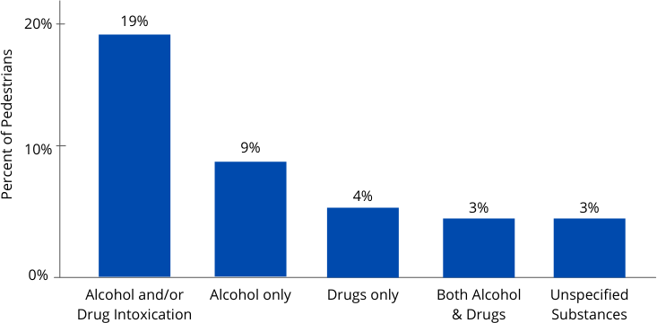
a October 1, 2016—September 30, 2017
b Counts were too low for a fact sheet on intoxicated bicyclists.
c MA CRISS data do not include cases in which crash victims were transported to out-of-state hospitals, police were not involved, crash reports were not submitted to the Registry of Motor Vehicles (RMV), or missing or incorrect data prevented data linkage. Data may contain some duplicate records and/or linkages of some hospital records with the wrong crash records.
d Any alcohol and/or drug intoxication includes use of unspecified substances.

Intoxication Rates in Hospitalized Pedestrians (continued)
We found no U.S. data on intoxication rates specifically in pedestrians hospitalized for MV crash injuries. However, in a study of alcohol and drug prevalence among seriously and fatally injured road users in five U.S. cities, 24.5% of pedestrians were positive for alcohol and 50.7% were positive for alcohol and/or drugs.⁶

Intoxication Rates by Sex
Intoxications rates in hospitalized pedestrians differed by sex. (Figure 2) Of hospitalized pedestrians:
Males were 2.4 times as likely as females to be identified as intoxicated at the time of the crash (26% vs. 11%, p < 0.0001).
We found no data on intoxication rates by sex in pedestrians injured or killed in crashes in the U.S.

Intoxication Rates by Age group
The frequency of alcohol/drug intoxication in hospitalized pedestrians differed by ages group. (Figure 3) Of hospitalized pedestrians:
Those ages 25-54 were significantly more likely to be identified as intoxicated than pedestrians under 25 or over 54 (p < 0.0001).
Nearly one in three (32%) of persons ages 25-54 were identified as intoxicated at the time of the crash.
We found no data on intoxication rates by age group in pedestrians with nonfatal injuries in the U.S. However, among pedestrians killed in MV crashes in the U.S. in 2018, pedestrians ages 21-24, 25-34, 35-44, and 45-54 had higher rates of intoxication (43-48%) than pedestrians ages 16-20 or ages 55 and older.
Figure 2. Intoxication Rates in Hospitalized Pedestrians by Sex, MA CRISS Data, 2012-2015 (n=965)
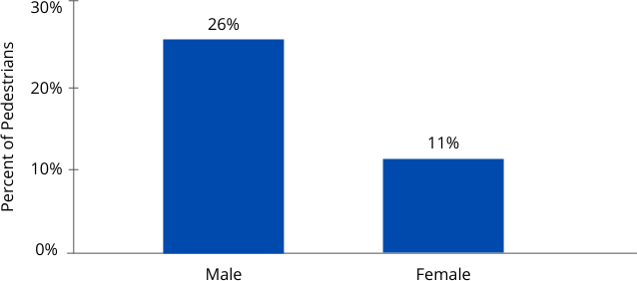

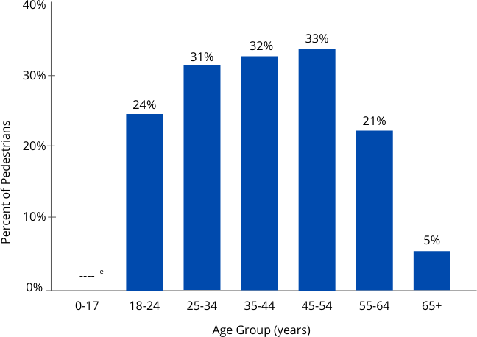
Figure 3. Intoxication Rates in Hospitalized Pedestrians by Age Group, MA CRISS Data, 2012-2015 (n=965)

Intoxication Rates by Race/Ethnicity
Of hospitalized pedestrians, we found no significant differences in intoxication rates between White non-Hispanic, Black non-Hispanic, and Hispanic pedestrians. The number of intoxicated Asian/Pacific Islanders was too low to report due to confidentiality guidelines.

We found no data on intoxication rates by race/ethnicity in studies of pedestrians killed or with nonfatal injuries in MV crashes in the U.S.

e Percentage is suppressed as the count was less than 11.

Intoxication Rates by County
Among hospitalized pedestrians, alcohol/drug intoxication rates also varied significantly by county of where the crash occurred (p < 0.03). Some counties with low counts were combined with neighboring counties if their intoxication rates were similar (Berkshire, Franklin, and Hampshire counties; Plymouth Barnstable, Dukes, and Nantucket counties). Counts for Bristol county were too low to release and the county's intoxication rate differed from neighboring counties. (Figure 4)
Counties with the highest rates of intoxication in hospitalized pedestrians were Hampden (31%) and Berkshire, Franklin, and Hampshire counties combined (26%). Most communities of Berkshire, Franklin, and Hampshire counties are rural.
Suffolk and Norfolk counties had the lowest rates of intoxication in hospitalized pedestrians (14%).
Reasons for differences in intoxication rates by county are unclear. We found no data on intoxication rates in pedestrians injured in an MV crash in rural vs. urban areas. Intoxication rates may be biased if healthcare providers or police in different counties test pedestrians for alcohol/drugs at different rates.

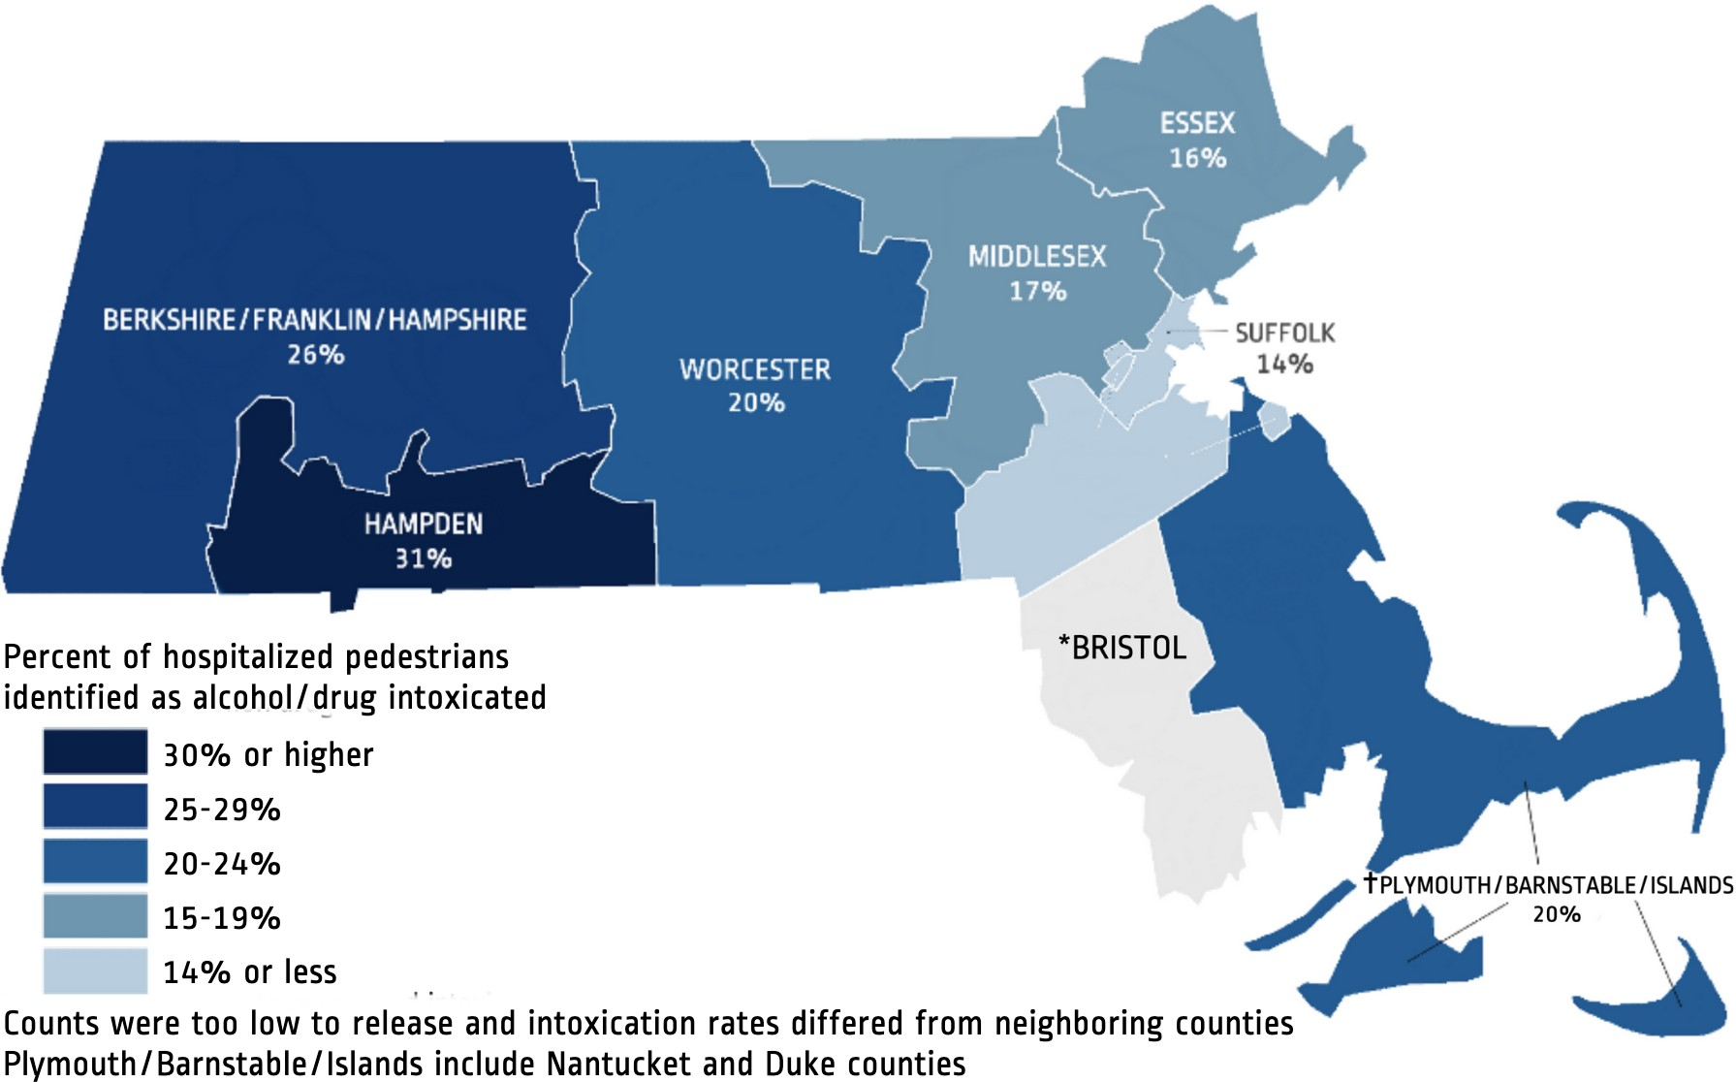
Figure 4. Intoxication Rates in Hospitalized Pedestrians by County where Crash Occurred, MA CRISS Data, 2012-2015 (n=965)

Limitations
Intoxication rates may be underestimated if pedestrians were not tested for alcohol/drugs or intoxication was not documented in the medical record or crash report. Intoxication rates may be biased by whether health care providers and police test for alcohol/drugs and how soon after the crash they are tested. Low numbers of hospitalized drivers in some demographic groups also limited the analysis. More recent hospital discharge data were not available for linkage with crash data at the time of the analysis.

Strategies to Reduce Intoxication-related Injuries Among Pedestrians
Injury Surveillance Program | Massachusetts Department of Public Health Office of Statistics and Evaluation, Bureau of Community Health and Prevention
mass.gov/injury-surveillance-program
These results underscore the critical need to monitor and reduce risks of injury to intoxicated pedestrians in Massachusetts. Strategies to reduce such risks include:
Promoting and improving availability and affordability of ride-sharing in affected communities. Supporting enforcement by the Alcohol Beverage Control Commission to reduce over-serving.7 Improving street lighting, particularly in areas with high densities of eating and drinking establishments.⁸
Closing streets, temporarily or permanently, in areas with high densities of eating and drinking establishments. Supporting strategies that lower vehicle speeds, including road diets or lane reductions, reduced speed limits, and default red signals at intersections during periods of low traffic demand, particularly in areas with high densities of eating and drinking establishments.^{9,} ¹⁰
Improving access to substance use disorder prevention, intervention, treatment, and recovery support services. Supporting measures to reduce intoxicated driving, as intoxicated pedestrians are sometimes struck by intoxicated drivers.⁷ See prevention strategies in Alcohol & Drug Intoxication in Drivers Hospitalized for Motor Vehicle Crash Injuries, Massachusetts, 2012 – 2015.
Implementing interventions consistent with a Complete Streets approach, including physically separating pedestrians and cars, bumping out curbs to decrease the distance pedestrians must traverse to cross roads, installing high-visibility crosswalk markings, and improving lighting and sight lines at crosswalks.⁸
Revising signal timings to reduce conflicts, including increasing time for pedestrians to cross intersections, and providing all-pedestrian phases and left-turn phases.¹¹
Creating communication campaigns that promote avoiding driving and walking while intoxicated and raise awareness of the associated risks to maintain safety among drivers and pedestrians.
Strategies to reduce overall pedestrian crashes described in the MA Strategic Highway Safety Plan (SHSP) 2018.

Data Sources & References
MA Crash-Related Injury Surveillance System data:
Inpatient Hospital Discharge data (Jan. 2012 – Sep. 2015), Center for Health Information and Analysis Crash Data System (Jan. 2012 – Sep. 2015), MA Registry of Motor Vehicles

1 FFY 2020 Massachusetts Highway Safety Plan
2 NHTSA Crashstats – DOT HS 812850
3 Kemnitzer CR, Pope CN, Nwosu A, Zhao S, Wei L, Zhu M. An investigation of driver, pedestrian, and environmental characteristics and resulting pedestrian injury. Traffic Injury Prevention. 2019;20(5):510-514. doi:10.1080/15389588.2019.1612886
4 Batouli G, Guo M, Janson B, Marshall W. Analysis of pedestrian-vehicle crash injury severity factors in Colorado 2006–2016. Accident Analysis & Prevention. 2020;148:105782. doi:10.1016/j.aap.2020.105782
5 Alcohol and Drug Involvement in MA Motor Vehicle Crashes
6 Berning et al. (2020, October). Drug and alcohol prevalence in seriously and fatally injured road users before and during the COVID-19 public health emergency (Report No. DOT HS 813 018). National Highway Traffic Safety Administration.
⁷ Fell JC, Scolese J, Achoki T, Burks C, Goldberg A, DeJong W. The effectiveness of alternative transportation programs in reducing impaired driving: A literature review and synthesis. Journal of Safety Research. 2020;75:128-139. doi:10.1016/j.jsr.2020.09.001
⁸ Mead J, Zegeer C, Bushell M. Evaluation of Pedestrian-Related Roadway Measures: A Summary of Available Research. Pedestrian and Bicycle Information Center; 2014. Accessed June 3, 2021.
9 Hutchinson TP, Kloeden CN, Lindsay VL. Countermeasures to the problem of accidents to intoxicated pedestrians. J Forensic Leg Med. 2010;17(3):115-119. doi:10.1016/j.jflm.2009.11.004
10 Archer J, Candappa N, Corben B. Effectiveness of the dwell-on-red signal treatment to improve pedestrian safety during high-alcohol
hours. Paper presented at: 2008 Australasian Road Safety Research, Policing and Education Conference; November 9-12, 2008; Adelaide, Australia. Accessed June 11, 2021. http://casr.adelaide.edu.au/rsr/RSR2008/ArcherJ.pdf
¹¹ Lenné MG, Corben BF, Stephan K. Traffic signal phasing at intersections to improve safety for alcohol-affected pedestrians. Accid Anal Prev. 2007;39(4):751-756. doi:10.1016/j.aap.2006.11.006
This document was supported by the National Center for Injury Prevention and Control of the Centers for Disease Prevention and Control (CDC)
under award number NU17CE924835. The content is solely the responsibility of the authors and does not necessarily represent the official views of the CDC.

