ODOR INVESTIGATION

Alcoholic Beverages Control Commission
239 Causeway Street
Boston, Massachusetts 02114

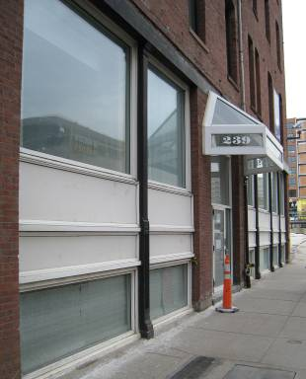

Prepared by:
Massachusetts Department of Public Health
Bureau of Environmental Health
Indoor Air Quality Program
March 2009

Background/Introduction
At the request of Ralph Sacramone, Executive Director, Alcoholic Beverages Control Commission (ABCC), the Massachusetts Department of Public Health (MDPH), Bureau of Environmental Health (BEH) provided assistance and consultation regarding odor concerns at the ABCC, 239 Causeway Street, Boston, Massachusetts. On February 10, 2009, a visit to conduct an odor investigation was made to the ABCC by Sharon Lee and James Tobin, Environmental Analysts/Inspectors within BEH’s Indoor Air Quality (IAQ) Program. Ms. Lee returned to the ABCC on February 12, 2009, accompanied by Michael Feeney, Director of BEH’s IAQ Program. The request was prompted by occupant concerns of odors in the building.
The facility at 239 Causeway Street is a five-story brick office building, constructed in the late 1800s as a factory/warehouse. The ABCC office occupies space on the first floor, and consists of perimeter offices and centralized cubicles.

Methods

BEH staff performed a visual inspection for potential sources of odors as well as any pathways that could provide a means of migration of odors into occupied areas. In addition, general indoor air quality tests for carbon monoxide, carbon dioxide, temperature and relative humidity were conducted with the TSI, Q-TRAK™ IAQ Monitor, Model 8551. Temperature measurements of building materials were taken with a Ryobi IR001 Non-contact Infrared Thermometer with Laser.

Results
Tests were taken during normal operations and results appear in Table 1.

Discussion

Ventilation
It can be seen from Table 1 that carbon dioxide levels were below 800 parts per million (ppm) in all areas surveyed. Ventilation is provided by a heating, ventilation and air conditioning (HVAC) system. Fresh air is introduced by air-handling units (AHUs). Heat pumps are located above ceiling tiles/in the ceiling plenum to facilitate airflow. Transfer air from the AHU is drawn into the heat pumps and delivered to work stations via ceiling-mounted air diffusers (Picture 1). Air drawn through metal/plastic grates into the ceiling plenum, which returns air to the AHUs where it is exhausted (Picture 1).
To maximize air exchange, the MDPH recommends that both supply and exhaust ventilation operate continuously during periods of occupancy. In order to have proper ventilation with a mechanical supply and exhaust system, the systems must be balanced to provide an adequate amount of fresh air to the interior of a room while removing stale air from the room. It is recommended that HVAC systems be re-balanced every five years to ensure adequate air systems function (SMACNA, 1994). The date of the last balancing of these systems was not available at the time of the assessment.
The Massachusetts Building Code requires that each room have a minimum ventilation rate of 20 cubic feet per minute (cfm) per occupant of fresh outside air or openable windows (SBBRS, 1997; BOCA, 1993). The ventilation must be on at all times that the room is occupied. Providing adequate fresh air ventilation with open windows and maintaining the temperature in the comfort range during the cold weather season is impractical. Mechanical ventilation is usually required to provide adequate fresh air ventilation.
Carbon dioxide is not a problem in and of itself. It is used as an indicator of the adequacy of the fresh air ventilation. As carbon dioxide levels rise, it indicates that the ventilating system is malfunctioning or the design occupancy of the room is being exceeded. When this happens, a buildup of common indoor air pollutants can occur, leading to discomfort or health complaints. The Occupational Safety and Health Administration (OSHA) standard for carbon dioxide is 5,000 parts per million parts (ppm). Workers may be exposed to this level for 40 hours/week, based on a time-weighted average (OSHA, 1997).
The MDPH uses a guideline of 800 ppm for publicly occupied buildings. A guideline of 600 ppm or less is preferred in schools due to the fact that the majority of occupants are young and considered to be a more sensitive population in the evaluation of environmental health status. Inadequate ventilation and/or elevated temperatures are major causes of complaints such as respiratory, eye, nose and throat irritation, lethargy and headaches. For more information concerning carbon dioxide, consult Appendix A.
Temperature measurements in occupied areas the on day of the assessment ranged from 71º F to 73º F, which were within the MDPH recommended comfort range. The MDPH recommends that indoor air temperatures be maintained in a range of 70º F to 78º F in order to provide for the comfort of building occupants. In many cases concerning indoor air quality, fluctuations of temperature in occupied spaces are typically experienced, even in a building with an adequate fresh air supply. In addition, it is difficult to control temperature and maintain comfort without operating the ventilation equipment as designed (e.g., supply deactivated/inoperable, exhaust obstructed).
The relative humidity ranged from 16 to 21 percent, which was below the MDPH recommended comfort range in all areas surveyed during the assessment. The MDPH recommends a comfort range of 40 to 60 percent for indoor air relative humidity. Relative humidity would be expected to drop below comfort levels during the heating season. The sensation of dryness and irritation is common in a low relative humidity environment. Low relative humidity is a very common problem during the heating season in the northeast part of the United States.

Odor Investigation
As previously mentioned, the assessment was prompted by complaints of odors. Occupants reported gas-like odors in the Chief Investigator’s office (CI office) at the northwest (Causeway St) side of the building, as well as the adjoining stairwell. At the time of the February 10, 2009 assessment, BEH staff detected a very slight musty odor in the CI office. BEH staff noted a cold draft from the wall along the building exterior. Surface temperature measurements of the floor (75º F at center of room, 65º F at wall coving) and exterior wall (68º F at upper wall near window) confirmed that it is likely cold outdoor air is penetrating into the wall cavity of the office wall. BEH staff removed the coving against the wall, and detected a strong draft of cold air from the space between the gypsum wallboard and carpeted floor (Picture 2). The temperature at this junction was 64º F. The source of the draft and odors appears to be a combination of air sources, which include the adjoining stairwell and breaches in the building exterior window systems.
The CI office is adjacent to a stairwell, which leads to the exterior of the building. BEH staff located spaces around the exterior door. The lack of appropriate door sweep and weather stripping can allow air and moisture to penetrate the building. More importantly, BEH staff observed an opening under the bottom staircase, which provides access to a pipe chaseway (Picture 3). This pipe chaseway runs below the CI office, conference room, Executive Director’s office, as well as other offices along this exterior wall; it is also parallel to Causeway Street (Picture 4). Debris was observed on the floor of the chaseway, and signs of water penetration were noted (Picture 5). Repeated water penetration and increased humidity during the summer months can result in odors, as the dirt, dust and other debris in this space is repeatedly exposed to moisture. Air movement into this space from the outside of the building (i.e., through breaches in the exterior door system can result in pressurization of the chaseway, which can push the odors into the stairwell or up the office wall space. At the time of MDPH’s visit on February 12, 2009, this opening had been sealed (Picture 6).
BEH staff also observed conditions around the building’s exterior and noted breaches in window system panels (Pictures 7 to 9). These breaches can allow air and moisture to penetrate the wall space between the exterior wall and the interior wall. Air from these breaches aide the movement of air/odors from the chaseway into offices spaces.
In order to explain how odors moving into occupied spaces, the following concepts concerning heated air and creation of air movement must be understood:
- Heated air in occupied areas will create upward air movement (stack effect).
- Cold air moves to hot air, creating drafts.
- As the heated air rises, negative pressure is created, drawing cold air to the heat source.
- Airflow created by the stack effect, drafts or wind-driven air can draw airborne odors and particulates into the air stream.
Each of these concepts influences the movement of odors from non-occupied to occupied spaces. Cooler air from the chaseway moves up the wall space towards warmer air in occupied areas. Infiltration of cold air from the building exterior creates a draft, which increases the draw of air from the chaseway up through the wall space and into occupied areas. The opening of the exterior door also increases air movement into the chaseway.
Furthermore, sidewalk grates were noted outside this area of the building (Picture 10). These grates allow heat and air to escape the subway system and pipes that run below the building. Odors can periodically be detected from air emanating from these grates, which can further contribute to odors within the ABCC occupied space.
Temperature differences between the wall space air and building materials (i.e., office wall and floor) can produce condensation in the window/wall spaces. Condensation is the collection of moisture on a surface at or below the dew point. The dew point is the temperature that air must reach for saturation to occur. During cooler months, indoor relative humidity is relatively low. Low relative humidity would reduce the likelihood of condensation on surfaces. However, during summer months, the interaction of the chilled air in the office with the warm, moist air from the chaseway compounded with hot, humid air form the outdoors could result in condensation generation. For example, at a temperature of 83º F and relative humidity of 60%, the dew point necessary for water to collect on a surface is 68º F. During summer months, any surfaces inside the ABCC offices with a temperature at or below 68º F would generate condensation. At the time of this assessment, the floor temperatures ranged from 75º F near the center of the room to 65º F at the wall/flooring junction. Given that indoor temperatures are maintained at similar temperatures during the heating and cooling months, it is likely that condensation is forming on the gypsum wallboard and carpeting, resulting in moistening of these materials.
The American Conference of Governmental Industrial Hygienists (ACGIH) recommends that porous materials be dried with fans and heating within 24 hours of becoming wet (ACGIH, 1989). If these materials are not dried within this time frame, mold growth may occur. Once colonized by microbes, the cleaning of water-damaged porous materials cannot be adequately cleaned to remove mold growth. Chronic moistening of materials in the ABCC may also be contributing to odors in these areas.

Other IAQ Evaluations
Indoor air quality can be negatively influenced by the presence of respiratory irritants, such as products of combustion. The process of combustion produces a number of pollutants. Common combustion emissions include carbon monoxide, carbon dioxide, water vapor and smoke (fine airborne particle material). Of these materials, exposure to carbon monoxide and particulate matter with a diameter of 2.5 micrometers (μm) or less (PM2.5) can produce immediate and acute health effects upon exposure. To determine whether combustion products were present inside the building, BEH staff obtained measurements for carbon monoxide.
Carbon monoxide is a by-product of incomplete combustion of organic matter (e.g., gasoline, wood and tobacco). Exposure to carbon monoxide can produce immediate and acute health affects. Several air quality standards have been established to address carbon monoxide and prevent symptoms from exposure to these substances. The MDPH established a corrective action level concerning carbon monoxide in ice skating rinks that use fossil-fueled ice resurfacing equipment. An operator of an indoor ice must take actions to reduce carbon monoxide levels, if those levels exceed 30 ppm, 20 minutes after resurfacing within a rink (MDPH, 1997).
The American Society of Heating Refrigeration and Air-Conditioning Engineers (ASHRAE) has adopted the National Ambient Air Quality Standards (NAAQS) as one set of criteria for assessing indoor air quality and monitoring of fresh air introduced by HVAC systems (ASHRAE, 1989). The NAAQS are standards established by the US EPA to protect the public health from six criteria pollutants, including carbon monoxide and particulate matter (US EPA, 2006). As recommended by ASHRAE, pollutant levels of fresh air introduced to a building should not exceed the NAAQS levels (ASHRAE, 1989). The NAAQS were adopted by reference in the Building Officials & Code Administrators (BOCA) National Mechanical Code of 1993 (BOCA, 1993), which is now an HVAC standard included in the Massachusetts State Building Code (SBBRS, 1997). According to the NAAQS, carbon monoxide levels in outdoor air should not exceed 9 ppm in an eight-hour average (US EPA, 2006).
Carbon monoxide should not be present in a typical, indoor environment. If it is present, indoor carbon monoxide levels should be less than or equal to outdoor levels. Outdoor carbon monoxide concentrations were non-detect (ND) (Table 1). Carbon monoxide levels measured in the building were also ND during the assessment.
Indoor air quality can also be negatively influenced by the presence of materials containing VOCs. VOCs are carbon-containing substances that have the ability to evaporate at room temperature. Frequently, exposure to low levels of total VOCs (TVOCs) may produce eye, nose, throat and/or respiratory irritation in some sensitive individuals. In an effort to determine whether VOCs were present in the building, air monitoring for TVOCs was conducted. An outdoor air sample was taken for comparison. Outdoor TVOC concentrations were ND. Indoor TVOC concentrations were also ND (Table 1).
In addition, staff reported sewer-like odors in the women’s restroom. As reported by ABCC staff, these odors occur periodically. BEH staff observed conditions in the women’s restroom and noted a floor drain. The floor drain appeared dry at the time of the assessment (Picture 11); however, no odors were detected. The most likely source of odors in the restroom is a dry drain trap in floor drain. The purpose of a drain trap is to prevent sewer system gases and odors from entering the occupied space. When water is poured into a trap, an air tight seal is created by the water in the U-bend section of the pipe. Water must be poured into the traps at least twice a week to maintain the integrity of the seal and prevent odors. Without water, the drain opens the room to the sewer system. If a mechanical device depressurizes the room, air, gas, and odors can be drawn from the sewer system into the room.
It appears that work to repair a pipe had been conducted in the women’s restroom (Picture 12); however, the tiles that were removed for the repair had not been replaced. According to ABCC staff, these tiles have been missing for some time. These tiles should be replaced to prevent movement of particles from the chaseway through the breaches around the gypsum wallboard into the restroom.
A water-damaged ceiling tile was observed in the CI’s office (Picture 1). Water-damaged/missing ceiling tiles can indicate roof or plumbing leaks. Water-damaged ceiling tiles can provide a source for mold growth and should be replaced after a water leak is discovered and repaired.
Lastly, exposed fiberglass insulation was observed in the ceiling plenum of the CI’s office (Picture 13). Fiberglass insulation can provide a source of skin, eye and respiratory irritation. If drawn into the ceiling’s HVAC system, fiberglass particles can be distributed throughout the office spaces.

Conclusions/Recommendations
In view of the findings at the time of this visit, the following recommendations are made to reduce/prevent odors and to improve indoor air quality:
- Seal breaches in the building’s exterior wall to prevent movement of outdoor air into the building.
- Ensure breaches between the pipe chaseway and the first floor are sealed to prevent movement of air up through the wallspace.
- Examine the wall and carpet tiles of offices (i.e., CI office, Conference room, Director’s office) along the building exterior to determine whether these materials have become water-damaged.
- Consider removing/replacing gypsum wallboard and floor tiles along the building exterior. Such remediation activities should be conducted in a manner consistent with recommendations in “Mold Remediation in Schools and Commercial Buildings” published by the US Environmental Protection Agency (US EPA, 2001). This document is available from the US EPA: http://www.epa.gov/iaq/molds/mold_remediation.html.
- Weather-strip the exterior door in the adjacent hallway.
- Pour water into floor traps at least twice a week to maintain the integrity of the seal and prevent odors.
- Replace missing tiles in women’s restroom wall to prevent movement of particles.
- Re-wrap insulation to prevent exposure.
- Refer to resources and other related indoor air quality documents located on the MDPH’s website for further building-wide evaluations and advice on maintaining public buildings. These documents are available at: http://mass.gov/dph/iaq.

References
ACGIH. 1989. Guidelines for the Assessment of Bioaerosols in the Indoor Environment. American Conference of Governmental Industrial Hygienists, Cincinnati, OH.
ASHRAE. 1989. Ventilation for Acceptable Indoor Air Quality. American Society of Heating, Refrigeration and Air Conditioning Engineers. ANSI/ASHRAE 62-1989
BOCA. 1993. The BOCA National Mechanical Code/1993. 8th ed. Building Officials & Code Administrators International, Inc., Country Club Hills, IL.
MDPH. 1997. Requirements to Maintain Air Quality in Indoor Skating Rinks (State Sanitary Code, Chapter XI). 105 CMR 675.000. Massachusetts Department of Public Health, Boston, MA.
OSHA. 1997. Limits for Air Contaminants. Occupational Safety and Health Administration. Code of Federal Regulations. 29 C.F.R 1910.1000 Table Z-1-A.
Sanford. 1999. Material Safety Data Sheet (MSDS No: 198-17). Expo® Dry Erase Markers Bullet, Chisel, and Ultra Fine Tip. Sanford Corporation. Bellwood, IL.
SBBRS. 1997. Mechanical Ventilation. State Board of Building Regulations and Standards. Code of Massachusetts Regulations. 780 CMR 1209.0
SMACNA. 1994. HVAC Systems Commissioning Manual. 1st ed. Sheet Metal and Air Conditioning Contractors’ National Association, Inc., Chantilly, VA.
US EPA. 2001. “Mold Remediation in Schools and Commercial Buildings”. Office of Air and Radiation, Indoor Environments Division, Washington, DC. EPA 402-K-01-001. March 2001. Available at: http://www.epa.gov/iaq/molds/mold_remediation.html
US EPA. 2006. National Ambient Air Quality Standards (NAAQS). US Environmental Protection Agency, Office of Air Quality Planning and Standards, Washington, DC. http://www.epa.gov/air/criteria.html.
Picture 1

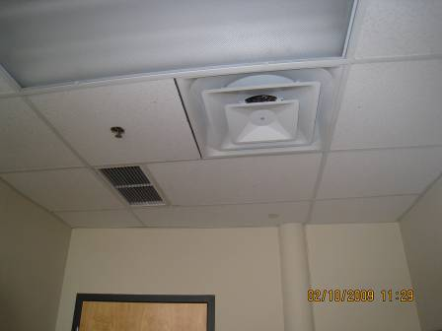
Exhaust vent
Water-damaged ceiling tile
supply vent

Supply and exhaust ventilation

Picture 2

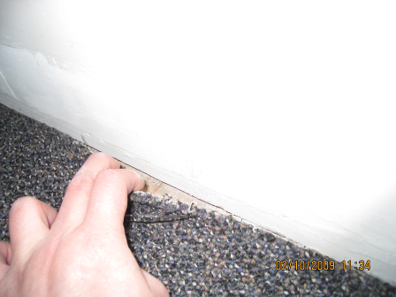

Space between floor and gypsum wallboard

Picture 3

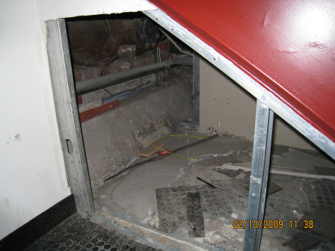

Opening under stairwell

Picture 4

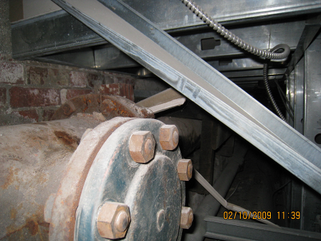

Pipe chaseway

Picture 5

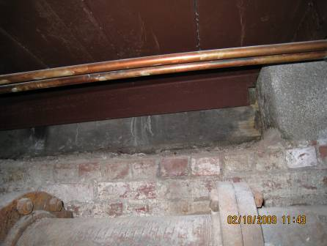
Water penetration
debris

Brick wall of chaseway, note signs of water penetration against foundation wall

Picture 6

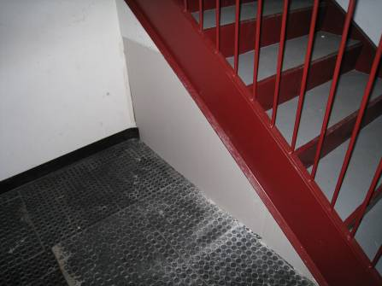

Opening under stairwell sealed
Picture 7

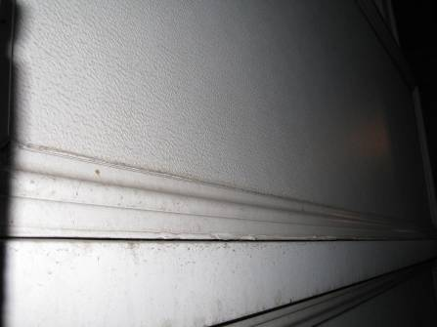

Breach in exterior wall panel

Picture 8

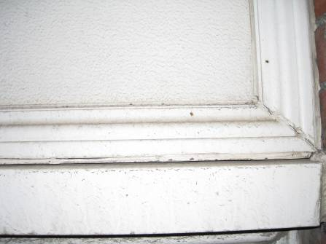

Breach in exterior wall panel

Picture 9

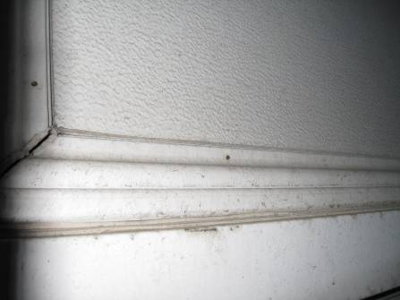

Breach in exterior wall panel

Picture 10

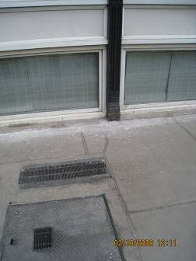

Exhaust grates in sidewalk

Picture 11

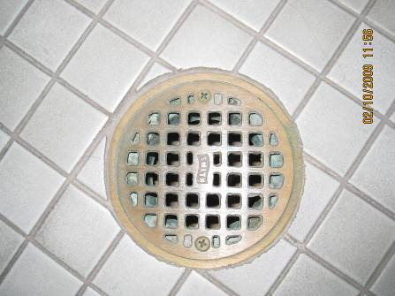

Floor drain in women’s restroom

Picture 12

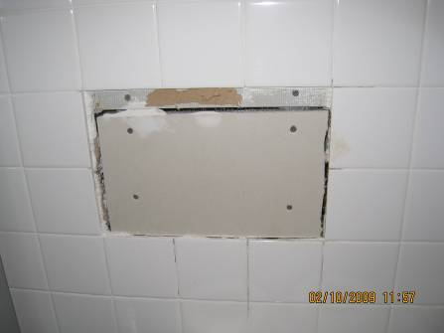

Missing wall tiles in women’s restroom

Picture 13

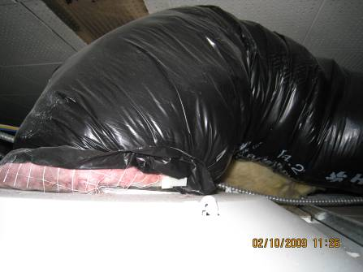

Exposed fiberglass insulation in ceiling plenum of CI’s office
- Location | Occupants  in Room | Temp  (°F) | Relative  Humidity  (%) | Carbon  Dioxide  (ppm) | Carbon Monoxide  (ppm) | VOCs (ppm) | Windows  Openable | Ventilation |  | Remarks
 |  |  |  |  |  |  |  | Supply | Exhaust | Remarks
Outside  (Background) |  | 33 | 19 | 457 | 2 | ND |  |  |  | Overcast, Heavy car traffic
CI’s office |  | 71-73 | 16 | 687 | ND | ND |  | Y | Y | Breaches along exterior wall  Floor temp:  - 75ºF at center of room  - 68ºF 6 inches from wall  - 65ºF at wall coving  - 64ºF in breach  Wall temp: 68ºF
Hallway/Stairwell |  |  |  |  |  |  |  |  |  | Breach under stairwell  Brick wall temp: 66ºF  Interior wall temp: 72ºF  Slight odor
Director’s office | 4 | 72 | 16 | 697 | ND | ND |  | Y | Y
Reception area | 6 | 73 | 21 | 789 | ND | ND |  | Y | Y

