INDOOR AIR QUALITY ASSESSMENT

Odor Investigation

**Alfred J. Gomes Elementary School**

286 S 2nd Street

New Bedford, MA

**June 2024**

Alfred J. Gomes Elementary School
286 S 2nd Street
New Bedford, MA


Prepared by:

Massachusetts Department of Public Health

Bureau of Climate and Environmental Health

Indoor Air Quality Program

Contents

EXECUTIVE SUMMARY 3

BACKGROUND 4

RESULTS AND DISCUSSION 4

Ventilation 5

HVAC System Maintenance 6

HVAC Types and Specific Conditions 6

Water Damage and Moisture Concerns 6

Water Damage Issues 7

Sources of Respiratory Irritants/Possible Asthma Triggers 8

CONCLUSIONS AND RECOMMENDATIONS 9

REFERENCES 12

PICTURES 13

HVAC pictures 13

Table 1 21

Location 21

Table 2A 22

Table 2B 23

Table 2C 24

Table 3 25

Table 4 27

# EXECUTIVE SUMMARY

The Massachusetts Department of Public Health’s Indoor Air Quality Program (MDPH IAQ) conducted an IAQ assessment of several common areas (atrium, forum, gymnasium and cafeteria) as well as the boiler room of the Alfred J. Gomes Elementary School located at 286 S 2nd Street in New Bedford on May 31, 2024. This assessment was coordinated through the New Bedford Health Department for the purpose of investigating general IAQ concerns as well as odors reported in the building. No other location was evaluated during the assessment (classrooms and offices). The request was prompted by general IAQ symptoms (i.e., tiredness) and odors that may be attributed to the boiler room. Note: these issues were reported by community members in the areas examined during after-hours meetings/activities.

The assessment was conducted by evaluating several key elements within the school; a visual inspection of the heating, cooling, and ventilation (HVAC) system components, water/microbial damage, cleanliness, point sources of respiratory irritants such as chemicals in areas with the reported odor issues. In an effort to identify odors sources air measurement of carbon dioxide (CO2), carbon monoxide (CO), temperature, relative humidity (RH), taken with a Qtrak 7575-X monitor was conducted along with measurement of small particulate matter (PM2.5) with a TSI DustTrak 8520. Additionally, total volatile organic compound (TVOC) measurements were taken with a RAE Systems, MiniRAE photo-ionization detector.

As a result of this assessment, there are several findings: odors of concern are likely attributed to the boiler room, the door to which was pegged open at the time of the assessment. In addition, air handling units and other HVAC components may be beyond their lifespan, which make maintenance increasingly difficult, and there are other issues such as dust/debris accumulated on vents. (Results and Discussion).

The MA DPH has previously conducted general IAQ assessments at the building. Reports regarding finding and recommendations can be found at <https://www.mass.gov/doc/alfred-j-gomes-elementary-school-may-2009-0/download> which contains a description of the buildings HVAC systems and condition noted.

Based on the results of the odor assessment the following primary recommendations are made: (Conclusions)

* Keep both internal and external boiler room doors closed at all times.
* Install weather-stripping on both internal and external boiler room doors and monitor for light penetration to check tightness.
* Ensure to operate all ventilation systems throughout the building *continuously* during periods of school occupancy, and after hours *as needed.*
* Clean dust/debris from supply, return, and exhaust vents on a regular basis.

(Conclusions and Recommendations)

# BACKGROUND

|  |  |
| --- | --- |
| Building: | Alfred J. Gomes Elementary School (GES) |
| Address: | 286 S 2nd Street  New Bedford, Massachusetts |
| Assessment Requested by: | Joseph Carvalho, Director of Environmental Health, New Bedford Health Department |
| Reason for Request: | General IAQ concerns, symptoms (i.e., tiredness) and odors that may be attributed to the boiler room. Note: these issues were reported by community members in the areas examined during after-hours meetings/activities. |
| Date of Assessment: | May 31, 2024 |
| Massachusetts Department of Public Health/Bureau of Climate and Environmental Health (MDPH/BCEH) Staff Conducting Assessment: | Cory Holmes, Assistant Director, IAQ Program |
| Building Description: | The GES is a two-story, brick and concrete building constructed on a slab foundation in the late 1970s. The building contains general classrooms, a main kitchen with four cafeterias, library, gym, music rooms, art rooms and office space. The building has a concrete honeycombed ceiling, with dropped ceiling tiles in some areas. The majority of heating, ventilation, and air conditioning (HVAC) components date back to original construction. However, it was reported that rooftop air handling units would be on a capital repair project for the summer of 2025. In addition, the roof is reported to be near or at the end of its service life. |
| Windows: | Most windows in the building are openable, although there were no openable windows in the areas examined on May 31, 2024. |

# RESULTS AND DISCUSSION

The following is a summary of indoor air testing results (Table 1)

|  |  |  |
| --- | --- | --- |
| * ***Carbon dioxide (CO2)*** | *a measure of the adequacy of ventilation* | Levels were below the MDPH guideline of 800 parts per million (ppm) in the areas surveyed. However, these areas were unoccupied at the time of assessment. Carbon dioxide levels would expect to be more elevated with increased occupancy. |
| * ***Temperature*** | *a measure of comfort* | Measurements were within or very close to the MDPH recommended range of 70°F to 78°F in occupied areas. |
| * ***Relative humidity*** | *a measure of comfort and, when in excess for an extended period, a way to reflect the potential for mold and fungal growth* | Measurements were within the MDPH recommended range of 40 to 60% in all areas tested. Relative humidity would be expected to be lower during cold outdoor temperatures and indoor heating. |
| * ***Carbon monoxide***   ***(CO)*** | *a product of combustion that can result in acute and long term cardiovascular, respiratory, and neurological symptoms* | Levels were non-detectible in all areas assessed. |
| * ***Total Volatile Organic Compounds (TVOCs)*** | *VOCs are carbon-containing substances that have the ability to evaporate at room temperature, which may produce eye, nose, throat and/or respiratory irritation in some sensitive individuals* | Levels were non-detectible in all areas assessed. |
| * ***Particulate matter (PM2.5)*** | *a way to measure inhalable particle distribution in the air* | Concentrations were below the National Ambient Air Quality Standard (NAAQS) of 35 micrograms per cubic meter (μg/m3) in all areas tested. |

## Ventilation

Ventilation refers to both the supply of fresh air and the removal of stale air from a room. The introduction of fresh air into an occupied space will dilute normally occurring pollutants that are generated by occupancy and other activities. In addition, an HVAC system will remove pollutants from a building if operating appropriately. All ventilation systems throughout the building should operate continuously during periods of occupancy.

The GES has rooftop air handing units (AHUs) that provide heat and fresh air for central and common areas. Mechanical ventilation for the areas examined on May 31st were supplied by rooftop AHUs. The air handling units bring in fresh air from the roof, filter it, heat it, and bring it into occupied areas through ceiling or wall-mounted supply vents (Pictures 1 and 2). These areas are also equipped with exhaust or return vents that remove stale air from rooms (Picture 3) (Table 2B).

The various types of ventilation components as well as devices that can move/redirect airflow are listed in Table 2A, Table 2B and Table 2C.

### HVAC System Maintenance

* Various components throughout the building are likely beyond their service life. According to the American Society of Heating, Refrigeration, and Air-Conditioning Engineering (ASHRAE), the service life of this type of unit is 15-20 years, assuming routine maintenance of the equipment (ASHRAE, 1991). As previously mentioned, AHUs are planning to be on a capital repair list for replacement over the summer of 2025.

### HVAC Types and Specific Conditions

**Balancing**

To have proper ventilation with a mechanical supply and exhaust system, a system must be balanced to provide an adequate amount of fresh air to the interior of a room while also removing stale air from the room.

It is recommended that HVAC systems be re-balanced every five years to ensure adequate air systems function (SMACNA, 1994).

(see HVAC pictures)

* Both supply and exhaust were operating at the time of assessment. MDPH IAQ staff asked school staff if it was possible that the HVAC system deactivated at a certain time after hours, which may have created adverse conditions (lack of air exchange) during evening meetings/events, but it was reported that the systems operate *continuously*.

## Water Damage and Moisture Concerns

Please note that the IAQ Program does not recommend conducting mold testing in a typical water damage remediation. For details, please consult [Guidance Regarding Testing for Mold in Water-Damaged Public Buildings](https://www.mass.gov/info-details/guidance-regarding-testing-for-mold-in-water-damaged-public-buildings) | Mass.gov

The application of a mildewcide to moldy porous materials is not recommended.

Molds are found naturally in our environment both indoors and outdoors. Inside, mold growth may occur when items, particularly porous products such as paper or gypsum wallboard, are exposed to moisture. Typical water sources include leaks, floods, and condensation. To avoid mold growth, dry all water-damaged items and affected areas within 24-48 hours and reduce indoor humidity. Some people with chronic respiratory conditions, such as asthma, are more likely to experience health symptoms associated with molds, including allergic reactions and respiratory irritation. Controlling moisture is the key to preventing mold growth and potential health symptoms.

Hot humid summers are becoming more frequent due to climate change. Massachusetts has experienced hot, humid, and rainy summers in 2018, 2021, and 2023. July of 2021 was the wettest ever recorded in Massachusetts, and the three-month period from June through August, known as the meteorological summer, was the fourth wettest on record, according to the National Oceanic and Atmospheric Administration’s (NOAA) Centers for Environmental Information (NOAA, 2021). The summer of 2023 was also hot, and wet, being measured as the second rainiest on record (WBUR, 2023). These conditions are challenging for buildings, particularly those without air conditioning.

During these hot and wet summers, extended periods of outdoor relative humidity above 70% occurred. Under these weather periods, public buildings experienced extended periods of water vapor exposure from high relative humidity. When exposed to these conditions, porous materials such as gypsum wallboard, cardboard, and other materials may become prone to developing mold colonization, particularly if located in areas that are prone to developing condensation on floors and walls (e.g., below grade space).

### Water Damage Issues

(see Water Damage and Moisture Concern Pictures)

* **No water damage issues were observed in the spaces examined on May 31st. with the exception of a periodic leak in the gymnasium (Picture 4).** Although this leak should be addressed to prevent further staining/damage, there were no porous building materials in the area susceptible to mold growth.

Several other conditions on the outside of the buildings were identified which can contribute to water issues, which are specified in Table 3. Several issues related to water infiltration were identified and are listed below.

**Mold Growth**

Porous materials (e.g., gypsum wallboard, ceiling tiles and carpeting) can be dried with fans and heating within 24 to 48 hours of becoming wet (US EPA, 2008).

If porous materials are not dried within this time frame, mold growth may occur.

* **Trees were in close proximity and overhanging the building (Pictures 5 and 6) which may prevent the exterior of the building from drying, and clog roof drains with leaves and other debris.** In severe weather, trees may also fall onto the building.

## Sources of Respiratory Irritants/Possible Asthma Triggers

For guidance on maintaining an asthma-friendly healthy school environment, please consult the MDPH Asthma Prevention and Control Program’s [Clearing the Air: An Asthma Toolkit for Healthy Schools](https://www.maasthma.org/schooltoolkit).

Possible asthma triggers and/or airborne pollutants exist in the building. These are listed below as well as in (Table 4).

(see Sources of Respiratory Irritant Pictures)

* **As mentioned, the boiler room doors were found pegged open (Pictures 7 and 8), which can allow odors and fumes into adjacent areas.** In addition, spaces were observed beneath interior and exterior doors (Pictures 9 and 10), which can allow for the migration of drafts, moisture and pests into the building.
* **The passive combustion air vents for the boiler room are located along busy Route 18 (Pictures 11 and 12). Under certain wind conditions, vehicle exhaust may migrate into the boiler room if the combustion air vent lacks or has louvers in the open position when the furnace is deactivated. If wind pressurizes the boiler room, boiler room odors may then migrate into occupied areas if the boiler room door is ajar or open.**
* **Some areas had carpet squares and area rugs (Pictures 13 and 14).** All rugs and carpeting should be cleaned regularly in accordance with IICRC recommendations, annually or semi-annually in soiled/high traffic areas (IICRC, 2012), to remove dust, debris, and odors. Used area rugs should not be brought into the school as they may harbor allergens such as pet dander. Area rugs should be stored in a climate-controlled area off the floor over the summer to prevent moistening due to condensation and high humidity.
* **Plush items/stuffed animals and upholstered furniture were noted in the Atrium (Picture 14).** These items should be cleaned periodically to remove dust and odors.
* **In some areas supply/exhaust vents were dusty (Table 1; Picture 15).** This dust can be aerosolized under certain conditions and can also be a medium for mold growth.

# CONCLUSIONS AND RECOMMENDATIONS

**Please note:** this report contains a series of recommendations that should serve as *Best Practices* that apply to most public-school buildings across the Commonwealth and should be shared amongst other buildings in the School District.

Issues typical to many schools were found in this building. The age of the HVAC equipment will make controlling temperature and airflow more difficult as time goes on. Drainage and water infiltration issues particularly in the gym should be addressed as the roof is likely past its service life. Other issues described can be mitigated with repairs/modifications to interior and exterior doors, and with changes to occupant behaviors to keep boiler room doors shut.

**Short-term recommendations** can be implemented as soon as practicable, however **long-term measures** are more complex and will require planning and resources to adequately address overall indoor air quality concerns within the building.

|  |  |  |
| --- | --- | --- |
| **Short-term Recommendations** | | |
| **HVAC System** | | |
|  | Ensure all univents and AHUs are on and operating during occupied periods including after typical school hours. |  |
|  | Periodically check the function of all exhaust vents and repair as needed. |  |
|  | Continue to change filters (using filters with a minimum efficiency rating value (MERV rating) of 8 or higher in univents and other HVAC units at least twice a year, and more often if the filters are obviously soiled when changed. |  |
|  | During filter changes, clean dust and debris from the inside of univent and HVAC system cabinets. |  |
|  | Have the HVAC system balanced if it has been more than 5 years since the last balancing. |  |

**Water Damage Sources**

|  |  |  |
| --- | --- | --- |
|  | Use these guidelines to control for moisture and increase comfort in a non-air-conditioned school especially during heatwaves. | * Mold Growth Prevention During Hot, Humid Weather <https://www.mass.gov/service-details/preventing-mold-growth-in-massachusetts-schools-during-hot-humid-weather> * Remediation and Prevention of Mold Growth and Water Damage in Public Schools <https://www.mass.gov/service-details/remediation-and-prevention-of-mold-growth-and-water-damage-in-public-schools-and> * Methods for Increasing Comfort in Non-air-conditioned Schools <https://www.mass.gov/doc/methods-for-increasing-comfort-in-non-air-conditioned-schools/download> |
|  | Trim trees and branches away from overhanging the roof and exterior walls. |  |
|  | Repair leak in gymnasium. |  |

**Respiratory Irritants/Possible Asthma Triggers**

|  |  |  |
| --- | --- | --- |
|  | Clean supply and return vents periodically to remove dust and debris. |  |
|  | Keep boiler room doors shut. |  |
|  | Examine if the combustion air vents for furnaces have louvers.   1. If louvers are present and are in the open position, close when furnace is deactivated. 2. If louvers are present but frozen in the open position, repair to make louvers closable when furnace is deactivated. 3. If combustion air vents do not have louvers, consider installing louvers on the combustion air vent to prevent pressurization of the boiler room when the furnace is deactivated. |  |
|  | Install weather-stripping beneath boiler room and exterior doors, monitor for light to ensure tightness. |  |
|  | Clean area rugs and carpets in accordance with IICRC recommendations, annually (or semi-annually in soiled/high traffic areas). Avoid bringing used area rugs into the school | IICRC. 2012. Institute of Inspection Cleaning and Restoration Certification. Institute of Inspection, Cleaning and Restoration Certification. Carpet Cleaning: FAQ. |
|  | Clean plush items (e.g., stuffed animals, cushions, pillows) and upholstered furniture to remove dust and odors. |  |

**Other Recommendations to Improve Air Quality Conditions**

|  |  |  |  |
| --- | --- | --- | --- |
|  | | Include an IAQ component in the school’s Wellness Advisory Committee program. An IAQ plan should have an IAQ liaison/teacher representative, a member of maintenance/facilities and administration that conduct regular walk-throughs to identify on-going and/or potential environmental issues. | |
|  | | For guidance on maintaining an asthma-friendly healthy school environment, please consult the MDPH Asthma Prevention and Control Program’s Clearing the Air: An Asthma Toolkit for Healthy Schools. | |
|  | | Utilize the US EPA’s (2000), “Tools for Schools”, as an instrument for maintaining a good IAQ environment in the building available at: https://www.epa.gov/iaq-schools. | |
|  | | Refer to resource manual and other related IAQ documents located on the MDPH’s website for further building-wide evaluations and advice on maintaining public buildings. These documents are available at: <http://mass.gov/dph/iaq>. | |
|  | | Test the school for radon by a certified radon measurement specialist during the heating season when school is in session. Radon measurement specialists and other information can be found at the links to the right. [www.nrsb.org](http://www.nrsb.org)  <http://aarst-nrpp.com/wp> | |
| **Long-term Recommendations** | |
|  | | Consider upgrade HVAC equipment that is beyond its service life. Consider consulting with a licensed vexillation engineer to examine functions of HVAC system and methods to improve operations improve n. | |
|  | | Consider replacing roof since it is past or near the end of its service life. | |
|  | | Remove trees from close proximity to the building. | |

# REFERENCES

ASHRAE. 1991. ASHRAE Applications Handbook, Chapter 33 “Owning and Operating Costs”. American Society of Heating, Refrigeration and Air Conditioning Engineers, Atlanta, GA.

ASHRAE. 2012. American Society of Heating, Refrigeration and Air Conditioning Engineers (ASHRAE) Standard 52.2-2012 -- Method of Testing General Ventilation Air-Cleaning Devices for Removal Efficiency by Particle Size (ANSI Approved).

IICRC. 2012. Institute of Inspection Cleaning and Restoration Certification. Institute of Inspection, Cleaning and Restoration Certification. Carpet Cleaning: FAQ.

MDPH. 2015. Massachusetts Department of Public Health. Indoor Air Quality Manual: Chapters I-III. Available at: [Indoor air quality - manual and appendices | Mass.gov](https://www.mass.gov/lists/indoor-air-quality-manual-and-appendices?_gl=1*1rcbeba*_ga*NTA2MjAzNDY1LjE3MTQwNzc0NDU.*_ga_MCLPEGW7WM*MTcxODIxODUzMy4xOC4wLjE3MTgyMTg1MzMuMC4wLjA.).

NOAA. 2021. Summer 2021 neck and neck with Dust Bowl summer for hottest on record. National Oceanic and Atmospheric Administration, 1401 Constitution Avenue NW, Room 5128, Washington, DC 20230 <https://www.noaa.gov/news/summer-2021-neck-and-neck-with-dust-bowl-summer-for-hottest-on-record>

SMACNA. 1994. HVAC Systems Commissioning Manual. 1st ed. Sheet Metal and Air Conditioning Contractors’ National Association, Inc., Chantilly, VA.

US EPA. 1993. Radon Measurement in Schools, Revised Edition. Office of Air and Radiation, Office of Radiation and Indoor Air, Indoor Environments Division (6609J). EPA 402-R-92-014.

US EPA. 2000. Tools for Schools. Office of Air and Radiation, Office of Radiation and Indoor Air, Indoor Environments Division (6609J). EPA 402-K-95-001, Second Edition. [Creating Healthy Indoor Air Quality in Schools | US EPA](https://www.epa.gov/iaq-schools).

US EPA. 2008. Mold Remediation in Schools and Commercial Buildings. US Environmental Protection Agency, Office of Air and Radiation, Indoor Environments Division, Washington, D.C. EPA 402-K-01-001. <http://www.epa.gov/mold/mold-remediation-schools-and-commercial-buildings-guide>.

WBUR. 2023. “It's been a summer of rain and flooding misery in Mass.” WBUR local news. September 12, 2023. <https://www.wbur.org/news/2023/09/12/summer-flooding-rain-massachusetts>.

(Click to link back to report)

# PICTURES

# HVAC pictures

**Picture 1**

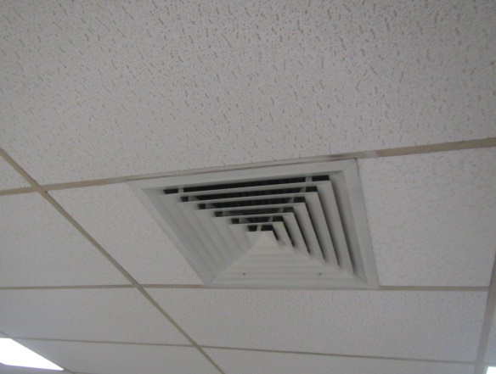

**Multi-directional ceiling-mounted supply vent**

**Picture 2**



**Wall-mounted supply vent**

**Picture 3**

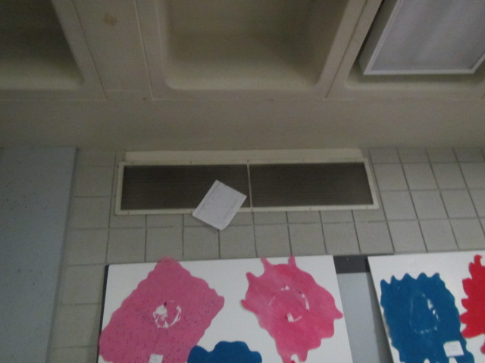

**Wall-mounted exhaust vent; paper on vent indicates draw/*suction into* vent**

Water Damage and Moisture Concern Pictures

(click to link back to report)

**Picture 4**

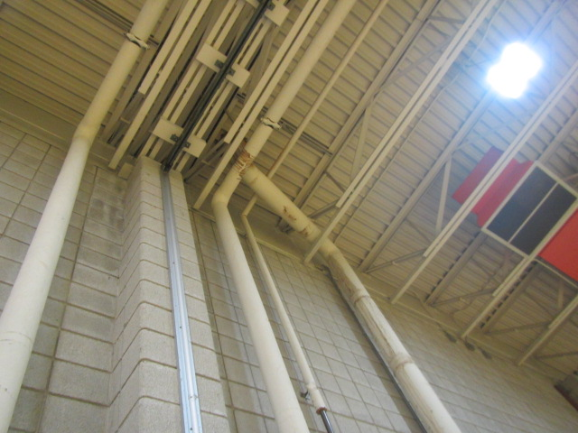

**Water staining on pipes near ceiling of gymnasium**

**Picture 5**

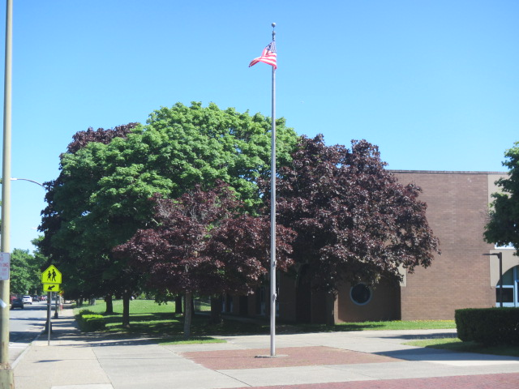

**Trees close to the building**

**Picture 6**

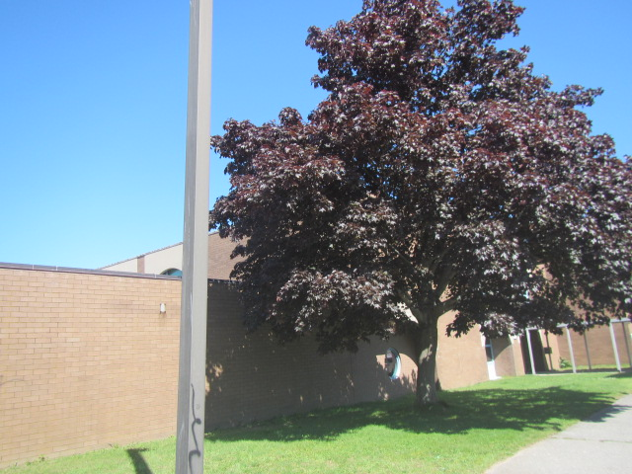

**Tree close to the building**

Sources of Respiratory Irritant Pictures

(Click to link back to report)

**Picture 7**

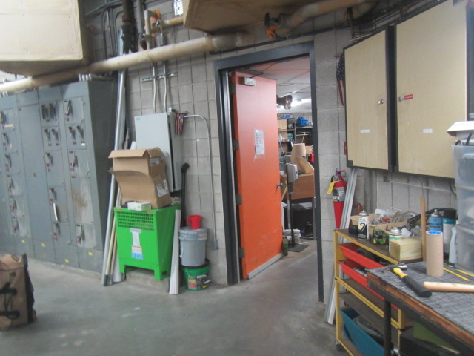

**Boiler room door propped open. Note: door open into custodial workshop**

**Picture 8**

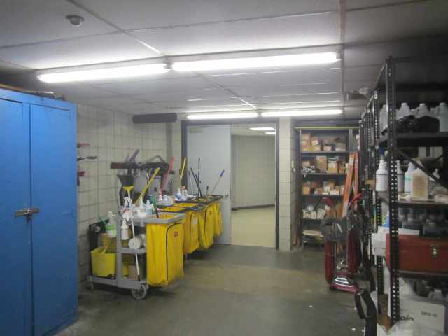

**Door to custodial workshop open to main hallway**

**Picture 9**

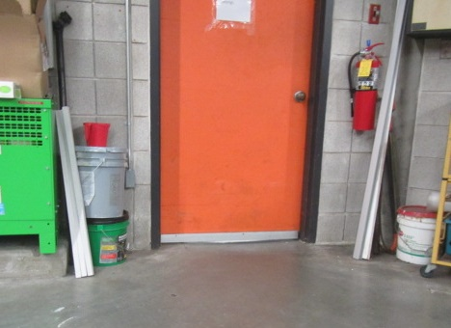

**Space/light seen beneath boiler room door**

**Picture 10**

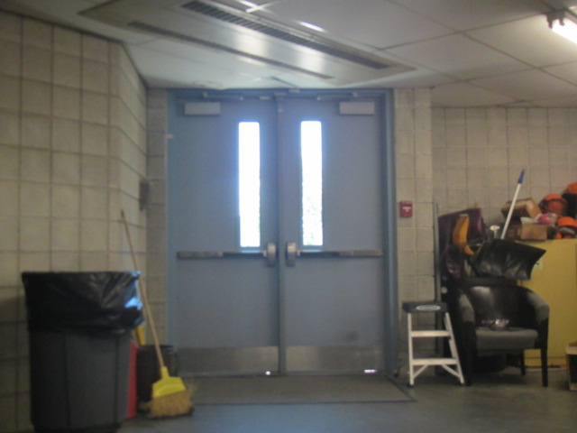

**Space/light seen beneath exterior door in custodial workshop**

**Picture 11**

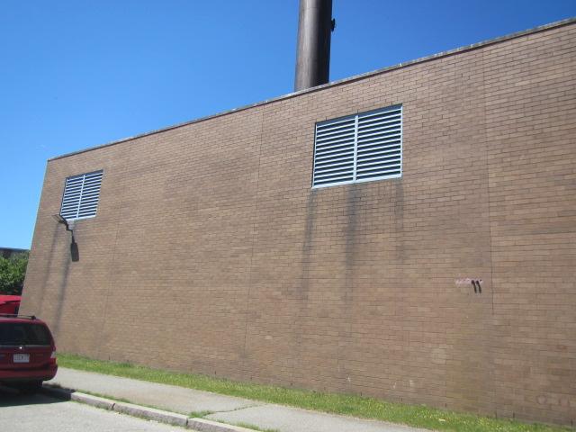

**Passive make-up air vents for the boiler room adjacent to Route 18**

**Picture 12**

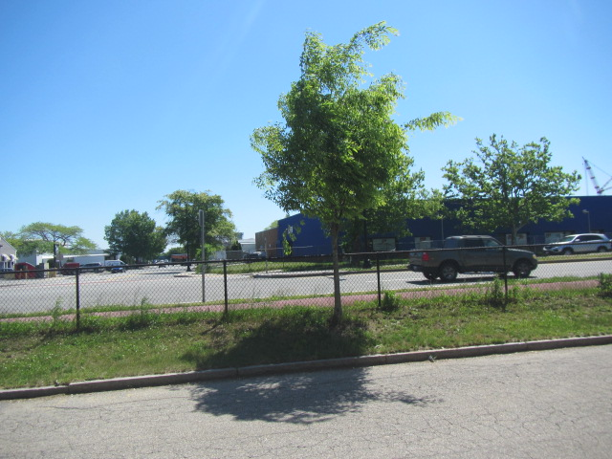

**View of Route 18 from directly outside boiler room in preceding picture**

**Picture 13**

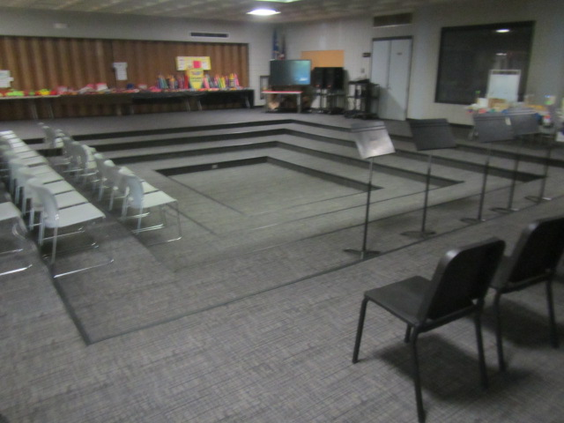

**Carpet squares in Forum**

**Picture 14**

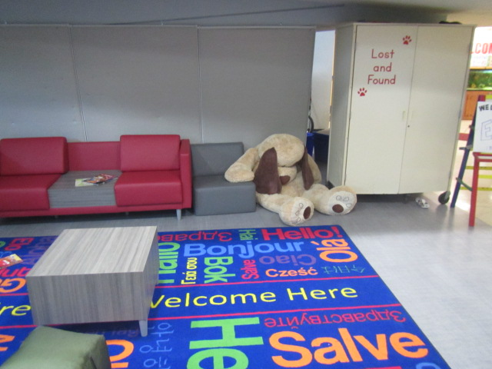

**Area carpet and plush animal in Atrium**

**Picture 15**

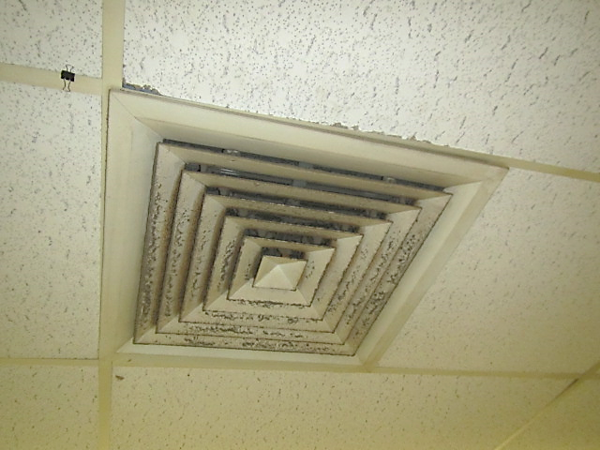

**Accumulated dust/debris on supply vent**

(Click to link back to report)

| Table 1  Location | **Carbon**  **Dioxide**  **(ppm)** | **Carbon Monoxide**  **(ppm)** | **Temp**  **(°F)** | **Relative**  **Humidity**  **(%)** | **PM2.5**  **(µg/m3)** | **Occupants**  **in Room** | **TVOCs**  **(ppm)** | **Windows**  **Openable** | **Ventilation** | | **Remarks** |
| --- | --- | --- | --- | --- | --- | --- | --- | --- | --- | --- | --- |
| **Supply** | **Exhaust** |
| Background (outside) | 479 | ND | 72 | 45 | 13 |  | ND |  |  |  | Cool, breezy, clear and sunny, moderate traffic on Route 18 |
| Atrium | 571 | ND | 71 | 47 | 14 | 4 | ND | N | Y | Y | Area rug, plush stuffed animal, hand sanitizer |
| Forum | 552 | ND | 71 | 47 | 14 | 4 | ND | N | Y | Y | Carpet squares-good condition |
| Gym | 500 | ND | 69 | 49 | 11 | 14 | ND | N | Y | Y | Periodic roof leaks, water staining on pipes (roof drain) |
| Boiler Room | 482 | ND | 73 | 40 | 26 | 0 | ND | N | Y | N | Doors pegged open, spaces beneath doors (interior and exterior) |
| Cafeteria |  |  |  |  |  |  |  |  | Y | Y | Dust/debris accumulation on vents |

(Click to link back to report)

# Table 2A

|  |  |  |  |  |  |
| --- | --- | --- | --- | --- | --- |
| **Equipment Present in Building**  **(X = Yes)** | **Type of Heating/Cooling Ventilation**  **Equipment** | **Fresh**  **Air**  **Supply**  **(X = Yes)** | **Type of Location(s)** | **Air Filters Installed**  **MERV Rating**  **(1-15, U*)**  **(X = Yes)** | **Comments** |
| X | Univents | X | Classrooms |  |  |
| X | Rooftop Air Handling Units | X | Common/  central areas |  |  |
|  | Outdoor, Ground-Installed Air Handling Units |  |  |  |  |
|  | Attic/Crawlspace Air Handling Units |  |  |  |  |
|  | Ceiling-Mounted Air Handling Units (including inside plenum) |  |  |  |  |
|  | Basement/Crawlspace-Installed Air Handling Units |  |  |  |  |
|  | Mechanical Room-installed Air Handling Units |  |  |  |  |
|  | Fan Coil Units |  |  |  |  |
|  | Window-Mounted Air Conditioners |  |  |  |  |
|  | Wall Louver-Controlled Gravity Air Supply |  |  |  |  |
| X | Windows |  |  |  |  |
|  | Fan in window (blowing in) |  |  |  |  |
|  | Built in wall fan (switched) |  |  |  |  |
|  | Heat recovery ventilator unit |  |  |  |  |
|  | Energy recovery ventilator unit |  |  |  |  |
|  | Chilled Beam |  |  |  |  |
|  | Passive combustion supply vent in basement/boiler room |  |  |  |  |

*U = Filter Rating underdetermined due to inaccessibility during building visit

(Click to link back to report)

# Table 2B

|  |  |  |  |  |
| --- | --- | --- | --- | --- |
| **Equipment Present in Building**  **(X = Yes)** | **Type of Exhaust Ventilation**  **Equipment** | **Ducted**  **To Outdoors**  **(X = Yes)** | **Type of Location(s)** | **Comments** |
| X | Rooftop Motors/Fans | X |  |  |
|  | Unit Exhaust |  |  |  |
| X | Ceiling Return Vent |  |  |  |
|  | Ceiling Return Vent, Plenum |  |  |  |
| X | Wall Return Vent |  |  |  |
| X | Kitchen Stove Hood |  |  |  |
| X | Restroom Exhaust Vent | X |  |  |
|  | Photocopier Exhaust Vent |  |  |  |
|  | Garage |  |  |  |
|  | Chemical Hood(s) |  |  |  |
|  | Locker Rooms |  |  |  |
|  | Showers |  |  |  |
|  | Lock up Cells |  |  |  |
|  | Clothes Dryers |  |  |  |
|  | Gas Water Heaters |  |  |  |
|  | Furnace-Flue to Chimney |  |  |  |
|  | Furnace/Boiler direct vent or power vent (no combustion air supply) |  |  |  |
|  | Kiln, Pottery |  |  |  |
|  | Dark Room |  |  |  |
|  | Generator Room |  |  |  |
|  | Wood Shop Dust Collector |  |  |  |
|  | Spray Paint Booths |  |  |  |
|  | Fan in window (blowing out) |  |  |  |

# Table 2C

|  |  |  |  |
| --- | --- | --- | --- |
| **Equipment Present in Building**  **(X = Yes)** | **Type of Equipment** | **Type of Location(s)** | **Comments** |
|  | Floor Fans, pedestal |  |  |
|  | Floor Fans, portable |  |  |
|  | Air Purifier (HEPA, other) |  |  |
|  | Floor heaters, portable |  |  |
|  | Refrigerators, Cold Beverage Vending Machines |  |  |
|  | Radiator, wall-mounted |  |  |
|  | Radiator, floor-mounted |  |  |
|  | Passive Vents (Wall/Door) |  |  |

(Click to link back to report)

# Table 3

| **Found in Building**  **X = Yes** | **Water-Damaged Materials, Building Components or Stored Materials** | **Location** | **Visible Microbial Growth?**  **X = Yes** | **Musty odor detected?**  **X = Yes** | **Comments** |
| --- | --- | --- | --- | --- | --- |
|  | Books-other bound materials |  |  |  |  |
|  | Brick walls – broken, missing mortar |  |  |  |  |
|  | Brick walls – blocked weep holes |  |  |  |  |
|  | Cardboard boxes |  |  |  |  |
|  | Carpet tiles |  |  |  |  |
|  | Carpet - Area rugs |  |  |  |  |
|  | Carpet wall-to-wall |  |  |  |  |
|  | Ceiling tiles - affixed directly to ceiling surface |  |  |  |  |
|  | Ceiling tiles - bowing-in suspended ceiling |  |  |  |  |
|  | Ceiling tiles - water-stained in splined ceiling |  |  |  |  |
|  | Ceiling tiles - water-stained in suspended ceiling |  |  |  |  |
|  | Chairs - laminated |  |  |  |  |
|  | Cloth |  |  |  |  |
|  | Countertops (around sinks) |  |  |  |  |
|  | Curtains |  |  |  |  |
|  | Dust/debris within AHU, uninvent, HVAC, chilled beam units, etc. (WD through condensation, humidity, or leaks) |  |  |  |  |
|  | Efflorescence (i.e., mineral deposits) |  |  |  |  |
|  | Engineered woods - particleboard, plywood, Masonite |  |  |  |  |
|  | Flooring – loosened tiles |  |  |  |  |
|  | Flooring - wooden |  |  |  |  |
|  | Furniture - laminated |  |  |  |  |
|  | Furniture - upholstered |  |  |  |  |
|  | Gypsum wallboard - ceiling |  |  |  |  |
|  | Gypsum wallboard - restroom wall |  |  |  |  |
|  | Gypsum wallboard - interior wall |  |  |  |  |
|  | Gypsum wallboard – located on exterior wall |  |  |  |  |
|  | HVAC drain pan – lack of draining |  |  |  |  |
|  | HVAC filters |  |  |  |  |
|  | Insulation- attic (paper-backed) |  |  |  |  |
|  | Insulation - inside air handling unit |  |  |  |  |
|  | Insulation - on pipe(s) fiberglass |  |  |  |  |
|  | Insulation - on pipe(s) other/plaster-like material |  |  |  |  |
|  | Insulation - wall cavity |  |  |  |  |
|  | Insulation – ceiling plenum |  |  |  |  |
|  | Modular furniture – walls/cloth partitions |  |  |  |  |
|  | Musical instrument cases |  |  |  |  |
|  | Plaster ceilings |  |  |  |  |
|  | Records/files |  |  |  |  |
|  | Refrigerator - door gasket |  |  |  |  |
|  | Refrigerator - drip pan |  |  |  |  |
|  | Refrigerator - Interior surfaces |  |  |  |  |
|  | Room divider - ceiling-mounted, sliding |  |  |  |  |
|  | Sink backsplash |  |  |  |  |
|  | Tables – laminated |  |  |  |  |
|  | Wallpaper |  |  |  |  |
|  | Wood - attic/roof materials |  |  |  |  |
|  | Wood - floor joists in basement ceiling |  |  |  |  |
|  | Wood - wall framing |  |  |  |  |
|  | Wood - window sills |  |  |  |  |
|  | Wood - window-mounted air conditioner framing |  |  |  |  |
| X | OTHER: Leak in gym, staining on pipes (roof drains) |  |  |  |  |

WHAT ARE ENVIRONMENTAL ASTHMA TRIGGERS?

Asthma triggers are any chemical, pollutant, or allergen that can make your asthma worse. Asthma triggers can also be strong chemical smells, dust, or pets. Your asthma triggers may be different from those of other people. Not all asthma triggers affect people the same way. Environmental asthma triggers are found both indoors and outdoors. DPH link: [Asthma and Your Environment (mass.gov)](https://www.mass.gov/doc/asthma-and-your-environment-english/download)

(click to link back to report)

# Table 4

| **Condition Present**  **X = Yes** | **Possible asthma symptom-inducing environmental pollutant** | **Recommendation to reduce or eliminate the pollutant** |
| --- | --- | --- |
| X | Water Damage and/or Mold  (allergen) | Identify water source and repair to eliminate.  Clean non-porous materials.  Remove and replace porous materials susceptible to mold growth.  Perform regular water damage assessments as a tool to ensure timely mitigation as needed.  Use NIOSH water damage assessment protocol as a guide: [NIOSH water damage assessment guideline](https://www.cdc.gov/niosh/docs/2019-115/pdfs/2019-115.pdf?id=10.26616/NIOSHPUB2019115&inf_contact_key=241b5c2ed98c27d94b530dedc36f1623f651f238aa2edbb9c8b7cff03e0b16a0). |
|  | Moistening of building components during hot, humid weather (>2 days in length) (mold, allergen) | Remove materials not dried in <2 days in a manner consistent with [US EPA Mold Removal in Commercial Buildings guideline](https://www.epa.gov/mold/pdf-version-checklist-mold-remediation-mold-remediation-schools-and-commercial-buildings).  Use dehumidification in occupied basement areas and other areas with chronic dampness. |
| X | Vegetation against exterior of building (water damage-mold) | Remove all vegetation preventing building exterior drying.  Remove all vegetation capable of falling onto a building or depositing debris onto the roof. |
|  | Personal humidifiers (lack of proper maintenance)  (pollutant and allergen) | Clean and maintain properly.  Use distilled water to eliminate metal and water treatment odors.  Maintain hydration by increasing water consumption. |
|  | Drains: Floor drains, Sink drains (abandoned use)  Water bubblers (abandoned use) | If in use, pour water into drain at least twice a week.  If not in use, seal the drain with an appropriate material in accordance with Massachusetts Plumbing Code (248 CMR 10.00). |
|  | Live Animals (turtles, gerbils, birds, rabbits, etc.) | Ensure cleanliness or remove animals from the location. |
|  | Improperly maintained aquariums and terrariums (allergen) | Maintain such equipment properly to eliminate odor.  Discontinue use. |
|  | Plants and flowers  (allergen and mold) | Keep indoor plants well maintained and not overwatered. Monitor for signs of mold and pests.  Ensure water for cut flowers does not become stagnant.  Ensure dried plant material is free of odors, mold, and pests and handled carefully  If asthma risks are high, eliminate plants and flowers. |
|  | HVAC system moisture issues  (mold, allergen) | Consult ASHRAE’s minimum standards for HVAC maintenance and inspection of commercial HVAC systems (<https://www.ashrae.org/technical-resources/bookstore/standards-180-and-211>). |
|  | HVAC system contaminant issues (allergen) | Consult ASHRAE’s minimum standards for HVAC maintenance and inspection of commercial HVAC systems (<https://www.ashrae.org/technical-resources/bookstore/standards-180-and-211>). |
|  | Indoor swimming pool odors outside of swimming pool (mold, chemical) | Maintain and operate pool HVAC systems to vent odors from building.  Ensure locker room exhaust vents are operating during building hours.  All doors leading to pool should be rendered airtight and be closed. |
| X | Pollen (allergen) | Recommend installation of MERV 8 or better filters if HVAC engineer confirms HVAC system can be so equipped without adversely affecting function.  Cut grass after hours.  Cut grass in a pattern to direct clippings away from exterior wall.  Remove trees and shrubs from in front of windows and air intakes. |
|  | Dry air | Maintain hydration.  Avoid overheating of air. |
| X | Dust mites  (allergen) | Recommendation to remove non-official upholstered furniture, area rugs, pillows, cushions, etc.  Cleaning with use of HEPA-filtered vacuum cleaner.  Eliminating clutter, storing items in dust and moisture-proof containers, and regularly removing dust through wet wiping. |
|  | Pests, including rodents and cockroaches  (allergen) | Use of integrated pest management guidelines, including:   * Proper disposal of food containers * Proper storage of food products in airtight containers * Elimination of use of food as art projects * Remove pest harborages/clutter * Regular monitoring for pests   [EPA IPM guideline link](https://www.epa.gov/ipm/introduction-integrated-pest-management) |
|  | Latex-containing materials | Remove tennis balls from furniture legs. |
|  | Fragrances  (chemical) | Eliminate point sources, such as:   * Plug-in air fresheners * Aroma/oil reed diffusers * Scented sprays * Discontinue use of other scented materials * Consult DPH fragrance guideline: [*Clean air is odor-free*](https://www.mass.gov/doc/clean-air-is-odor-free-removing-fragrances-to-improve-indoor-air-quality-in-schools-and-0/download) |
|  | Strong smells from /use of Chemicals (such as cleaning products)  (chemical) | Use building-issued cleaning products.  Use products in accordance with manufacturer’s instructions including dilution, application, and ventilation.  Avoid using products that are stronger than needed for the situation. |
|  | Strong odors from new building materials (carpeting/furniture)  (chemical) | Use low VOC-emitting materials.  Air out materials (outside or in unoccupied area) prior to installation. |
|  | Tobacco smoke  Secondhand Smoke  (pollutant) | Eliminate tobacco smoking.  Seal all shared wall penetrations. |
|  | Products with a strong odor such as paint, perfume, hairspray, air fresheners, bug-spray, laminators, candles, wax melters, dry erase markers and other VOC-containing products  (chemical) | If essential:   * Provide proper exhaust ventilation to eject aerosolized product directly outdoors. * Avoid/reduce use during occupied hours.   If not necessary, remove and eliminate. |
| X | Vehicle exhaust  (pollutant) | Enforce anti-idling regulations and post signs to give notice.  Relocate vehicles away from fresh air intakes.  Require cars to park face-in at building walls.  [MA anti-idling law FAQs](https://www.mass.gov/files/documents/2018/02/20/idling-faq.pdf#:~:text=The%20Massachusetts%20Anti-Idling%20Law%20The%20goal%20of%20the,sometime%20wonder%20when%20idling%20might%20be%20considered%20necessary.)  Nearby highways/roadways |
|  | Vapors and or fumes from gas, oil, or kerosene stoves  (pollutant) | Operate stove hood when stove in use.  Install stove hood if not present.  Ensure equipment is in good working order. |
|  | Ozone (pollutant) | Eliminate use of ozone generating equipment. |
|  | Window Air Conditioners (if not properly maintained) (allergen) | Equip with proper filter and clean periodically.  Clean drip pans.  Install in window with weathertight, non-mold-growth sustaining material. |
|  | Pottery (pollutant) | Do not operate kiln during occupied hours.  Operate kiln with exhaust system activated.  Seal all seams and holes in kiln vent.  Ensure kiln exhaust discharge terminates outdoors. |
| X | Carpeting (allergen) | Clean carpeting in a manner consistent with IICRC standards, including regular vacuuming with a high efficiency particulate air (HEPA) filtered vacuum in combination with annual cleaning or semi-annual cleaning in soiled high traffic areas. |
|  | Sweeping/dusting vs HEPA vacuuming/wet wiping  (allergen or pollutant) | Refrain from using feather dusters or brooms.  Utilize HEPA vacuums and wet wiping to minimize aerosolizing particulate matter. |
|  | Lack of adequate air exchange/mechanical ventilation | Make repairs as necessary and ensure all HVAC system components are operating continuously when building is occupied. |
|  | Lack of local exhaust at source of pollution (vocational shop activities, kitchen exhaust hood) (all) | Recommend installation of exhaust ventilation to direct pollutants directly outdoors. |
|  | Renovating buildings while occupied  (chemical) | Use all SMACNA guidelines for Renovation While Buildings Are Occupied. For information, visit <https://www.mass.gov/service-details/construction-and-renovation-generated-pollutants-in-occupied-buildings>. |
|  | Chemistry program chemical storage  (chemical) | Repair (if needed) and operate chemical storeroom vents appropriately.  Reduce or eliminate unneeded or overstocked chemicals.  Store all chemicals in a manner to separate incompatible chemicals.  Keep chemical storerooms clean. |
|  | Photocopiers/duplicating machines | All machines must have dedicated exhaust vents. |
| X | Boiler room (odors) | Keep boiler room doors shut. Install weather-stripping, ensure tightness by monitoring for light around doors. |