INDOOR AIR QUALITY ASSESSMENT

Alfred J. Gomes Elementary School
286 South Second Street
New Bedford, Massachusetts 02740

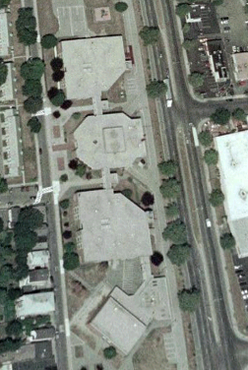

Prepared by:
Massachusetts Department of Public Health
Bureau of Environmental Health
Indoor Air Quality Program
May 2009

Background/Introduction
At the request of New Bedford Mayor Scott Lang, the Massachusetts Department of Public Health (MDPH), Bureau of Environmental Health (BEH) provided assistance and consultation regarding indoor air quality (IAQ) at the Alfred J. Gomes Elementary School (GES) located at 286 South Second Street, New Bedford, Massachusetts. The assessment was coordinated with the Mayor’s Office, the New Bedford Health Department (NBHD), and the New Bedford School Department (NBSD) in an on-going effort to monitor and improve IAQ conditions in New Bedford’s public schools.
On March 13, 2009, Cory Holmes and James Tobin, Environmental Analysts/Inspectors for BEH’s Indoor Air Quality (IAQ) Program, made a visit to the GES to conduct an assessment. During portions of the assessment, BEH staff were accompanied by Marco Pimentel, Senior Custodian; Doug Sewall, Junior Custodian; Lawrence Oliveira, Chief Administrator Finance and Operations, NBSD; and Bruce Feno, Supervisor of Custodians, NBSD.
BEH previously visited the school on September 5, 2008 to conduct a preliminary walkthrough. A report detailing conditions observed at the time was issued (MDPH, 2008). As part of the preliminary walkthrough, BEH staff examined the spatial configuration of the GES and mechanical ventilation components with the recommendation to return to the building to conduct a full IAQ assessment.
The GES is a two-story, brick and concrete building constructed on a slab foundation in the late 1970s. The building contains general classrooms, main kitchen with four cafeterias, library, gym, music rooms, art rooms and office space. The building has a concrete honeycombed ceiling, with drop ceiling tiles in some areas. The majority of classrooms are carpeted, and in many areas appear to date back to original construction. Some carpeting has been replaced over the years; however, it was reported that current policy is to replace carpets with tile as necessary. Windows are openable throughout the building.
Methods
Air tests for carbon monoxide, carbon dioxide, temperature and relative humidity were conducted with the TSI, Q-Trak, IAQ Monitor, Models 8554 and 7565. Air tests for airborne particle matter with a diameter less than 2.5 micrometers were taken with the TSI, DUSTTRAK™ Aerosol Monitor Model 8520. MDPH staff also performed visual inspection of building materials for water damage and/or microbial growth.
Results
The school houses approximately 825 elementary students in pre-kindergarten to grade 5 with approximately 110 staff members. Tests were taken during normal operations at the school and results appear in Table 1.
Discussion
Ventilation
It can be seen from Table 1 that carbon dioxide levels were below 800 parts per million (ppm) in sixty of sixty-one areas, indicating adequate air exchange throughout the building at the time of the assessment. It is important to note, however, that several areas had open windows or were empty/sparsely populated, which can greatly reduce carbon dioxide levels. Carbon dioxide levels would be expected to increase with higher occupancy and windows closed.
Fresh air for exterior classrooms is supplied by unit ventilator (univent) systems (Picture 1). A univent draws fresh, outdoor air through an air intake located on the exterior wall of the building (Picture 2), and return air from the room through an air intake located at the base of the unit (Figure 1). Fresh and return air are mixed, filtered, heated and provided through an air diffuser located in the top of the unit.
A univent heats or cools a room based on the temperature set point of the system. A room requires heating in the morning when the temperature set point is raised in preparation for the school day. During the day, the combination of waste heat from building occupants, electrical equipment (including lighting), and solar gain on the building envelope may cause a room to require cooling instead of heating to maintain thermal comfort for the room occupants. In this event, a univent will deliver cool outside air to the room during the heating season.
Univents were operating in the majority of rooms at the time of the assessment; however, BEH staff found several univents switched ‘off’, preventing fresh air from being introduced into these rooms (Table 1). Further, univent air diffusers and returns were blocked by books, furniture and other stored items in front and on top of the unit, thereby limiting airflow in these rooms. Univents in classrooms 726 and 344 were making “rattling” noises and should be examined by the school’s heating, ventilating and air conditioning (HVAC) vendor. In order for univents to provide fresh air as designed, air diffusers, intakes and returns must remain free of obstructions. Importantly, these units must remain “on” and be allowed to operate while rooms are occupied. A constant supply of fresh, outdoor air can provide greater assurance of good indoor air quality and improved comfort.
Exhaust ventilation in exterior classrooms is provided by wall or ceiling vents ducted to rooftop motors (Pictures 3 and 4). Exhaust ventilation systems continuously remove air that has become stale from moisture, odors, and pollutants. As with the univents, exhaust vents were operating in the majority of areas surveyed during the assessment (Table 1). Mr. Pimentel reported that several of the rooftop exhaust motors needed to be serviced/repaired and orders had been placed to obtain replacement parts. In classroom 250, the exhaust vent was covered with cardboard and sealed with tape to avoid backdrafting (Picture 5). Once the exhaust motor for this area is repaired, the blockage should be removed from the vent to allow air exchange.
The HVAC system for interior/centralized areas consists of rooftop air-handling units (AHUs) (Picture 6). AHUs draw in fresh, outdoor air through air intakes; filter, heat and/or cool the air; then distribute it to occupied areas via ceiling-mounted air diffusers (Picture 7). Exhaust air is drawn through ceiling-mounted vents and ducted back to the AHUs. These systems were functioning at the time of the assessment.
To maximize air exchange, the MDPH recommends that both supply and exhaust ventilation operate continuously during periods of school occupancy. In order to have proper ventilation with a mechanical supply and exhaust system, the systems must be balanced to provide an adequate amount of fresh air to the interior of a room while removing stale air from the room. It is recommended that HVAC systems be re-balanced every five years to ensure adequate air systems function (SMACNA, 1994). Information concerning balancing was not available at the time of this assessment.
The Massachusetts Building Code requires that each room have a minimum ventilation rate of 15 cubic feet per minute (cfm) per occupant of fresh outside air or openable windows (SBBRS, 1997; BOCA, 1993). The ventilation must be on at all times that the room is occupied. Providing adequate fresh air ventilation with open windows and maintaining the temperature in the comfort range during the cold weather season is impractical. Mechanical ventilation is usually required to provide adequate fresh air ventilation.
Carbon dioxide is not a problem in and of itself. It is used as an indicator of the adequacy of the fresh air ventilation. As carbon dioxide levels rise, it indicates that the ventilating system is malfunctioning or the design occupancy of the room is being exceeded. When this happens, a buildup of common indoor air pollutants can occur, leading to discomfort or health complaints. The Occupational Safety and Health Administration (OSHA) standard for carbon dioxide is 5,000 parts per million parts of air (ppm). Workers may be exposed to this level for 40 hours/week, based on a time-weighted average (OSHA, 1997).
The MDPH uses a guideline of 800 ppm for publicly occupied buildings. A guideline of 600 ppm or less is preferred in schools due to the fact that the majority of occupants are young and considered to be a more sensitive population in the evaluation of environmental health status. Inadequate ventilation and/or elevated temperatures are major causes of complaints such as respiratory, eye, nose and throat irritation, lethargy and headaches. For more information concerning carbon dioxide, consult Appendix A.
During the assessment, indoor temperature measurements ranged from 67º F to 79º F, which were within or close to the MDPH recommended comfort range. The MDPH recommends that indoor air temperatures be maintained in a range of 70º F to 78º F in order to provide for the comfort of building occupants. In many cases concerning indoor air quality, fluctuations of temperature in occupied spaces are typically experienced, even in a building with an adequate fresh air supply. Occupants in classrooms 247 and 251 had reported problems with excessive heat to the school’s HVAC technician on-site at the time of the assessment.
The relative humidity in the building ranged from 9 to 17 percent on the day of the assessment, which was below the MDPH recommended comfort range. The MDPH recommends a comfort range of 40 to 60 percent for indoor air relative humidity. Relative humidity levels in the building would be expected to drop during the winter months due to heating. The sensation of dryness and irritation is common in a low relative humidity environment. Low relative humidity is a very common problem during the heating season in the northeast part of the United States.
Microbial/Moisture Concerns
BEH staff examined building materials for water damage and/or microbial growth. The amount of moisture/water in the air and in/on materials is the most important factor that contributes to microbial growth. Mold grows rapidly whenever water and nutrients (i.e., organic matter) are available. Therefore, in order to control mold growth, it is necessary to identify and eliminate water moistening building materials.
A number of areas (classrooms, common areas and hallways) had water-damaged ceiling tiles, which can indicate leaks from the roof or plumbing system (Pictures 8 through 11/Table 1). Water-damaged ceiling tiles can indicate sources of water penetration and provide a source of mold growth. In the music room, dark staining that appeared to be mold growth was visible on a ceiling tile near the wall-mounted air-conditioner (Picture 9). Water damage to ceiling tiles was particularly noted around ceiling vents, most likely due to condensation from the air conditioning system (Picture 10). Ceiling tiles should be replaced after a water leak is discovered and repaired. At the time of assessment, BEH staff recommended that this ceiling tile be removed and replaced.
The building appears to have had water infiltration issues through the building envelope as evidenced by water stained concrete ceilings (Picture 11) and efflorescence on interior brick (Pictures 12 and 13). Efflorescence is a characteristic sign of water damage to building materials, but it is not mold growth. As moisture penetrates and works its way through building materials (e.g., masonry), water-soluble compounds dissolve, creating a solution. As this solution moves to the surface, the water evaporates, leaving behind white, powdery mineral deposits.
Air infiltration was noted around windows throughout the school. In classroom 729, BEH observed sizable gaps around the window frame (Picture 14). In this condition, moisture-laden air can move into the building and subsequently damage building materials, which can lead to musty odors and mold growth under certain conditions. In addition, air infiltration around the window systems can make temperature control difficult to maintain. Repairs to the window systems are necessary to prevent further air infiltration and water penetration.
Open seams between sink countertops and walls were observed in several rooms (Picture 15/Table 1). Improper drainage or sink overflow can lead to water penetration into the countertop, cabinet interior and areas behind cabinets. If not watertight, moisture can penetrate through the seam, causing water damage and potential mold growth. Water penetration and chronic exposure of porous and wood-based materials can cause these materials to swell and show signs of water damage. Repeated moistening of porous materials can result in mold growth.
Several classrooms had a number of plants. Moistened plant soil and drip pans can be sources of mold growth. Plants should be equipped with drip pans; the lack of drip pans can lead to water pooling and mold growth on windowsills. Plants are also a source of pollen. Plants should be located away from the air stream of ventilation sources to prevent the aerosolization of mold, pollen or particulate matter throughout the classroom (Picture 16).
Other IAQ Evaluations
Indoor air quality can be negatively influenced by the presence of respiratory irritants, such as products of combustion. The process of combustion produces a number of pollutants. Common combustion emissions include carbon monoxide, carbon dioxide, water vapor and smoke (fine airborne particle material). Of these materials, exposure to carbon monoxide and particulate matter with a diameter of 2.5 micrometers (μm) or less (PM2.5) can produce immediate, acute health effects upon exposure. To determine whether combustion products were present in the indoor environment, BEH staff obtained measurements for carbon monoxide and PM2.5.

Carbon Monoxide
Carbon monoxide is a by-product of incomplete combustion of organic matter (e.g., gasoline, wood and tobacco). Exposure to carbon monoxide can produce immediate and acute health affects. Several air quality standards have been established to address carbon monoxide and prevent symptoms from exposure to these substances. The MDPH established a corrective action level concerning carbon monoxide in ice skating rinks that use fossil-fueled ice resurfacing equipment. If an operator of an indoor ice rink measures a carbon monoxide level over 30 ppm, taken 20 minutes after resurfacing within a rink, that operator must take actions to reduce carbon monoxide levels (MDPH, 1997).
The American Society of Heating Refrigeration and Air-Conditioning Engineers (ASHRAE) has adopted the National Ambient Air Quality Standards (NAAQS) as one set of criteria for assessing indoor air quality and monitoring of fresh air introduced by HVAC systems (ASHRAE, 1989). The NAAQS are standards established by the US EPA to protect the public health from six criteria pollutants, including carbon monoxide and particulate matter (US EPA, 2006). As recommended by ASHRAE, pollutant levels of fresh air introduced to a building should not exceed the NAAQS levels (ASHRAE, 1989). The NAAQS were adopted by reference in the Building Officials & Code Administrators (BOCA) National Mechanical Code of 1993 (BOCA, 1993), which is now an HVAC standard included in the Massachusetts State Building Code (SBBRS, 1997). According to the NAAQS, carbon monoxide levels in outdoor air should not exceed 9 ppm in an eight-hour average (US EPA, 2006).
Carbon monoxide should not be present in a typical, indoor environment. If it is present, indoor carbon monoxide levels should be less than or equal to outdoor levels. On the day of assessment, outdoor carbon monoxide concentrations ranged from non-detect (ND) to 3.5 ppm (Table 1). Carbon monoxide levels measured in the school ranged from ND to 3.0 ppm, which were reflective of outside ambient conditions. The most likely source of measurable levels of carbon monoxide was vehicle exhaust. The GES is located in close proximity to Route 18 which serves as a major roadway traveling north/south through the city of New Bedford (Picture 17).

Particulate Matter (PM2.5)
The US EPA has established NAAQS limits for exposure to particulate matter. Particulate matter is airborne solids that can be irritating to the eyes, nose and throat. The NAAQS originally established exposure limits to particulate matter with a diameter of 10 μm or less (PM10). According to the NAAQS, PM10 levels should not exceed 150 microgram per cubic meter (μg/m³) in a 24-hour average (US EPA, 2006). These standards were adopted by both ASHRAE and BOCA. Since the issuance of the ASHRAE standard and BOCA Code, US EPA established a more protective standard for fine airborne particles. This more stringent PM2.5 standard requires outdoor air particle levels be maintained below 35 μg/m³ over a 24-hour average (US EPA, 2006). Although both the ASHRAE standard and BOCA Code adopted the PM10 standard for evaluating air quality, MDPH uses the more protective PM2.5 standard for evaluating airborne particulate matter concentrations in the indoor environment.
Outdoor PM2.5 concentrations were measured at 6 μg/m³ (Table 1). PM2.5 levels measured in the school were between 4 to 11 μg/m³ (Table 1). Both indoor and outdoor PM2.5 levels were below the NAAQS PM2.5 level of 35 μg/m³. Frequently, indoor air levels of particulates (including PM2.5) can be at higher levels than those measured outdoors. A number of mechanical devices and/or activities that occur in schools can generate particulate during normal operations. Sources of indoor airborne particulates may include but are not limited to particles generated during the operation of fan belts in the HVAC system, cooking in the cafeteria stoves and microwave ovens; use of photocopiers, fax machines and computer printing devices; operation of an ordinary vacuum cleaner and heavy foot traffic indoors.

Volatile Organic Compounds
Indoor air concentrations can be greatly impacted by the use of products containing volatile organic compounds (VOCs). VOCs are carbon-containing substances that have the ability to evaporate at room temperature. Frequently, exposure to low levels of total VOCs (TVOCs) may produce eye, nose, throat and/or respiratory irritation in some sensitive individuals. For example, chemicals evaporating from a paint can stored at room temperature would most likely contain VOCs. In an effort to identify materials that can potentially increase indoor VOC concentrations, BEH staff examined classrooms for products containing these respiratory irritants.
Several classrooms contained dry erase boards and related materials. Materials such as dry erase markers and dry erase board cleaners may contain VOCs, such as methyl isobutyl ketone, n-butyl acetate and butyl-cellusolve (Sanford, 1999), which can be irritating to the eyes, nose and throat. Cleaning products were also found on countertops and sinks in some classrooms. Like dry erase materials, cleaning products contain VOCs and other chemicals that can be irritating to the eyes, nose and throat of sensitive individuals.
Plug-in air fresheners were in use in a few areas (Picture 18/Table 1). Many air fresheners contain 1,4-dichlorobenzene, a VOC which may cause reductions in lung function (NIH, 2006). Furthermore, deodorizing agents do not remove materials causing odors, but rather mask odors that may be present in the area. Air fresheners contain chemicals that can be irritating to the eyes, nose and throat of sensitive individuals. Further, air fresheners do not remove materials causing odors, but rather mask odors which may be present in the area.
In an effort to reduce noise from sliding chairs, tennis balls had been sliced open and placed on chair legs (Picture 19). Tennis balls are made of a number of materials that are a source of respiratory irritants. Constant wearing of tennis balls can produce fibers and cause TVOCs to off-gas. Tennis balls are made with a natural rubber latex bladder, which becomes abraded when used as a chair leg pad. Use of tennis balls in this manner may introduce latex dust into the school environment. Some individuals are highly allergic to latex (e.g., spina bifida patients) (SBAA, 2001). It is recommended that the use of materials containing latex be limited in buildings to reduce the likelihood of symptoms in sensitive individuals (NIOSH, 1997). A question and answer sheet concerning latex allergy is attached as Appendix B (NIOSH, 1998).

Other Conditions
Other conditions that can affect indoor air quality were observed during the assessment. In several classrooms, items were observed on windowsills, tabletops, counters, bookcases and desks. The large number of items stored in classrooms provides a source for dusts to accumulate. These items (e.g., papers, folders, boxes) make it difficult for custodial staff to clean. Items should be relocated and/or be cleaned periodically to avoid excessive dust build up. In addition, these materials can accumulate on flat surfaces (e.g., desktops, shelving and carpets) in occupied areas and subsequently be re-aerosolized causing further irritation.
A number of supply diffusers (and surrounding ceiling tiles), exhaust vents and personal fans in classrooms were observed to have accumulated dust/debris (Picture 20). Re-activated supply vents/fans can aerosolize dust accumulated on fan blades/housing. If exhaust vents are not functioning, backdrafting can occur, which can re-aerosolize dust particles.
As previously mentioned, carpet in several areas is original to the building (approximately 25 to 30 years old) and was extremely worn and damaged (Pictures 21 and 22). Disintegrating textiles can be a source of airborne particulates, which can be irritating to the eyes, nose and throat.
It was reported to BEH staff that children eat in the classrooms. To reduce the potential for contamination from food spillage, food should be eaten in the cafeteria, not in classrooms. This is particularly important in classrooms that are carpeted since carpeting can hold food crumbs and attract pests. The presence of pests inside a building can produce conditions that degrade indoor air quality.
Finally, an occupant in classroom 318 reported that pieces of dark debris are sometimes observed originating from the univent. BEH staff opened the unit to examine the interior to find the fiberglass insulation panel on the inner side of the cabinet soiled and damaged (Picture 23). A tremendous amount of air flows through the univent; as it flows across the damaged insulation panel it appears likely that pieces of it slough off and can be distributed by the univent air diffuser.
Conclusions/Recommendations
In view of the findings at the time of the assessment, the following recommendations are made to improve indoor air quality:
- Continue to operate all ventilation systems throughout the building (e.g., gym, cafeteria, classrooms) continuously during periods of school occupancy
- Inspect univents in classrooms 726 and 344 (noise); and 247 and 251 (excessive heat) for proper function. Make adjustments/repairs as needed.
- Continue with repairs to restore exhaust ventilation. Once repaired, remove any blockages from exhaust vents to ensure adequate airflow.
- Inspect all exhaust motors and belts periodically for proper function. Repair and replace as necessary.
- Use openable windows in conjunction with mechanical ventilation to increase air exchange. Care should be taken to ensure windows are properly closed at night and weekends to avoid the freezing of pipes and potential flooding.
- Consider adopting a balancing schedule of every 5 years for all mechanical ventilation systems, as recommended by ventilation industrial standards (SMACNA, 1994).
- For buildings in New England, periods of low relative humidity during the winter are often unavoidable. Therefore, scrupulous cleaning practices should be adopted to minimize common indoor air contaminants whose irritant effects can be enhanced when the relative humidity is low. To control for dusts, a high efficiency particulate arrestance (HEPA) filter equipped vacuum cleaner in conjunction with wet wiping of all surfaces is recommended. Avoid the use of feather dusters. Drinking water during the day can help ease some symptoms associated with a dry environment (throat and sinus irritations).
- Ensure building envelope/plumbing leaks are repaired. Remove/replace any water-damaged ceiling tiles, particulary in the music room.
- Scrape/clean efflorescence from masonry walls and monitor for further water penetration. Clean, prepare, and re-paint concrete ceilings in water damaged areas once leaks are repaired.
- Encourage staff to monitor their classrooms for active leaks/water damage and report to school maintenance staff for prompt remediation.
- Work with HVAC Engineer to examine best methods to avoid condensation around metal vents in air-conditioned music room(s).
- Seal areas around sinks to prevent water damage to the interior of cabinets and adjacent wallboard.
- Ensure plants have drip pans. Examine drip pans periodically for mold growth and disinfect with an appropriate antimicrobial where necessary. Remove plants from the air stream of mechanical ventilation.
- Store cleaning products properly and out of reach of students. All cleaning products used at the facility should be approved by the school department with MSDS’ available at a central location.
- Refrain from using strongly scented materials (e.g., plug-in air fresheners).
- Relocate or consider reducing the amount of materials stored in classrooms to allow for more thorough cleaning of classrooms. Clean items regularly with a wet cloth or sponge to prevent excessive dust build-up.
- Clean supply/exhaust vents, surrounding ceiling tiles and personal fans periodically of accumulated dust. If ceiling tiles cannot be cleaned, replace.
- Clean carpeting annually (or semi-annually in soiled/high traffic areas) as per recommendations of The Institute of Inspection, Cleaning and Restoration Certification (IICRC). Copies of the IICRC fact sheet can be downloaded at: http://www.cleancareseminars.com/carpet_cleaning_faq4.htm (IICRC, 2005)
- Continue with carpet replacement protocol throughout the building as funds become available.
- Limit the amount of drinking and eating in the classroom. Make sure food and liquids are stored in tightly sealed containers, to prevent pests from multiplying.
- Remove and replace damaged/soiled interior insulation panels in univents as necessary. Replace with an appropriate fire-rated material. Consider consulting the manufacturer for comparable replacement advice.
- Consider adopting the US EPA (2000) document, “Tools for Schools”, as an instrument for maintaining a good indoor air quality environment in the building. This document is available at: http://www.epa.gov/iaq/schools/index.html.
- Refer to resource manual and other related indoor air quality documents located on the MDPH’s website for further building-wide evaluations and advice on maintaining public buildings. These documents are available at: http://mass.gov/dph/indoor_air.

References
ASHRAE. 1989. Ventilation for Acceptable Indoor Air Quality. American Society of Heating, Refrigeration and Air Conditioning Engineers. ANSI/ASHRAE 62-1989.
BOCA. 1993. The BOCA National Mechanical Code/1993. 8th ed. Building Officials & Code Administrators International, Inc., Country Club Hills, IL.
IICRC. 2005. Carpet Cleaning FAQ 4 Institute of Inspection, Cleaning and Restoration Certification. Institute of Inspection Cleaning and Restoration, Vancouver, WA.
MDPH. 1997. Requirements to Maintain Air Quality in Indoor Skating Rinks (State Sanitary Code, Chapter XI). 105 CMR 675.000. Massachusetts Department of Public Health, Boston, MA.
MDPH. 2008. Indoor Air Quality Preliminary Assessment, Alfred J. Gomes Elementary School, New Bedford, MA. Massachusetts Department of Public Health, Bureau of Environmental Health, Boston, MA. October 2008.
NIH. 2006. Chemical in Many Air Fresheners May Reduce Lung Function. NIH News. National Institute of Health . July 27, 2006. http://www.nih.gov/news/pr/jul2006/niehs-27.htm
NIOSH. 1997. NIOSH Alert Preventing Allergic Reactions to Natural Rubber latex in the Workplace. National Institute for Occupational Safety and Health, Atlanta, GA.
NIOSH. 1998. Latex Allergy A Prevention. National Institute for Occupational Safety and Health, Atlanta, GA.
OSHA. 1997. Limits for Air Contaminants. Occupational Safety and Health Administration. Code of Federal Regulations. 29 C.F.R 1910.1000 Table Z-1-A.
Sanford. 1999. Material Safety Data Sheet (MSDS No: 198-17). Expo® Dry Erase Markers Bullet, Chisel, and Ultra Fine Tip. Sanford Corporation. Bellwood, IL.
SBAA. 2001. Latex In the Home And Community Updated Spring 2001. Spina Bifida Association of America, Washington, DC.
SBBRS. 1997. Mechanical Ventilation. State Board of Building Regulations and Standards. Code of Massachusetts Regulations. 780 CMR 1209.0
SMACNA. 1994. HVAC Systems Commissioning Manual. 1st ed. Sheet Metal and Air Conditioning Contractors’ National Association, Inc., Chantilly, VA.
US EPA. 2000. Tools for Schools. Office of Air and Radiation, Office of Radiation and Indoor Air, Indoor Environments Division (6609J). EPA 402-K-95-001, Second Edition. http://www.epa.gov/iaq/schools/tools4s2.html
US EPA. 2006. National Ambient Air Quality Standards (NAAQS). US Environmental Protection Agency, Office of Air Quality Planning and Standards, Washington, DC. http://www.epa.gov/air/criteria.html.
Picture 1

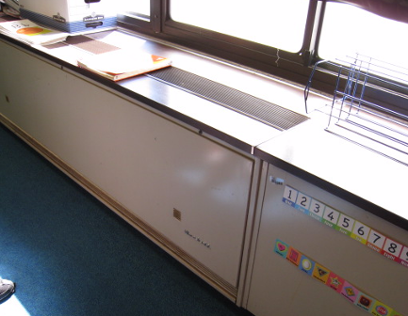

Classroom Univent

Picture 2

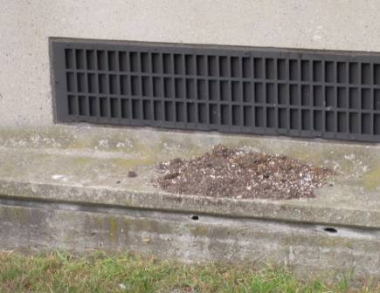

Univent Fresh Air Intake

Picture 3

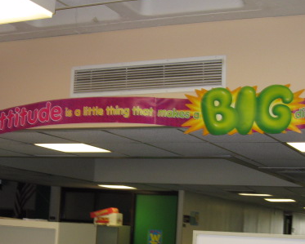

Classroom Exhaust Vent

Picture 4
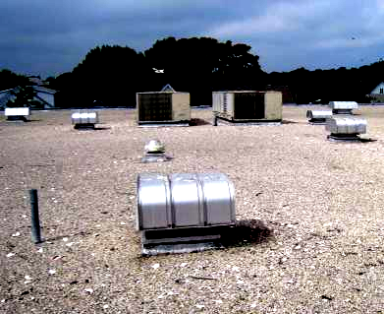

Rooftop Exhaust Motors

Picture 5

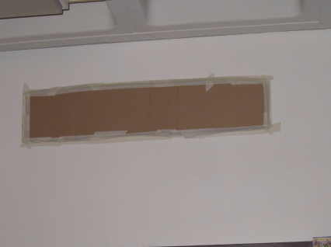

Classroom 250 Exhaust Vent Covered with Cardboard to Prevent Backdrafting

Picture 6

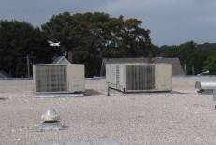

Rooftop AHUs

Picture 7

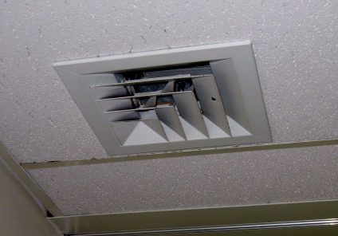

Ceiling-Mounted Supply/Return Vent

Picture 8

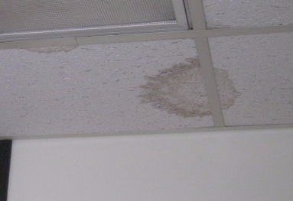

Water Damaged Ceiling Tiles

Picture 9

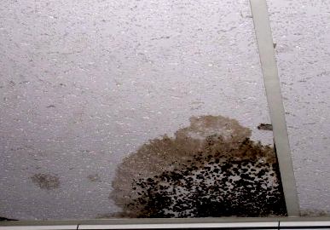

Water Damaged Ceiling Tile in Music Room Colonized With Mold

Picture 10

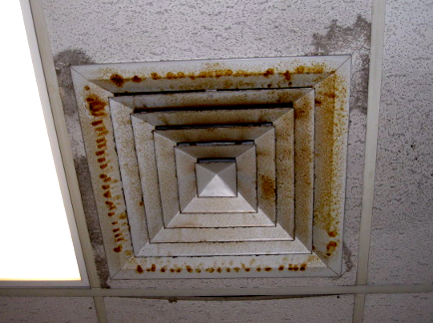

Water Damaged Ceiling Tile in Music Room Note Rusted Metal Diffuser
Due to Condensation from AC

Picture 11

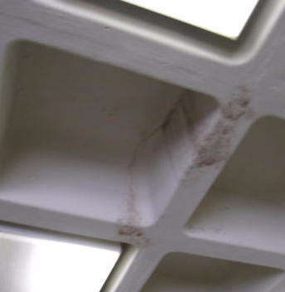

Signs of Water Penetration/Staining on Concrete Honeycomb Ceiling

Picture 12

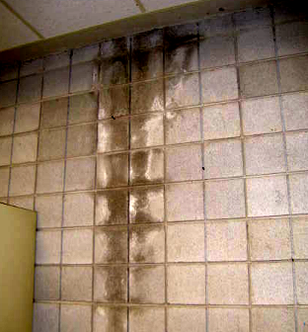

Water Staining and Efflorescence on Interior Masonry Walls

Picture 13

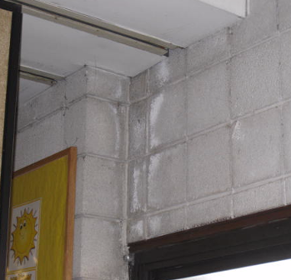

Water Staining and Efflorescence on Interior Masonry Walls

Picture 14

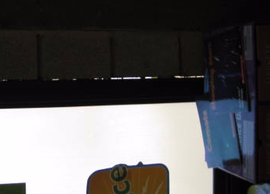

Light Penetrating around Window Frame in Classroom 729

Picture 15

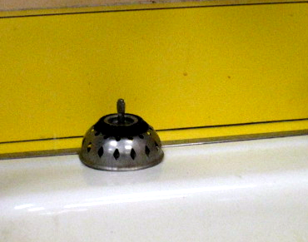

Breach between Sink Backsplash and Countertop

Picture 16

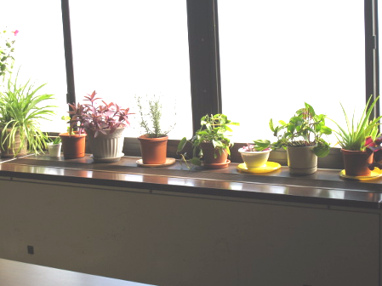

Plants on Univent

Picture 17
Route 18

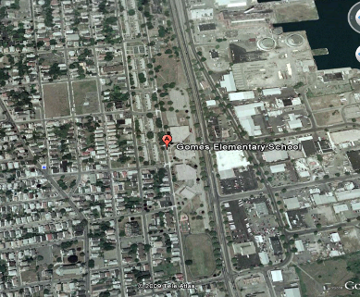

Proximity of Gomes Elementary School to Route 18

Picture 18

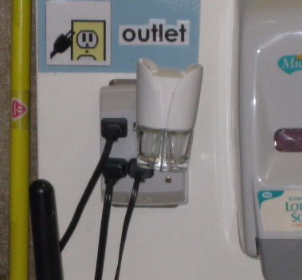

Plug-In Air Freshener in Classroom

Picture 19

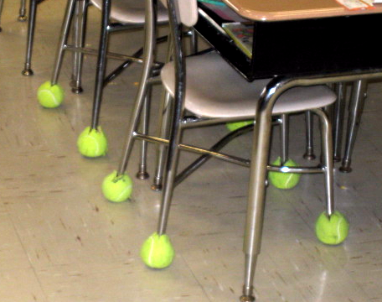

Tennis Balls on Chair Legs

Picture 20

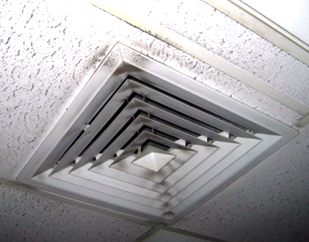

Dust/Debris Accumulation on Supply Vent and Surrounding Ceiling Tiles

Picture 21

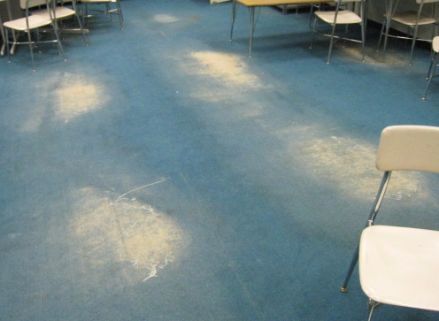

Vintage/Damaged Carpeting, Note Bare/Worn Spots as Indicated by Light Areas

Picture 22

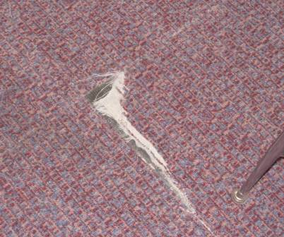

Worn/Damaged Carpeting

Picture 23

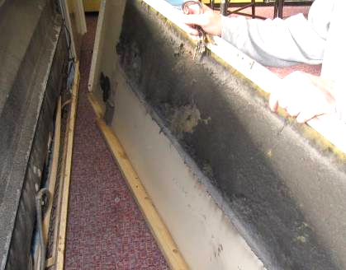

Soiled/Damaged Fiberglass Insulation Panel on Interior Cabinet of Univent
Location/ Room | Occupants  in Room | Temp  (°F) | Relative  Humidity  (%) | Carbon  Dioxide  (ppm) | Carbon Monoxide  (ppm) | PM2.5  (µg/m³) | Windows  Openable | Ventilation |  | Remarks
 |  |  |  |  |  |  |  | Supply | Exhaust | Remarks
Background |  | 39 | 22 | 320 | ND – 3.5 | 6 |  |  |  | Cold, scattered clouds, winds 5-15 mph gusts up to 25 mph, moderate to heavy traffic on Route 18
748 | 19 | 71 | 16 | 446 | ND | 4 | Y | Y | Y | Sink countertop/backsplash breach
750 Office | 0 | 73 | 13 | 560 | ND | 4 | N | Y | Y
747 | 19 | 73 | 15 | 650 | ND | 6 | Y | Y | Y | Sink countertop/backsplash breach
745 | 16 | 74 | 13 | 536 | ND | 5 | Y | Y | Y | 4 CT (foyer)
742 | 6 | 75 | 10 | 422 | ND | 6 | Y | Y | Y | 2 PC, 1 lamination machine
727 | 20 | 71 | 13 | 600 | ND | 6 | Y | Y | Y | Plants, plug-in, Sink countertop/backsplash breach
726 | 19 | 75 | 12 | 625 | ND | 6 | Y | Y | Y | UV-rattling noise, Sink countertop/backsplash breach
Vice Principal Office | 0 | 72 | 10 | 367 | ND | 6 | N | Y | Y
Resource Office | 4 | 72 | 11 | 411 | ND | 6 | N | Y | Y | Lamination machine, PC
519 Computer Room | 6 | 72 | 11 | 458 | ND | 5 | Y | Y | Y
526 | 0 | 71 | 11 | 378 | ND | 5 | Y | Y | Y | PF
527 | 0 | 70 | 12 | 371 | ND | 8 | Y | Y | Y | UF-diffuser covered, 2 CT
502 Conference Room | 0 | 68 | 12 | 402 | ND | 5 | N | Y | Y
504 | 4 | 71 | 12 | 400 | ND | 5 | Y | Y | Y | UV-off, 2 CT
301 Cafeteria Lounge | 0 | 70 | 11 | 372 | ND | 6 | Y | Y | N
342 | 3 | 71 | 13 | 502 | ND | 5 | Y | Y | Y | 2 PC
326 | 0 | 71 | 12 | 451 | ND | 6 | Y | Y | Y | Window open, occupants at lunch ~ 15 mins
329 | 0 | 72 | 12 | 500 | ND | 4 | Y | Y | Y | Occupants at lunch ~ 15 mins
330 | 0 | 71 | 11 | 409 | ND | 5 | Y | Y | Y | 20 occupants at lunch ~ 15 mins, window open
327 | 0 | 72 | 11 | 417 | ND | 5 | Y | Y | Y | Occupants at lunch ~ 20 mins
344 | 20 | 73 | 13 | 550 | ND | 7 | Y | Y | Y | Exhaust off, UV-noise, 4 CT (entrance)
300 Cafeteria | ~ 50 | 76 | 14 | 752 | ND | 6 | Y | Y | Y
315 | 6 | 76 | 11 | 464 | ND | 6 | Y | Y | Y
316 | 11 | 73 | 11 | 541 | ND | 5 | Y | Y | Y | Sink countertop/backsplash breach
318 | 29 | 75 | 17 | 625 | ND | 7 | Y | Y | Y | UV-insulation soiled/damaged-sloughing off
200 Cafeteria | ~50 | 75 | 12 | 458 | ND | 7 | Y | Y | Y | Plants
247 | 0 | 75 | 12 | 527 | ND | 6 | Y | Y | Y | Exhaust off, 4 CT, plants, occupants at lunch ~20mins
248 | 0 | 75 | 11 | 512 | ND | 6 | Y | Y | Y | 2 CT (outside door), occupants at lunch ~20mins, plants
250 | 0 | 78 | 12 | 705 | ND | 5 | Y | Y | Y | Exhaust off/sealed with cardboard-backdrafting
245 | 5 | 79 | 12 | 415 | ND | 6 | Y | Y | Y
Art | 2 | 71 | 11 | 380 | 1.0 | 5 | N | Y | Y | 22 occupants gone ~10 mins, 3 CT, 1 dislodged CT
629 | 1 | 74 | 13 | 380 | ND | 5 | Y | Y | Y | 12 occupants gone ~ 1 hr 20 mins
630 | 1 | 72 | 11 | 361 | ND | 5 | Y | Y | Y | 11 occupants gone ~ 1 hr 20 mins
741 | 20 | 67 | 15 | 615 | 0.7 | 5 | Y | Y | Y | UV off, plants on UV; Efflorescence on wall; CPs on sink; carpet in poor condition; Sink countertop/backsplash breach, dust accumulation on exhaust vent
729 | 21 | 69 | 14 | 643 | 0.8 | 6 | Y | Y | Y | UV off, stored items on UV; Carpet in poor condition; AD; Breach in window system, dust accumulation on exhaust vent
Library | 0 | 72 | 10 | 446 | 0.8 | 5 | N | Y | Y
348 | 12 | 72 | 14 | 755 | ND | 6 | Y | Y | Y | Furniture in front of UV
347 | 8 | 72 | 14 | 748 | ND – 1.6 | 5 | Y | Y | Y | Wall crack
346 | 26 | 72 | 15 | 884 | ND | 6 | Y | Y | Y | Books on UV, Furniture in front of UV
319 | 13 | 76 | 11 | 592 | ND | 5 | Y | Y | Y | Plants on UV
322 | 0 | 76 | 11 | 550 | ND | 6 | N | Y | Y | Cracked/WD CTs
321 | 0 | 76 | 11 | 544 | ND | 7 | N | Y | Y | WD CTs around supply vent
219 | 1 | 72 | 12 | 440 | ND | 7 | Y | Y | Y | UV off, CPs; Sink countertop/backsplash breach
220 | 0 | 72 | 11 | 432 | ND | 9 | Y | Y | Y | UV-off, Efflorescence on wall
229 | 21 | 74 | 14 | 692 | ND – 2.3 | 8 | Y | Y | Y | UV-off, Furniture in front of UV
230 | 17 | 76 | 13 | 654 | ND – 0.8 | 10 | Y | Y | Y | UV-off, Furniture in front of UV; CPs
232 | 14 | 76 | 12 | 614 | ND – 2.3 | 7 | Y | Y | Y | CPs; PF
Music | 0 | 77 | 9 | 402 | ND – 3.0 | 11 | N | Y | Y | WD CTs; AC on wall
651 | 1 | 68 | 15 | 438 | ND | 6 | Y | Y | Y | UV-off, dust accumulation on exhaust vent
650 | 1 | 72 | 12 | 422 | ND | 6 | Y | Y | Y | CPs; PF, dust accumulation on exhaust vent
648 | 0 | 74 | 12 | 411 | ND | 7 | Y | Y | Y
647 | 1 | 74 | 10 | 401 | ND | 6 | Y | Y | Y | UV on but no air flow from diffuser
619 | 3 | 71 | 13 | 450 | ND | 7 | Y | Y | Y | Plants on UV; Efflorescence on wall; Aqua
Nurse | 2 | 73 | 12 | 448 | ND | 6 | N | Y | Y | WD CTs
229/230/232 common area | 1 | 78 | 9 | 460 | ND | 6 | N | Y | Y
633 | 0 | 70 | 10 | 353 | ND | 5 | Y | Y | Y
645 | 4 | 77 | 11 | 380 | ND | 7 | Y | Y | Y | PC, Lamination machine
646 | 1 | 76 | 10 | 416 | ND | 6 | N | Y | Y
620 | 19 | 72 | 12 | 469 | ND | 6 | N | Y | Y | 1 CT
622 Inner Office | 0 | 72 | 12 | 473 | ND | 5 | N | Y | Y
600 Cafeteria | 0 | 70 | 11 | 351 | ND | 5 | N | Y | Y

Building envelope means the roof, exterior walls, exterior windows, exterior doors and foundation of a building.

