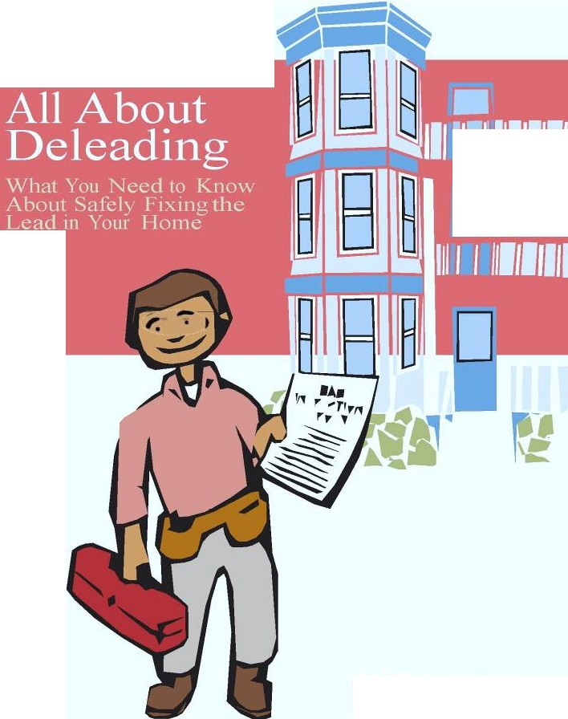

□

Ch!ldhood Lead
p Poisoru•ng prevention rogram (CLPPP)

Ca11 for free.· 1 - 800 -53?-9571

Getting Started
Protecting Children from Lead Poisoning | page 2
Massachusetts Lead Law | page 3
What is Deleading? | page 4
Getting Your Home Inspected for Lead | page 5
Different Ways of Deleading
Low-Risk Deleading | page 7
Encapsulation | page 9
Moderate-Risk Deleading | page 11
High-Risk Deleading | page 13
Other Options and Resources
Is Financial Help Available? | page 14
How Do I Get a Letter of Compliance? | page 15
Interim Control | page 17
Resources | back cover

Protecting Children from Lead Poisoning

Using this book
This book tells you what you need to know about fixing the lead hazards in your home. This is called deleading. Follow the steps in this book to make your home safe for everyone who lives there.
CLPPP is here to help you. If you have any questions about deleading, call us toll-free at 1-800-532-9571. Thank you for doing your part to keep children safe.
CLPPP stands for Childhood Lead Poisoning Prevention Program

How do children get lead poisoning?
Most of the lead poisoning in Massachusetts comes from lead paint in older homes. Many homes built before 1978 have lead paint on the inside and the outside of the building. When old paint cracks and peels, it creates lead dust. Lead dust gets into a child’s body when he puts his hands and toys in his mouth.
- Lead hurts the brain, kidneys, and nervous system.
- Children between the ages of 9 months and 6 years are most at risk.
- Even at low levels, lead can make it hard for children to learn, pay attention, and behave.

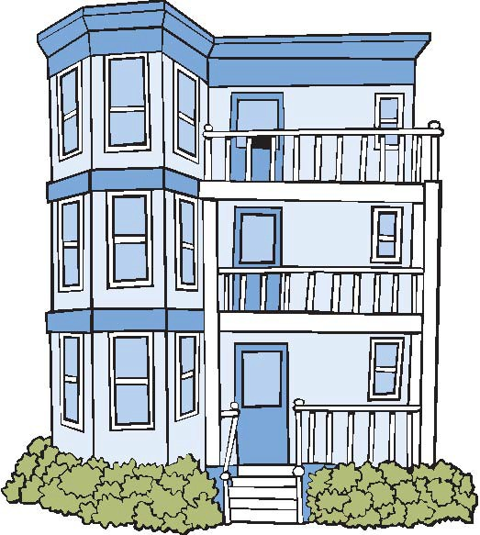
2

Massachusetts Lead Law

The Lead Law protects a child’s right to a lead-safe home. The Lead Law requires making homes safe if they were built before 1978 and have a child under the age of 6 living there.
Property owners must comply with the Lead Law. If a child gets lead poisoning from his or her home, the owner is responsible, even if the owner didn’t know about the lead. It is the owner’s job to find out about lead! Have the home inspected.

There are 2 ways to comply with the law:
- Remove or cover all of the lead hazards in the home. After the work is done safely and approved, you will get a Letter of Full Deleading Compliance.
or
- Fix only the urgent lead hazards. This temporary method is called interim control. After the work is done safely and approved, you will get a Letter of Interim Control. This letter is good for up to 2 years. After that, the hazards must be permanently corrected if children under 6 still live there.

3

What Is Deleading?

Deleading is work done to remove or cover lead hazards in the home. Deleading includes things like replacing windows and woodwork, scraping or covering old paint, and encapsulation.

Who can delead?
Homeowners who are trained and authorized can do low-risk and moderate-risk deleading. High-risk deleading must be done by a licensed deleader. This booklet explains the different types of deleading and how you can learn to do the work yourself.

Homeowners can also have an agent do low-risk or moderate-risk deleading. An agent is any person who does work for a homeowner. An agent can be an employee, a family member, or a friend. An agent must be 18 years of age or older. The agent must get authorized to do the work. Some lead safe renovators can do moderate risk deleading. Go to www.mass.gov/LWD/Labor-standards/lead-program

IMPORTANT!
A homeowner cannot do any deleading work before:
- The home is inspected by a licensed inspector
- The owner or agent is trained to do the work.
- The owner or agent has an authorization number from CLPPP.
- The owner or agent has notified all par ties when the work will begin.

If you do not follow these steps, you are risking the health of children and occupants and you will not get a Letter of Full Deleading Compliance or Interim Control.

4

Getting Your Home Inspected for Lead

How do I know if there is lead in my home?
The first step is to have your home tested for lead. Your home must be tested by a licensed lead inspector. You must have a full inspection.

Where do I find a licensed lead inspector?
There is a list of licensed lead inspectors on the CLPPP website at www.mass.gov/dph/clppp or call CLPPP at 1- 800-532-9571.

What type of lead inspector should I look for?
Lead inspectors must be licensed by CLPPP. You can call CLPPP to find out if anyone has complained about a lead inspector and to check on the license.
If you want a Letter of Interim Control, you must hire a risk assessor. A risk assessor is a lead inspector with extra training. A risk assessor will identify urgent lead hazards in your
home.

Do not remove or cover paint until the home is inspected by a licensed lead inspector! If lead is found, it must be fixed by someone who has been trained and authorized to do the work safely.

What does the lead inspector do?
The inspector will test the painted surfaces inside and outside your home for lead. The inspector will record all of the lead hazards on a lead inspection report. He will test everything on the lot, like sheds and garages.
After the inspection is completed, the lead inspector will give you a full report of the lead hazards in your home. The report should be given to you within 10 days of the inspection. The inspector should explain the report and give you information on lead. The inspector must also give a copy of the report to any tenants living in the home. If you are having trouble understanding your lead inspection report, call your inspector or call CLPPP at 1-800-532-9571.

How much will an inspection cost?
A lead inspection can cost up to $300 for a small apartment and up to $500 for a larger home. It is a good idea to get a price estimate from more than one inspector before you make your decision.
How long will the inspection last?
A full inspection will usually last at least 3 to 4 hours. The time of the inspection depends on the size of your home.

Getting a re-inspection
After you delead, you will need to hire a licensed lead inspector to do a final re-inspection of your home. This can be the same inspector who tested the home the first time or it can be a different licensed inspector. Be sure to ask the inspector what he or she charges for a re-inspection and dust samples.

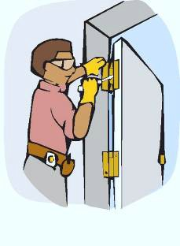
Low-Risk Deleading

What is low-risk deleading?
Low-risk deleading is work that trained homeowners may do without being a licensed deleader. Low-risk work includes:
- Removing doors, cabinet doors, and shutters from hinges
- Covering surfaces
- Applying vinyl siding to buildings
- Tape-testing surfaces for encapsulation and applying encapsulants (there is a separate training booklet for encapsulation)

Who can do low-risk deleading?
Low-risk deleading may be done by anyone 18 years of age or older who has been trained and authorized to do the work. If a homeowner does not want to do the work themselves, they can have an agent do the work for them. An agent is any person who does work for a homeowner. An agent can be an employee, a family member, or a friend. If you hire someone to vinyl side your home, he or she can also be an agent for low-risk deleading work.

How can I get trained and authorized to do low-risk deleading?
In order to do low-risk deleading, you must:
- Contact CLPPP to get a free copy of the Low-Risk Deleading Guide.
- Read the Low-Risk Deleading Guide.
- Take the at-home quiz.
- Mail the quiz back to CLPPP.
If you pass the at-home quiz, CLPPP will mail you an authorization number.

When can low -risk deleading be done?
Low-risk deleading work can only be done after you:
  - Have a lead inspection.
  - Receive your Low-Risk Authorization Number from CLPPP. If you are using encapsulants, you must also get an encapsulation authorization number (see next page).
  - Send out deleading notification to CLPPP, the Department of Labor Standards (DLS), and your local Board of Health. If there are tenants living in the building the notification must be sent 10 days before you start the work.

You must receive an authorization number from CLPPP before you start any work. Call 1-800-532-9571 for a copy of the Low-Risk Deleading Guide and the at-home quiz or visit www.mass.gov/dph/CLPPP

Encapsulation

What is encapsulation?
Encapsulation is work that trained homeowners may do without being a licensed deleader. Encapsulation means applying a special liquid coating, called encapsulant, over lead paint. Anyone applying encapsulant must do a tape-test to make sure existing paint is strong enough to hold the encapsulant.
  - Encapsulants are available in many paint and hardware stores.
  - Encapsulants work well on wood that is in very good condition.

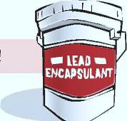
Regular paint is not an encapsulant!

Who can do encapsulation?
Encapsulation may be done by anyone 18 years of age or older who has been trained and authorized to do the work. If a homeowner does not want to do the work themselves, they can have an agent do the work for them. An agent is any person who does work for a homeowner. An agent can be an employee, a family member, or a friend. Call 1-800-532-9571 to request a copy of the Encapsulation Handbook or visit www.mass.gov/dph/CLPPP

Call 1-800-532-9571 to request a copy of the Encapsulation Handbook or visit http://www.mass.gov/dph/CLPPP

9

How can I get trained and authorized to do encapsulation?
In order to do encapsulation, you must:

- Contact CLPPP to get a free copy of the Encapsulation Handbook.
- Read the Encapsulation Handbook.
- Take the at-home quiz.
- Mail the quiz back to CLPPP.
If you pass the quiz, CLPPP will mail you an authorization number.

When can encapsulation work be done?
Encapsulation work can only be done after you:
  - Have a lead inspection.
  - Receive your Encapsulation Authorization Number from CLPPP.
  - Send out deleading notification to CLPPP, the Department of Labor Standards (DLS), and your local Board of Health. If there are tenants living in the building the notification must be sent 10 days before you start the work.

Before you apply encapsulants, a licensed lead inspector must test your home for lead and approve the sites you want to encapsulate.

Moderate-Risk Deleading

What is moderate-risk deleading?
Moderate-risk deleading is work that trained homeowners may do without being a licensed deleader. Moderate-risk work includes:
  - Removing windows, woodwork and other sur faces
  - Repairing or repainting (making intact) small amounts of lead paint (no more than 2 square feet per interior room or 20 square feet on the exterior).

You cannot remove walls or ceilings or do demolition work as part of moderate-risk.

Who can do moderate-risk deleading?
Moderate-risk deleading may be done /by anyone /18 years of age or older who has been trained and authorized to do the work. If a homeowner does not want to do the work themselves, they can have an agent do the work for them. An agent is any person who does work for a homeowner. An agent can be an employee, a family member, or a friend.

How can I get trained and authorized to do moderate-risk deleading?
In order to do moderate-risk deleading, you must:
- Complete a one-day long Moderate-Risk Training Course. The course will cover working safely and clean-up.
- Take the Moderate-Risk Test that CLPPP will send you after you finish the course.
- Mail the moderate-risk test back to CLPPP.

If you pass the moderate-risk test, CLPPP will mail you an authorization number.

Some lead safe renovators may also do moderate risk. Go to ://www.mass.gov/LWD/Labor-Standards/lead-

Remember: Anyone planning to do moderate-risk work must have the necessary carpentry skills and the time to do the work!
  - Inspectors cannot approve a poor carpentry job.
  - Families cannot stay in the home during moderate-risk work on the inside.

How do I find a moderate-risk training course near me?
Private trainers generally charge about $200 for the 8 hour training course. Some providers offer courses at least twice a month, including night and weekend trainings. Always confirm course dates with the trainer.

A list of moderate-risk training providers is included with this booklet. More detailed information is available on the CLPPP website: ://www.mass.gov/dph/ .

If you want to hire a contractor (like a window replacement company), make sure the contractor is a licensed lead-safe renovator or a licensed deleader. You can check these licenses by calling the Department of Labor Standards (DLS) at 1- 617-626-6960 or visit www.mass.gov/LWD/LaborStandards/lead- program

High-Risk Deleading

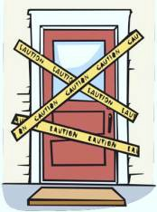
What is high-risk deleading?
High-risk deleading is work that must be done by a Licensed Deleader. High-risk work includes:
  - Scraping paint
  - Using chemical paint strippers
  - Demolition
  - Making large amounts of lead paint intact.

How do I find a licensed deleader?
There is a list of licensed deleading contractors on the CLPPP website at: www.mass.gov/dph/clppp. A contractor must be licensed by the Department of Labor Standards (DLS). It is a good idea to get at least three price estimates before choosing a licensed deleader. You should call DLS to:
  - Check the license number to be sure it is current, and has not been taken away or suspended.
  - Find out if any complaints have been filed against the contractor.

What should I look for in a contract with a licensed deleader?
Make sure you get a written contract! The contract should have the name, license number and contact info for the deleader responsible for the job. It should also include:
  - What type of work will be done and what type of materials will be used.
  - About how long the job will take, including a start and end date.
  - A plan about clean up and re-painting. Be sure the deleader will clean up your home at no extra charge
until it passes re-inspection.
  - A payment plan for the work. For example, part of the money given up front, part during the job, and the final part given after you receive your Letter of Full Deleading Compliance.

Is Financial Help Available?

Yes! There is money available to help you. Call the Get the Lead Out program for details at: 1-617-854-1000. Or visit www.masshousing.com.

Get the lead out
The Get the Lead Out program provides low-cost financing to homeowners to remove or cover lead paint. Some homeowners may be able to get loans that don’t need to be paid back until the home is refinanced or sold.

Local programs
There may be financing for deleading available in your local community. Contact your local office of Community Development or Planning at City Hall to find out.

Tax credit
If you receive a Letter of Full Deleading Compliance, you are eligible for up to
$3,000 credit on your state income taxes. If you receive a Letter of Interim Control, you are eligible for a $1,000 credit on your state income taxes for each unit you make lead safe.

To get a copy of Schedule LP and additional information regarding the Lead Paint Tax Credit contact the Massachusetts Department of Revenue at 617-887- MDOR or 1-800-392-6089, or www.mass.gov/dor

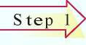
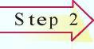
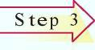
How Do I Get a Letter of Compliance?

Have your home inspected
First, have your home inspected by a licensed lead inspector. This will determine where the lead hazards are in your home and what needs to be fixed. If there are no lead hazards and no signs of unauthorized deleading, then the inspector will issue a Letter of Initial Compliance.
Decide who will do the work
If you plan to do the low-risk and moderate-risk deleading yourself, you must first get authorization from CLPPP.
- Think about if you have the time and skills to do the work.
- If the work is considered high-risk, or you do not want to do it yourself, hire a licensed deleader or a lead-safe renovator.
Send notification
You must send deleading notification before you do the work. If there are tenants living in the home, you must give notification 10 days before you delead.
- Deleading notification should be sent to all occupants of the building, CLPPP, the Department of Labor Standards (DLS), and your local Board of Health.
- You do not need to wait 10 days before you begin the work if no one is living in the home or if you are the only one living in the home. You must still send the deleading notification.

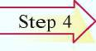
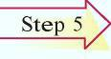
Do the work
Occupants cannot be in the home during most deleading work.

- If high-risk or moderate-risk deleading will take place inside the home, occupants must relocate until the work is done.
- Before the occupants return home, you must have a re-occupancy inspection by a lead inspector. If needed, remaining low-risk deleading can be done after the occupants have returned home.
- If you are doing low-risk work, the work area must be cleaned up at the end of the day. Occupants do not need to relocate.
Have a final re-inspection
After all of the work is finished, hire a licensed lead inspector to do a final re-inspection of your home. This can be the same inspector who tested the home the first time or a different inspector. The inspector will need to take a set of lead dust wipes that must meet clearance levels.
- If the lead hazards have been corrected, the inspector will issue a Letter of Full Deleading Compliance.

A Letter of Full Deleading Compliance and your Re-Inspection Report (which shows how each surface was fixed) are very important legal documents. Keep them in a safe place so you do not lose them.

Interim Control

What is interim control?
Interim Control is a way for homeowners to fix urgent lead hazards in order to protect children from lead. It gives owners up to 2 years to delead a home and come into full compliance. By the end of 2 years, the home must be fully deleaded if a child under 6 lives there.

Urgent lead hazards include:
- chipping, peeling, or loose paint
- windows with lead paint
- window wells that are not smooth or easy to clean
- structural defects such as roof leaks that cause paint to peel

How do I identify the urgent lead hazards?
A licensed risk assessor will inspect your home and determine which lead hazards need to be corrected in order to get a Letter of Interim Control.

A risk assessor is a lead inspector with extra training. A risk assessor will identify urgent lead hazards in your home. For a list of licensed risk assessors, call CLPPP at 1-800-532-9571 or visit www.mass.gov/dph/CLPPP

How Do I Get a Letter of Interim Control?

Have your home inspected by a risk assessor
First, hire a licensed risk assessor to identify the urgent lead hazards in your home. If you plan to do the low-risk and moderate-risk deleading yourself, you must first get authorization from CLPPP. If the work is considered high-risk, or you do not want to do it yourself, hire a licensed deleader.
Have a re-inspection
After the deleading is finished, hire a risk assessor to re-inspect the home. The assessor will take dust wipes to check for lead.

If the urgent problems have been fixed, the risk assessor will give you a Letter of Interim Control, which is good for one year. The owner can have the home re-inspected before the end of the year. If the home passes the inspection, the Letter of Interim Control will be renewed for one more year.
Follow-up within two years for full compliance
By the end of 2 years, the home must be deleaded for full compliance if a child under 6 lives there.

Resources
Childhood Lead Poisoning Prevention Program (CLPPP)
MA Department of Public Health
250 Washington Street, Seventh Floor Boston, MA 02108
1-800-532-9571 (toll free)

To find a licensed lead inspector or deleader visit the CLPPP website at: www.mass.gov/dph/clppp

Department of Labor Standards
Lead Program
Department of Labor and Workplace Development 19 Staniford St., 2nd floor
Boston, MA 02114
1-617-626-6960
www.mass.gov/LWD/Labor-standards/lead-program

To find your local Board of Health:
Massachusetts Association of Health Boards 1-508-643-0234
www.mahb.org

For financial help:
Get the Lead Out Program 1-617-854-1000
http://www.masshousing.com/portal/server.pt

FOR MORE INFORMATION, CONTACT:
Childhood Lead Poisoning Prevention Program (CLPPP) Massachusetts Department of Public Health
250 Washington Street, Seventh Floor Boston, MA 02108

Call for free: 1-800-532-9571
On the web: www.mass.gov/dph/clppp

Massachusetts Department of Public Health Bureau of Environmental Health

