**All in a Day’s Work!**

The MDDC’s Photo Contest Showcasing Individuals with Developmental Disabilities

Making a Living in the Community

***AND THE WINNER IS…***

First Place goes to **Jill Alongi** from Braintree.

Jill is employed at both the Stop & Shop in Weymouth and the Stop & Shop in Braintree. She works in the bakery department at each branch as a Bakery Associate. Thank you to everyone who entered the Council’s Disability Employment Photo contest. The Council was impressed by all the pictures we received depicting individuals with disabilities working at diverse jobs in the community.

Below are the pictures that received the most votes but in our opinion, all the pictures are winners!

In this picture she can be seen helping to bake cookies with a big smile on her face. Jill loves to work in the bakery and to be surrounded by all sorts of treats and desserts that she gets to help make.



Second place is a tie and goes toBOTH **Rachel Tamulevich** from Hansonand **Jack Sullivan** from Hingham

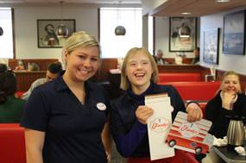

Rachel Tamulevich is a memory-maker, at Friendly's in Pembroke. Rachel helps with many of the restaurant operation responsibilities. She gets great satisfaction from checking off her items on her checklist of chores.

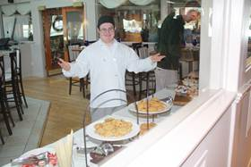

Jack Sullivan greets people at Sunday brunch at Atlantica in Cohasset.