Commonwealth of Massachusetts
Executive Office of Health and Human Services

Office of Medicaid
www.mass.gov/masshealth
MassHealth
All Provider Bulletin 247
September 2014

TO: All Providers Participating in MassHealth

FROM: Kristin L. Thorn, Medicaid Director

RE: Free Enhanced Text Messaging Service to Support Pregnant Women and New Mothers

Overview
How Text4baby Works
- Women who Text BABY (or BEBE for Spanish) to 511411 receive three weekly text messages timed to their due date or their baby's birth date up to age one.
- Text messages provide information on a broad range of topics including prenatal care, immunizations, safe sleep, how to avoid substance abuse, well-child care, injury prevention, and other critical health and safety issues. Messages also link to educational videos and mobile health pages, health-related services, and urgent health alerts.
- The Text4baby Appointment Reminder feature allows participants to set up text message reminders for appointments and is free to all participants.
- Text4baby messages are carefully reviewed by a council of experts representing the American Academy of Pediatrics, American College of Nurse-Midwives, American College of Obstetricians and Gynecologists, Centers for Disease Control and Prevention, March of Dimes, U.S. Department of Health and Human Services (HHS) and other maternal and child health experts.

In an effort to support and improve postpartum care in Massachusetts, MassHealth has partnered with Text4baby, a free mobile health service of the National Healthy Mothers, Healthy Babies Coalition. The partnership will provide critical health and safety information, and Massachusetts-specific resources to pregnant women and new mothers with children under age one. MassHealth requests your assistance in enrolling women in this service.
Background
Text4baby supports women by providing accurate and timely health information and resources in a format that they know and frequently use. Research shows that text messaging is higher among women of childbearing age, low-income, and minority populations. The Massachusetts Women, Infants and Children (WIC) Nutrition Program has been promoting Text4baby to participants since 2010.
External evaluations of Text4baby have shown significant positive results.
- 74% of participants reported that Text4baby messages informed them of medical warning signs that they did not know.
- 65% of participants reported that Text4baby helped them remember an appointment or immunization that they or their child needed.
Reference: Text4baby CSU and UCSD Evaluation
Improving Postpartum Visit Rates
The Text4baby postpartum visit module was developed as part of a pilot project with the Centers for Medicare & Medicaid Services (CMS) in California, Ohio, Oklahoma, and Louisiana. Text4baby pilot partners have been customizing content and messages to improve a range of selected health measures, including rates of postpartum care visit attendance and smoking cessation during pregnancy to improve maternal knowledge on reducing preterm delivery.

MassHealth
All Provider Bulletin 247
September 2014
Page 2

MassHealth seeks to increase the number of women who attend their postpartum check-ups. See Physician Bulletin 95 (July 2013) for reference. In order to improve postpartum visit attendance, MassHealth is working with Text4baby to customize and send educational messages from the Text4baby postpartum visit module to MassHealth members. Messages will include appointment reminders, links to Massachusetts-specific resources, and information encouraging new mothers to talk to their provider about important postpartum issues such as birth control, Type 2 diabetes, and their emotional and physical well-being. MassHealth’s collaboration with Text4baby is being fully-funded through a portion of a $1.8 million Adult Medicaid Quality Grant from CMS.
Below is a schematic of the messages that will be disseminated to MassHealth members.
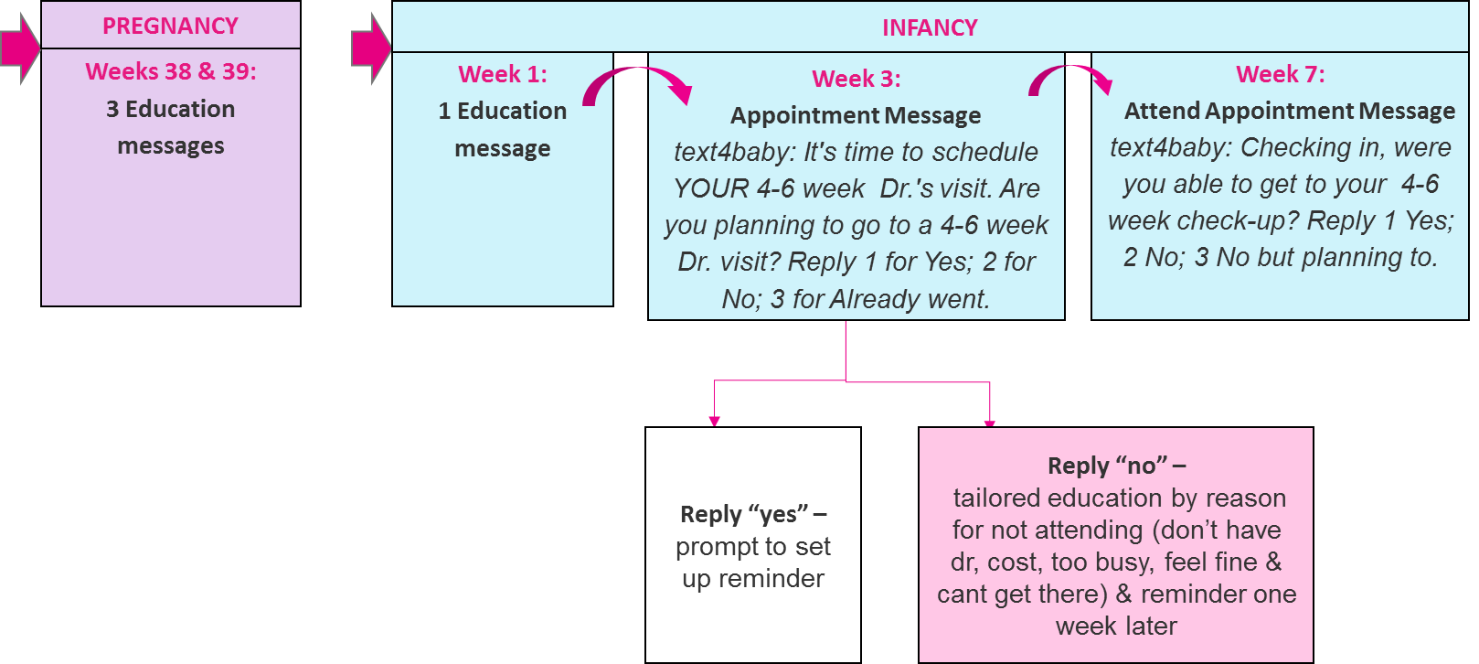
Postpartum Visit Module Flow 2014
Talking to Patients about Text4baby
Health care providers are critical partners in enrolling women in Text4baby. Given the limited time available to discuss every health topic, Text4baby is an important tool to engage and reinforce the clinical guidance provided to patients.
Here are some best practices you can use to promote Text4baby:
- Integrate Text4baby enrollment into prenatal and postpartum care as part of your hospital or clinic workflow. Encourage your patients to sign up by texting BABY or (BEBE for Spanish) to 511411 on their cellphones.
- Place Text4baby tear pads next to your check-in/check-out desks and ask staff to encourage moms to take a sheet. Free Text4baby promotional materials are available for downloading and printing on the MassHealth Text4baby website under Resources.
- Post Text4baby flyers in your waiting areas, exam rooms, and on bulletin boards.
- Promote Text4baby via social media (@mytext4baby).
- Add the Text4baby web enrollment button to your practice’s website.
- Add a Text4baby reminder prompt to your electronic health record.

MassHealth
All Provider Bulletin 247
September 2014
Page 3

If your MassHealth patient does not have a cell phone, she may qualify to receive a free phone through the Massachusetts Lifeline Program. For additional information or assistance, you may contact the Consumer Division of the Department of Telecommunications and Cable (DTC) at 1-800-392-6066.
Questions
If you have any questions about the information in this bulletin, please contact the MassHealth Customer Services Center at 1-800-841-2900, e-mail your inquiry to providersupport@mahealth.net, or fax your inquiry to 617-988-8974.

