Commonwealth of Massachusetts
Executive Office of Health and Human Services

Office of Medicaid
www.mass.gov/masshealth

MassHealth
All Provider Bulletin 250
August 2015

TO: All Providers Participating in MassHealth
FROM: Daniel Tsai, Assistant Secretary for MassHealth 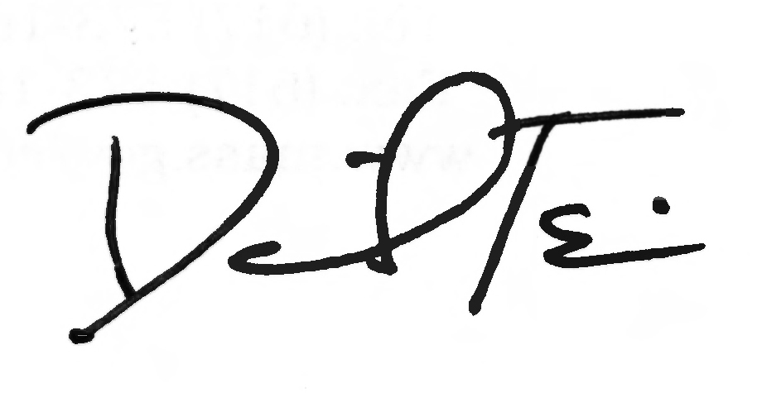

RE: Enhancements to the Provider Revalidation Process

Background

In March of 2014 MassHealth began its provider revalidation initiative as required by Section 6401 of the Affordable Care Act. Providers who were enrolled with MassHealth on or before March 25, 2011, are required to complete revalidation by March 24, 2016. For details on revalidation, please refer to All Provider Bulletin 242.

Enhancements to the Provider Revalidation Process

Your continued participation in MassHealth is important to us. MassHealth has recently made some enhancements to the revalidation process in order to streamline this critical initiative. We encourage all providers who have been selected for revalidation to review these enhancements described below.

- Wet Signatures. MassHealth no longer requires original wet signatures on the Federally Required Disclosures Form (FRDF) or the Data Collection Form (DCF). Digital images and copies of signatures will now be accepted on these forms.
- Streamlined Process. MassHealth no longer requires the following documents as a requirement of revalidation: copies of Electronic Fund Transfer, MA W-9 (unless you are currently receiving payments and need to make a change to your legal name or banking information), and copies of licensure.

The following elements are still required for revalidation.

- Provider Online Service Center (POSC) panel confirmation and attestation. If you don’t have access to the POSC, please see below for information about setting up account access.
- A Federally Required Disclosures Form (FRDF). This form can now be uploaded with your submission on the POSC.
- Site visits for certain provider types.
- CORI background check for certain provider types.

Provider Education Opportunities

Bi-Monthly Revalidation Webinars

All MassHealth providers are invited to join the retooled Revalidation Tutorial Webinars held

(continued on next page)

MassHealth
All Provider Bulletin 250
August 2015
Page 2

Provider Education Opportunities (cont.)

every second Thursday and fourth Tuesday of the month. These webinars will provide you step-by-step instructions on how to access your information on the POSC, change/update your profile information, and upload and complete other documentation. Contact revalidation@mahealth.com for more information.

Revalidation Provider Trainings

MassHealth also offers providers the opportunity to participate in individualized training sessions conducted over the phone or in person. Please contact revalidation@mahealth.com for more information.

Access to the Provider Online Service Center

Access to the Provider Online Service Center is required for revalidation in order to review your information and complete the online attestation. If you do not have access to the POSC, you must submit a Data Collection Form (DCF) with the administrator’s information. You don’t have to wait for a Revalidation Notice to begin your DCF. The DCF can be found at www.mass.gov/eohhs/docs/masshealth/provider-services/forms/posc-dc.pdf. You can e-mail the completed form to pinregistrationsupport@mahealth.net or fax it to 617-988-8974.

Questions and Resources

For more information and valuable resources to assist you in meeting the requirements for compliance with revalidation, please visit www.mass.gov/eohhs/provider/insurance/masshealth/provider-enrollment/provider-revalidation.html

If you have any questions about the information in this bulletin, please e-mail your inquiry to providersupport@mahealth.net, fax your inquiry to 617-988-8974, or contact the MassHealth Customer Service Center at 1-800-841-2900.

