Commonwealth of Massachusetts
Executive Office of Health and Human Services

Office of Medicaid
www.mass.gov/masshealth
MassHealth
All Provider Bulletin 256
October 2015

TO: All Providers Participating in MassHealth
FROM: Daniel Tsai, Assistant Secretary for MassHealth 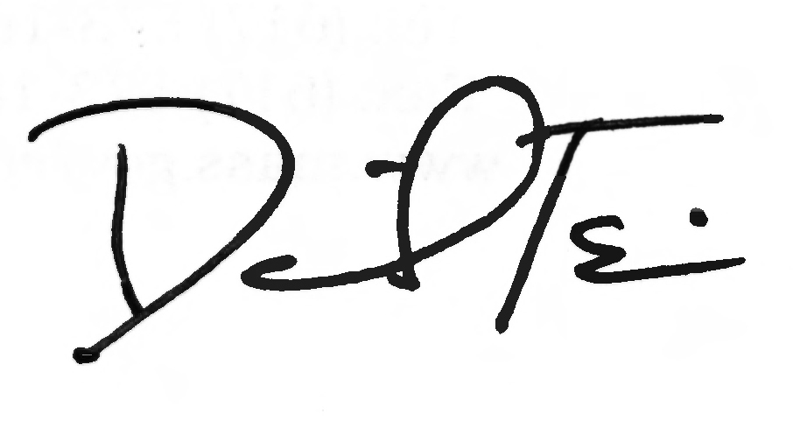

RE: The Overpayment Disclosure Process

Introduction

This bulletin supplements All Provider Bulletin 224, issued in March 2012, to inform MassHealth providers of federal requirements imposed by the Affordable Care Act (ACA) of 2010 to report and return overpayments received from MassHealth.

Provider Overpayment Disclosure Form

To aid providers in the disclosure process, MassHealth has developed a Provider Overpayment Disclosure form for use when disclosure via the Provider Online Service Center (POSC) or direct data entry (DDE) is not appropriate. This form captures key information that will allow MassHealth to identify the affected claims, such as the Internal Control Number (ICN), the provider’s name and number, and the date of service.

The voluntary disclosure process also requires providers to summarize why the disclosure is being made and to provide, among other items, the following information.

- How the error was discovered
- A description of the corrective action plan implemented to ensure the error does not occur again
- The reason for the overpayment
- Whether the provider has a corporate integrity agreement with the U.S. Office of Inspector General (OIG) or is under the OIG Self-Disclosure Protocol
- The timeframe and total amount of overpayments during the period when the problem existed that caused the overpayments
- MassHealth Provider Identification Number
- National Provider Identification Number/Service Location (NPI/SL)
- The amount of the overpayment
- Additionally, if a statistical sample was used to determine the overpayment amount, a description of the statistically valid methodology used to determine the overpayment

Examples of potential reasons are (a) collection from Medicare A or B; (b) collection from auto insurance or Workers’ Compensation; (c) claim was paid to the wrong provider; (d) erroneous duplicate payment for the same service date; and (e) collection from credit balance on patient account.

(continued on next page)

MassHealth
All Provider Bulletin 256
October 2015
Page 2

Provider Overpayment Disclosure Form (cont.)

Providers should be aware that MassHealth monitors both the number of occurrences and dollar amounts of voids and/or adjustments, as well as any patterns of voids and/or adjustments. MassHealth discourages providers from attempting to avoid the completions and submission of the Provider Overpayment Disclosure Form when circumstances warrant its use.

Obtaining a Provider Overpayment Disclosure Form

The Provider Overpayment Disclosure Form (ODF-0312) may be downloaded from the MassHealth website at www.mass.gov/masshealth. Providers who are unable to access the form online may obtain a copy by sending an e-mail to providercomplianceunit@umassmed.edu, or by mailing the request to the following address.

MassHealth Provider Compliance Unit
529 Main Street, Box 26
Suite 320
Charlestown, MA 02129-1120

Returning Overpayments

For the disclosure and repayment of simple, routine overpayments, providers should continue to use the standard administrative and billing methods of resolution. Nonpharmacy providers should submit voids and, in the case of adjustments, replacement transactions through the POSC using DDE or the HIPAA-compliant 837 format. Please refer to the appropriate 837 HIPAA ASC-X12 implementation guide.

Providers who are unable to use the 837 transaction to process voids may use the paper MassHealth Void Request Form. For more information on the Void Request Form / VR-1 (Rev. 5/14), refer to the MassHealth All Provider Bulletin 152 (April 2006).

If the overpayment identified by the provider is not a simple, routine void or replacement
transaction, federal and state laws and regulations require that providers report these transactions in writing. Please see 42 U.S.C. 1320a-7k(d) and 130 CMR 450.235(B), which states, “A provider must report in writing and return any overpayments to the MassHealth agency within 60 days of the provider identifying such overpayment or, for payments subject to reconciliation based on a cost report, by the date any corresponding cost report is due, whichever is later.”

Returning overpayments–Pharmacy

Pharmacy providers should continue to submit claim reversals as B2 transactions through the Pharmacy Online Processing System (POPS).

Returning overpayments–Dental

Dental providers should continue to submit claim reversal transactions through DentaQuest (1-800-207-5019).
(continued on next page)

MassHealth
All Provider Bulletin 256
October 2015
Page 3

Overpayment Recovery

Once the full overpayment has been determined, MassHealth will initiate its standard recoupment process. The provider should not send a check for any overpayment unless the provider has received prior written approval from MassHealth.

MassHealth will not accept any payment from the provider before it reviews the provider’s submission and confirms the accurate amount of the overpayment. During the pendency of the process, the provider should not void or correct any of the claims involved unless instructed to do so by MassHealth.

Questions

If you have any questions about the information in this bulletin, please contact the MassHealth Customer Service Center at 1-800-841-2900, e-mail your inquiry to providersupport@mahealth.net, or fax your inquiry to 617-988-8974.

Follow us on Twitter @MassHealth.

