MassHealth
Commonwealth of Massachusetts
Executive Office of Health and Human Services

Office of Medicaid
www.mass.gov/masshealth
All-Provider Bulletin 261
September 2016

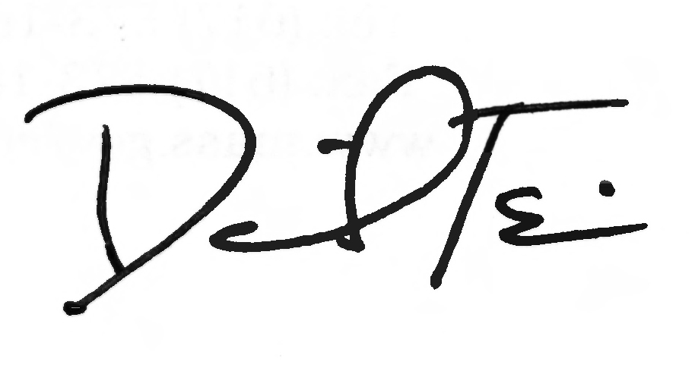

TO: All Providers Participating in MassHealth

FROM: Daniel Tsai, Assistant Secretary for MassHealth

RE: Plan Selection Periods and Fixed Enrollment Periods for Members Enrolled in a Managed Care Organization (MCO)

Background

Effective October 1, 2016, MassHealth will begin implementing Plan Selection Periods which will be followed by Fixed Enrollment Periods for members enrolled in Managed Care Organizations (MCOs). These changes will be communicated to members in late August via a mailing to affected heads of household. MassHealth encourages providers to familiarize themselves with the information outlined in this bulletin. Additional information and support can be found at www.mass.gov/masshealth (click on “MassHealth Providers.”)

Start of Plan Selection Periods and Fixed Enrollment Periods

Effective October 1, 2016, all members enrolled in MCOs will have an annual Plan Selection Period. This is a period of 90 days during which members can consider their options and choose to enroll in a different MCO or enroll in the Primary Care Clinician (PCC) Plan if they wish. Aside from a limited set of circumstances, the annual Plan Selection Period is a member’s only opportunity to change plans.
Once their annual Plan Selection Period has ended, members will be placed in a Fixed Enrollment Period. Members will not be able to change plans until their next Plan Selection Period, except in a limited set of qualifying circumstances.
All affected heads of household will receive a notice from MassHealth on or about August 25, 2016, explaining these changes. These changes will also be reflected in MassHealth regulations, specifically 130 CMR 508.004, which are currently being amended.
The start and end dates of annual Plan Selection Periods are member specific. Not all MassHealth members will experience Plan Selection Periods and the following Fixed Enrollment Periods at the same time. All members will receive written notice from MassHealth providing the unique start and end dates of their Plan Selection Period. The first Plan Selection Period will begin on October 1, 2016. MassHealth Customer Service will be able to assist members with any questions.
Please note that Fixed Enrollment Periods will not apply to members enrolled in the PCC Plan or to children enrolled with MassHealth through the Department of Youth Services or the Department of Children and Families. Such members can continue to change plans at any time.

MassHealth

All Provider Bulletin 261

September 2016

Page 2

Questions

For additional information about the Plan Selection and Fixed Enrollment Periods, including a list of Provider Q&A’s and a copy of the letter sent to affected heads of household, please visit www.mass.gov/masshealth. (Click on “MassHealth Providers.”)
If you cannot find the answer to your question at www.mass.gov/masshealth, please contact the MassHealth Customer Service Center by e-mail at providersupport@mahealth.net, by fax at
617-988-8974, or by phone at 1-800-841-2900.

Follow us on Twitter @MassHealth.

