Commonwealth of Massachusetts
Executive Office of Health and Human Services

Office of Medicaid
www.mass.gov/masshealth
MassHealth
All Provider Bulletin 264
January 2017

TO: All Providers Participating in MassHealth
FROM: Daniel Tsai, Assistant Secretary for MassHealth 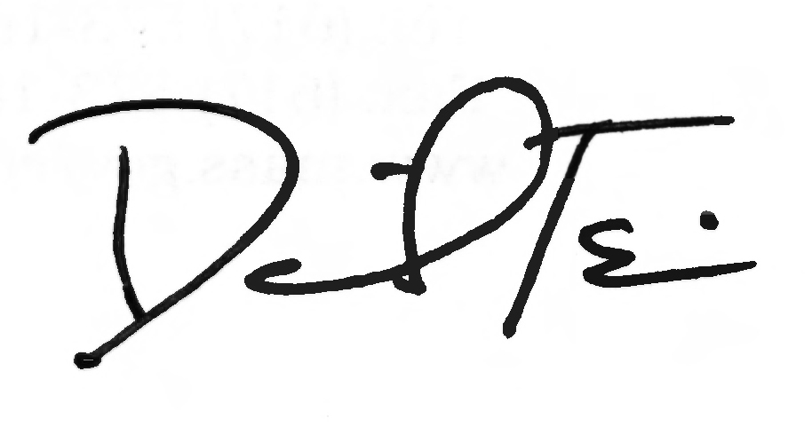

RE: Clarification on MassHealth Residency Requirement and Process for Reporting Non-residents Receiving MassHealth

Background

This bulletin clarifies MassHealth residency requirements and describes the steps providers should take if they suspect that a current MassHealth member does not meet the residency requirement. MassHealth Program Integrity Unit staff will review the reported information. MassHealth eligibility for members who do not meet the residency requirements will be terminated.

MassHealth Residency Requirements

As a condition of MassHealth eligibility, an applicant or member must be a resident of the Commonwealth of Massachusetts.

Individuals 21 years of age or older who live in the Commonwealth, with or without a fixed address, are considered residents if either of the following is the case:
- they intend to reside in the Commonwealth, or
- they have entered the Commonwealth with a job commitment or they are seeking employment.

Individuals younger than 21 years of age who live in the Commonwealth with or without a fixed address are considered residents if either of the following is the case:
- they are capable of indicating intent, and they are either married or emancipated from their parents, and
  - they intend to reside in the Commonwealth, or
  - they have entered the Commonwealth with a job commitment or they are seeking employment; or
- they are not capable of indicating intent and
  - they live in the Commonwealth with or without a fixed address, or
  - they are living with their parent or caretaker who meets the residency rules for individuals over 21 years of age.

Certain exceptions to these general rules apply. Please refer to MassHealth residency regulations at 130 CMR 503.002: Residence Requirements and 517.002: Residence Requirements for details.

Individuals who are visiting Massachusetts, including those who are visiting for personal pleasure or for the purposes of receiving medical care in a setting other than a nursing facility, do not meet the residency requirement for MassHealth.
(continued on next page)

MassHealth

All Provider Bulletin 264

January 2017

Page 2

MassHealth Residency Requirements

Applicants completing the Massachusetts Application for Health and Dental Coverage and Help Paying Costs (ACA-3) or the Application for Health Coverage for Seniors and People Needing Long-Term-Care Services (SACA-2) must attest to Massachusetts residency on the application. Applicants who do not meet the residency requirements will not be approved for MassHealth. If you are helping someone to complete an application, you must advise them to check “no” to the residency question if they are visiting Massachusetts for personal pleasure or for the purposes of receiving medical care in a setting other than a nursing facility.

Process for MassHealth Members Suspected of Non-residency

Hospitals, community health centers, and other providers may receive information from a patient that indicates the individual may not meet the MassHealth residency requirements described above.

If a provider suspects that a MassHealth applicant or member does not meet MassHealth residency requirements, as in the case of a member who is visiting Massachusetts for the purposes of receiving medical care in a setting other than a nursing facility, the provider should take the following steps to make a referral to MassHealth Program Integrity Unit.

- Provider Responsibility
Providers should complete the MassHealth Program Integrity Referral Form (see [link]) if they suspect that a MassHealth applicant or member does not meet the MassHealth residency requirements.

E-mail the completed MassHealth Program Integrity Referral Form and a copy of any supporting documentation to integrityreferral@massmail.state.ma.us to refer the case to the MassHealth Program Integrity Unit for investigation.

- MassHealth Program Integrity Unit Responsibility
On receipt of the e-mail, MassHealth Program Integrity Unit staff will review the case and provided documentation to determine if verification of residency is needed.
Attachments

Sample MassHealth Program Integrity Referral Form. The MassHealth Program Integrity Referral Form can be found at http://www.mass.gov/eohhs/gov/laws- regs/masshealth/provider-library/masshealth-provider-forms.html

Questions

If you have any questions about the information in this bulletin, please contact the MassHealth Customer Service Center at 1-800-841-2900, e-mail your inquiry to providersupport@mahealth.net, or fax your inquiry to 617-988-8974.



MASSHEALTH RESIDENCY PROGRAM INTEGRITY REFERRAL FORM

Provider Contact Information:
Provider Name: _______________________________________________________
Contact Name: ________________________ Telephone Number: _______________
E-mail Address: _______________________________________________________
Patient Information:
Applicant/Member Name: _________________________________________________
Date of Birth: _______________MassHealth ID # (if applicable): ________________
Is the patient currently on MassHealth? □ Yes □ No
If no, has the patient applied for MassHealth? □ Yes □ No
Where did patient complete the MassHealth application, if known?
_____________________________________________________________________
Did patient express intent to live in Massachusetts? □ Yes □ No
Why do you believe patient does not meet MassHealth residency requirement?
___________________________________________________________________________________________________________________________________________________________________________________________________________________________________________________________________________________________________________________________________________________________________________________________________________________________________________________________________________________________________

Submit via e-mail to: integrityreferral@massmail.state.ma.us and attach copies of any supporting documentation.

MH-REF (01/17)

