MassHealth
Commonwealth of Massachusetts
Executive Office of Health and Human Services

Office of Medicaid
www.mass.gov/masshealth
All Provider Bulletin 266
March 2017

TO: MassHealth Providers
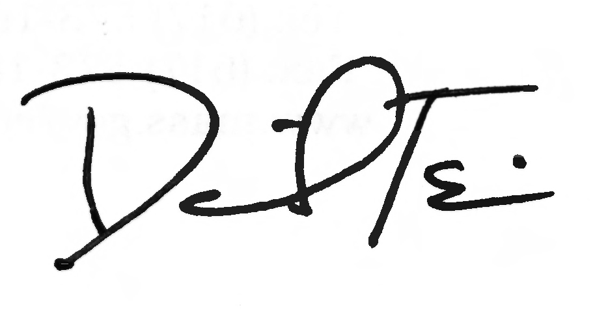

FROM: Daniel Tsai, Assistant Secretary for MassHealth

RE: MassHealth Coverage of AAC Non-Dedicated Device
New Prior Authorization Process

Background

MassHealth covers medically necessary alternative and augmentative communication (AAC) devices under its durable medical equipment (DME) program. To be eligible for federal matching funds (federal financial participation or FFP), items covered by MassHealth as DME must have a primary medical purpose, as required by the federal definition of DME. Under 42 CFR 440.70, DME is “used primarily and customarily to serve a medical purpose… [and is] generally not useful in the absence of disability, illness, or injury.” Under state law, MassHealth may generally only cover items or services eligible for FFP. There are two main categories of AAC devices:
Dedicated devices: are devices limited to primarily serve a medical purpose, such that they are generally NOT useful in the absence of disability, illness, or injury. MassHealth covered AAC devices include tablet-sized medical devices that are compatible with various speech generation software and applications. Federal matching funds are available for dedicated devices.
Non-dedicated devices: have a NON-MEDICAL main purpose and generally ARE useful in the absence of disability, illness or injury, for example a non-medical electronic tablet. Federal matching funds are not available for non-dedicated devices. However, as described below, MassHealth covers non-dedicated devices under certain limited circumstances.

Limited Coverage of Non-Dedicated AAC Devices
In general, MassHealth does not provide coverage for items or services unless federal matching funds are available; however, state law (M.G.L. c. 118E, sec. 10H) authorizes the expenditure of 100 percent state funds for “non-dedicated” devices, including non-medical electronic tablets that can serve as a member’s medically necessary AAC under certain circumstances. Specifically,
- Members under 21
- With a diagnosis of an autism spectrum disorder
- Who have a severe expressive communication disorder

(continued on next page)

MassHealth
All Provider Bulletin 266
March 2017
Page 2

- Who meet MassHealth’s Prior Authorization (PA) requirements for covered (dedicated) AAC. (See MassHealth Guidelines for Medical Necessity Determination for Augmentative and Alternative Communication Devices and Speech Generation Devices (AAC Medical Necessity Guidelines), available at http://www.mass.gov/eohhs/docs/masshealth/guidelines/mng-aac.pdf
- May be eligible for a non-covered (non-dedicated) AAC device
- Only if the total cost to MassHealth for a comparable non-covered, non-dedicated device is equal to or less than the net cost of the approved, covered (dedicated) AAC device. For purposes of this cost comparison, MassHealth will compare its net cost for a dedicated device after applying any costs covered by a member’s insurance other than MassHealth (third party liability or TPL) to the cost of a non-dedicated device.
Note that all other MassHealth requirements apply and must be met, including but not limited to, member eligibility requirements and third party liability requirements, such as those related to MassHealth’s role as payor of last resort. See e.g., 130 CMR 409.403 (member eligibility) and 409.428 (DME AAC provisions); 130 CMR 450.316 (TPL). MassHealth regulations at 130 CMR 450.105 specifically state, for each coverage type, which services are covered and which members are eligible to receive those services.

Summary of Changes
Coverage of Non-dedicated Devices: Effective for dates of service on or after March 1, 2017, non-dedicated devices are covered under the circumstances described in the AAC Medical Necessity Guidelines at http://www.mass.gov/eohhs/docs/masshealth/guidelines/mng-aac.pdf.
PA Request by MassHealth-enrolled Speech Language Pathologist: As part of the PA request, the speech-language pathologist (SLP) must obtain and submit:
- an evaluation by a speech language pathologist experienced in AAC service delivery
- a copy of an evaluation documenting a diagnosis of autism spectrum disorder made by a licensed physician or psychologist experienced in the diagnosis and treatment of autism with developmental or child/adolescent expertise
- a written prescription for the AAC device signed by the member’s primary care provider, and
- A completed PA with these requirements itemized for the non-dedicated device.
  - The primary diagnosis corresponding to the speech impairment and a secondary diagnosis corresponding to autism spectrum disorder
  - The MassHealth-enrolled SLP will coordinate with the MassHealth durable medical equipment (DME) provider and include any medically necessary accessories a member may need to assist in using the non-dedicated AAC device.

(continued on next page)

MassHealth
All Provider Bulletin 266
March 2017
Page 3

Follow-up Speech Language Pathologist Visits: The MassHealth-enrolled SLP must have an in person office visit with the member to instruct the member in the appropriate use of the non-dedicated AAC device and accessories furnished for the member. Please reference the AAC Clinical Medical Necessity Guidelines for additional information.
Table 1 below summarizes coverage of AAC devices.
Summary of AAC Coverage
Category of AAC Devices | AAC Devices | Coverage Effective Date
“Dedicated” AAC Devices  Note: MassHealth does not cover cellular/data | - Communication boards or books;  - Electro larynxes;  - Speech/voice amplifiers; and  - Electronic devices that produce speech or written output, including tablet-sized medical devices compatible with various speech generation software and applications | No change in coverage. Currently covered under MassHealth Program Regulations 130 CMR 409.428.
Non-dedicated Devices  Note: MassHealth does not cover cellular/data | - Apple iPads  - Covered iPad Model: iPad Air 2  - Covered iPad Capacity: 32GB | Coverage subject to the conditions and limitations described in this bulletin and related materials is effective for dates of service on or after  March 1, 2017.

Related Services Continue to be Covered
There is no change to MassHealth coverage for AAC-related services. MassHealth will continue to cover DME accessories that are medically necessary for a member’s use of an AAC device (whether the AAC device is dedicated or non-dedicated). Such accessories may include, but are not limited to, speakers, cases or other protective devices for the tablet, mounting post, or sip and puff accessories. All accessories continue to require MassHealth prior approval.

MassHealth will also continue to cover speech therapist services related to the use of an AAC device.

Clinical Guidelines for Prior Authorization Process
MassHealth created Guidelines for Medical Necessity Determination (AAC Medical Necessity Guidelines) to identify the clinical information that MassHealth needs to determine medical necessity through its PA process for coverage of augmentative and alternative communication (AAC) devices. MassHealth bases these Guidelines on generally accepted standards of practice, review of the medical literature, and federal and state policies and laws applicable to Medicaid programs. The AAC Medical Necessity Guidelines are available at http://www.mass.gov/eohhs/docs/masshealth/guidelines/mng-aac.pdf.

Providers should consult MassHealth regulations at 130 CMR 409.000, giving particular attention to Section 409.428 (concerning AAC devices).

(continued on next page)
MassHealth
All Provider Bulletin 266
March 2017
Page 4

Prior Authorization for AAC Device
All AAC devices (dedicated and non-dedicated) and accessories require Prior Authorization (PA) from MassHealth. Prior authorization does not waive any other prerequisites for payment including, but not limited to, requirements relating to member eligibility or other health insurance payments.

AAC Dedicated Devices—PA Submitted by DME Provider
MassHealth has not made any changes to the process for DME providers to request PA for medically necessary AAC dedicated devices and accessories. Please reference the AAC Medical Necessity Guidelines.

AAC Non-Dedicated Devices—PA Submitted by MassHealth-enrolled SLP
A request for PA of AAC non-dedicated devices and accessories must be submitted to MassHealth by a MassHealth-enrolled SLP. The MassHealth-enrolled SLP is required to coordinate with the member’s providers and provide clinical documentation as outlined in the MassHealth AAC Medical Necessity Guidelines.

Submitting PA: Instructions for submitting PA requests for non-dedicated devices are listed in the AAC Medical Necessity Guidelines at http://www.mass.gov/eohhs/docs/masshealth/guidelines/mng-aac.pdf

Job Aid: MassHealth created a Job Aid to assist providers when submitting a PA for AAC non-dedicated devices on the POSC. The Create an AAC Non-Dedicated Device Request is available at: http://www.mass.gov/eohhs/gov/newsroom/masshealth/providers/mmis-posc/first-time-user/get-trained.html

Claim Submission to MassHealth

AAC Dedicated Devices
DME claims submission will not change. When submitting claims to MassHealth for AAC dedicated devices, please reference the MassHealth DME Provider Manual for current guidance. See http://www.mass.gov/eohhs/gov/laws-regs/masshealth/provider-library/provider-manual/durable-medical-equipment-manual.html

AAC Non-Dedicated Devices
When submitting claims to MassHealth for an AAC non-dedicated device and accessories, please use the following service codes.

(continued on next page)

MassHealth
All Provider Bulletin 266
March 2017
Page 5

Submitting Claims to MassHealth for AAC Non-Dedicated Device and Accessories
Authorized  Provider Type | Description of Service | Procedure Code | Modifier | Billed Amount | Comments
Speech Language Therapist | iPad | E2510 - Speech generating device, synthesized speech, permitting multiple methods of message formulation and multiple methods of device access (MassHealth usage of this code with modifier is for non-dedicated speech generating device) | TW (iPad) | $0 | MassHealth will purchase the iPad and will be providing the Therapist with the iPad for delivery to the member
 | iPad software | E2511 – Speech generating software program | TW | $0 | MassHealth will purchase the iPad and will be providing the Therapist with the iPad for delivery to the member
 | iPad Protective Case | E2599 - Accessory for speech generating device, not otherwise classified (protective case) | TW | $0 | MassHealth will purchase the iPad and will be providing the Therapist with the iPad for delivery to the member
 | Follow up Visits | 92609 - Therapeutic service(s) for the use of speech generating device, including programming and modification | TW | No changes. MassHealth will pay the existing MassHealth rate | See AAC Medical Necessity Guidelines
DME Provider | Accessories (ex. mounting systems, speakers etc.) | E2512 - Accessory for speech generating device, mounting system  E2599 - Accessory for speech generating device, not otherwise classified [not covered if used as a modification to home internet or phone services.] | TW | No changes for DME Providers | DME Providers should continue to follow current MassHealth billing protocol when billing for DME accessories.

(continued on next page)
MassHealth
All Provider Bulletin 266
March 2017
Page 6

Questions

Providers serving members enrolled in a MassHealth-contracted managed care organization (MCO) or a MassHealth-contracted integrated care organization (ICO) should refer to the MCO’s or ICO’s medical policies for covered services.

If you have any questions about the information in this bulletin, please contact the MassHealth Customer Service Center at 1-800-841-2900, e-mail your question to providersupport@mahealth.net, or fax your inquiry to 617-988-8974.

Follow us on Twitter @MassHealth.

