Commonwealth of Massachusetts
Executive Office of Health and Human Services

Office of Medicaid
www.mass.gov/masshealth

MassHealth
All Provider Bulletin 273
November 2017

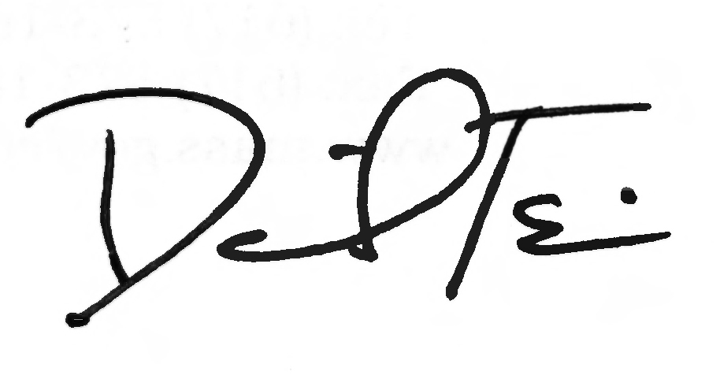
TO: All Providers Participating in MassHealth

FROM: Daniel Tsai, Assistant Secretary for MassHealth

RE: MassHealth Coordination of Benefits (COB) Billing Best Practices and New Claim Error Codes

Background

The purpose of this bulletin is to remind providers that you must apply the “best practices” described in this bulletin when billing claims to MassHealth for members who have other insurance (Medicare, Medicare Advantage, or Commercial) in addition to MassHealth. This bulletin also describes new Coordination of Benefits (COB) edits that will be implemented in December 2017.

Diligent Efforts

Per MassHealth and Third-Party Liability (TPL) regulations, providers must make “diligent efforts” to identify and obtain payment from all other liable parties. Diligent efforts include but are not limited to

- determining the existence of health insurance by asking the member if he or she has other insurance and by using other insurance eligibility verification resources available to the provider; and
- verifying the member’s other health insurance coverage, currently known to MassHealth through its Eligibility Verification System (EVS), on each date of service and at the time of billing.
Updating Other Insurance Information

If a provider has evidence that a member’s other health insurance information differs from what appears on the EVS, you must fax or mail a Third Party Liability Indicator (TPLI-MH) form along with acceptable documentation described below to the contact information located at the bottom of the form. To access the TPLI-MH form, use the hyperlinks in this section or go to www.mass.gov/masshealth. Providers may also request the form by
- e-mailing publications@mahealth.net
- calling MassHealth Customer Service at 1-800-841-2900, or
- faxing a Request for MassHealth Forms (RMF) form to 617-988-8973

The TPLI-MH form should be submitted with acceptable documentation verifying the coverage change to ensure that the member’s file is updated to reflect current information. Acceptable documentation for updating a member’s insurance information includes an explanation of benefits (EOB), a letter from an employer or health insurance carrier, or a copy of the member’s health insurance card for any new insurance. This information can also be found in Appendix A of the MassHealth provider manual.

(continued on next page)

MassHealth

All Provider Bulletin 273

November 2017

Page 2

Compliance with Other Payer Billing Rules

When the member has other insurance, providers must submit the claim to the other payer, following the other payer’s billing and authorization guidelines. If the claim is denied for reasons other than a correctable error, or if there is a remaining patient responsibility, providers may submit the claim to MassHealth including the COB adjudication information as it appears on the other payer’s EOB. Providers may not submit the claim to MassHealth if the claim is denied for noncompliance with any one of the payer’s billing and authorization requirements.

New COB Claim Editing

When a provider bills MassHealth for a service that has been denied by the other payer, the claim/claim detail line must contain valid Claim Adjustment Group Codes (CAGCs) and Claim Adjustment Reason Codes (CARCs) as they appear on the other payer’s EOB or 835.

The Health Insurance Portability and Accountability Act (HIPAA) standard CAGCs represent the other payer’s assignment of financial responsibility and CARCs represent the other payer’s reason for denial of the claim/claim detail line. Both pieces of information are critical for MassHealth to determine its financial responsibility for the claim/claim detail line and must be reported accurately on the claim.

Enhanced COB claim editing utilizing CAGC and CARC will be in effect for all claims adjudicated on or after December 17, 2017. This change will enforce MassHealth TPL regulations to ensure that MassHealth pays for claims/claim detail lines only when there is a member liability and does not pay when the provider is financially obligated for the claim/claim detail line. Providers are reminded that they are prohibited from billing the patient when the CAGC indicates that the provider is financially obligated for the claim/claim detail.

New Claim Error Codes

The following edits will set on claims/claim details lines that have been denied by the other payer.

- 2601 – Other payer denial payable
- 2602 – Other payer denial requires review
- 2603 – Other payer denial not payable per rules
- 2604 – Other payer denial not payable

COB Claims Billing References

Providers should refer to the following regulations and guides located in the provider manual when submitting COB claims:

- MassHealth Administrative and Billing Regulations at 130 CMR 450.316 through 450.318; and
- Sub Chapter 5: Administrative and Billing Instructions, Part 7. Other Insurance.

To download Provider Online Service Center (POSC) Job Aids for COB claims submissions, go to http://www.mass.gov/eohhs/gov/newsroom/masshealth/providers/mmis-posc/training/get-trained.html.
(continued on next page)

MassHealth

All Provider Bulletin 273

November 2017
Page 3

COB Claims Billing References (cont.)

To request a copy of any of the MassHealth Companion Guides please contact MassHealth Customer Service at 1-800-841-2900.

Questions

If you have any questions about the information in this bulletin, please contact the MassHealth Customer Service Center at 1-800-841-2900, email your inquiry to providersupport@mahealth.net, or fax your inquiry to 617-988-8974.

Follow us on Twitter @MassHealth

