Commonwealth of Massachusetts
Executive Office of Health and Human Services

Office of Medicaid
www.mass.gov/masshealth

MassHealth
All-Provider Bulletin 277
August 2018

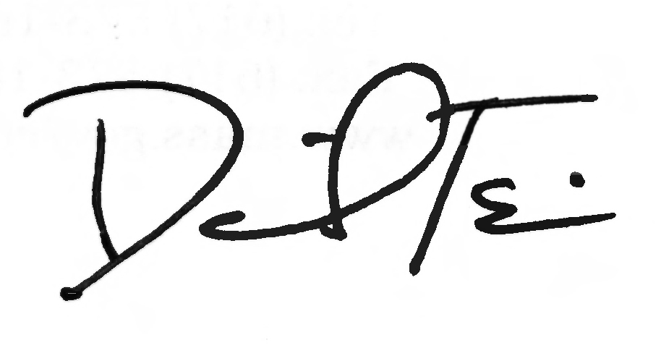
TO: All Providers, Accountable Care Organizations, and Managed Care Organizations Participating in MassHealth

FROM: Daniel Tsai, Assistant Secretary for MassHealth

RE: Changes to Billing for Services Delivered by School-Based Health Centers Operated through Community Health Centers

Overview

School-based health centers (SBHCs) are important providers of health care services for students, including those enrolled in MassHealth. SBHCs operate on school grounds as a partnership between the school and a community health organization, such as a community health center (CHC), hospital system, or local health department.
The majority of children enrolled in MassHealth who access SBHC services do so through SBHCs operating and billing through CHCs. In the interest of supporting these SBHCs and CHCs, MassHealth is simplifying the billing process for providers enrolled as CHCs when they deliver services to eligible MassHealth members at an SBHC, as discussed below.

CHC Billing for Services Provided at School Based Health Centers

Effective for dates of service on or after September 1, 2018, community health centers should submit claims for services delivered at SBHCs directly to MassHealth for payment, even if the member is otherwise enrolled in managed care. This includes claims submitted by CHCs for all services delivered at SBHCs to eligible MassHealth members in Standard, CommonHealth, Family Assistance, or CarePlus and includes those members enrolled in the Primary Care Clinician (PCC) Plan, Primary Care Accountable Care Organizations (Primary Care ACOs), Accountable Care Partnership Plans (ACPPs), or managed care organizations (MCOs).
Providers enrolled as CHCs must submit claims for services rendered in a SBHC directly to MassHealth. CHCs may not submit SBHC claims to ACPPs or MCOs.
Effective for dates of services on or after September 1, 2018, when billing MassHealth for services provided in a school-based health center, CHCs must enter the place of service (POS) code 03 in the appropriate data field on the claim to indicate that the service was rendered at a SBHC.

(continued on next page)

MassHealth

All-Provider Bulletin 277

August 2018

Page 2

PCC/PCP Referral Requirements

Also, effective for dates of services on or after September 1, 2018, SBHCs operated through CHCs will not be required to have a referral from the member’s PCC or primary care provider (PCP) to deliver services or submit claims for such services. The lists of services requiring referrals for members enrolled in the PCC Plan or a Primary Care ACO in MassHealth regulations are being modified to reflect the change. See 130 CMR 450.118(J)(5): Exceptions to Services Requiring Referrals and 130 CMR 450.119(I)(5).
However, SBHCs are required to identify the member’s health plan and primary care provider of record through EVS and are expected to coordinate with the member’s health plan and primary care provider to ensure that services are provided in a comprehensive manner that fully supports the health needs of the member.

Hospital Billing for Services Provided at School Based Health Centers

At this time, billing procedures for services delivered by SBHCs affiliated with hospitals or hospital-licensed health centers have not changed. Billing done through hospitals will continue to be submitted directly to the health plan in which the member is enrolled, subject to the billing procedures and referral requirements of the ACO, MCO, or PCC plan.

Other Billing Types

Please note: the billing procedures for members in MassHealth Limited, Children’s Medical Security Plan (CMSP), and the Health Safety Net have not changed.

MassHealth Website

This bulletin is available on the MassHealth website at www.mass.gov/masshealth-provider-bulletins.
To sign up to receive email alerts when MassHealth issues new bulletins and transmittal letters, send a blank email to join-masshealth-provider-pubs@listserv.state.ma.us. No text in the body or subject line is needed.

Questions

If you have any questions about the information in this bulletin, please contact the MassHealth Customer Service Center at (800) 841-2900, email your inquiry to providersupport@mahealth.net, or fax your inquiry to (617) 988-8974.

