Commonwealth of Massachusetts
Executive Office of Health and Human Services

Office of Medicaid
www.mass.gov/masshealth
MassHealth
All Provider Bulletin 279
November 2018

TO: All Providers Participating in MassHealth

FROM: Daniel Tsai, Assistant Secretary for MassHealth

RE: Accountable Care Organization (ACO) Primary Care Exclusivity and related information about Medication Assisted Treatment Services, School-Based Health Centers, and the MassHealth Eligibility Verification System (EVS)

This bulletin provides guidance and clarification regarding primary care exclusivity requirements for Accountable Care Organizations (ACOs), including how primary care exclusivity relates to other MassHealth programs, Medication Assisted Treatment Services, and School-Based Health Centers. This bulletin also includes information about related EVS enhancements.

MassHealth now offers an expanded selection of managed care health plan options for MassHealth managed care eligible members. These options are 17 ACOs (including Accountable Care Partnership Plans, Primary Care ACOs, and MCO-Administered ACOs), two Managed Care Organizations (MCO), and the Primary Care Clinician (PCC) Plan.

MassHealth managed care eligible members are:
- Younger than age 65, without any third-party insurance coverage (including Medicare);
- Living in the community (do not reside in a long term care facility); and
- Covered by MassHealth Standard, CommonHealth, CarePlus, or Family Assistance

ACO Primary Care Exclusivity
Primary care exclusivity only applies to ACOs. When MassHealth managed care members enroll with an ACO, they select, or are assigned, to a primary care practice entity site where they exclusively receive all of their primary care services and care coordination by an individual primary care practitioner (PCP) employed by, or contracted with, the practice entity.

Primary care exclusivity requirements are set forth in MassHealth ACO contracts. Pursuant to those contracts, a primary care practice entity that contracts with an ACO (also referred to as network PCPs or participating PCPs) may only empanel managed care members who are also enrolled in that same ACO and may only provide primary care services to managed care members who are also enrolled in that same ACO. They may not provide primary care services or empanel MassHealth managed care members enrolled in an MCO, the Primary Care Clinician (PCC) Plan, or any other ACO.

MassHealth
All Provider Bulletin 279 November 2018
Page 2
ssHealth
All Provider Bulletin XXX
June 2018

Primary care exclusivity is applied at the site level because the member is assigned to the primary care practice entity site rather than to the individual PCPs performing the primary care functions and services at the site. As is the case today, individual practitioners may have arrangements with two or more practice entity sites of care where they practice (e.g., on different days of the week), and these sites may or may not all be in the same ACO. These arrangements continue to be permitted without changes.

Primary care exclusivity does not apply to PCPs serving members in the Special Kids Special Care Program.

Primary Care Exclusivity Not Applicable to MassHealth Fee-For-Service, OneCare, SCO, or PACE Enrollees
PCPs who contract with ACOs (again, also referred to as participating PCPs or network PCPs) may continue to provide services to MassHealth FFS, OneCare, SCO, and PACE members regardless of their contracts with ACOs.
Exclusivity does not apply to other MassHealth programs, such as:
- MassHealth Fee-for-service (FFS) (including those over age 65 or with third-party coverage)
- OneCare
- Senior Care Options (SCO)
- Program of All-inclusive Care for the Elderly (PACE)
Providers who contract with an ACO may continue to provide services to members enrolled in the above programs regardless of their contracts with ACOs.
Primary Care Exclusivity and Medication Assisted Treatment (MAT) Services
Addiction pharmacotherapy, commonly known as medication assisted treatment (MAT), is a critical component of MassHealth’s strategy to serve members with an opioid use disorder. MassHealth recognizes the unique nature of MAT and is committed to removing barriers and to supporting members in accessing MAT services.

PCPs that also provide MAT services may provide MAT services to members enrolled in any ACO, MCO, or the PCC Plan, without regard to limitations related to primary care exclusivity. This allows PCPs to provide MAT services to members who are not enrolled in the PCP’s ACO or members who live outside the ACO’s service area.

MAT providers must make necessary network and/or payment arrangements with the member’s plan or MassHealth to ensure payment. For more information regarding MAT services, refer to
All Provider Bulletin 276 (May 2018) in the MassHealth Provider Library.

MassHealth
All Provider Bulletin 279 November 2018
Page 3
ssHealth
All Provider Bulletin XXX
June 2018

Primary Care Services Delivered by School-Based Health Centers (SBHCs) Operated through Community Health Centers (CHCs)
Effective for dates of service on or after September 1, 2018, SBHCs operated through CHCs can serve all MassHealth members and must submit claims for services delivered at SBHCs directly to MassHealth. CHCs may not submit SBHC claims to Accountable Care Partnership Plans or MCOs.
This includes all services delivered at SBHCs to eligible MassHealth members, regardless of whether the member is enrolled in an ACO, MCO, or the PCC Plan.

Effective for dates of services on or after September 1, 2018, SBHCs operated through CHCs are not required to have a referral from the member’s PCC or PCP to deliver services or submit claims for such services. At this time, billing procedures for services delivered by SBHCs affiliated with hospitals or hospital-licensed health centers (HLHCs) have not changed. Billing done through hospitals will continue to be submitted directly to the health plan in which the member is enrolled, subject to the billing procedures and referral requirements of the ACO, MCO, or PCC Plan.

Primary care exclusivity requirements neither apply nor impact primary care services delivered by SBCHs operated through CHCs. See All Provider Bulletin 277 in the MassHealth Provider Library for more information.

Specialist, Hospital, and Other Providers
Primary care exclusivity requirements neither apply to nor impact specialists, hospitals, and other providers—including behavioral health providers. Specialists, hospitals, and other providers may continue to provide specialty services across MassHealth managed care options. Such providers may contract with multiple health plans at the same time and may provide services to members in any of the health plans with which the providers have contracts.

Primary Care ACOs and the PCC Plan use the MassHealth fee-for-service network of specialists and hospitals. Specialists, hospitals, and other providers may see MassHealth members enrolled in a Primary Care ACO Plan or the PCC Plan if the provider a MassHealth participating provider contracted to provide medical services to eligible members that are paid or payable by the MassHealth agency.

Accountable Care Partnership Plans and MCOs each use their own respective network of specialists and hospitals. Specialists, hospitals, and other providers may see members enrolled in an Accountable Care Partnership Plan or an MCO only if they are contracted with the member’s Accountable Care Partnership Plan or MCO. Providers interested in joining the network of an Accountable Care Partnership Plan or MCO must contact that health plan directly for information.

Long-term services and supports (LTSS) are paid directly by MassHealth. These services include Personal Care Attendant, Adult Foster Care, Group Adult Foster Care, Adult Day Health, Day Habilitation, Continuous Skilled Nursing, and long-term (over 100 days) Nursing Facility, Chronic Disease, and Rehabilitation Hospital services. Providers do not need to contract with the new health plans to provide these services to MassHealth managed care eligible members.

MassHealth
All Provider Bulletin 279 November 2018
Page 4
ssHealth
All Provider Bulletin XXX
June 2018

The contracting and payment process will also not change for dental services, non-emergency medical transportation services, and all other services that MassHealth covers directly for MassHealth managed care eligible members and that are not covered by the member’s health plan.

MassHealth Eligibility Verification System (EVS) Enhancements
There are two types of Restrictive Messages that appear on EVS:
- Eligibility Restrictive Messages; and
- Managed Care Data Restrictive Messages
The Managed Care Data Restrictive Messages have been enhanced for all MassHealth managed care health plans to identify which type of health plan a member is enrolled in, and contact information for assistance with inquiries regarding billing and service authorization for medical and behavioral health claims, including contact information for behavioral health vendors.

Note: Managed Care Data Restrictive Messages will only appear in EVS for managed care members. EVS will only display a member’s current eligibility, not future eligibility.

Providers can continue to check member enrollment and eligibility using the Eligibility Verification System (EVS) on the Provider Online Service Center (POSC).

MassHealth
All Provider Bulletin 279 November 2018
Page 5
ssHealth
All Provider Bulletin XXX
June 2018

EVS Screenshot Example – Managed Care Eligibility Response
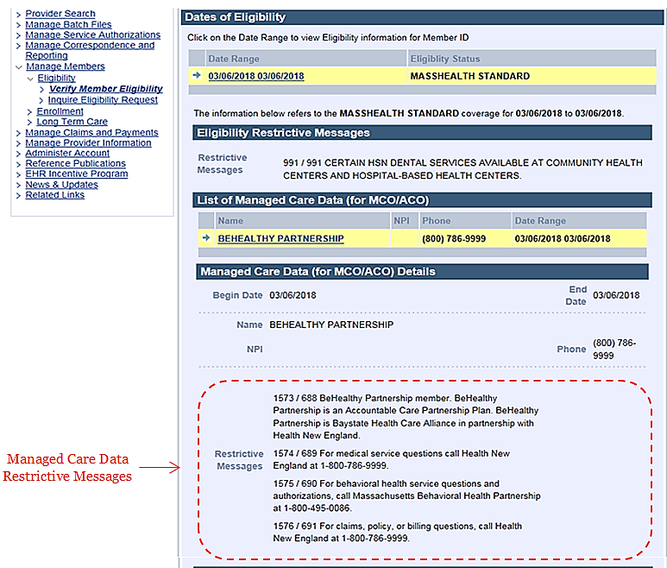

MassHealth
All Provider Bulletin 279 November 2018
Page 6
ssHealth
All Provider Bulletin XXX
June 2018

EVS Screenshot Example – FFS Eligibility Response
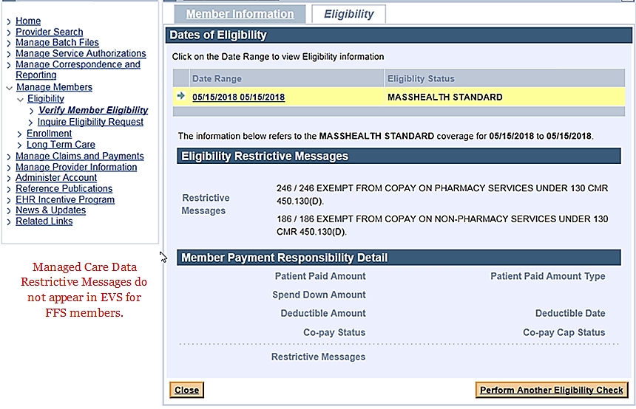

MassHealth
All Provider Bulletin 279 November 2018
Page 7
ssHealth
All Provider Bulletin XXX
June 2018

EVS Screenshot Example – FFS with Third Party Medicare Coverage
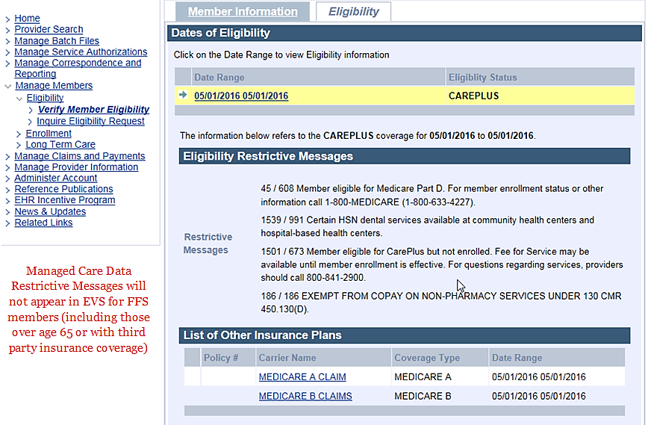
MassHealth
All Provider Bulletin 279 November 2018
Page 8
ssHealth
All Provider Bulletin XXX
June 2018

Additional Resources for Providers
For more information about these changes, please visit
- https://www.mass.gov/lists/all-provider-bulletins
- www.mass.gov/payment-care-delivery-innovation-pcdi-for-providers
- www.mass.gov/lists/provider-pcdi-resources
- www.mass.gov/masshealth-for-providers
To sign up for email notifications when MassHealth publishes new provider bulletins and transmittal letters, send a blank email to join-masshealth-provider-pubs@listserv.state.ma.us.
Questions
If you have questions about the information in this bulletin, please email your inquiry to the MassHealth Customer Service Center at providersupport@mahealth.net or call
(800) 841-2900 (TTY: (800) 497-4648).

