# All Provider Bulletin 399



Commonwealth of Massachusetts

Executive Office of Health and Human Services

Office of Medicaid

[www.mass.gov/masshealth](https://www.mass.gov/orgs/masshealth)

**DATE:** January 2025

**TO:** All Providers Participating in MassHealth

**FROM:** Mike Levine, Assistant Secretary for MassHealth [signature of Mike Levine]

RE: New MassHealth Member Card

## Overview

In January 2025, MassHealth will begin issuing MassHealth member cards with a new design and updated language.

MassHealth is not automatically issuing new member cards to all members. Instead, MassHealth will use the updated design for any new cards created after January 1, 2025, according to normal processes (for example, when a new member joins MassHealth or a current member requests a replacement card).

### Instructions to Providers

Providers must accept all valid versions of the MassHealth member card. This includes both the previous version of the MassHealth member card, as well as the new design going into circulation in January 2025. Additionally, providers must accept valid digital member cards presented by members using the MyServices portal.

### Image of the New MassHealth Member Card

Please see below for images of the new MassHealth member card:

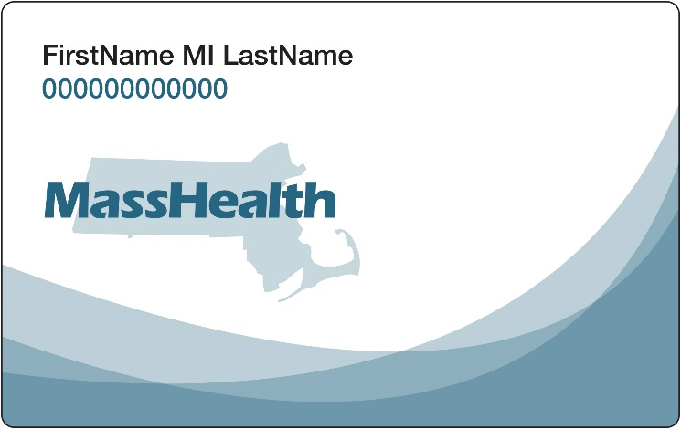

Front of card

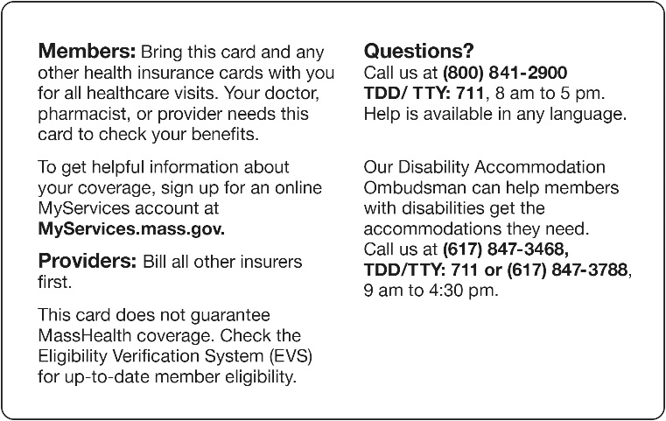

Back of card

## MassHealth Website

This bulletin is available on the [MassHealth Provider Bulletins](http://www.mass.gov/masshealth-provider-bulletins) web page.

[Sign up](https://www.mass.gov/forms/email-notifications-for-provider-bulletins-and-transmittal-letters) to receive email alerts when MassHealth issues new bulletins and transmittal letters.

## Questions?

If you have questions about the information in this bulletin, please contact:

### Long-Term Services and Supports

Phone: (844) 368-5184 (toll free)

Email: [support@masshealthltss.com](mailto:support@masshealthltss.com)

Portal: [MassHealthLTSS.com](https://www.masshealthltss.com/s/?language=en_US)

Mail: MassHealth LTSS

PO Box 159108

Boston, MA 02215

Fax: (888) 832-3006

### All Other Provider Types

Phone: (800) 841-2900, TDD/TTY: 711

Email: [provider@masshealthquestions.com](mailto:provider@masshealthquestions.com)

Facebook logo[MassHealth on Facebook](https://www.facebook.com/MassHealth1/) LinkedIn logo
[MassHealth on LinkedIn](https://www.linkedin.com/company/masshealth) X logo (formerly Twitter)[MassHealth on X](https://www.twitter.com/MassHealth) YouTube logo
[MassHealth on YouTube](https://www.youtube.com/channel/UC1QQ61nTN7LNKkhjrjnYOUg)