**INDOOR AIR QUALITY ASSESSMENT**

**Allendale Elementary School**

**180 Connecticut Avenue**

**Pittsfield, MA**

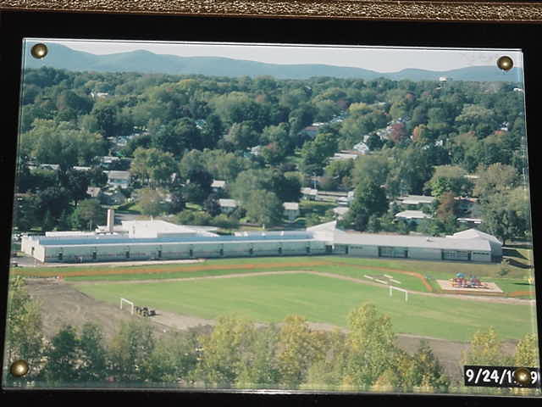

Prepared by:

Massachusetts Department of Public Health

Center for Environmental Health

Emergency Response/Indoor Air Quality Program

December 2005

# Background/Introduction

At the request of Dr. Phillip Adamo and Ms. Roberta Orsi, Pittsfield Board of Health (BOH), the Massachusetts Department of Public Health (MDPH), Center for Environmental Health (CEH), provided assistance and consultation regarding indoor environmental concerns at the Allendale Elementary School (AES), 180 Connecticut Street, Pittsfield, Massachusetts. The BOH request was prompted by concerns about possible contamination of the school’s indoor environment in relation to a nearby disposal area containing soils contaminated with polychlorinated biphenyl compounds (PCBs).

On November 22, 2005, a visit to conduct an assessment of the AES was made by Michael Feeney, Director of CEH’s Emergency Response/Indoor Air Quality (ER/IAQ) Program. Elaine Krueger, Director of the CEH Environmental Toxicology Program (ETP) and Michael Celona of CEH’s ETP accompanied Mr. Feeney to determine the best strategy for follow up testing for PCBs within the school. Ann M. Kuhn, Principal of the AES, accompanied CEH staff during this assessment.

The AES is a single-story, yellow brick building that contains two wings. The original building was constructed in 1951 (Picture 1). The building was renovated in 1999 to add a new wing of classrooms (rooms 14 -23 and a media center) (Picture 2). The 195l building was renovated at that time. A suspended ceiling was installed, univents were rebuilt in place and all windows and door systems were replaced. A crawlspace exists beneath the 1951 wing , which has access ports in several classrooms (Picture 3). It appears that the 1999 wing was constructed on a slab with no discernable crawlspace. Windows throughout the building are openable.

# Methods

Air tests for carbon dioxide, carbon monoxide, temperature and relative humidity were conducted with the TSI, Q-TRAK™ IAQ Monitor, Model 8551. Air tests for airborne particulate matter with a diameter less than 2.5 micrometers were taken with the TSI, DUSTTRAK™ Aerosol Monitor Model 8520. Screening for total volatile organic compounds (TVOCs) was conducted using a Thermo Environmental Instruments Inc., Model 580 Series Photo Ionization Detector (PID). MDPH staff also performed a visual inspection of building materials for water damage and/or microbial growth.

As discussed, MDPH staff also evaluated the building to determine appropriate locations of indoor sampling for PCBs. The sampling plan and methods as well as results of the PCB sampling are included as Appendix A of this report.

# Results

This school houses approximately 360 pre-kindergarten through fifth grade students, and approximately 25 staff members. Tests were taken during normal operations at the school. Results appear in Table 1.

# Discussion

## Ventilation

It can be seen from Table 1 that carbon dioxide levels were above 800 parts per million (ppm) in seven out of thirty-four rooms surveyed. Most of these appear to be in classrooms within the 1951 wing. For this reason the ventilation system should be evaluated to determine if it is properly balanced. Please note that a number of areas sampled were not occupied, which can greatly reduce carbon dioxide levels Fresh air in classrooms is supplied by unit ventilator (univent) systems. A univent draws air from outdoors through a fresh air intake located on the exterior wall of the building and returns air through an air intake located at the base of the unit (Figure 1). Fresh and return air are mixed, filtered, heated and/or cooled and provided to classrooms through a diffuser located on the top of the unit. Mechanical exhaust ventilation in classrooms is provided by a combination of ceiling-mounted (Picture 4) or wall-mounted (Pictures 5 and 6) exhaust vents ducted to rooftop exhaust fans.

To maximize air exchange, the MDPH recommends that both supply and exhaust ventilation operate continuously during periods of school occupancy. In order to have proper ventilation with a mechanical supply and exhaust system, the systems must be balanced to provide an adequate amount of fresh air to the interior of a room, while removing stale air from the room. It is recommended that HVAC systems be re-balanced every five years to ensure adequate air systems function (SMACNA, 1994). The date of the last balancing was likely when the building was renovated in 1999.

The Massachusetts Building Code requires that each room have a minimum ventilation rate of 15 cubic feet per minute (cfm) per occupant of fresh outside air or openable windows (SBBRS, 1997; BOCA, 1993). The ventilation must be on at all times that the room is occupied. Providing adequate fresh air ventilation with open windows and maintaining the temperature in the comfort range during the cold weather season is impractical. Mechanical ventilation is usually required to provide adequate fresh air ventilation.

Carbon dioxide is not a problem in and of itself. It is used as an indicator of the adequacy of the fresh air ventilation. As carbon dioxide levels rise, it indicates that the ventilating system is malfunctioning or the design occupancy of the room is being exceeded. When this happens, a buildup of common indoor air pollutants can occur, leading to discomfort or health complaints. The Occupational Safety and Health Administration (OSHA) standard for carbon dioxide is 5,000 parts per million parts of air (ppm). Workers may be exposed to this level for 40 hours/week, based on a time-weighted average (OSHA, 1997).

The Department of Public Health uses a guideline of 800 ppm for publicly occupied buildings. A guideline of 600 ppm or less is preferred in schools due to the fact that the majority of occupants are young and considered to be a more sensitive population in the evaluation of environmental health status. Inadequate ventilation and/or elevated temperatures are major causes of complaints such as respiratory, eye, nose and throat irritation, lethargy and headaches. For more information concerning carbon dioxide, see Appendix B.

Temperature measurements ranged from 68o F to 73o F, with most areas within the MDPH recommended comfort range (Table 1). The MDPH recommends that indoor air temperatures be maintained in a range of 70o F to 78o F in order to provide for the comfort of building occupants. In many cases concerning indoor air quality, fluctuations of temperature in occupied spaces are typically experienced, even in a building with an adequate fresh air supply.

The relative humidity measurements ranged from 27 to 35 percent, which were below the MDPH recommended comfort range. The MDPH recommends a comfort range of 40 to 60 percent for indoor air relative humidity. Relative humidity levels in the building would be expected to drop during the winter months due to heating. The sensation of dryness and irritation is common in a low relative humidity environment. Low relative humidity is a very common problem during the heating season in the northeast part of the United States.

## Microbial/Moisture Concerns

A significant number of classrooms had water damaged ceiling tiles. There was no visible evidence however of mold growth or water damaged materials in any other area during this evaluation.

A number of sources for roof leaks exist in the AES. As reported by Ms. Kuhn, the roof of the original building was damaged by trespassers who skateboarded on the roof. This activity would be expected to cause mechanical damage to roof materials, which would then lead to leaks during rainstorms. In addition, roof areas that are most likely to experience leaks are those where penetrations through the roof plane exist (e.g., skylights, exhaust vents) and/or sections of the roof abut the exterior wall. In this case, it appears that these conditions exist above the water damaged ceiling tiles in classrooms in both wings. In general, where two dissimilar materials meet on the exterior of a building, the seam between these materials is likely to be a point source for water penetration. The installation of flashing allows for water to transition from one surface to the next. Without properly installed flashing, water can penetrate through the seam resulting in water damage and potential mold growth. For example, water damage in one classroom in the new wing was located in a section of the ceiling tile system that was roughly beneath an exhaust vent on the roof, which is the only penetration through the roof in the vicinity of this classroom. Ceiling tiles around the exhaust vent for the kiln were also water damaged, which can also indicate flashing problems for this vent system.

## Other IAQ Evaluations

Indoor air quality can be adversely impacted by the presence of respiratory irritants, such as products of combustion. The process of combustion produces a number of pollutants. Common combustion products include carbon monoxide, carbon dioxide, water vapor and smoke (fine airborne particle material). Of these materials, exposure to carbon monoxide and particulate matter with a diameter of 2.5 micrometers (μm) or less (PM2.5) can produce immediate, acute health effects upon exposure. To determine whether combustion products were present in the school environment, MDPH staff obtained measurements for carbon monoxide and PM2.5.

Carbon monoxide is a by-product of incomplete combustion of organic matter (e.g., gasoline, wood and tobacco). Exposure to carbon monoxide can produce immediate and acute health affects. Several air quality standards have been established to address carbon monoxide pollution and prevent symptoms from exposure to these substances. The MDPH established a corrective action level concerning carbon monoxide in ice skating rinks that use fossil-fueled ice resurfacing equipment. If an operator of an indoor ice rink measures a carbon monoxide level over 30 ppm, taken 20 minutes after resurfacing within a rink, that operator must take actions to reduce carbon monoxide levels (MDPH, 1997).

ASHRAE has adopted the National Ambient Air Quality Standards (NAAQS) as one set of criteria for assessing indoor air quality and monitoring of fresh air introduced by HVAC systems (ASHRAE, 1989). The NAAQS are standards established by the US EPA to protect the public health from 6 criteria pollutants, including carbon monoxide and particulate matter (US EPA, 2000a). As recommended by ASHRAE, pollutant levels of fresh air introduced to a building should not exceed the NAAQS (ASHRAE, 1989). The NAAQS were adopted by reference in the Building Officials & Code Administrators (BOCA) National Mechanical Code of 1993 (BOCA, 1993), which is now an HVAC standard included in the Massachusetts State Building Code (SBBRS, 1997). According to the NAAQS established by the US EPA, carbon monoxide levels in outdoor air should not exceed 9 ppm in an eight-hour average (US EPA, 2000a).

Carbon monoxide should not be present in a typical, indoor environment. If it is present, indoor carbon monoxide levels should be less than or equal to outdoor levels. For the AES, indoor carbon monoxide concentrations were non-detect or ND (Table 1). Carbon monoxide levels measured outside the school were also ND.

As previously mentioned, the US EPA also established NAAQS for exposure to particulate matter. Particulate matter is airborne solids that can be irritating to the eyes, nose and throat. According to the NAAQS, PM10 levels should not exceed 150 micrograms per cubic meter (μg/m3) in a 24-hour average (US EPA, 2000a). This standard was adopted by both ASHRAE and BOCA. Since the issuance of the ASHRAE standard and BOCA Code, US EPA proposed a more protective standard for fine airborne particles. This more stringent PM2.5 standard requires outdoor air particulate levels be maintained below 65 μg/m3 over a 24-hour average (US EPA, 2000a). Although both the ASHRAE standard and BOCA Code adopted the PM10 standard for evaluating air quality, MDPH uses the more protective PM2.5 standard for evaluating airborne particulate matter concentrations in the indoor environment.

Outdoor PM2.5 concentrations were measured at 1 μg/m3 (Table 1). PM2.5 levels measured indoors ranged from 1 to 15 μg/m3, which were below the NAAQS PM2.5 level of 65 μg/m3 in all areas. Frequently, indoor air levels of particulates (including PM2.5) can be at higher levels than those measured outdoors. A number of mechanical devices and/or activities that occur in schools can generate particulate during normal operations. Sources of indoor airborne particulates may include but are not limited to particles generated during the operation of fan belts in the HVAC system, cooking in the cafeteria stoves and microwave ovens; use of photocopiers, fax machines and computer printing devices; operation of an ordinary vacuum cleaner; and heavy foot traffic indoors.

Indoor air quality can also be impacted by the presence of materials containing volatile organic compounds (VOCs). VOCs are substances that have the ability to evaporate at room temperature. Frequently, exposure to low levels of total VOCs (TVOCs) may produce eye, nose, throat and/or respiratory irritation in some sensitive individuals. For example, chemicals evaporating from a paint can stored at room temperature would most likely contain VOCs. In an effort to determine whether VOCs were present in the building, air monitoring for TVOCs was conducted. Outdoor air samples were taken for comparison. Outdoor TVOC concentrations were ND (Table 1). Indoor TVOC measurements throughout the building were also ND.

Please note, TVOC air measurements are only reflective of the indoor air concentrations present at the time of sampling. Indoor air concentrations can be greatly impacted by the use of TVOC-containing products. While no measurable TVOC levels were detected in the indoor environment, VOC-containing materials were noted. Several classrooms contained dry erase boards and dry erase board markers. Materials such as dry erase markers and dry erase board cleaners may contain VOCs, such as methyl isobutyl ketone, n-butyl acetate and butyl-cellusolve (Sanford, 1999), which can be irritating to the eyes, nose and throat.

The original building contains crawlspaces beneath its floor. In order to ascertain whether a pathway for air and associated pollutants exists for materials to migrate from the crawlspace into occupied areas, the interiors of several univents were examined. In the experience of CEH staff, holes through which univent electrical conduit and heat pipes pass are frequently unsealed, creating a direct pathway for crawlspace air to be drawn into classrooms. Examination of several univents found that the space around heat pipes and electrical conduit to be sealed with a sealant compound (Pictures 7 and 8). Univents are also equipped to filter both outdoor air and return air from classrooms. Each univent examined was equipment with three pleated filters that are installed with metal spacers that prevent air bypass between filters (Picture 9) and filter. Also of note were steel lids that cover crawlspace access ports that are located directly beneath univent return vents (Picture 10). Seals and holes in these lids appear to be unsealed. All holes and seams of these lids should be sealed to prevent crawlspace air migration into classrooms.

# Conclusions/Recommendations

In view of the findings at the time of the assessment, the following recommendations are made:

1. Prevent access to the roof by trespassers.
2. Once the access to the roof is secured, repair the roof.
3. Replace water damage ceiling tiles.
4. Seal all seams and holes in crawl space lids.
5. Increase fresh air supply by univents.
6. Once both the fresh air supply is increased, the ventilation system should be re-balanced.
7. For buildings in New England, periods of low relative humidity during the winter are often unavoidable. Therefore, scrupulous cleaning practices should be adopted to minimize common indoor air contaminants whose irritant effects can be enhanced when the relative humidity is low. To control for dusts, continue to use a high efficiency particulate arrestance (HEPA) filter equipped vacuum cleaner in conjunction with wet wiping of all surfaces is recommended. Drinking water during the day can help ease some symptoms associated with a dry environment (throat and sinus irritations).
8. Consider adopting the US EPA (2000b) document, “Tools for Schools”, to maintain a good indoor air quality environment in the building. This document can be downloaded from the Internet at <http://www.epa.gov/iaq/schools/index.html>.
9. Refer to resource manuals and other related indoor air quality documents for additional building-wide evaluations and advice on maintaining public buildings. These materials are located on the MDPH’s website <http://mass.gov/dph/iaq>.

**References**

ASHRAE. 1989. Ventilation for Acceptable Indoor Air Quality. American Society of Heating, Refrigeration and Air Conditioning Engineers. ANSI/ASHRAE 62-1989

BOCA. 1993. The BOCA National Mechanical Code/1993. 8th ed. Building Officials and Code Administrators International, Inc., Country Club Hill, IL

MDPH. 1997. Requirements to Maintain Air Quality in Indoor Skating Rinks (State Sanitary Code, Chapter XI). 105 CMR 675.000. Massachusetts Department of Public Health, Boston, MA.

OSHA. 1997. Limits for Air Contaminants. Occupational Safety and Health Administration. Code of Federal Regulations. 29 C.F.R 1910.1000 Table Z-1-A.

SBBRS. 1997. Mechanical Ventilation. State Board of Building Regulations and Standards. Code of Massachusetts Regulations. 780 CMR 1209.0.

SMACNA. 1994. HVAC Systems Commissioning Manual. 1st ed. Sheet Metal and Air Conditioning

US EPA. 2000a. National Ambient Air Quality Standards (NAAQS). US Environmental Protection Agency, Office of Air Quality Planning and Standards, Washington, DC. <http://www.epa.gov/air/criteria.html>.

US EPA. 2000b. Tools for Schools. Office of Air and Radiation, Office of Radiation and Indoor Air, Indoor Environments Division (6609J). EPA 402-K-95-001, Second Edition. <http://www.epa.gov/iaq/schools/tools4s2.html>

**Figure 1**

**Unit Ventilator (Univent)**

Mixed Air

Air Diffuser

**Outdoors Indoors**

Fan

Heating/Cooling Coil

Air Mixing Plenum

Filter

Outdoor Return

Air Air

Air

Flow

Control

Louvers

1. **Air Flow**

= Fresh Air/Return Air

= Mixed Air

**Picture 1**

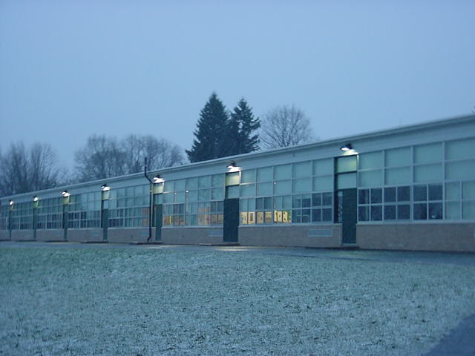

**1951 Wing**

**Picture 2**

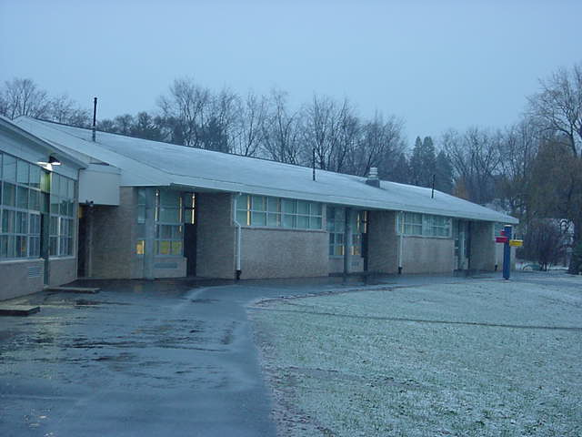

**1991 Wing**

**Picture 3**

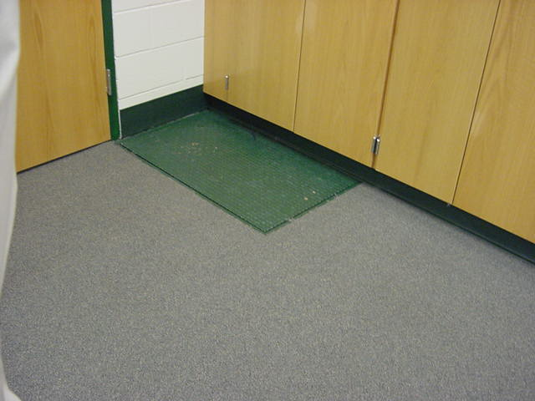

**Crawlspace Access Port**

**Picture 4**

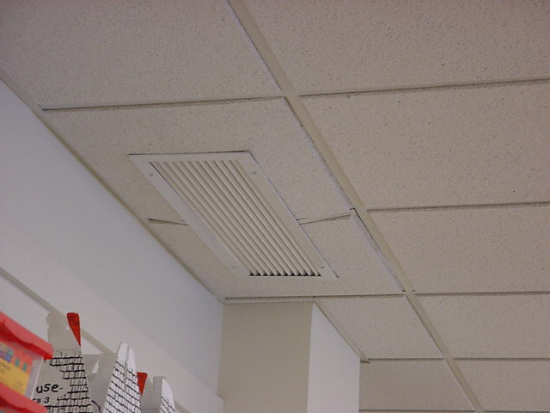

**Ceiling Mounted Exhaust Vent**

**Picture 5**

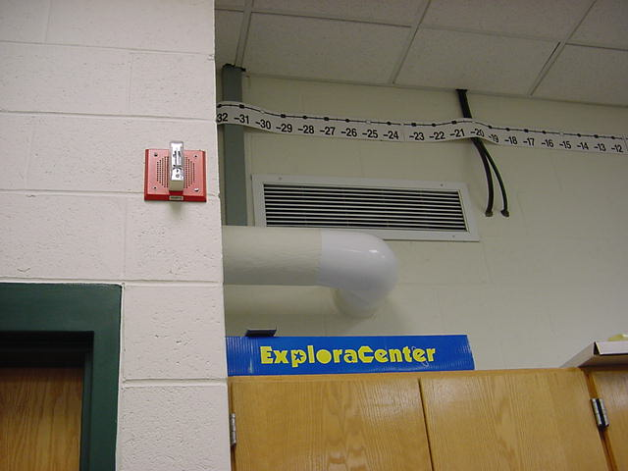

**Wall Mounted Exhaust Vent, 1991 Wing**

**Picture 6**

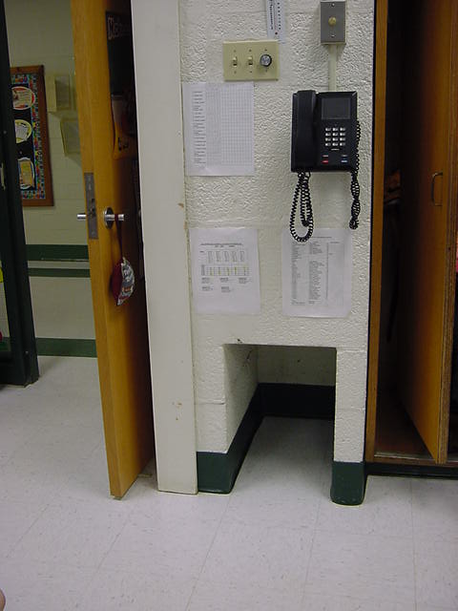

**Wall-Mounted Exhaust Vent, 1951 Wing**

**Picture 7**

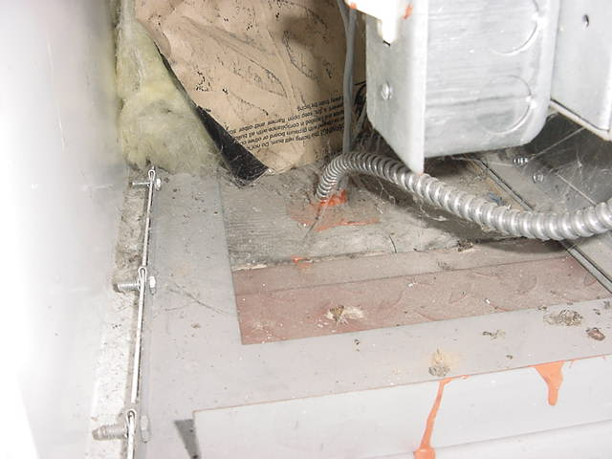

**Univent Electrical Conduit, Note Sealant (arrow)**

**Picture 8**

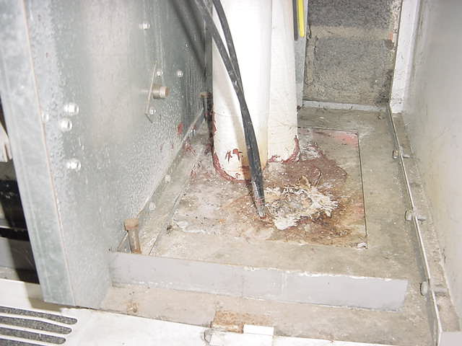

**Univent Heating Pipe, Note Sealant (arrow)**

**Picture 9**

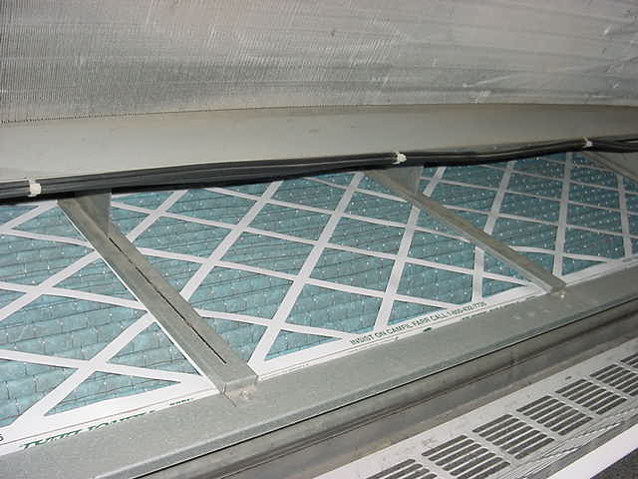

**Univent Filters Equipped with Spacers**

**Picture 10**

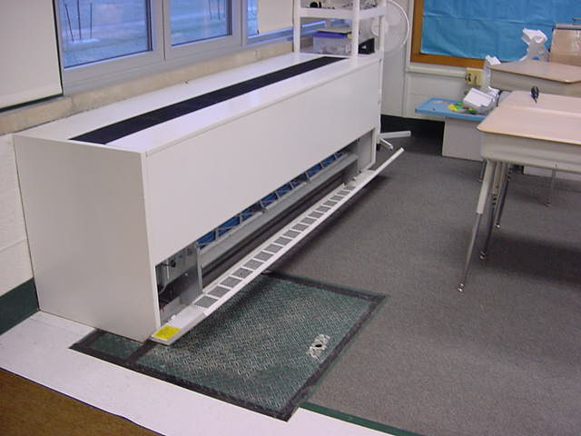

**Crawlspace Access Portal Located Directly beneath Univent Return Vents**

| 1. **Location** | **Carbon**  **Dioxide**  **(*ppm)** | **Carbon**  **Monoxide**  **(*ppm)** | **TVOCs**  **(*ppm)** | **Ultra-fine**  **Particulate** | **Temp**  **(°F)** | **Relative**  **Humidity**  **(%)** | **Occupants**  **in Room** | **Windows**  **Openable** | **Ventilation** | | **Remarks** |
| --- | --- | --- | --- | --- | --- | --- | --- | --- | --- | --- | --- |
| **Supply** | **Exhaust** |
| Outdoors, back of building | 360 | ND | ND | 1 | < 32 | 87 |  |  |  |  |  |
| Outdoors, back of building | 355 | ND | ND | 1 | < 32 | 88 |  |  |  |  |  |
| 10 | 520 | ND | ND | 1 | 72 | 29 | 0 | Y | Y | Y | 2 water damaged ceiling tiles |
| 14 | 692 | ND | ND | 10 | 71 | 30 | 19 | Y | Y | Y |  |
| 15 | 623 | ND | ND | 4 | 72 | 29 | 23 | Y | Y | Y |  |
| 16 | 464 | ND | ND | 6 | 71 | 27 | 17 | Y | Y | Y |  |
| 17 | 571 | ND | ND | 7 | 73 | 27 | 19 | Y | Y | Y | 1 water damaged ceiling tiles |
| 18 | 593 | ND | ND | 1 | 73 | 27 | 15 | Y | Y | Y |  |
| 19 | 558 | ND | ND | 1 | 73 | 27 | 14 | Y | Y | Y | 1 water damaged ceiling tiles |
| 20 | 565 | ND | ND | 8 | 73 | 29 | 17 | Y | Y | Y | 5 water damaged ceiling tiles |
| 21 | 596 | ND | ND | 5 | 73 | 29 | 20 | Y | Y | Y |  |
| 22 | 502 | ND | ND | 4 | 72 | 27 | 14 | Y | Y | Y |  |
| 23 | 773 | ND | ND | 4 | 72 | 32 | 19 | Y | Y | Y |  |
| 24 | 755 | ND | ND | 7 | 71 | 32 | 21 | Y | Y | Y | 7 water damaged ceiling tiles |
| 25 | 858 | ND | ND | 15 | 71 | 32 | 19 | Y | Y | Y |  |
| 26 | 545 | ND | ND | 2 | 71 | 28 | 14 | Y | Y | Y | 1 water damaged ceiling tiles |
| 27 | 903 | ND | ND | 1 | 71 | 31 | 21 | Y | Y | Y | 5 water damaged ceiling tiles |
| 28 | 512 | ND | ND | 1 | 71 | 29 | 0 | Y | Y | Y |  |
| 29 | 808 | ND | ND | 7 | 71 | 30 | 16 | Y | Y | Y | 8 |
| 30 | 847 | ND | ND | 6 | 71 | 31 | 23 | Y | Y | Y | 3 water damaged ceiling tiles |
| 31 | 851 | ND | ND | 3 | 71 | 31 | 23 | Y | Y | Y | 7 water damaged ceiling tiles |
| 32 | 808 | ND | ND | 4 | 71 | 31 | 28 | Y | Y | Y | 1 water damaged ceiling tiles |
| 33 | 655 | ND | ND | 4 | 72 | 30 | 18 | Y | Y | Y | 11 water damaged ceiling tiles |
| 8A | 896 | ND | ND | 1 | 71 | 35 | 5 | Y | Y | Y |  |
| 9 t | 426 | ND | ND | 1 | 71 | 28 | 0 | Y | Y | Y | 3 water damaged ceiling tiles  3 water damaged ceiling tiles in kiln room |
| Cafeteria | 608 | ND | ND | 10 | 71 | 33 | 11 | Y | Y | Y |  |
| Copy room | 631 | ND | ND | 2 | 70 | 32 | 0 | N | Y | Y | 4 water damaged ceiling tiles |
| Guidance | 527 | ND | ND | 14 | 71 | 29 | 0 | Y | Y | Y |  |
| Gym | 597 | ND | ND | 5 | 72 | 29 | 26 | N | Y | Y |  |
| Health office | 617 | ND | ND | 1 | 68 | 35 | 1 | Y | Y | Y | 1 water damaged ceiling tiles |
| Media center | 363 | ND | ND | 2 | 68 | 28 | 0 | Y | Y | Y | y |
| Office | 727 | ND | ND | 2 | 71 | 38 | 1 | N | Y | Y |  |
| Principal | 614 | ND | ND | 1 | 66 | 38 | 0 | Y | Y | Y | 9 water damaged ceiling tiles |
| Reading room | 629 | ND | ND | 3 | 71 | 29 | 3 | Y | Y | Y |  |
| Speech | 576 | ND | ND | 1 | 69 | 29 | 0 | Y | Y | Y |  |
| Staff room | 509 | ND | ND | 1 | 70 | 31 | 0 | N | Y | Y |  |

**Appendix A**

**PCB Testing Results**

**Allendale School, Pittsfield, MA**



The Commonwealth of Massachusetts

Executive Office of Health and Human Services

Department of Public Health

Center for Environmental Health

250 Washington Street, Boston, MA 02108-4619

|  |
| --- |
| MITT ROMNEY  GOVERNOR  KERRY HEALEY  LIEUTENANT GOVERNOR  TIMOTHY R. MURPHY  SECRETARY  PAUL J. COTE, JR.  COMMISSIONER |

Memorandum

To: Phil Adamo, M.D., Chairman, Pittsfield Board of Health

From: Suzanne K. Condon, Associate Commissioner, Center for Environmental Health

Re: Allendale School PCB Sampling

Date: Tuesday, December 6, 2005

The purpose of this memorandum is to provide an evaluation of the recent dust wipe, air filter, and indoor air testing for polychlorinated biphenyl compounds (PCBs) at the Allendale Elementary School in Pittsfield, Massachusetts (see Figure 1). The testing was prompted by a request for assistance from the Pittsfield Board of Health and concerns about ongoing activities at a nearby General Electric site being used for disposal of soil contaminated with PCBs. The results of the overall indoor air environmental evaluation are the subject of a separate report. This memo focuses on PCB exposure concerns.

The Massachusetts Department of Public Health, Center for Environmental Health (MDPH/CEH), Environmental Toxicology Program and Emergency Response/Indoor Air Quality Program staff conducted an initial site visit at the Allendale School on Tuesday, November 22, 2005, during which preliminary information was collected (e.g., building design, ventilation conditions, indicator environmental tests), and locations throughout the school were identified for subsequent PCB testing. Ms. Ann Kuhn, Principal of the Allendale School, accompanied MDPH on the site visit. MDPH/CEH contracted with an environmental consulting firm, Environmental Compliance Services, Inc. (ECS), located in Agawam, Massachusetts, to conduct the PCB sampling and analysis at the school. On Friday, November 25, ECS staff, accompanied by MDPH/CEH Environmental Toxicology Program staff, collected 44 dust wipe and 6 air filter samples from throughout the school. On Thursday, December 1, 2005 two indoor air samples were collected over a 24-hour period, along with one outdoor air sample (for comparison purposes). For completeness, additional surface wipe and air filters were taken during the December 1 sampling effort. Dust wipe samples were collected from 20 rooms (i.e., rooms 9, 10, 15, 17, 18, 19, 20, 21, 22, 23, 24, 25, 26, 27, 28, 29, 30, 31, 32, and 33), as well as the gymnasium and the cafeteria. Air filter samples from the univentilators were collected from rooms 15, 19, 23, 28, and 32, as well as the cafeteria. Indoor air samples previously mentioned were collected from rooms 20 and 28, as well as one outdoor sample collected outside the hallway doors between rooms 23 and 24 (see Table 1 and Figure 2).

The sample locations were chosen based on proximity of the rooms to the side of the school closest to the General Electric Hill 78 Area disposal site, as well as from both surfaces that children or teachers come into most contact with frequently (e.g., desk**s**, computer tables, play stove) and areas that are likely cleaned less frequently (e.g., bookshelves, areas of visible dust accumulation). Selection of locations for wipe samples also considered information obtained during the site visit on Tuesday, November 22, such as proximity to air supply/ventilation units. Such locations may present pathways for outdoor air to enter classrooms. Air filter samples were taken from filters located in classroom ventilation units, most of which faced the disposal area. Indoor air samples were collected in rooms chosen based on their proximity to the side of the school toward the disposal site, the fact that there were doors in these rooms that opened directly outdoors facing the disposal site, or other unique factors.

All samples were delivered to Spectrum Analytical Laboratory in Springfield, Massachusetts, for analysis for the presence of PCBs. Analysis for all samples was conducted using standard U.S. Environmental Protection Agency methods: SW846, 8082 for surface wipe and filter samples, and TO-4A for air samples.

The results of the surface wipe samples (a total of 88 samples) were all non-detectable for PCBs. No detectable PCBs were measured in a total of 12 air filter samples. Finally, neither of the two indoor air samples had any detection of PCBs nor did the outdoor air sample taken for background purposes.

These results do not indicate opportunities for exposure to PCBs in the indoor environment at the Allendale School at this time based on this testing. The school’s interior was generally noted as very clean.

The MDPH/CEH is committed to continuing to work with the local board of health, school officials, community residents, elected officials, and state and federal regulatory agencies to address PCB-related health concerns at the Allendale School. If you have any questions or if we can be of further assistance, please feel free to contact us at 617-624-5757.

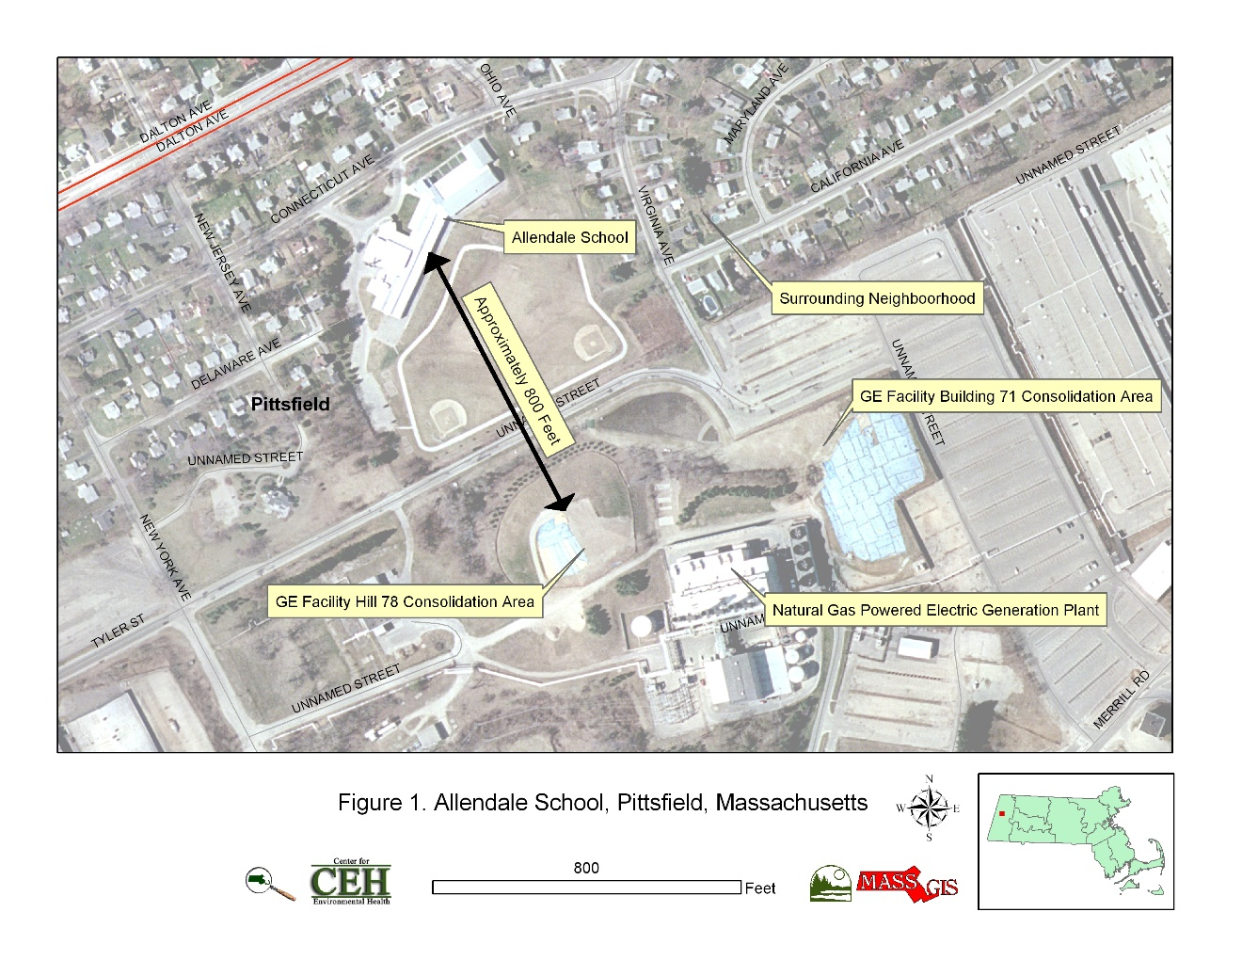**Table 1. Location and Types of Sampling**

|  |  |  |  |
| --- | --- | --- | --- |
| Room | Dust Wipe | Vent Filter | Air |
| **#9** | **X** |  |  |
| **#10** | **X** |  |  |
| **#15** | **X** | **X** |  |
| **#17** | **X** |  |  |
| **#18** | **X** |  |  |
| **#19** | **X** | **X** |  |
| **#20** | **X** |  | **X** |
| **#21** | **X** |  |  |
| **#22** | **X** |  |  |
| **#23** | **X** | **X** |  |
| **#24** | **X** |  |  |
| **#25** | **X** |  |  |
| **#26** | **X** |  |  |
| **#27** | **X** |  |  |
| **#28** | **X** | **X** | **X** |
| **#29** | **X** |  |  |
| **#30** | **X** |  |  |
| **#31** | **X** |  |  |
| **#32** | **X** | **X** |  |
| **#33** | **X** |  |  |
| **Cafeteria** | **X** | **X** |  |
| **Gymnasium** | **X** |  |  |
| **Outdoors** |  |  | **X** |

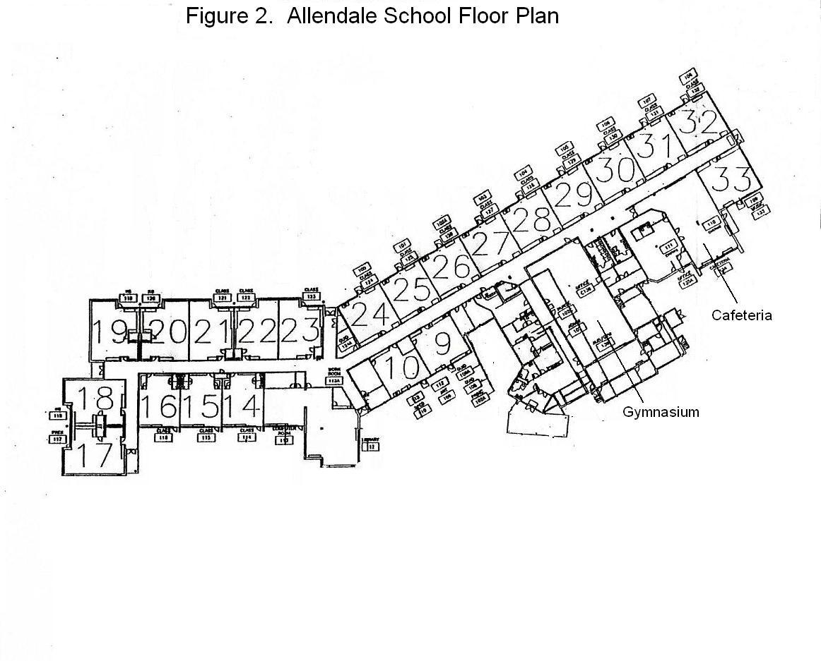

**Carbon Dioxide and its Use in Evaluating Adequacy**

**of Ventilation in Buildings**

The Bureau of Environmental Health’s (BEH) Indoor Air Quality (IAQ) Program examines indoor air quality conditions that may have an effect on building occupants. The status of the ventilation system, potential moisture problems/microbial growth and identification of respiratory irritants are examined in detail, which are described in the attached report. In order to examine the function of the ventilation system, measurements for carbon dioxide, temperature and relative humidity are taken. Carbon dioxide measurements are commonly used to assess the adequacy of ventilation within an indoor environment.

Carbon dioxide is an odorless, colorless gas. It is found naturally in the environment and is produced in the respiration process of living beings. Another source of carbon dioxide is the burning of fossil fuels. Carbon dioxide concentration in the atmosphere is approximately 250-600 ppm (Beard, 1982; NIOSH, 1987).

Carbon dioxide measurements within an occupied building are a standard method used to gauge the adequacy of ventilation systems. Carbon dioxide is used in this process for a number of reasons. Any occupied building will have normally occurring environmental pollutants in its interior. Human beings produce waste heat, moisture and carbon dioxide as by-products of the respiration process. Equipment, plants, cleaning products or supplies normally found in any building can produce gases, vapors, fumes or dusts when in use. If a building has an adequately operating mechanical ventilation system, these normally occurring environmental pollutants will be diluted and removed from the interior of the building. The introduction of fresh air both increases the comfort of the occupants and serves to dilute normally occurring environmental pollutants.

An operating exhaust ventilation system physically removes air from a room and thereby removes environmental pollutants. The operation of supply in conjunction with the exhaust ventilation system creates airflow through a room, which increases the comfort of the occupants. If all or part of the ventilation system becomes non-functional, a build up of normally occurring environmental pollutants may occur, resulting in an increase in the discomfort of occupants.

The MDPH approach to resolving indoor air quality problems in schools and public buildings is generally two-fold: 1) improving ventilation to dilute and remove environmental pollutants and 2) reducing or eliminating exposure opportunities from materials that may be adversely affecting indoor air quality. In the case of an odor complaint of unknown origin, it is common for BEH staff to receive several descriptions from building occupants. A description of odor is subjective, based on the individual’s life experiences and perception. Rather than test for a potential series of thousands of chemicals to identify the unknown material, carbon dioxide is used to judge the adequacy of airflow as it both dilutes and removes indoor air environmental pollutants.

As previously mentioned, carbon dioxide is used as a diagnostic tool to evaluate air exchange by building ventilation systems. The presence of increased levels of carbon dioxide in indoor air of buildings is attributed to occupancy. As individuals breathe, carbon dioxide is exhaled. The greater the number of occupants, the greater the amount of carbon dioxide produced. Carbon dioxide concentration build up in indoor environments is attributed to inefficient or non-functioning ventilation systems. The Occupational Safety and Health Administration (OSHA) standard for carbon dioxide is 5,000 parts per million parts of air (ppm). Workers may be exposed to this level for 40 hours/week, based on a time-weighted average (OSHA, 1997).

Carbon dioxide can be a hazard within enclosed areas with **no air supply**. These types of enclosed areas are known as confined spaces. Manholes, mines and sewer systems are examples of confined spaces. An ordinary building is not considered a confined space. Carbon dioxide air exposure limits for employees and the general public have been established by a number of governmental health and industrial safety groups. Each of these standards of air concentrations is expressed in parts per million (ppm). *Table 1* is a listing of carbon dioxide air concentrations and related health effects and standards.

The MDPH uses a guideline of 800 ppm for publicly occupied buildings (Burge et al., 1990; Gold, 1992; Norback, 1990; OSHA, 1994; Redlich, 1997; Rosenstock, 1996; SMACNA, 1998). A guideline of 600 ppm or less is preferred in schools due to the fact that the majority of occupants are young and considered to be a more sensitive population in the evaluation of environmental health status. Several sources indicate that indoor air problems *are significantly reduced* at 600 ppm or less of carbon dioxide (ACGIH, 1998; Bright et al., 1992; Hill, 1992; NIOSH, 1987). Inadequate ventilation and/or elevated temperatures are major causes of complaints such as respiratory, eye, nose and throat irritation, lethargy and headaches.

Air levels for carbon dioxide that indicate that indoor air quality may be a problem have been established by the American Society of Heating, Refrigerating and Air-conditioning Engineers (ASHRAE). Above 1,000 ppm of carbon dioxide, ASHRAE recommends adjustment of the building’s ventilation system (ASHRAE, 1989). In 2001, ASHRAE modified their standard to indicate that no more than 700 ppm above the outdoor air concentration; however 800 ppm is the level where further investigation will occur.

Carbon dioxide itself has no acute (short-term) health effects associated with low level exposure (below 5,000 ppm). The main effect of carbon dioxide involves its ability to displace oxygen for the air in a confined space. As oxygen is inhaled, carbon dioxide levels build up in the confined space, with a decrease in oxygen content in the available air. This displacement of oxygen makes carbon dioxide a simple asphyxiant. At carbon dioxide levels of 30,000 ppm, severe headaches, diffuse sweating, and labored breathing have been reported. No **chronic** health effects are reported at air levels below 5,000 ppm.

Air testing is one method used to determine whether carbon dioxide levels exceed the comfort levels recommended. If carbon dioxide levels are over 800-1,000 ppm, the MDPH recommends adjustment of the building's ventilation system. The MDPH recommends that corrective measures be taken at levels above 800 ppm of carbon dioxide in office buildings or schools. (Please note that carbon dioxide levels measured below 800 ppm may not decrease indoor air quality complaints). Sources of environmental pollutants indoors can often induce symptoms in exposed individuals regardless of the adequacy of the ventilation system. As an example, an idling bus outside a building may have minimal effect on carbon dioxide levels, but can be a source of carbon monoxide, particulates and odors via the ventilation system.

Therefore, the MDPH strategy of adequate ventilation coupled with pollutant source reduction/removal serves to improve indoor air quality in a building. Please note that each table included in the IAQ assessment lists BEH comfort levels for carbon dioxide levels at the bottom (i.e. carbon dioxide levels between 600 ppm to 800 ppm are acceptable and <600 ppm is preferable). While carbon dioxide levels are important, focusing on these air measurements in isolation to all other recommendations is a misinterpretation of the recommendations made in these assessments.

**Table 1: Carbon Dioxide Air Level Standards**

|  |  |  |  |
| --- | --- | --- | --- |
| **Carbon Dioxide**  **Level** | **Health Effects** | **Standards or Use of Concentration** | **Reference** |
| 250-600 ppm | None | Concentrations in ambient air | Beard, R.R., 1982  NIOSH, 1987 |
| 600 ppm | None | Few indoor air complaints, used as reference for air exchange for protection of children | ACGIH, 1998; Bright et al., 1992; Hill, 1992; NIOSH 1987 |
| 800 ppm | None | Used as an indicator of ventilation adequacy in schools and public buildings, used as reference for air exchange for protection of children | Mendler, 2003  Bell, A. A., 2000; NCOSP, 1998;  SMACNA, 1998; EA, 1997;  Redlich, 1997; Rosenstock, 1996; OSHA, 1994; Gold, 1992;  Burge et al., 1990; Norback, 1990 ;  IDPH, Unknown |
| 1000 ppm | None | Used as an indicator of ventilation inadequacy concerning removal of odors from the interior of building. | ASHRAE, 1989 |
| 950-1300 ppm* | None | Used as an indicator of ventilation inadequacy concerning removal of odors from the interior of building. | ASHRAE, 1999 |
| 700 ppm (over background) | None | Used as an indicator of ventilation inadequacy concerning removal of odors from the interior of building. | ASHRAE, 2001 |
| 5000 ppm | No acute (short term) or chronic (long-term) health effects | Permissible Exposure Limit/Threshold Limit Value | ACGIH, 1999  OSHA, 1997 |
| 30,000 ppm | Severe headaches, diffuse sweating, and labored breathing | Short-term Exposure Limit | ACGIH, 1999  ACGIH. 1986 |

* outdoor carbon dioxide measurement +700 ppm

**References**

ACGIH. 1986. Documentation of the Threshold Limit Values. American Conference of Governmental Industrial Hygienists. Cincinnati, OH.

ACGIH. 1998. Industrial Ventilation A Manual of Recommended Practice. 23rd Edition. American Conference of Governmental Industrial Hygienists. Cincinnati, OH.

ACGIH. 1999. Guide to Occupational Exposures-1999. American Conference of Governmental Industrial Hygienists, Cincinnati, OH.

ASHRAE. 1989. Ventilation for Acceptable Indoor Air Quality. American Society of Heating, Refrigeration and Air Conditioning Engineers. ANSI/ASHRAE 62-1989.

ASHRAE. 1999. Ventilation for Acceptable Indoor Air Quality. American Society of Heating, Refrigeration and Air Conditioning Engineers. ANSI/ASHRAE 62-1999.

ASHRAE. 2001. Ventilation for Acceptable Indoor Air Quality. American Society of Heating, Refrigeration and Air Conditioning Engineers. ANSI/ASHRAE 62-2001.

Beard, R.R. 1982. Chapter Fifty-two, Inorganic Compounds of Oxygen, Nitrogen, and Carbon. *Patty’s Industrial Hygiene and Toxicology, Vol. IIc*. *3rd ed.* Clayton, G. D. & Clayton, F. E., eds. John Wiley & Sons, New York, NY.

Bright, P.; Mader, M.; Carpenter, D.; and Hermon-Cruz, I.Z. 1992. Guideline for Indoor Air Surveys. Brooks Air Force Base, TX. Armstrong Laboratory, Occupational and Environmental Health Directorate. NTIS AL-TR-1992-0016.

Burge, H. and Hoyer, M. 1990. Focus On … Indoor Air Quality. Appl. Occup. Environ. Hyg. 5(2):88.

EA. 1997. Indoor Air Quality. Environment Australia, Department of the Environment, Sport and Territories, Canberra, Australia.  
<http://laptop.deh.gov.au/soe/1996/publications/technical/pubs/12indora.pdf>

Gold, D. 1992. Indoor Air Pollution. Clinics in Chest Medicine. 13(2):224-225.

Hill, B.; Craft, B.; and Burkart, J. 1992. Carbon Dioxide, Particulates and Subjective Human Responses in Office Buildings without Histories of Indoor Air Quality Problems. Appl. Occup. Environ. Hyg. 7(2): 101-111.

IDPH. Unknown. Illinois Department of Public Health Guidelines for Indoor Air Quality. Illinois Department of Public Health, Springfield, Il. <http://www.idph.state.il.us/envhealth/factsheets/indoorairqualityguide_fs.htm>

Mendler, S. and Odell, W. 2003. Indoor Air Quality for the EPA. *ArchitectureWeek.*  April 16, 2003. <http://www.architectureweek.com/2003/0416/environment_1-2.html>

NCOSP. 1998. Workplace Requirements for Safety & Health, Indoor Air Quality 3.3.3. NC Office of State Personnel, Raleigh, NC. <http://www.oshr.nc.gov/Support/Safety/safetyhandbook.pdf>

NIOSH. 1987. Guidance for Indoor Air Quality Investigations. Cincinnati, OH. National Institute for Occupational Safety and Health, Hazards Evaluations and Technical Assistance Branch, Division of Surveillance, Hazard Evaluation and Field Studies.

Norback, D.; Torgen, M.; and Edling, C. 1990. Volatile Organic Compounds, Respirable Dust, and Personal Factors Related to Prevalence and Incidence of Sick Building Syndrome in Primary Schools. British Journal of Industrial Medicine. 47:740.

OSHA. 1994. Occupational Safety and Health Administration. Indoor Air Quality (Proposed Regulation), Federal Register 59:15968-16039, (1994) Appendix A.

OSHA. 1997. Limits for Air Contaminants. Occupational Safety and Health Administration. Code of Federal Regulations. 29 C.F.R 1910.1000 Table Z-1-A.

Redlich, C.; Sparer, J.; and Cullen, M. 1997. Sick-building Syndrome. Lancet. 349:1016.

Rosenstock, L. 1996. NIOSH Testimony to the U.S. Department of Labor on Air Quality, Appl. Occup. Environ. Hyg. 11(12):1368.

SMACNA. 1998. Indoor Air Quality: A Systems Approach. 3rd ed. Sheet Metal and Air Conditioning Contractors’ National Association, Inc, Chantilly, VA. National Association, Inc.