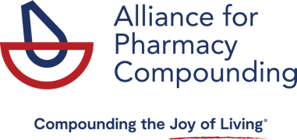
100 Daingerfield Road, Suite 100
Alexandria, VA 22314

www.a4pc.org

February 20, 2024

Massachusetts Department of Public Health
William Anderson
Office of the General Counsel
250 Washington Street
Boston, MA 02108

Dear Department of Public Health:

I am writing on behalf of the Alliance for Pharmacy Compounding to express concern about the proposed amendment to 801 CMR 4.02 (247): Fees for Licenses, Permits, and Services to be Charge by State Agencies. The proposed fees may be cost-prohibitive for some pharmacies and thus could serve to impede Massachusetts patients’ access to essential medications.

The amendment to 801 CMR 4.02 establishes non-resident and increases resident pharmacy license fees significantly, particularly for non-sterile and sterile compounding. Based on our research, these fees appear to be considerably higher than those in other states. In addition, it is unclear whether pharmacies will be required to hold multiple licenses depending on their practice and location. For instance, does the sterile compounding pharmacy license fee also cover that pharmacy’s non-sterile operations, or must both fees be paid if a pharmacy does both sterile and non-sterile compounding?

We kindly ask the Board to share justification for these fees and provide answers to these questions.

Thank you for this opportunity to comment on this amendment. Please direct any questions to me at scott@a4pc.org.

Best,
Scott Brunner, CAE
Chief Executive Officer

The Alliance for Pharmacy Compounding is the voice for pharmacy compounding, representing more than 500 compounding small businesses – including compounding pharmacists and technicians in both 503A and 503B settings – as well as prescribers, educators, researchers, and suppliers.

