Data Brief:
THE ARGEO PAUL CELLUCCI
AMYOTROPHIC LATERAL SCLEROSIS (ALS) REGISTRY OF MASSACHUSETTS
In 2008, resident concerns over potential geographic “hotspots” and/or increasing rates of Amyotrophic Lateral Sclerosis (ALS) prompted the Massachusetts legislature to enact a law establishing the first statewide ALS registry in the country. The Massachusetts Department of Public Health’s Bureau of Environmental Health (MDPH/BEH) has since built the Argeo Paul Cellucci ALS Registry using rigorously developed protocols for the comprehensive collection and evaluation of data on ALS occurrence in Massachusetts.
Massachusetts Department of Public Health May 2016

As a rare disease, ALS requires multiple years of data to assess potential trends in occurrence. Accordingly, this data brief highlights analyses from the first five years of the Registry which includes case reports of ALS patients in Massachusetts from 2007 through 2011. The medical records of 2012 and 2013 patients are currently being reviewed and records for 2014 patients are being collected. Indications from the 2012, 2013, and 2014 medical records suggest that the number of new ALS cases appears to be consistent with previous years.

A total of 826 new ALS cases were reported to MDPH/BEH over the five-year period 2007-2011, or approximately 165 new cases per year. Adjusting for age, this means that the annual average rate of newly diagnosed ALS cases (incidence) in Massachusetts was 2.2 people per 100,000. This rate is similar to other reports in the scientific literature that estimate the rate of new ALS cases to be about 2.1 per 100,000 people per year.¹ The average annual age-adjusted number of residents living with ALS on December 31 of each year (prevalence) was 5.6 per 100,000. This is comparable to the range of estimates of people living with ALS from the scientific literature, which is about 4.1-7.9 per 100,000.¹ Therefore, the occurrence of ALS in Massachusetts does not appear to be different from that observed elsewhere.

Exhibit 1: Annual Age-Adjusted Occurrence of ALS in Massachusetts, 2007-2011

The chart above shows the rate of new ALS cases and the proportion of people living with ALS statewide over the first five years of the Registry. A slight, non-statistically significant, increase in the proportion of the population living with ALS can be noted. However, no such increase is present in the rate of new ALS cases, suggesting that the lower estimates of all cases living with ALS during the Registry’s first couple of years may be a result of incomplete reporting of cases diagnosed prior to the start of the Registry.

Exhibit 2: Average Annual Age-Adjusted Rate of New Cases of ALS in Massachusetts on December 31, by County, 2007-2011
95% Confidence Interval
ALS occurrence was also evaluated by county and community. Some variation was observed across counties, but based on the first five years of ALS Registry data, no statistically significant differences were observed in the rate of new ALS cases by county across Massachusetts compared to the statewide rate. The wide error bars indicate that more years of data are needed to produce more precise estimates, particularly in sparsely populated areas such as Dukes and Nantucket Counties.

Exhibit 3: Average Annual Age-Adjusted Number of All ALS Cases in Massachusetts on December 31, by County, 2007-2011

95% Confidence Interval
In comparison with the statewide estimate, none of the county values for the number of all ALS cases present by county were statistically significantly different.

Estimated rates and numbers of ALS patients by community can be viewed on the MDPH/BEH website (www.mass.gov/dph/environmental_health). No community estimates were statistically significantly higher than the statewide estimates. However, as shown in the map below, a few communities had a statistically significantly lower number of people living with ALS compared to the state.
Exhibit 4: Average Annual Age-Adjusted Number of All ALS Cases in Massachusetts on December 31, by Community, 2007-2011
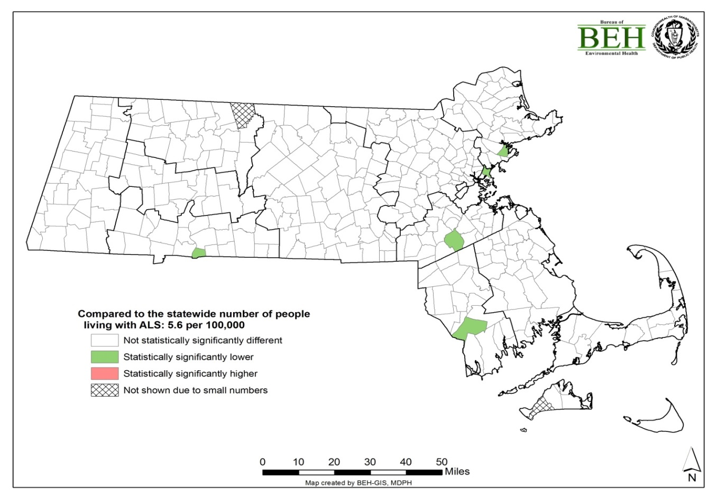

ALS Registry data are being used to investigate geographic patterns and hotspots of ALS in Massachusetts and to explore whether environmental concerns may have an impact on rates of disease. Analyses to date have not found any significant elevation in ALS occurrence, but additional years of data are needed for a more robust determination of local disease patterns. Researchers can apply for access to the data through the Department’s Institutional Review Board (IRB). The IRB has the goal of ensuring that the rights of subjects being considered for inclusion in research are protected in accordance with federal and states privacy regulations and policies.

Further details about the Registry data presented and about the Registry itself can be found on the MDPH/BEH website (www.mass.gov/dph/environmental_health).

Technical Notes
- Approximately 600-700 potential ALS patients are reported annually to MDPH/BEH by hospitals, clinics, physicians, and vital records for any patient diagnosed with or treated for ALS while residing in Massachusetts. A trained MDPH/BEH Registry nurse conducts a full review of the medical records for each patient reported. Before being added to the Registry, all diagnoses are verified by a consulting neurologist.
- Beginning in late 2016, future updates of data for the Argeo Paul Cellucci ALS Registry will be provided on the ALS Registry website and also on a public data portal, where users can view summary data geographically and across time, as well as by other variables such as social determinants of health. The public portal is called Environmental Public Health Tracking (EPHT) and can be found at https://matracking.ehs.state.ma.us. The portal can be viewed by the public now for a variety of health outcomes other than ALS, including cancer and pediatric asthma.
- No information on individual ALS patients or information that could be used to identify individual patients is presented in any MDPH/BEH publications or included on the ALS Registry website or the EPHT portal.
- The 2012 and 2013 ALS data will be available on the ALS website and the EPHT portal in 2016.

References
¹Chio A, Logroscino G, Traynor BJ, Collins J, Simeone JC, Goldstein LA, White LA. Global epidemiology of amyotrophic lateral sclerosis: a systematic review of the published literature. Neuroepidemiology 2013; 41(2):118-130.

