Alternate Electronic Visit Verification (EVV) Implementation in Massachusetts

Wednesday, February 13, 2019

Slide 1:

Today’s Agenda
- 21st Century Cures Act
- Massachusetts’ Plan for EVV Implementation
- Alternate EVV Estimated Timeline
- Alternate EVV Experience Questions

Slide 2:

21st Century Cures Act mandates EVV use
- Electronic Visit Verification (EVV) refers to the technology a worker uses during a home visit to capture information about the services provided
- Federal law requires EVV for the following Medicaid services:
  - Personal care by 1/1/2020
  - Home health by 1/1/2023
- EVV required for Medicaid services but EOHHS will be requiring it for EOEA Non-Medicaid services as well
- States face a reduction in federal matching funds if they do not implement EVV on time, although states can apply for a 1 year exemption

Slide 3:

Massachusetts’ goals for EVV implementation

Quality: promote quality outcomes for consumers by ensuring appropriate service delivery
Efficiency: reduce administrative burden of paper timesheets
Program Integrity: reduce billing errors and unauthorized spending

Slide 4:

Hybrid EVV Model to be Deployed for EOEA Programs (Frail Elder Waiver and Home Care)
EVV Options for ASAP-contracted providers
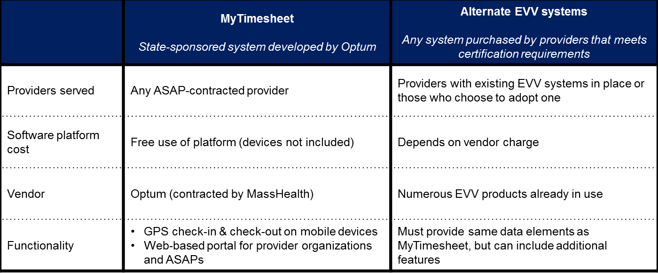
Regular uploads
Automated data flow

State EVV Database

Slide 5:

Alt-EVV: Process & Estimated Timeline
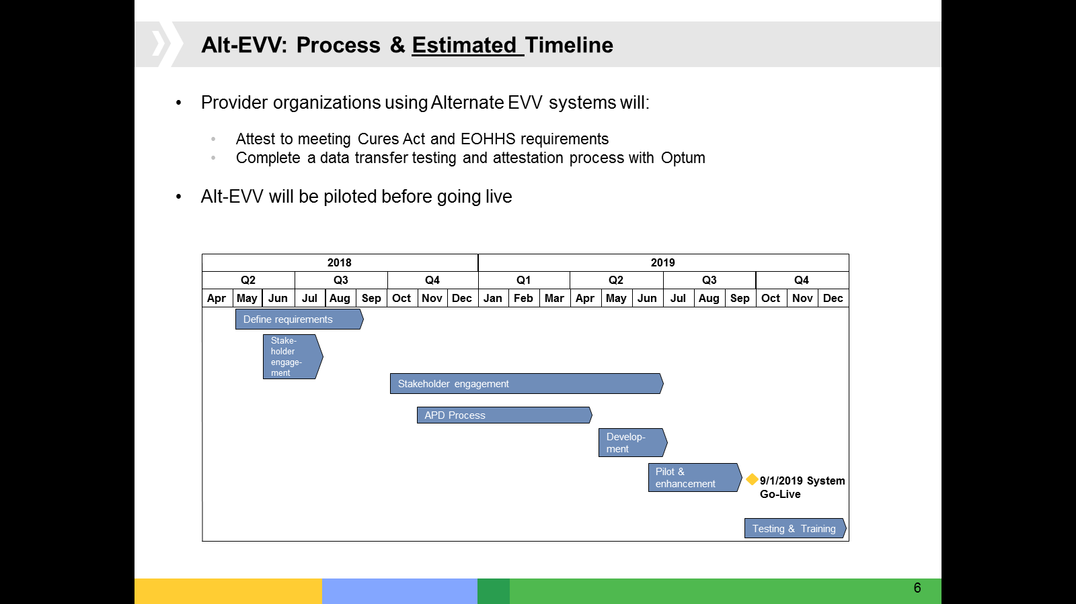

Slide 6:

Alternate EVV Experience Questions

Choosing an Alternate EVV System
- What prompted your organization to adopt an EVV system? How has the use of EVV affected your operations, logistics, and program integrity? Has it made it easier or more difficult?

Slide 7:

Alternate EVV Experience Questions

Consecutive Services
- How does your system accommodate for situations such as a service authorization that is for one hour of one service and one hour of another service consecutively on the same day? Does the worker check in and check out only once each day, or per service, or in some other manner?

Slide 8:

Alternate EVV Experience Questions

Actual versus Authorized Time
- How is the recorded service data matched with, or compared against, the authorization for the respective services? For example, do you compare the hours that a worker checks in and out to provide the service to the authorization in the care plan or similar authority?

Slide 9:

Alternate EVV Experience Questions

Visits Outside of EVV
- If a worker is unable to use EVV to capture a visit, how do you capture/verify that visit?

Slide 10:

Alternate EVV Experience Questions

Visits Outside of EVV
- What is the proportion of visits not captured/verified electronically?

Slide 11:

Alternate EVV Experience Questions

Companion Services
- If your agency provides Companion services, do you include them as part of your EVV software?
a. Has including those service(s) in your EVV made operations / logistics easier?
b. What is your reasoning for including companion services? e.g. the same direct care aides are performing companion services plus other services that do require EVV, so it is easier to require it for all services.

Slide 12:

Alternate EVV Experience Questions

Implementation Challenges
- What have been some of the notable challenges during the implementation process?

Slide 13:

Alternate EVV Experience Questions

Implementation Benefits
- What are some positive insights/outcomes you experienced during the implementation process?

Slide 14:

Alternate EVV Experience Questions

EVV Data
- Are you able to parse/filter your EVV data by specific programs and/or services?

Slide 15:

Alternate EVV Experience Questions

User Access Management
- What type of user access management plan do you have for your EVV system?

Slide 16:

Alternate EVV Experience Questions

EVV Training
- What types of training/re-training do you provide to workers on the use of EVV?

Slide 17:

Alternate EVV Experience Questions

EVV Customer Service
- What is the volume of customer service calls or troubleshooting requests you receive from users?

Slide 18:

Thank You!
Information about EOHHS’ EVV Implementation can be found at:

https://www.mass.gov/guides/mytimesheet-electronic-visit-verification-system

Feedback/questions related to EVV can be submitted to EOHHS by emailing:

EVVfeedback@State.MA.US

