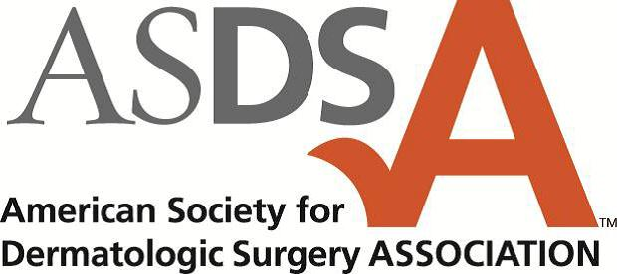

May 19, 2017

Ms. Eileen Prebensen
Senior Policy Counsel
Board of Registration in Medicine
200 Harvard Mills Square
Suite 330
Wakefield, MA 01880

Re: Oppose Draft 243 CMR 2.07 (14)

Dear Ms. Prebensen,

On behalf of the 245 of members of the Massachusetts Academy of Dermatology and nearly 14,000 members of the American Academy of Dermatology Association and American Society for Dermatologic Surgery Association, we are writing in strong opposition to a proposal that would require physicians who accept a patient for treatment of a known or suspected cancer to provide the patient with certain defined information. The process of providing the information would be documented through informed consent and as part of the medical record. Members of our respective organizations are committed to excellence in medical and surgical treatment of skin disease; advocating high standards in clinical practice, education, and research in dermatology; and supporting and enhancing patient care to reduce the burden of disease. The adoption of this proposal is a significant and unnecessary burden that would affect our ability to achieve these goals. Further, providing the required information to every patient with suspected cancer could cause undue duress. For the reasons detailed below, we urge the members of the Board of Registration in Medicine to oppose subsection (14) of 243 CMR 2.07.

The list of proposed topics will not improve patient care. Understanding the patient’s medical history enables dermatologists and dermatologic surgeons to determine what should be discussed during an office visit or prior to surgery. Included in every discussion with our patients is a list of alternative treatments. Patients should not be seen as a “one-size fits all” and the topics to be discussed during a patient encounter should be a joint decision between the physician and patient. Mandating certain issues to be discussed is an intrusion into the physician-patient relationship. Additionally, we are deeply concerned that the proposal includes patients with “suspected cancer.” Discussing many of the topics listed in the proposal with such patients could cause emotional distress. The patient’s medical history should guide whether such alternatives should be discussed.

Lastly, this proposal would significantly delay patient care. Including the proposed list of topics in every discussion with our patients (those with cancer and suspected cancer) could easily add at least 10 minutes of face-to-face time with each patient and at least 2 hours per day on administrative work to document the conversation. We support transparency so that the patient is empowered to make an educated decision concerning his or her care; however, the proposal does not achieve such objective. Instead, the proposal is an intrusion into the patient-physician relationship. If adopted, physicians will be required to comply with another administrative requirement at the expense of time spent on patient care.

Our undersigned organizations appreciate the opportunity to comment on this proposal. Many members of the Board of Registration in Medicine understand firsthand that physicians spend far too much time on administrative tasks, taking precious time away from their patients. We look forward to working with you to ensure we promote transparency in a way that does not increase administrative burdens for physicians and unnecessary anxiety for our patients. Should you have any questions, please do not hesitate to contact Lisa Albany, associate director, state policy for the American Academy of Dermatology Association at 202-712-2615 or lalbany@aad.org.
Thank you for your consideration.

Sincerely,
Henry W. Lim, M.D., FAAD
President
American Academy of Dermatology Association

Thomas E. Rohrer, MD
President
American Society for Dermatologic Surgery Association

Ira L. Skolnik, MD, Ph.D., FAAD
President
Massachusetts Academy of Dermatology

